For or Since?

Painting1,2,4: by Tony Yu
有人說人像圖片的力量在於眼神與動作, 我不小心在網路上看到一位學生的創作 (1,2,4),你覺得哪張圖像對你最有感覺?昨天發現我家的11歲老狗開始長老人斑了,害我開始想到生老病死的人生必經之路。雖然是一邊學英文,也順便看看藝術,看看人生吧
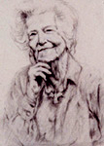
he has been living in New York _________1925. She has not changed much. She is a nurse. And She has been doing the same job _____nearly 40 years; and she has been driving the same car ___________I was a boy. And She has had that curly hair ____her early 20s.
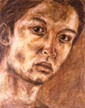
e only slept ______four hours last night---he has been up _________four o’clock this morning. He is so tired, and he thinks he could sleep _____a week.
H

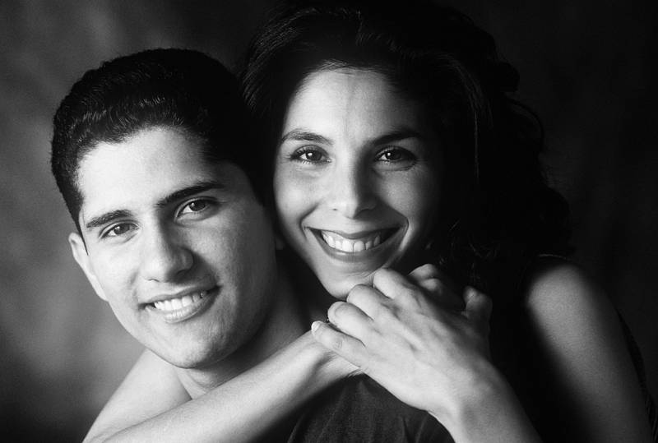
e have known each other _______most of our lives, but we have only been married _____a few months.

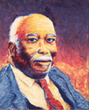
e has been driving _____his 17th birthday, and he is now 51, so he has been driving _______34 years.

