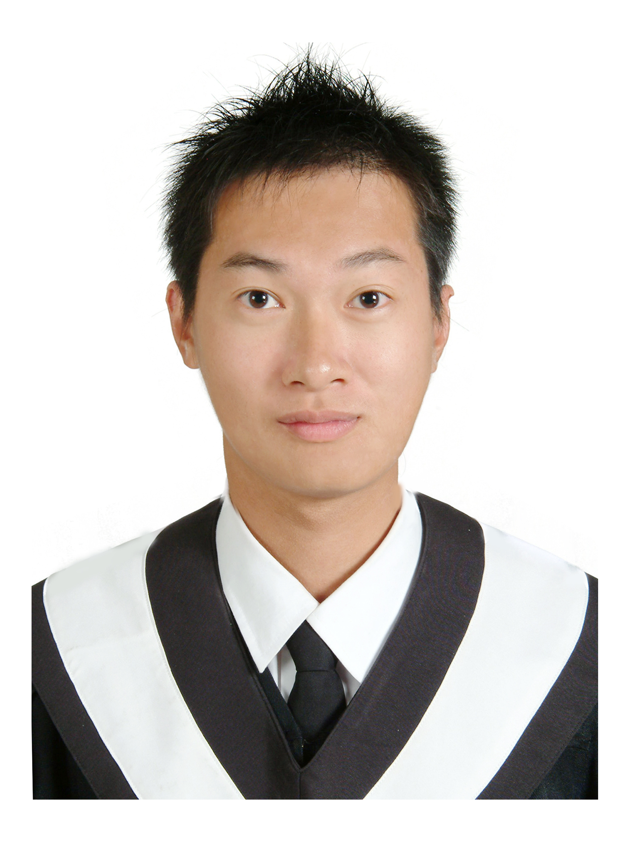
遠東版 單字教室
New Far East - English Reader
Vocabulary Classroom

慧燈中學 戴逸群老師 主編

Lesson 3 The All-important Pumpkin

0. pumpkin 南瓜 A big, round, orange fruit that grows on a vine along the ground. People often
carve faces in pumpkins at Holloween.
Vegetable
 | 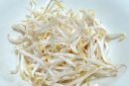 | 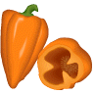
竹筍 | 豆芽菜 | 甜椒
 | 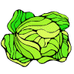 | 
花椰菜（綠） | 高麗菜 | 花椰菜（白）
 |  | 
芹菜 | 小黃瓜 | 茄子
 | 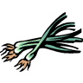 | 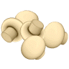
葫蘆 | 蔥 | 蘑菇
 | 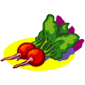 | 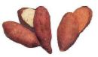
洋蔥 | 小蘿蔔 | 地瓜
Fruit
 |  | 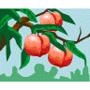
甜瓜 | 梨子 | 油桃
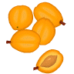 |  | 
杏仁 | 梅子 | 葡萄
 |  | 
櫻桃 | 萊姆 | 蔓月莓
 |  | 
小紅莓 | 鵝莓 | elderberries
 | EMBED Word.Picture.8 | 
黑莓 | 金柑 | 紅葡萄柑
 | 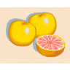 | 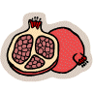
黑葡萄柑 | 葡萄柚 | 石榴
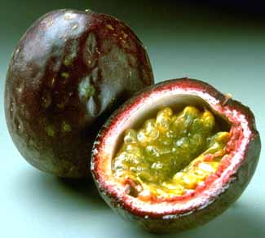 |  | 
百香果 | 芭樂 | 小番茄
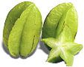 | 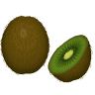 | 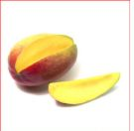
楊桃 | 奇異果 | 芒果
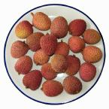 | 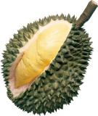 | 
荔枝 | 榴連 | 木瓜
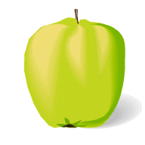 |  | 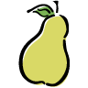
無花果 | 鳳梨 | 洋梨

1. meaningful (adj) 富有意義的 Useful or significant in some way.
meaning (n) 意義 The idea behind something spoken or written.

2. afterward (adv) 之後 Later.
= __________

3. bake 烤 To cook food in an oven, especially bread or cake.
 __________ 麵包店 : The bakery is famous for its cheesecake.
 __________ 麵包師傅

4. frost (n) 霜 Powdery ice that forms on things in freezing weather.

5. cultivate (v) 栽培 If you cultivate land, you grow crops on it.
cultivation (n) 耕種
 cultivated (adj) 有教養的；栽種的

6. native (adj) 出生地的 Belonging to a person because of where he or she was born.
native (n) 當地人 A person, an animal, or a plant that originally lived or grew in a certain place.
Native Americans 印地安人
 __________ __________/ __________母語

7. stew (n) 燉菜 A dish made of meat or fish and vegetables cooked slowly in liquid.
stew (v) 文火燉煮 To cook something for a long time over low heat.
 __________ __________ 燉羊肉
 stew in one’s own juice 自作自受: Don’t just sit there stewing in your own juice of hatred.

8. vitamin (n) 維他命 One of the substances in food that is necessary for good health.
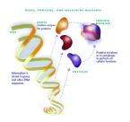 |  | 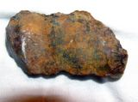
蛋白質 | 鈣質 | 鐵質
 |  | 
脂肪 | 藥丸 | 維骨力

9. mineral (n) 礦物質 A substance found in nature that is not an animal or a plant.
 mine 採礦；礦坑
 miner 礦工
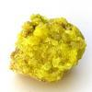 | 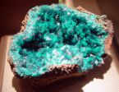 | 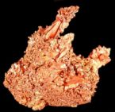
硫磺 | turquoise 綠松石 | 銅
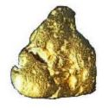 | 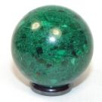 | 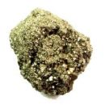
金 | malachite 孔雀石 | pyrite 黃鐵礦
10. amusing (adj) 好笑的；有趣的 Funny and interesting
amuse (v) 使開心；逗（某人）笑 To make someone laugh or smile.
amusement (n) 娛樂
 __________ __________ 遊樂園 A place where people pat to go on rides, play games of
skills, and enjoy other forms of entertainment.
amused (adj) 感興趣的；覺得有趣的

11. guide (n)指引；指南
guide (v) 引領；嚮導 To help someone, usually by showing the person around a place or
by leading the person across difficult country.
guidance (n) 指導；輔導 Advice or counsel, especially about a student’s future plans

12. expression 措詞 A phrase that has a particular meaning
表情 The look on someone’s face
express (v) 表達 To show what you feel or think by saying, doing, or writing something.
expressive (adj) 表示的；表達的 Filled with meaning or feeling.
 expressionless (adj) 無表情的
 __________ __________ 限時郵件

13. harvest (n) 收割；收穫 The gathering in of crops that are ripe, or the crops gathered in.
(v) 收割 To collect or gather up crops.

14. price 奬賞 The amount that you have to pay for something.

15. fertilizer (n) 肥料 A substance added to soil to help plants grow
fertilize (v) 施肥 To put a substance such as manure on land to make it richer
 fertile (adj) 肥沃的；多產的
 fertility (n) 肥沃；多產

16. originate (v) 開始；起源 To begin from somewhere or something.
 origin (n) 起源；出處
 original (adj) 原始的；富有創意的
 originally (adv) 本來；原來

17. joyous (adj) 快樂的；歡喜的 Extremely happy; joyful

18. occasion (n) 慶典 A special or important event.
occasional (adj) 偶爾的
occasionally (adv) 偶爾地
 __________ __________ (s) 不時地：On occasion, Naomi and her husband spend a
romantic night at a fancy restaurant.

19. spirit (n) 幽靈 A ghost.
心靈 The part of a person that is believed to control thoughts and feelings; the soul.
心情 (pl.) A person’s mood or state of mind.
 spiritual (adj) 精神的To do with the soul and not with physical things.
 spirituality (adv) 精神上地

20. hollow (v) 挖空 If you hollow something out, you take its insides out.
hollow (adj) 中空的 If something is hollow, it has an empty space inside it.
 hollow out 挖空：To make a jack-o’-lantern, first you need to hollow out a pumpkin.

21. evil (adj) 邪惡的 Wicked and cruel
evil (n) 惡事

22. carve (v) 雕刻 To cut a shape out of a piece of wood, stone, or other substance.
carving (n) 雕刻品

23. scary (adj) 嚇人的；恐怖的 Causing fear.
scare (v) 使…害怕 To frighten a person or an animal.
scared (adj) 受驚嚇的
 __________ __________ 恐怖電影

24. glow (v) 發光 If something glows, it gives off a steady, low light, often because it is hot.
glow (n) 光輝 A light from something that glows.

25. broil (v) 燒烤 To cook by exposing food diretly to the source of heart.
broiling (adj) 酷熱的
 __________ __________ 烤雞

