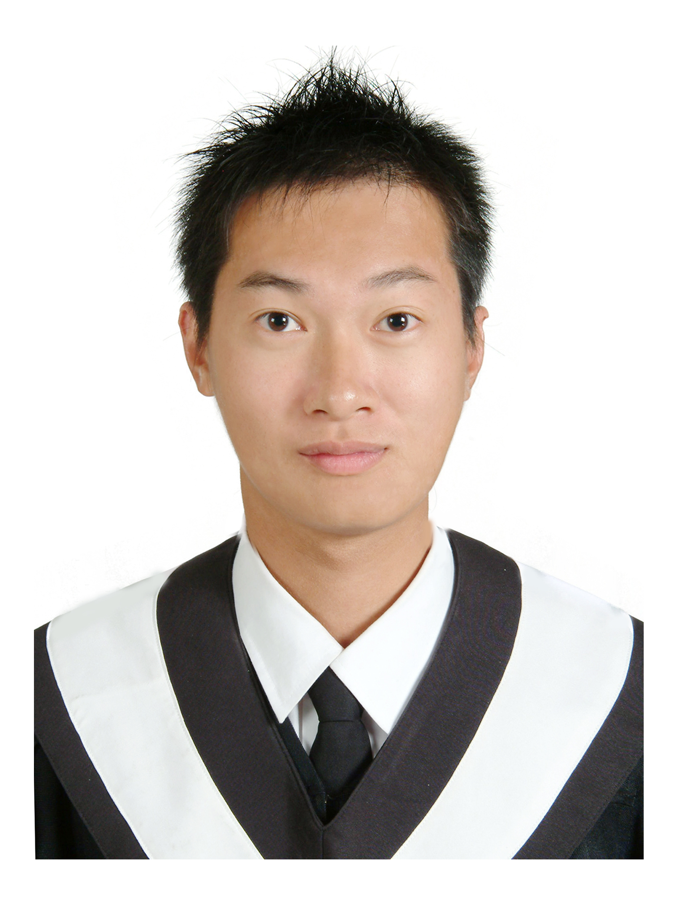
遠東版 單字教室
New Far East - English Reader

Vocabulary Classroom 戴逸群老師 主編

Lesson 1 General MacArthur’s Player for His Son
版權所有 ，翻印必究

1. brave 勇敢的 Brave describes someone who is unafraid to face danger
Synonyms: brave
 __________: The courageous rescue workers searched the collapsed building despite the risks.
 __________: It was a bold move for Dorothy to speak to the Wizard of Oz.
 __________: The fearless performers walked on the tightrope high above the floor of the circus tent.
 __________: The sergeant received many medals for his heroic deeds during the war.
 __________: It took a valiant effort to carry the injured hiker down the mountain.
Antonym: 憋三，淑辣
 __________
 __________

2. face 臉 (n) 面對 (v)

3. defeat 失敗 To beat someone in a war or a competition

4. humble 謙遜的；卑微的 Modest and not proud

5. gentle 和善的；溫柔的 Kind and sensitive
平緩的 Not extreme ex. a gentle slope/hill
6. victory 勝利 A win in a battle or contest.
Synonyms: victory

 __________ (n): 勝利 The football team achieved a complete triumph.
 __________ (n): Mr. Ian win the class’s respect.
 Win 的三態變化 __________(現在式) __________(過去式) __________(過去分詞)
 詞類變化 victorious (adj) 勝利的
victor (n) 獲勝者

7. knowledge 知識 The things that someone knows; information.
Knowledgeable (adj) 有知識的
 (諺語) 知識就是力量。____________________________________________________
 know 的三態變化 __________(現在式) __________(過去式) __________(過去分詞)

8. ease (n) 舒適；安逸 Freedom from hard work, pain, or discomfort,
(v) 減輕 To make less difficult

9. stress (n) 壓力 Worry, strain or pressure.
(v) 著重；強調 To pronounce a word with more loudness or emphasis on a certain

syllable.
 詞類變化 stressful (adj) 帶來壓力的

10. difficulty 困難 A problem.
 have difficulty (in) V-ing 做～有困難

11. compassion 同情；憐憫 A feeling of sympathy for and a desire to help someone who is
suffering.
compassionate 有同情心的；慈悲的

12. master (v) 駕馭；精通 If you master a subject or skill, you become very good at it.
master (n) 主人；名家；碩士 A person with power, rule, or authority over another
 a Master of __________= M.A. 文科碩士
 a Master of __________= M.S. 理科碩士

13. seek 試圖 To try.
尋求 To look or search for something.
 __________ and __________捉迷藏
 seek 的三態變化 __________(現在式) __________(過去式) __________(過去分詞)

14. weep 哭泣
 weep 的三態變化 __________(現在式) __________(過去式) __________(過去分詞)
 不同的哭法 weep 無聲的流淚 cry 放聲大哭的哭 sob 抑制感情的啜泣
15. humility 謙遜；謙恭 If you show humility, you are not too proud, and you recognize your
own faults.

 詞類變化 humiliate (v) 羞辱
humiliating (adj) 羞辱的；丟臉的
humiliation (n) 羞辱；恥辱

16. simplicity (n) 樸素；單純
simple (adj) 簡樸的；簡單的
simply (adv) 簡單地；僅僅

17. wisdom (n) 智慧 knowledge, experience, and good judgment.
wise (adj) Having or showing good judgment and intelligence.
 wisdom tooth 智齒(單數) wisdom teeth (複數)

18. meekness (n) 溫良；柔順
meek (adj) 溫順的 Quiet, humble, and obedient.
 as meek as a __________ 和小綿羊ㄧ樣溫柔

19. dare (v) 敢 To be brave enough to do something.
dare (助) 敢
 __________ __________ __________ read my diary! 你竟敢看我日記！
 __________ __________ __________ call me pussy again! 警告你別再叫我娘泡！

