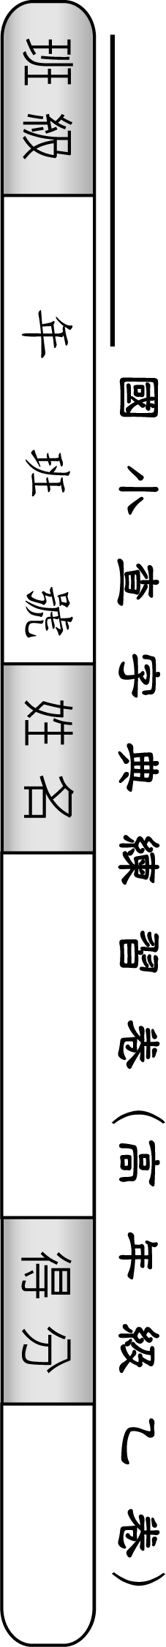
50 | 49 | 48 | 47 | 46 | 45 | 44 | 43 | 42 | 41 | 40 | 39 | 38 | 37 | 36 | 35 | 34 | 33 | 32 | 31 | 30 | 29 | 28 | 27 | 26 | 題號
率 | 丞 | 皆 | 覆 | 誦 | 嘉 | 夥 | 敦 | 惹 | 牧 | 韋 | 塵 | 曼 | 奈 | 卓 | 喪 | 蝕 | 穎 | 州 | 尚 | 系 | 穹 | 礙 | 畢 | 皺 | 字別
 |  |  |  |  |  |  |  |  |  |  |  |  |  |  |  |  |  |  |  |  |  |  |  |  | 部首
 |  |  |  |  |  |  |  |  |  |  |  |  |  |  |  |  |  |  |  |  |  |  |  |  | 筆畫
 |  |  |  |  |  |  |  |  |  |  |  |  |  |  |  |  |  |  |  |  |  |  |  |  | 注音
 |  |  |  |  |  |  |  |  |  |  |  |  |  |  |  |  |  |  |  |  |  |  |  |  | 頁數
 |  |  |  |  |  |  |  |  |  |  |  |  |  |  |  |  |  |  |  |  |  |  |  |  | 造詞

25 | 24 | 23 | 22 | 21 | 20 | 19 | 18 | 17 | 16 | 15 | 14 | 13 | 12 | 11 | 10 | 9 | 8 | 7 | 6 | 5 | 4 | 3 | 2 | 1 | 題號
戴 | 晉 | 毫 | 冊 | 鋤 | 肩 | 腐 | 歐 | 胡 | 賴 | 虛 | 席 | 鞠 | 末 | 凱 | 疏 | 乘 | 乍 | 幕 | 囊 | 局 | 商 | 嚮 | 承 | 騰 | 字別
 |  |  |  |  |  |  |  |  |  |  |  |  |  |  |  |  |  |  |  |  |  |  |  |  | 部首
 |  |  |  |  |  |  |  |  |  |  |  |  |  |  |  |  |  |  |  |  |  |  |  |  | 筆畫
 |  |  |  |  |  |  |  |  |  |  |  |  |  |  |  |  |  |  |  |  |  |  |  |  | 注音
 |  |  |  |  |  |  |  |  |  |  |  |  |  |  |  |  |  |  |  |  |  |  |  |  | 頁數
 |  |  |  |  |  |  |  |  |  |  |  |  |  |  |  |  |  |  |  |  |  |  |  |  | 造詞

