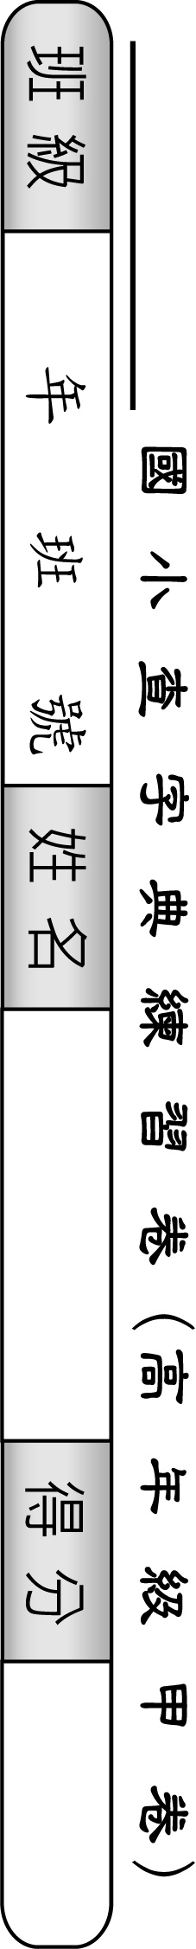
50 | 49 | 48 | 47 | 46 | 45 | 44 | 43 | 42 | 41 | 40 | 39 | 38 | 37 | 36 | 35 | 34 | 33 | 32 | 31 | 30 | 29 | 28 | 27 | 26 | 題號
豔 | 幻 | 扇 | 劣 | 兵 | 耕 | 衷 | 良 | 屯 | 竊 | 聳 | 盈 | 猶 | 歸 | 痰 | 獻 | 舍 | 辭 | 竭 | 協 | 丈 | 琵 | 壽 | 悉 | 妝 | 字別
 |  |  |  |  |  |  |  |  |  |  |  |  |  |  |  |  |  |  |  |  |  |  |  |  | 部首
 |  |  |  |  |  |  |  |  |  |  |  |  |  |  |  |  |  |  |  |  |  |  |  |  | 筆畫
 |  |  |  |  |  |  |  |  |  |  |  |  |  |  |  |  |  |  |  |  |  |  |  |  | 注音
 |  |  |  |  |  |  |  |  |  |  |  |  |  |  |  |  |  |  |  |  |  |  |  |  | 頁數
 |  |  |  |  |  |  |  |  |  |  |  |  |  |  |  |  |  |  |  |  |  |  |  |  | 造詞
25 | 24 | 23 | 22 | 21 | 20 | 19 | 18 | 17 | 16 | 15 | 14 | 13 | 12 | 11 | 10 | 9 | 8 | 7 | 6 | 5 | 4 | 3 | 2 | 1 | 題號
凸 | 奏 | 旦 | 鳴 | 凡 | 輝 | 舟 | 爾 | 首 | 疑 | 弄 | 膏 | 哲 | 鬥 | 索 | 勾 | 棄 | 垂 | 穀 | 孕 | 哀 | 奪 | 雁 | 臨 | 禿 | 字別
 |  |  |  |  |  |  |  |  |  |  |  |  |  |  |  |  |  |  |  |  |  |  |  |  | 部首
 |  |  |  |  |  |  |  |  |  |  |  |  |  |  |  |  |  |  |  |  |  |  |  |  | 筆畫
 |  |  |  |  |  |  |  |  |  |  |  |  |  |  |  |  |  |  |  |  |  |  |  |  | 注音
 |  |  |  |  |  |  |  |  |  |  |  |  |  |  |  |  |  |  |  |  |  |  |  |  | 頁數
 |  |  |  |  |  |  |  |  |  |  |  |  |  |  |  |  |  |  |  |  |  |  |  |  | 造詞

