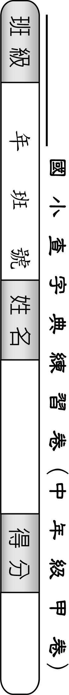
50 | 49 | 48 | 47 | 46 | 45 | 44 | 43 | 42 | 41 | 40 | 39 | 38 | 37 | 36 | 35 | 34 | 33 | 32 | 31 | 30 | 29 | 28 | 27 | 26 | 題號
奧 | 裂 | 豪 | 巢 | 昂 | 登 | 釋 | 案 | 務 | 衛 | 盡 | 顯 | 典 | 崇 | 泰 | 辛 | 朗 | 存 | 維 | 參 | 暫 | 瓜 | 免 | 奮 | 變 | 字別
 |  |  |  |  |  |  |  |  |  |  |  |  |  |  |  |  |  |  |  |  |  |  |  |  | 部首
 |  |  |  |  |  |  |  |  |  |  |  |  |  |  |  |  |  |  |  |  |  |  |  |  | 筆畫
 |  |  |  |  |  |  |  |  |  |  |  |  |  |  |  |  |  |  |  |  |  |  |  |  | 注音
 |  |  |  |  |  |  |  |  |  |  |  |  |  |  |  |  |  |  |  |  |  |  |  |  | 頁數
 |  |  |  |  |  |  |  |  |  |  |  |  |  |  |  |  |  |  |  |  |  |  |  |  | 造詞

25 | 24 | 23 | 22 | 21 | 20 | 19 | 18 | 17 | 16 | 15 | 14 | 13 | 12 | 11 | 10 | 9 | 8 | 7 | 6 | 5 | 4 | 3 | 2 | 1 | 題號
牽 | 帝 | 亂 | 耗 | 差 | 訓 | 瓦 | 既 | 史 | 冠 | 止 | 窗 | 農 | 展 | 夢 | 帽 | 夠 | 孝 | 察 | 受 | 由 | 置 | 千 | 難 | 尤 | 字別
 |  |  |  |  |  |  |  |  |  |  |  |  |  |  |  |  |  |  |  |  |  |  |  |  | 部首
 |  |  |  |  |  |  |  |  |  |  |  |  |  |  |  |  |  |  |  |  |  |  |  |  | 筆畫
 |  |  |  |  |  |  |  |  |  |  |  |  |  |  |  |  |  |  |  |  |  |  |  |  | 注音
 |  |  |  |  |  |  |  |  |  |  |  |  |  |  |  |  |  |  |  |  |  |  |  |  | 頁數
 |  |  |  |  |  |  |  |  |  |  |  |  |  |  |  |  |  |  |  |  |  |  |  |  | 造詞

