Can a fish crawl out of water? Are there animals that never drink? Can a frog survive being frozen solid? Since life on Earth began in water some 3.5 billion years ago, living organisms have evolved an amazing variety of techniques for surviving different water conditions. Water is one of life's essential ingredients. And life exists wherever there's water. Only in the driest parts of Chile's Atacama Desert, where rain hasn't fallen for decades, is life nearly absent. Everywhere else, animals and plants use water of all sorts, salty or fresh, hot or cold, plenty of water or almost no water at all.

魚能離開水生活嗎？您看過從不喝水的動物嗎？蜻蛙能在冰凍的狀態下生存嗎？大約在35億年前，生命開始出現在水中，為了存活在各種不同水的狀態，活的有機體演化出各種不同的驚人技巧。水是生物存活必要的元素之一。只要有水的地方，就有生物的存在只有在極度乾燥的地，方像是智利的砂漠，好幾十年下不到幾滴雨，才幾乎找不到生命，其它任何地方，不論是淡水或鹹水，冷的或熱的，充沛或稀少，動植物使用各種型態的水維生。

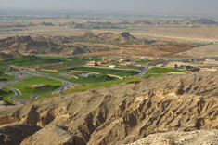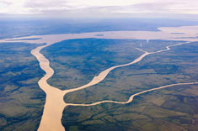

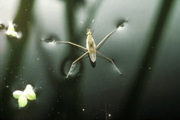

Water Strider

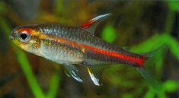

Glowlight tetra (Hemigrammus erythrozonus)

© Peter and Martin Hoffmann

Flooded with Water
You might think that freshwater fish have it easy, at least where water is concerned. But actually, fish have too much of a good thing: water is constantly flowing into their bodies as they use their gills to breathe. To prevent their tissues from becoming too watery, their kidneys continually drain water into their urine. At the same time, these fish also must actively pump salt in from the water. Saltwater fish have the opposite problem—they have to bring in water while pumping out salt.
您或許認為淡水魚很容易取得淡水，實際上，對魚而言，水是一件難以忍受的東西。為了用鰓呼吸，水不停地流入魚的身體，為了避免魚身體的組織含水量過多，魚的腎臟須持續將水排出身體成為尿，同時間，魚須從水中吸取鹽分。鹹水魚剛好有相反的問題，鹹水魚須輸入身體大量的水，排出大量的鹽分。

Cold or Hot, the Water's Fine
From the coldest ice fields of Antarctica to gaps in the ocean floor spewing water superheated by molten rock, life persists and even thrives. Extremely hot water, which would be deadly for most species, is just the right temperature for certain creatures. And in the places where water freezes, animals have evolved surprising ways of either keeping warm or coping with the cold.
從最冷的極地冰原，到從海底裂口，因熔化岩石噴出的極度熱水，都有生命延續，甚至大量繁殖，對大部分的物種而言，熱水是致命的，但對特定生物來說，正是適當的溫度。在冷凍的地方，動物已發展出對付寒冬，或保溫的神奇方法。
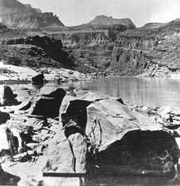

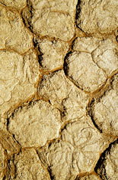

Frogsicle
Wood frogs are cold-blooded, so they can't keep warm in freezing temperatures. In winter, wood frogs make lots of the sugar glucose, which they pump to all parts of their bodies. The glucose acts like antifreeze, thus preventing the frog's cells from being pierced by tiny crystals of ice. The water between the cells does freeze, meaning the animal's entire body becomes solid, like a frog-shaped ice cube. When the weather warms up, the frog thaws out and hops away.
蛙
樹蛙是冷血動物，因此在冰凍的溫度下，無法保持身體溫暖，在冬季，樹蛙體內製造許多葡萄糖，葡萄糖就抗凍劑一樣，讓蜻蛙的細胞避免被冰柱刺穿，介於細胞間的水會結冰，這意味整支蜻蛙會變成固體，就像一塊蛙形的冰塊，當天氣變暖時，蜻蛙會融解並跳走。

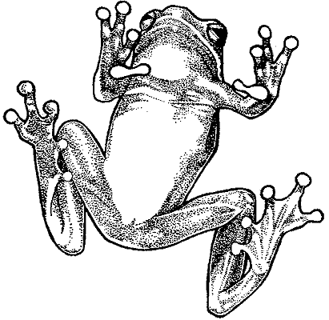

Soft, Boiled Worm
On the floor of the Pacific Ocean, plumes of superheated water burst out of cracks in Earth's crust. Clustered around these cracks, Pompeii worms withstand water temperatures as high as 80°C (176°F), hotter than any other animal. How do these creatures survive in water that's almost boiling? Some scientists suspect that colonies of bacteria, which grow like tiny hairs along the worm's body, may carry heat-resistant proteins that help protect the animal.
在太平洋的海底，羽毛狀的水柱從地殻的裂縫流出，有一種蟲能耐得高達攝氏80度的高溫，為什麼這種生物能在幾近沸騰水中生存，一些科學家認為，在這些蟲的身體上，可能有一些富有抗熱蛋白的細菌，這些細菌具有保護這些蟲的能力。

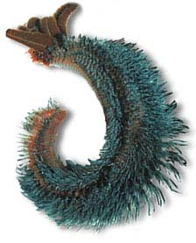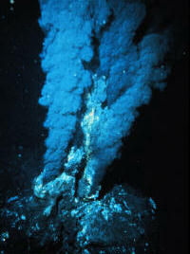

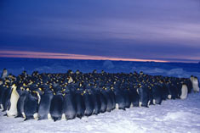

Emperor penguin huddle, Antarctica

© Doug Allan/Naturepl.com

Huddle Up
Imagine standing outside in the bitter cold for two solid months. How would you stay warm? In the pitch-dark winters of Antarctica, where emperor penguins lay their eggs on the ice, temperatures can plunge to -40°C (-40°F) with winds up to 200 kilometers (124 miles) an hour. A layer of blubber and a thick coat of feathers help penguins keep warm. But males must stand in the cold incubating an egg for about two months without a break. So thousands of these expectant fathers often huddle together for warmth, with the penguins on the outer edge of the group constantly trying to move toward the middle.
擠成一團
想像一下，在酷冷的寒冬裡，如何能在外面站兩個月，如何能讓身體保暖，在極地淒黑的寒冬裡，國王在冰塊上下蛋，溫度可直落到攝氏零下40度，風力可達每小時200公里，厚厚羽毛及一層油脂幫助企鵝保暖，但是公企鵝必須在寒冬中，沒有休息地站兩個月孵蛋。因此，往往幾千支的準爸爸擠在一起，在外圍的企鵝總是不停地想往內移動。

Gathering Water
Sometimes it can be hard to find a drink of water. Many animals and plants use special tricks to get what they need. These species have evolved techniques for collecting the water that's most readily available, whether it's dripping down the side of a tree or falling out of the sky.
集水
有時候要找到水還真難，許多動植物用特殊技巧來滿足所需，這些動物巳發展出特別的技巧，來獲得現成的水，這些水有些是從樹幹流下來的，有些是從天空落下。



Like Water Off a Lizard's Back
When rain falls in the Chihuahuan Desert of the southwestern U.S. and northern Mexico, the parched, porous soil quickly soaks up the water, making it difficult for animals to get enough to drink. The Texas horned lizard collects drinking water by using tiny channels between the horned scales on its back to guide the water toward its mouth. These lizards also broaden their backs and lower their heads to ensure that hardly a drop is lost.
從蜥蝪背部流下的水
在美國西南部的沙漠裡，當下雨時，被烤燙的砂很快的吸取水分，使動物很難找到足夠的水喝。德州蜥蜴背上有一些鱗片，這些鱗片形成微細的管道，將水引導至蜥蜴的嘴。這些蜥蜴還會張開背部，以確保這難得的流入口中。
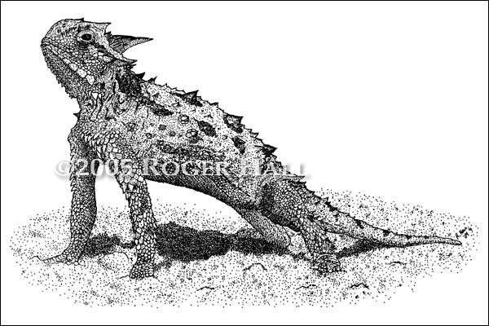

Emperor penguin huddle, Antarctica

© Doug Allan/Naturepl.com

Huddle Up

Tree

© Digital Vision/AGE Fotostock

No Desert Too Dry
All living things need water-it's essential for the chemical reactions of life. But some creatures need only a little. Desert plants and animals thrive where there's less than 25 centimeters (10 inches) of rain each year. Animals may use certain physical features of their bodies to avoid wasting water, or certain behaviors, such as staying out of the sun. Plants, meanwhile, may store water in their tissues, or develop longer roots to tap water deep underground.

沒有太乾燥的沙漠

所有生物都需要水，水是生命化學反應中必要的成份，在年雨量不到30公分的沙漠裡，動植物依然茂盛成長，動物利用身體的一些特性，來避免浪費水，或一些行為，例如避免日曬。植物可同時在組織內儲存水，也可長出較長的根，以吸取地下水。

Life. Just Add Water
No bigger than a speck, tiny eight-legged creatures called tardigrades live either in ocean or freshwater habitats. If drought strikes, they essentially shut down their metabolism and shrivel up in a ball called a tun, waiting until water returns. They'll wait a long time-as much as several years, in fact-allowing them to survive better in unpredictable environments. Tardigrade tuns can also withstand oxygen deprivation and extreme heat or cold.
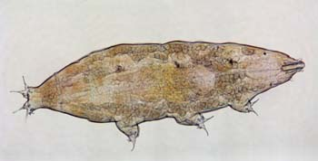



Kangaroo rat

© Joe McDonald/Visuals Unlimited

Doesn't Drink the Water
Is it possible to survive without drinking any water at all? Kangaroo rats prove that it is. Some species get all the water they need from the food they eat. Their kidneys help by recycling water more than four times as efficiently as human kidneys do. They also conserve what little water they do take in by keeping out of the sun during the daytime, emerging from their burrows to look for food after dark when temperatures drop.

沒喝水行嗎？
若一點水也沒喝，還可能生存嗎？袋老鼠可以做到，一些品種從所吃的食物，取得所需的水，比起人類的腎臟，這些動物的腎臟的效率高出四倍，不停地循環體內的水，為了保存體內的水分，這些動物避免在日照時出現，等到太陽下山，溫度下降時，才跑出洞外找食物。
Banner-tailed kangaroo rat
Dipodomys spectabilis
Range: Deserts of southwestern U.S. and northern Mexico

A Breath of Dry Air
Camels don't store water in their humps-instead, their humps store fat. So then how do camels stay hydrated? Look into the nose of the camel's skull and you'll see one feature that helps them conserve water. The intricate surfaces that fill their nasal passages sponge up nearly all the moisture from the air they breathe out. Camels also can tolerate a much higher peak body temperature, 41?C (106?F), than most mammals. So when it's hot, they don't have to waste water by sweating.
呼吸乾燥的空氣
駱駝的駝峰所儲存的是脂肪，而不是水分，所以駱駝是如何保持不脫水，看看駱駝骨架上的鼻子，您將會發現如何保持水分的特性，在複雜的鼻管表面上，呼出空氣的水氣塞滿了鼻管通道的海綿組織，比起任何其它哺乳動物，駱駝更能忍受高溫，甚至攝氏41度，所以天氣熱時，駱駝不會因流汗而浪費水分。


Surviving in Saltwater
No matter how thirsty you are, drinking seawater will only make you thirstier. Seawater is too salty for humans and most land animals—it's about 3.5 percent salt by weight. Seawater dehydrates you because the amount of water needed to flush the excess salt from your body would be more than what you drank. But many animals that live in or near the ocean have evolved ways to pump out the extra salt while keeping their water levels in balance.
在海水中生存
不管你多渴，喝海水只會讓您更渴，對於人類及部分的動物來說，海水的含鹽都是太多了，海水的含鹽量大約是百分之3.5，一旦喝了海水後，為了排除體內的鹽，就必須喝更多的淡水。不過生活在海邊的一些動物，體內巳發展出一些功能，能將過量的鹽排出體外，以保持身體內水的平衡。
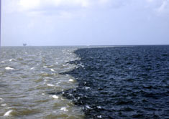

Secreting Salt
A wandering albatross spends months at a time flying or floating on the open ocean, far from any source of fresh water. So albatrosses have evolved a way to drink seawater, which is too salty for most birds and land animals. To get rid of excess salt from the water and food they ingest, albatrosses have salt glands just behind their eye sockets. The glands excrete a highly concentrated salt solution that drains out through the tip of the beak.
對大部分的鳥類及動物而言，海水實在太鹹了，然而信天翁可以在廣闊的海上飛好幾個月，在飛翔期間，完全吃不到淡水，因此信天翁發展出一種喝海水的方式，以排除從水中及食物，排除過量的鹽。在眼窩的後側，有一條的鹽腺，所分泌的高濃度鹽素，會從鳥嘴流出。
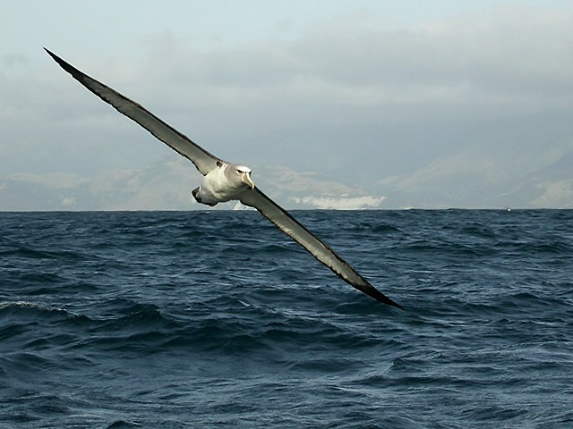

Soaking in Salt
Most fish that live in the ocean tend to lose water-the high salt content of the ocean causes water to constantly flow out through the fish's gills. So fish need to drink lots of seawater to stay hydrated. And because seawater is so salty, they also must pump out the excess salt, both through their kidneys and using specialized cells in their gills.
浸泡在鹽裡面
因海水的鹽分很高，促使大量的水須不斷流經魚的鰓，在流失大量水分的情況下，魚必須不停的喝下大量的水，以防脫水，也因為海水的鹽量太多了，魚必須透過腎臟及鰓的特殊細胞，將過多的鹽排出。
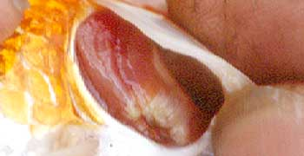
鰓

Bony Saltwater Fish
1. WATER naturally seeks a chemical balance, or equilibrium. That means water flows from areas of higher water concentration to areas of lower water concentration to equalize the system. WATER concentration inside a fish is higher than in the ocean itself because the ocean is so SALTY. As a result, most saltwater fish constantly lose WATER through their gills and skin.
2. Because the fish is losing WATER, it must drink a lot to stay hydrated-but SALTY seawater is the only water around.
3. To get rid of excess SALT, the fish's kidneys pump lots of salt into its urine.
水會自然地達成化學上平衡，也就是高濃度的水，會流向低濃度的水，以達成平衡，魚體內水的濃度高於海水，因為海水太多鹽了，因此大部分的鹹水魚，不斷的從鰓及皮膚失去水分。
因為魚不斷的失去水分，為了避免脫水，魚必須不停地喝水，但身旁也只有海水可喝。
為了排除過量的鹽，魚的腎臟須將大量的鹽排入尿液。
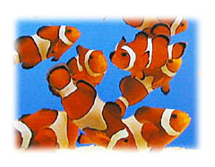

Sharks
1. Sharks don't lose WATER the way bony fish do-their bodies stay in balance with the ocean in a different way, thanks to the chemical called urea. There's essentially as much UREA and other chemicals in water inside a shark as there is SALT in seawater. So the shark stays in balance with the saltwater outside its body and water doesn't constantly flow out.
2. Instead of drinking WATER, the shark absorbs some seawater (and SALT) through its gills.
3. A gland in the shark's digestive system gets rid of excess SALT.
鯊魚
鯊魚以不同的方式，來達到水的平衡，為了與體外的鹽量相等，鯊魚體內能分泌等量的尿素及其它化學物質，所以鯊魚能與體外的鹽水保持平衡，魚不用不停的讓水流出體外。



In Balance with the Ocean
All the salt in the ocean can make life complicated for animals living there. Sharks cope with the salty water by generating lots of the chemical urea. This substance, produced throughout the shark's body, counterbalances the salt in the ocean water. In other words, there's as much salt in the seawater as there is urea (and other chemicals) in the water inside the shark's tissues . So sharks don't lose water the way fish do. The shark gets rid of excess salt using a salt-excreting gland near its anus.
海洋中的鹽，能讓生存在海洋動物的生命變得複雜，鯊魚藉著尿素來對付海水，這個物質在鯊魚的全身產生，與海水中的鹽達成平衡，換句話說，海水中有多少鹽，在鯊魚的體內就有尿素。所以鯊魚不像其它魚類不斷的失去水分。在肛門的附近，鯊魚的體內有一條排鹽腺，將體內過多的鹽排出。

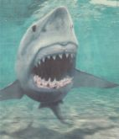

In and Out of Water
Life in water has both advantages and drawbacks. So some animals live in the water only when the need arises. Some frogs and insects, for instance, spend the early parts of their lives in water. Other animals, such as otters, move easily between water and land. And as bad as it may sound to be a fish out of water, some fish voluntarily crawl onto land when it suits them.
水中的生命有優點，也有缺點，一些動物只有在需要水時，才會生活在水中，例如一些青蛙和昆蟲，將生命的前期生活在水中，其它動物，像水獺，能輕易地在水陸間移動。對魚來說，沒有水是不好的事，但只要無傷，有些魚還是會爬上陸地。
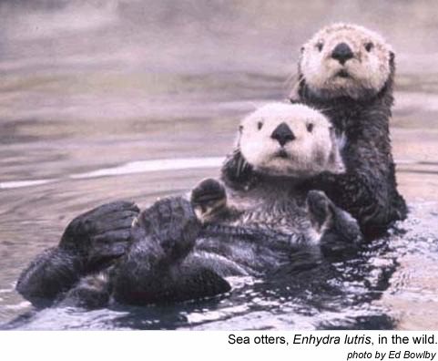

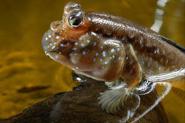

Atlantic mudskipper (Periophthalmus barbarus)

© Stephen Dalton/Minden Pictures

Fish Out of Water flip
By flipping a pair of well-muscled pectoral fins, a mudskipper can drag itself out of the water to look for insects and other food. These fish can also use their tails to "skip" over land. Like most fish, mudskippers can use their gills to breathe underwater, but they also have two ways of breathing on land. They can carry water in chambers attached to their gills, and they can absorb oxygen directly from the air through the linings of their mouths.
藉著輕彈胸鰭，泥鰍可以離開水面去尋找昆虫及其它食物，這些魚可以使用尾巴在陸地上跳躍，在水中這些魚以鰓呼吸，在陸地上，這些魚可用兩種方式呼吸，可以用附著於肺的腔室攜帶水，也可以嘴巴的內襯吸取氧氣。

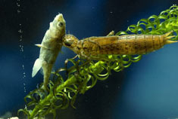

An Aeshna dragonfly nymph eating a stickleback fish

© Stephen Dalton/Minden Pictures

From Swimming to Flying
Dragonflies spend the first several months of life in water, and the rest of it almost entirely in the air. Juvenile dragonflies, called nymphs, crawl around ponds, feasting on other insect larvae and even small fish. If threatened, a dragonfly nymph can escape by squirting a jet of water from the gill chamber in its tail. Once fully developed, the dragonfly climbs out of the water, sheds its old skin and flies away, rarely visiting the water again until it's time to lay eggs.
從游泳到飛翔
蜻蜓在生命的前幾個月生活在水中，其餘的日子幾乎全在空中，青蛙的幼兒游在水中，以其它昆蟲的幼蟲及小魚維生，若遇到危險，蜻蜓的幼蟲會從尾巴的氣箱噴出水，一旦發育完成，蜻蜓會爬出水面，脫光皮膚飛走，一直到產卵前，很少再飛到水面。



Girl Drinking

© Natasha Paterson/AGE Fotostock

Humans and Water
Compared to the other animals featured in this section, humans seem to be at a disadvantage when it comes to water. We're dependent on the day-to-day availability of fresh, clean water. We can't survive on seawater, we can't live underwater and we can't capture rainwater on our backs. We lose water through perspiration, urination and by exhalation—we breathe out water vapor. Only by using our intelligence and ingenuity have humans managed to live in areas where water is relatively scarce, as well as places where it's salty or frozen.
當我提到水時，相較於其它動物，人類似乎處於不利的地位，我們人類每天需要新鮮水乾淨的水，我們無法以飲用海水生活，不能在水中生活，不可以用背部抓取雨水。同時我透過流汗、排尿、及呼吸不斷的失去水分。生活在水源稀少、冰凍、及鹽化地方的人們，只有藉由運用智力及創造力，才能求得生存之道。

How much water is inside you?
The rule of thumb is that humans are about 60 percent water by weight. Because of differences in body fat, men carry a little more than that, women a little less.
體內有多少水
水分佔人體體重的百分之60，因為體內脂肪的差異，男性的水分比女性的水分多一點。

How Much Water Should I Drink?
Contrary to popular wisdom, you don't need to drink eight glasses of water a day to replenish your body's water supply. The water in food gives you about 20 percent of your daily needs. Beverages like milk or juice help keep you hydrated too. The best rule of thumb for most people: drink water whenever you're thirsty.

By the Numbers
- A typical woman needs about 2.7 liters (0.7 U.S. gallons) of water per day.
- A typical man needs about 3.7 liters (one U.S. gallon) per day.
我們每天應喝多少水
我們每天所需要的水分，有百分之二十是來自於我們所享用的食物，牛奶及果汁也補充了一些水分，所以每天應喝多少水呢？最好的方式是，只要口渴就喝。若要以容量表示，女性每天約需要2.7公升，男性約需要3.7公升。
