
i
1
The Chopsticks I Use for Lunch Every Day
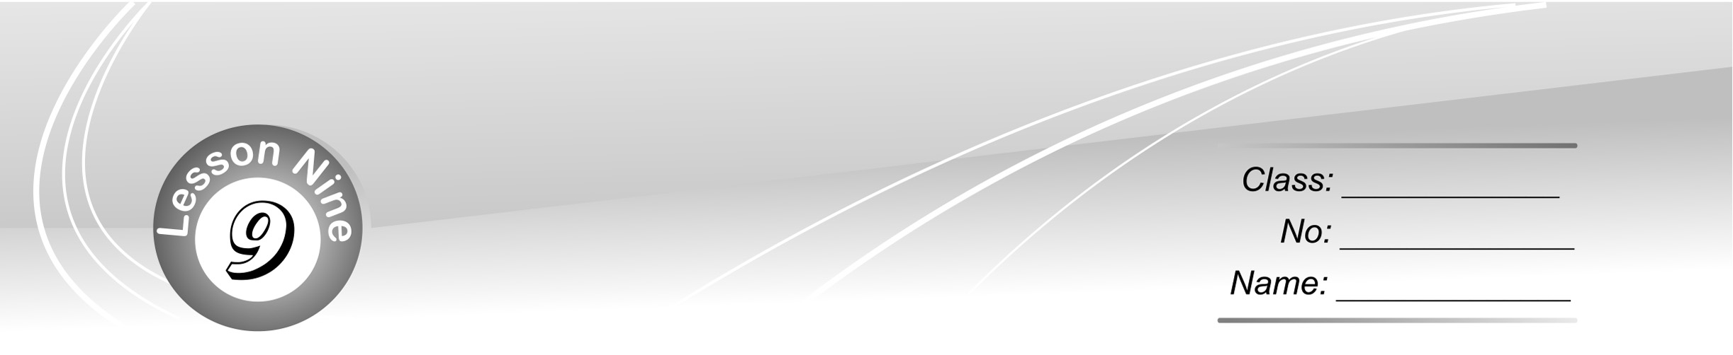
3

4

Reading comprehension
分段能力指標：2-2-2, 2-2-4, 6-1-2, 6-1-7
活動方式：Individual work
活動說明：閱讀理解測驗。


Green Plan in Wonder City
Make new out of the old!
Since 1996, Wonder City has started a green plan and has been greatly successful in many ways. Places that were not used anymore, like railways, factories, and open lands, have been changed and brought to new life. They have now become parks, restaurants, museums, or shopping centers. They look fresh and clean with trees, flowers, and pieces of art. Old River, for example, is now a pink belt in the spring with born-to-smiles on both of its sides. They are beautiful and smell great. Many people take a walk or go bicycling along the banks of the river. Because of this plan, the city has become cleaner and younger. Every year in May, a big green festival is celebrated in Wonder City. People from other cities go to the festival to learn how to make their own cities more beautiful.

( C ) 1. What is the reading about?
(A) An art festival. (B) A vacation plan.
(C) The change of a city. (D) The history of a river.
( B ) 2. Which is NOT part of the plan?
(A) Growing trees. (B) Building hotels.
(C) Making use of art. (D) Using closed factories.
( C ) 3. What is a born-to-smile?
(A) A belt. (B) A color.
(C) A flower. (D) A piece of art.

