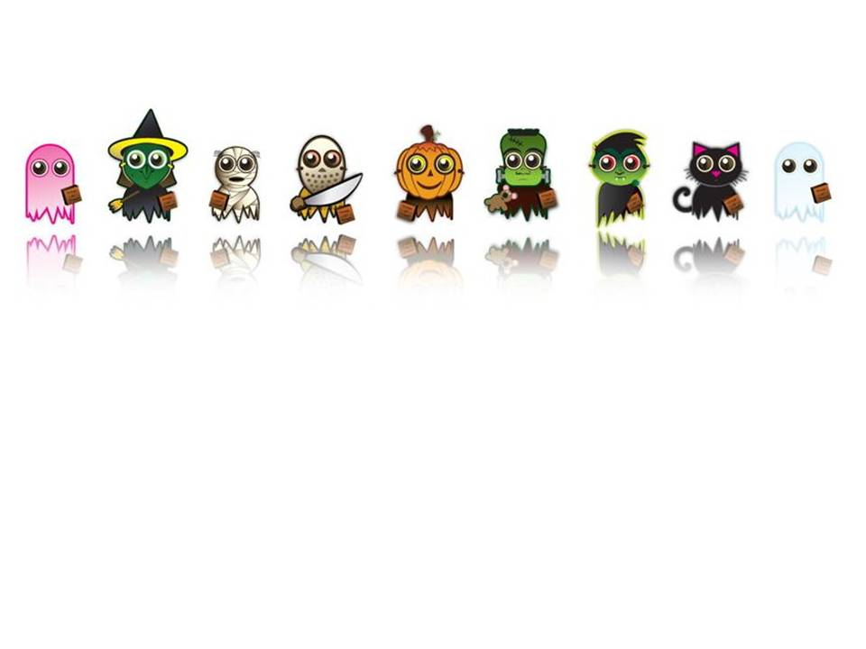

5年1班兒童劇劇本
Halloween萬聖節
故事精神：與朋友相處要多感恩、知足、善解、包容。

Action 1
(Music and dance)
Mary: I do like Halloween very, very much.
Joyce: Because of candies?
Mary: Yeah! You are right.
Tom:Whenever I thought about candies, like chocolate, taffy, jelly beans, butterfinger, caramel candies. Oh! they are so sweet, I can't wait.
Bob: So, where is the first stop?
Helen: Let me think, ……., Mr. Dickson. He is a nice person.
Mary: OK. Let’s go!

(Boys and girls walk to Dickson’s house, then knock the door)
All: Happy Halloween! Trick or treat!
Dickson: Hey! kids. Happy Halloween! I have some candies for you all.
(Dickson gives candies to the kids)
All: Thank you. Mr. Dickson.
John: You are so nice, bye.
Dickson: Good night, kids.

Joyce: next?
John: Mrs. Harford.
Mary: Let’s go!
(Boys and girls walk to Harford’s house, then knock the door)
All: Happy Halloween! Trick or treat!
Harford: Happy Halloween!
Mary: Good evening, Mrs. Harford.
Harford: I have some apples for you.
(Harford gives apples to the kids)
All: Thank you. Mrs. Harford.
Harford: Good night, kids.
Joyce: And next?
John: Mr. Smith.
Mary: I think Mr. Scott.
John: Smith. (Argumentatively)
Mary: Mr. Scott.
John: Smith.
Mary: Mr. Scott.
John: OK, separate. Anyone with me?
Mary: Fine. Anyone with me?
(Kids separate to two teams and leave)

Action 2
Helen: Would you think something strange?
Bob: Yeah, where are we?
Nancy: we lost?
Mary: Well, I don’t know. I am not sure.
Sheron:You are not sure? How could you say that.
Mary:I am sorry. but I don't know where are we.
Bob: Hey, look at that.
Helen: I am scared.
(The corpses come out from tombs; kids scream and run)
Mary: Run! Run!
Bob: Hide there! Hide there!

Action 3
Monster1: Why did the kids run away? I just wanna say “Hello” to them.
Monster2: Look at yourself, every kid saw you and ran away as soon as possible.
(Comes the ghosts)
Witch1: Hey, I heard kids scream. Did I miss anything?
Monster2: Yeah, kids were playing Trick-or-treat.
Witch2: What! Trick-or-treat. It’s funny.
Vampire:I have slept for one year long. Now, I wake up.
Bat1, Bat2:Yeah, wakeup! Yeah, wakeup!
Mummy2: Look at the bandages. They drove me crazy.
Monster3: This is Halloween. This is our night.
All: Yeah.This is Halloween. This is our night.
(Music and dance, after dance all the monsters left)

Action 4
Helen: Have they gone?
Bob: Come on.
Nancy: What can we do? I am scared.
Mary: Let me call John. (Use a mobile phone)
Mary: Hello, John.
John: Mary?
Mary: John, we are lost. And we saw monsters and ghosts.
John: Monsters and ghosts?
Mary: Yes, please come to help us. We need help.
John: But, where are you?
Mary: I don’t know. Maybe in the cemetery.
John: Cemetery?
(The monsters come out, kids scream and run)
John: Hello, hello, hello…….

Monster1: Hey! Hey! Take easy. We won’t hurt you. We just need friends.
Witch1: We like Halloween. We wanna play Trick-or-treat.
Witch3:Don't you think it's party time?
Monster1: Not all the monsters are bad guys. Look at us, we are so friendly.
Monster2: So nice.
Monster3: So cute.
(All laugh)
Sheron: Are you serious.
Bob: You will not hurt anyone?
Monster2: Come on. Welcome to our ghost town. Let me show you something.
Witch2: Come on, this way.

Action 5
John: Mary needs help. She said they saw ghosts and monsters.
Joyce: What! Ghosts and monsters.
Rose: Oh my goodness! So terrible.
Pony: So, what should we do.
Lily: Go home. Let's call it a day.
Rose :I think it's the best answer, That's enough for me.
Peter: But they are our friends. We can not just go away and leave them alone.
Lily: But there are ghosts and monsters over there.
John: I have to help them.
Sowa:Yes, We can't leave them alone.
Joyce: Count me in.
Peter: Lily?
Lily: OK. Ok.
Sowa:Let's go.
(Kids go to cemetery)

Action 6
Catgirl: So, what do you think about our ghost town now?
Mary: Well, a little queer.
Bob: Dusty.
Nancy: Dark ....and cold, ...a little.
Helen: But I think it’s fantastic, it's cool.
Monster3: You do? You can always come to play with us in our ghost town.
Mary: Oh, I guess so.
(John and the other kids come)
John: Mary.
Monster, go away. Monster, go away.
(Lily scream)
Mary: Take easy! Take easy! John. They are monsters, but they are our friends.
All monsters: She said friends.
John: How come?
Bob: They are friendly. And they just like play Halloween game.
Peter: No kidding.
Mary: Sure. Trust me. They have no malice to us.
Mummy1 :Do't you think we are terrible?
Kids:No.
Pumpkin:Do't you think we are ugly?
Kids:No.
Vampire:Do't you think we are evil?(Bat1 and Bat2 flap wings)
Kids:No.
Bat1, Bat2:Yeah, we are not evil, we are not evil.
Catgirl:Thank you. Thank you all. It's really nice of you.
Monster1: Come on. It’s Halloween party time.
Tom: Halloween party time?
Monster1: Yeah, come on, my friends, join us.
(Halloween Dance)

All: Treat anyone with respect, everyone will be your friend.

與朋友相處要多感恩、知足、善解、包容。
~END

Mary金妮 | Tom 立軒 | Witch1若彤
Joyce 明玫 | Bob 暐哲 | Witch2宸均
Helen 思婷 | Dickson 翊安 | Witch3優華
Lily 雁慈 | John 佑宇 | Catgirl 沛雯
Rose 心云 | Peter珉瑋 | Monster1 立揚
Nancy 婷之 | Pony 偉騰 | Monster2 慈喻
Sheron 孟蓁 | Sowa 恩霆 | Monster3 翃陞
Mrs. Harford. 羽彤 |  | Mummy1 繼暘
 |  | Mummy2 昱翔
 |  | Pumpkin 梁郭
 |  | Vampire 立欣
 |  | Bat1 守億
 |  | Bat2 岑華

