< English worksheet 英語學習單 > Class: Name:
milk pizza cake water juice

hamburger sandwichtea ice cream

chocolate
請將上面食物分成 hungry 和 thirsty兩類!
hungry (adj.)餓的 | thirsty (adj.)渴的
I am ________________. ( hungry / thirsty )
I want some _________________________. 我想要ㄧ些…
Here is some __________________________.這裡有一些...
(please draw the picture.請畫出圖片)
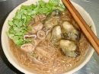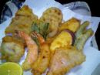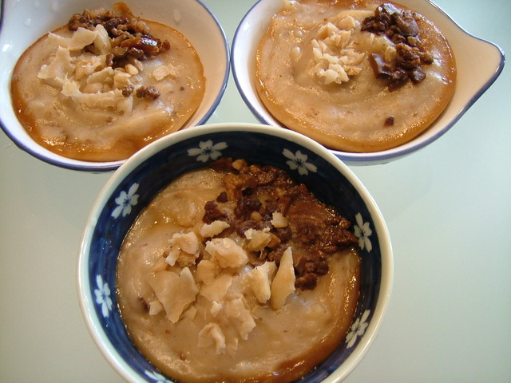

蚵仔麵線 天婦羅 碗粿
Oyster Thin Noodles Tempura Salty Rice Pudding

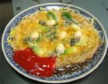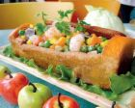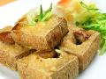

蚵仔煎 棺材板 臭豆腐
Oyster Omelet Coffin Stinky Tofu
Hey ,boys and girls! Are you hungry? What do you want to eat?
I am ________________.  I want some ______________.  Here is some ______________. | Miss Lin is ____________.  She wants some __________.  Here is some _____________.
你還知道哪些台灣好吃的小吃呢?請把它們剪貼或畫下來!

