Very Hungry Caterpillar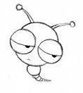
1.Please draw a caterpillar.
小朋友，請你畫出一隻毛毛蟲。

2.If you were a hungry caterpillar, what do you want to eat?
如果你是一隻很餓很餓的毛毛蟲，你想要吃什麼呢？請將你想吃的東西寫或畫下來。

3.What did the caterpillar become? Please draw it down.
這隻毛毛蟲最後變成了什麼?請小朋友發揮你的想像力將它畫出來。

