_____________________ 的網

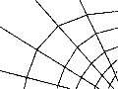
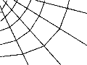

為了救韋伯，我想織的字是_________________________________________________________

因為_____________________________________________________________________________

_________________________________________________________________________________

_________________________________________________________________________________

_________________________________________________________________________________

_________________________________________________________________________________

