Name: ________________ Class: __________ Date: __________ Score: __________
English 3 (New Go SuperKids!) Quiz Unit 2解答
A. Look and match. 將圖片連至正確的單字。 20%
❶  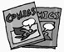 | ❷  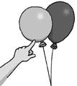 | ❸  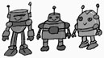 | ❹  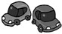
 |  |  | 
 |  |  | 
robots | balloons | comic books | toy cars
B. Fill in. 依提示，填空完成對話。30%
❶ | ❷  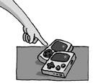 | ❸  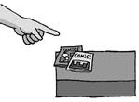
A: What are these ?  B: They are balloons . | A: What are these ?  B: They are video games . | A: What are those ?  B: They are comic books.

C.Read and check. 依圖示，勾選出正確的答案。30%
❶ | ❷ | ❸
A:  What are these?   What’s this?  B: They’re comic books. | A: What are these?  B:  It’s a balloons.   They’re balloons. | A: What are these?  B:  They’re video games.   They’re toy cars.
D. Look and write. 看圖完成句子。 20%
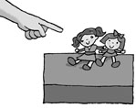
❶ What are those?
They are dolls.
❷ What are these?  TThey are toy cars. | 