
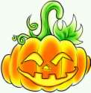
Halloween Day
- What date is Halloween day ?
- Please write down the story about Halloween.

- Do you know Jack-o-lantern? How does it look like? Try to draw one.

- What do people do on Halloween Day?

- How will you dress up yourself if we hold a Halloween party?




