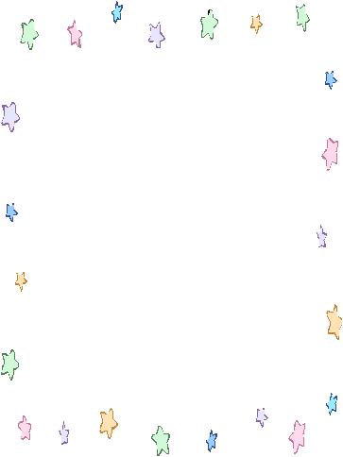

u_e :cute duke excuse mute
tune
The toy dog is cute. But it is mute.

u : hut lunch nut plus study
Justin lives in a hut. He is eating a nut.

