附件1-7
蜜蜜甜心糖
___年___班___號 姓名：____________
各位小朋友，今天得到的魔法寶物是「蜜蜜甜心糖」，這星期請你每天都要記得吃一顆蜜蜜甜心糖，讚美一下你的家人，相信有你的讚美，你的家人一定會擁有一整天的好心情喔！
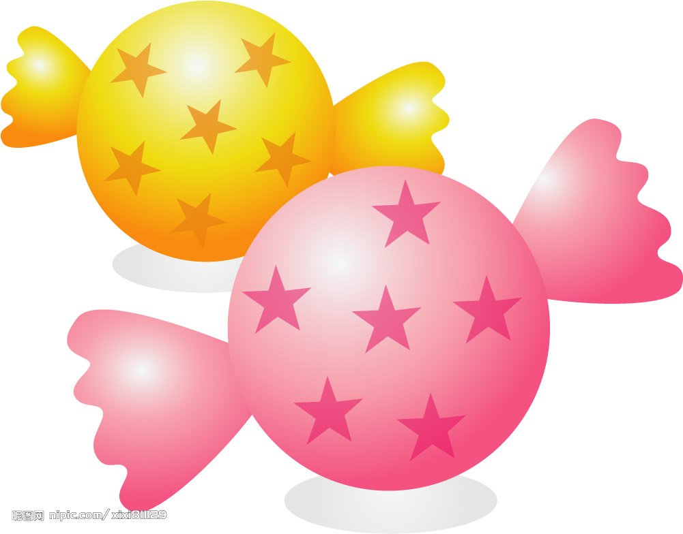
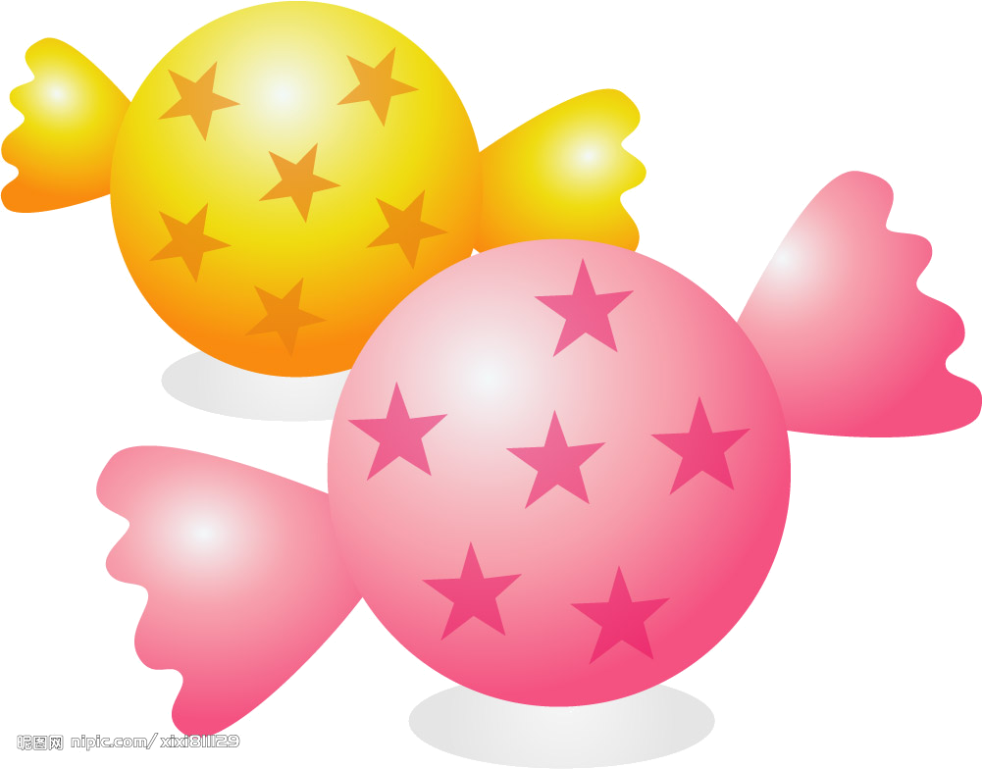
讚美對象：_____________
讚美內容：_____________
_________________________________________________________________________

讚美對象：_____________
讚美內容：_____________
_________________________________________________________________________

讚美對象：_____________
讚美內容：_____________
_________________________________________________________________________

讚美對象：_____________
讚美內容：_____________
_________________________________________________________________________

讚美對象：_____________
讚美內容：_____________
_________________________________________________________________________

讚美對象：_____________
讚美內容：_____________
_________________________________________________________________________

讚美對象：_____________
讚美內容：_____________
_________________________________________________________________________

