新竹縣尖石鄉玉峰國民小學 一○六學年度第 一 學 期 第二次定期評量試題
科 目 | 英語科  （何嘉仁版） | 年級 | 六年甲班 | 座號 |  | 姓名 |  | 命  題  者 | 周文淵老師

一、Listen and Circle 仔細聽，將正確的發音字圈起來：(每個答案2分，共10分)
- (1) lid limb limp
(2) dune dumb dump
(3) clip cling climb
(4) crumb crump crutch
(5) thud thumb thump
二、Listen and Number 仔細聽，將生字圖依照聽到的順序編號：(每個答案2分，共10分)
- (a) □ (b) □
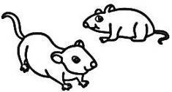 
(c) □ (d) □
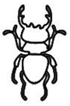 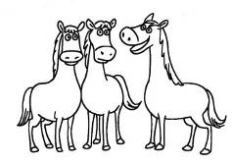
(e) □
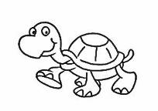
三、Listen and Check 仔細聽問句，勾選出正確的答句：(每個答案2分，共10分)
- (1)
□ Yes, there is.
□ Yes, it is.

(2) □ They’re in the bathroom.
□ No, there aren’t.
(3) □ There’s one TV.
□ No, there isn’t.
(4) □ Yes. There are four chairs in
the dining room.
□ Yes. There are four tables in
the dining room.
(5) □ There’s one table.
□ No, there aren’t.
四、仔細看，將生字圖依照正確的順序編號：(每個答案2分，共10分)
- (1) There’s one horse.
(2) There’s one mouse.
(3) There are four turtles.
(4) There are five beetles.
(5) There are four butterflies.
(a) □ (b) □
 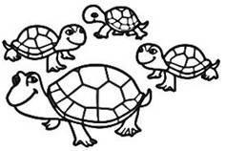
(c) □ (d) □
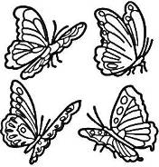 
(e) □
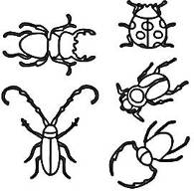
五、讀一讀，依提示完成句子：(每個答案2分，共10分)
- (1)
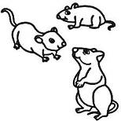
(2)
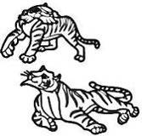
(3)
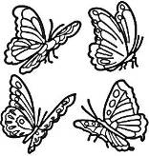
(4)

(5)
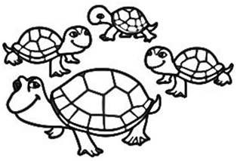
hippo mouse tiger turtle
butterfly
There are three
__________.
There are two
__________.
There are four
__________.
There’s one
__________.
There are four
__________.
六、仔細看，將與句子相符的圖片打勾：(每個答案2分，共10分)
- A: Are there any chairs in the
dining room?
B: Yes. There are six chairs.
□ □
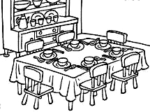 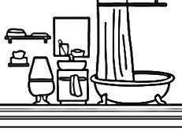

- There’s one chair in the kitchen.
□ □
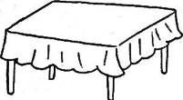 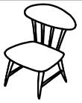
- A: How many tables are there in
the bedroom?
B: There’s one table.
□ □
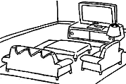 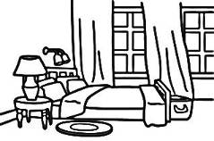
- A: How many hippos are there?
B: There’s one hippo.
□ □

- There’s one lion.
□ □
 
七、讀一讀，選出正確的答案：(每個答案2分，共10分)
- ( ) How many _____ are there?
(A) mice
(B) mouse
(C) mouses
- ( ) There are _____ in the
bathroom.
(A) a window
(B) two windows
(C) many window
- ( ) A: _____________
B: There is one mouse.
(A) How’s the mouse?
(B) How many mice are there?
(C) How many mice do you
have?
- ( ) Is there _____ in the
bedroom?
(A) computer
(B) a computer
(C) three computers
- ( ) A: How many beetles are
there?
B: _____________
(A) They’re in the park.
(B) They’re fifty dollars.
(C) There are ten beetles.

八、讀一讀，短文或對話與下列敘述相符的畫圈，不符的畫叉：(每個答案2分，共12分)
- In Ivy’s house
Ivy: Welcome to my house!
Joe: Wow! You have a beautiful
house.
Ivy: Thank you. This is my living
room. There’s a TV, a table
and two sofas. I like to watch
TV with my mom after dinner.
Joe: That’s great. Are there any
windows here?
Ivy: Yes. There are three windows.
They’re here.
Joe: The view is great.
Ivy: Yes, it is. Let me show you my
bedroom.
(In Ivy’s bedroom)
Joe: There are many books and
pictures.
Ivy: Yes. I have thirty books and
twenty pictures in this room.
I like to read and draw!
sofa 沙發；after 在之後
view 視野

(1) □ Joe has a beautiful house.
(2) □ There are a table and two
sofas in Ivy’s living room.
(3) □ There isn’t a TV in Ivy’s
living room.
(4) □ There are two windows in
Ivy’s living room.
(5) □ There are thirty books in
Ivy’s bedroom.
(6) □ There are twenty pictures
in Ivy’s dining room.
九、Speaking 口說測驗(每個答案2分，共18分
1.tigers( )
2.hippos( )
3.turtles( )
4.beetles( )
5.How many tigers are there?
6.living room( )
7.kitchen( )
8.window( )
9.Are there any chairs in the living room?

恭喜你，終於完成了!有時間再檢查一次，看看是否有地方忘記回答或是有不確定的答案需要再想想!☺

