新竹縣尖石鄉玉峰國民小學 一○六學年度第 一 學 期 第二次定期評量試題
科 目 | 英語科  （何嘉仁版） | 年級 | 五年甲班 | 座號 |  | 姓名 |  | 命  題  者 | 周文淵老師

一、Listen and Circle 仔細聽，將正確的發音字圈起來：(每個答案2分，共10分)
- (1) than pan ban
(2) horn thorn worn
(3) boost boots booth
(4) bathe bass bait
(5) mash mad math
二、Listen and Number 仔細聽，將生字圖依照聽到的順序編號：(每個答案2分，共10分)
- (a) □ (b) □
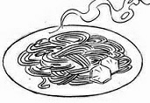 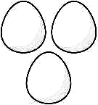
(c) □ (d) □
 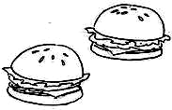
(e) □
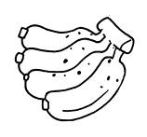
三、Listen and Check 仔細聽，將正確的句子打勾：(每個答案2分，共10分)
- (1)
□ It’s sunny and windy.
□ It’s windy and cloudy.

(2)
□ It’s cold.
□ It’s cool.
(3)
□ It’s rainy.
□ It’s warm.
(4)
□ How’s the weather?
□ How old are you?
(5)
□ It’s cloudy and hot.
□ It’s cloudy.
四、仔細看，正確的生字畫圈，錯誤的生字畫叉：(每個答案2分，共10分)
- □ warm 
- □ sandwiches 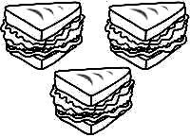
- □ apples 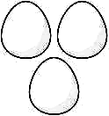
- □ bananas 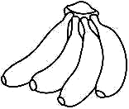
- □ sunny 

五、讀一讀，選出與前者畫線部分發音相同的字：(每個答案2分，共10分)
- □ wither (A) hat (B) that
- □ thus (A) clothe (B) hush
- □ loathe (A) whoa (B) this
- □ shop (A) shot (B) white
- □ hate (A) whale (B) hot
六、讀一讀，對的句子畫圈，錯的句子畫叉：(每個答案2分，共10分)
- □ A: Does Tom like sandwiches?
B: Yes, he is. He likes sandwiches.
- □ We likes eggs.
- □ A: How’s the weather?
B: It’s sunny.
- □ A: Do your sisters like apples?
B: No, they don’t.
They like bananas.
- □ It’s warm.
七、讀一讀，根據事實、圖示或提示回答問題：(每個答案2分，共10分)
- A: Do you like oranges? 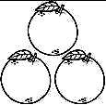☺
B: _________ I like oranges.
- A: Is it rainy?
B: _______________ It’s rainy.
- A: Is it warm? 
B: _______________________

- A: Is it sunny? 
B: No, it’s not. _______________
- A: Does she like bananas?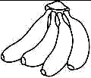☺
B: _______________________
八、讀一讀，選出正確的答案：(每個答案2分，共10分)
- ( ) A: Is _____ rainy?
B: Yes, it is.
(A) he
(B) it
- ( ) A: Does she like noodles?
B: Yes, she does. _______
(A) She likes noodles.
(B) She likes sandwiches.
- ( ) A: Do the boys like oranges?
B: _____________
(A) No, they don’t.
They like bananas.
(B) No, they’re not.
They like bananas.
- ( ) A: _____ they like eggs?
B: Yes, they do.
(A) Are
(B) Do
- ( ) He _____ bananas.
(A) like
(B) likes

九、Speaking 口說測驗(每個答案2分，共20分
1.sunny( )
2.windy( )
3.warm( )
4.cold( )
5.How’s the weather?
6.bananas( )
7.oranges( )

8.hamburgers( )
9.sandwiches( )
10.Do you like noodles?

恭喜你，終於完成了!有時間再檢查一次，看看是否有地方忘記回答或是有不確定的答案需要再想想!☺

