新竹縣尖石鄉玉峰國民小學 一○六學年度第 一 學 期 第一次定期評量試題
科 目 | 英語科  （何嘉仁版） | 年級 | 五年甲班 | 座號 |  | 姓名 |  | 命  題  者 | 周文淵老師

一、Listen and Circle 仔細聽，將正確的發音字圈起來：(每個答案2分，共10分)
- (1) cat catch cash
(2) chin shin tin
(3) hop shop chop
(4) cheap sheep heap
(5) chime crime shine
二、Listen and Mark 仔細聽，錄音內容和圖片相符畫圈，不符畫叉：(每個答案2分，共10分)
- (1) □ (2) □
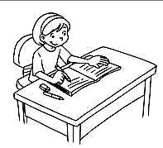 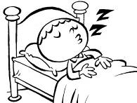
(3) □ (4) □
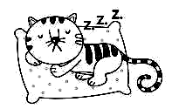 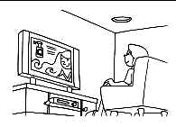
(5) □
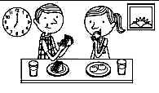
三、Listen and Choose 仔細聽，選出正確的答案：(每個答案2分，共10分)
- (1) ( ) Jack is ___.
(A) studying
(B) sleeping
(C) swimming

(2) ( ) Yes, ___. ___ sleeping.
(A) she is; She’s
(B) she’s; She’s
(C) he is; He’s
(3) ( ) A: Is he watching TV?
B: No. He’s ___.
(A) flying a kite
(B) riding a bike
(C) eating dinner
(4) ( ) A: ___ eating breakfast?
B: No, ___.
(A) Are you; I’m not
(B) Are they; they’re not
(C) Are you; we’re not
(5) ( ) A: Are they ___?
B: Yes, they are.
(A) surfing the Internet
(B) eating breakfast
(C) doing their homework
四、仔細看，選出正確的生字：(每個答案2分，共10分)
- ( ) I’m ___. 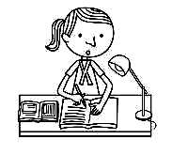
(A) doing my homework
(B) swimming
- ( ) They’re ___. 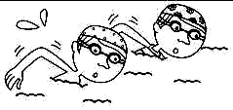
(A) swimming
(B) sleeping
- ( ) He’s ___. 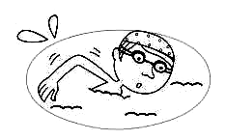
(A) sleeping
(B) swimming
- ( ) I’m ___. 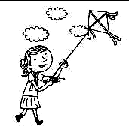
(A) flying a kite
(B) surfing the Internet
- ( ) We’re ___.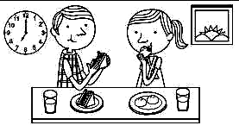
(A) eating lunch
(B) eating breakfast
五、讀一讀，選出與前者畫線部分發音相同的字：(每個答案2分，共10分)
- □ such (A) itch (B) fish
- □ chat (A) fetch (B) shape
- □ rush (A) hatch (B) shine
- □ mash (A) gosh (B) fuss
- □ shut (A) chuck (B) sheet
六、讀一讀，對的句子畫圈，錯的句子畫叉：(每個答案2分，共10分)
- □ A: What‘s the boy doing?
B: Yes, he is.
- □ A: Is she doing her homework?
B: No, she’s not. She’s flying
a kite.
- □ A: Is she doing her homework?
B: She’s doing her homework.
- □ A: Are your sisters sleeping?
B: Yes, they are. They’re sleeping.
- □ A: What‘s the boy doing?
B: He can cook.
七、仔細看，將與句子相符的圖片打勾：(每個答案2分，共10分)

- A: Is your brother studying?
B: No, he’s not. He’s sleeping.
□ □
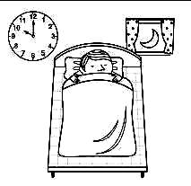 
- A: What are they doing?
B: They’re eating dinner.
□ □
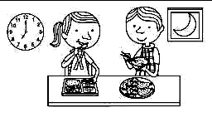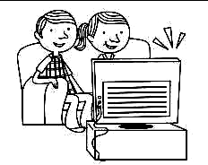
- I’m surfing the Internet.
□ □

- They’re swimming.
□ □
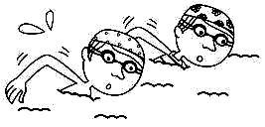
- A: Is Bob doing his homework?
B: No, he’s not. He’s sleeping.
□ □
 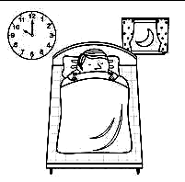
八、讀一讀，選出正確的答案：(每個答案2分，共10分)
- ( ) We _____ surfing the Internet.
(A) are
(B) am

- ( ) A: _____________
B: They’re eating lunch.
(A) What are the girls doing?
(B) What‘s the girl doing?
- ( ) I’m _____ breakfast.
(A) eat
(B) eating
- ( ) A: Are they swimming?
B: No, they’re not.________
(A) They’re swimming.
(B) They’re sleeping.
- ( ) A: _____________
B: I’m watching TV.
(A) What are you doing?
(B) What am I doing?
九、讀一讀，根據圖片及短文圈出正確的答案：(每個答案2分，共10分)
- 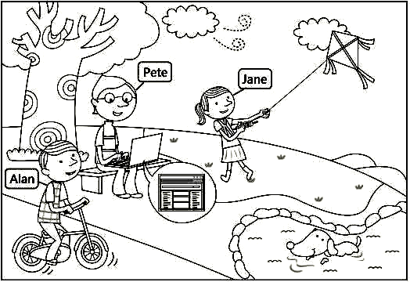
It’s nine o’clock in the morning.
Jane and her friends are at the park.
Jane is (1)( flying a kite / studying ).
Pete is (2)(surfing the Internet /
watching TV ). What’s Alan doing?
He’s (3)( eating breakfast / riding a bike ).
And look! A dog is at the park, too.
It’s not (4)( swimming / sleeping ).
It’s (4)( studying / swimming ).
十、Translation翻譯：(每題2分，共10分)
1.study( )
2.sleep( )
3.swim( )
4.ride a bike( )
5.surf the Internet( )

