Unit 3 Test Name: ______________________________
___/30
page 1
___/6
 | Match and color.

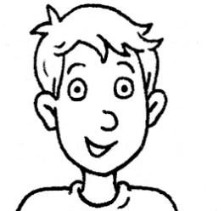  1.  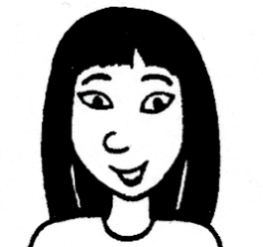  2.  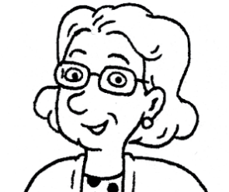  3.  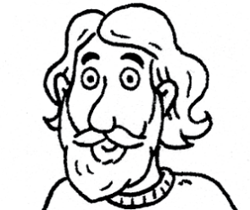  4.  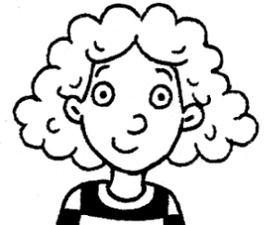  5.  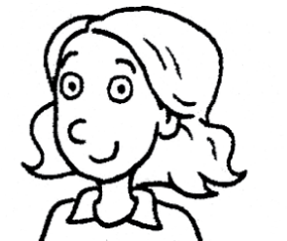  6. | •  •  •  •  •  • | • She has long, black hair  and brown eyes.  • He has wavy hair  and a beard.  • She has curly, red hair  and green eyes.  • She has wavy, blond hair  and blue eyes.  • He has short, blond hair  and blue eyes.  • She has shoulder-length,  gray hair and glasses.
___/5
 | Listen and number.
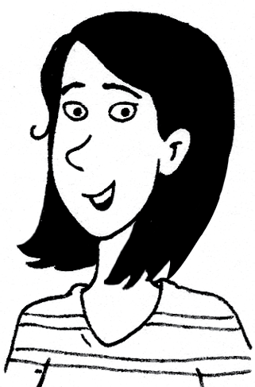
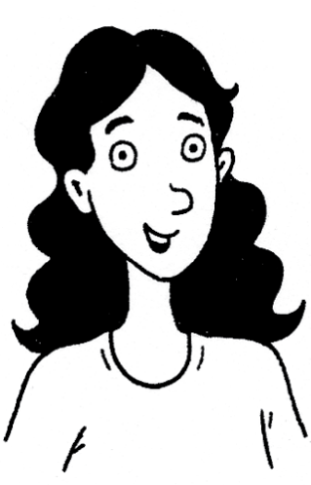
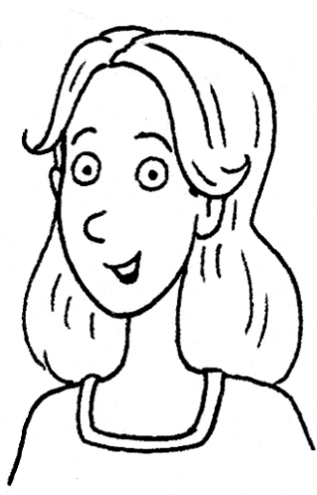
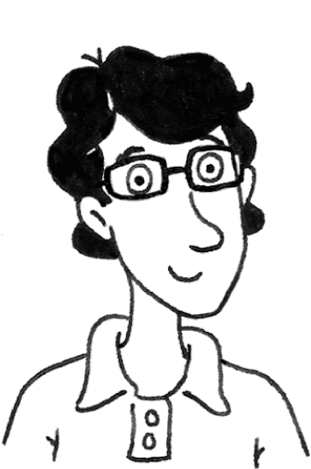
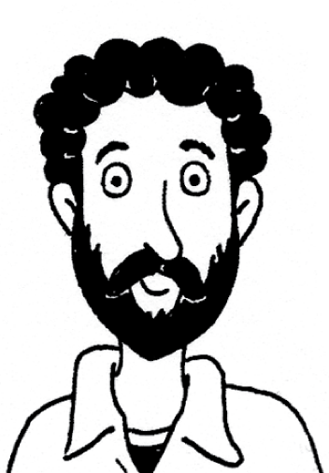

Unit 3 Test Name: ______________________________
page 2

black brown striped white old
___/10
Write.

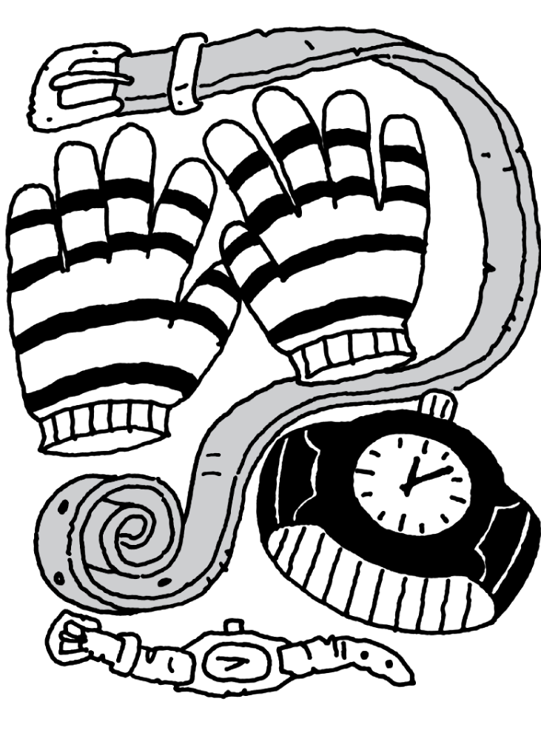  1  2  3  4 |  | 1. What does the _____ look like?  It’s _______ and ________  2. What do the _______ look like?  They’re _______ and _______  3. Which _______ does he want to wear?  He wants to wear the ___________ one.  4. Which _______ does she want to wear?  She wants to wear the ____________ one.  ___/3
 | Match.
1. Good luck on the test. ●  2. Oh, no! The test! ●  3. Which one is your friend? ● |  |  | ● Don’t worry. I can help you.  ● He’s the one with the blue hat.  ● Thanks. You, too.

___/6
Write.
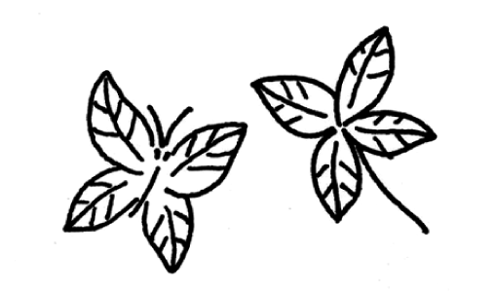
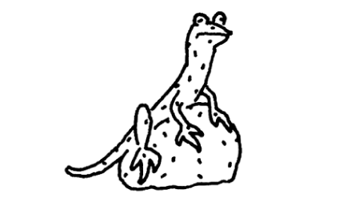
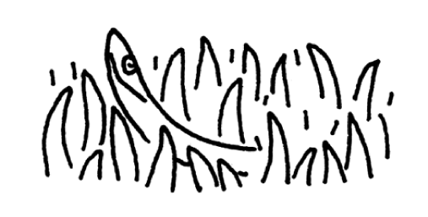
1.  2.  3. | The butterfly looks like the________________  What does the lizard look like? It’s the same  ___________as the ___________  What does the snake look like? It’s the same  __________ and ________ as the ________

