Unit 3

- Look and write. (20%)
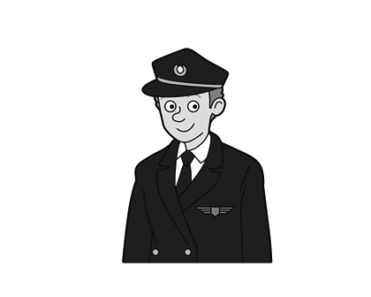 | 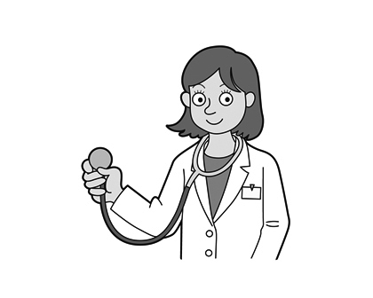 | 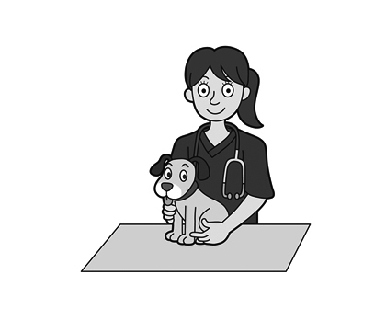 | 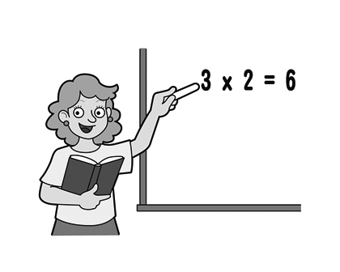
1. | 2. | 3. | 4.

- Read and choose. (15%)
( ) 1. This is _____ father. a. X b. my c. an
( ) 2. He is _____ doctor. a. X b. a c. an
( ) 3. This is my brother. _____ a vet. a. He b. Hes c. He’s

- Fill in the blanks with am, are or is (15%)
  - I ______ a baker.
  - My brother _______ a pilot.
  - She _______a teacher.
  - My sister ________ five.
  - You _______ an actor.
- Right (O) or Wrong (X). (20%)
( ) 1. This is Oscar. Hes my brother.
( ) 2. This is my sister. She is a vet.
( ) 3. This’s my mom. She is a teacher.
( ) 4. My sister is dancer. She’s happy.

- Unscramble the sentences. (15%)
  - my / this / brother / is / . -> ____________________________________
  - is / he / actor / an / . -> ________________________________________
  - nine / my / is / sister / . -> ______________________________________

- Look and write. (15%)
e.g. | 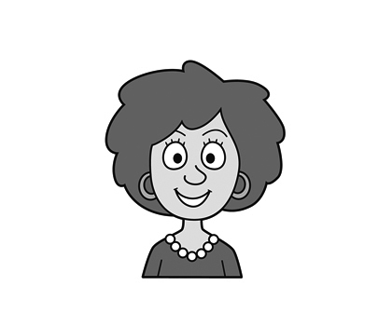 |  | This is my mom. She’s a vet.
1. | 
2. | 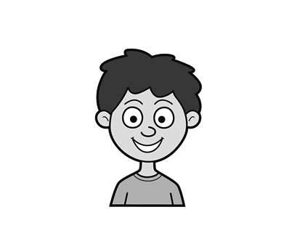
3. | 