Sun - Tek Elementary School
4th Grade — Third Practice Test

Class _________________ Name ______________________

English | Reading | Writing | Total
/60 | /20 | /20 | /100

Listening
Question One:
Listen carefully to the article about Dolphins and then answer the questions.

1. What are dolphins? Underline the correct answer.
fish / reptiles / mammals / amphibians

2. Fish have fins, while dolphins have ________? Underline the correct answer.
flippers / flappers / feet / wings

3. How do dolphins move their tails when they swim? Underline the correct answer.
right to left / side to side / left to right / up and down

4. What can fish do, but dolphins cannot do? Underline the correct answer.
swim /jump out of the water /breathe in water /move their tails

5. How do dolphins use sounds? Underline TWO things.
to find things / to swim / to “talk” to each other / to breathe

6. Underline TWO tricks you can teach a bottle-nosed dolphin.
smiling / throwing balls through nets / finding things /jumping through hoops

7. Fill in the correct word:
Bottle-nosed dolphins look like they are smiling .

8. Fill in the correct word:
Bottle-nosed dolphins can even walk on water, using their strong tails.
( / 10 )
English
Question Two:
Read the story and then replace the underlined words with the correct object or subject pronoun.

Cindy and Ivan were playing with the ball. Cindy wanted to kick the ball, but Ivan said Cindy and
Ivan should rather throw the ball to each other. Jack and Jolin ran by and took the ball.
Ivan shouted at Jack and Jolin. “Give the ball back to Cindy!” My dad bought it for Cindy and me
for Christmas!”
Jolin laughed at Ivan and said, “Jack and I won’t give the ball back!” Then Jack and Jolin ran away.

Cindy and Ivan were playing with the ball. 1. She wanted to kick 2.it,
but 3.he said 4. they should rather throw the ball to each other.
Jack and Jolin ran by and took the ball. Ivan shouted at 5.them. “Give the ball
back to 6.her!” My dad bought it for 7. us for Christmas.
Jolin laughed at 8. him and said, “9.We won’t give the ball back!”
Then 10. they ran away.
( /10) Question Three:
Look at the pictures and complete the sentences. Use too or enough and one of the adjectives.
big short strong tall

1. He is not tall enough to reach the shelf.

2. The car is not big enough to get in.

3. His legs are too short to ride the bike.

4. He isn’t strong enough to lift the weights. ( /8)

Question Four:
Write new sentences like in the example.
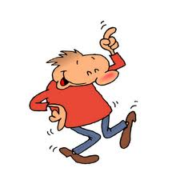
Ray has to practice the dance.
a) What does he have to do?
b) He doesn’t have to practice the dance.
c) Does he have to practice the dance?


Sisy has to make a cake.
a) What does she have to do?
b) She doesn’t have to make a cake.
c) Does she have to make a cake?

They have to kick the ball.
a) What do they have to do?
b) They don’t have to kick the ball.
c) Do they have to kick the ball?
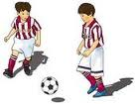

We have to feed the fish.
a) What do we have to do?
b) We don’t have to feed the fish.
c) Do we have to feed the fish?
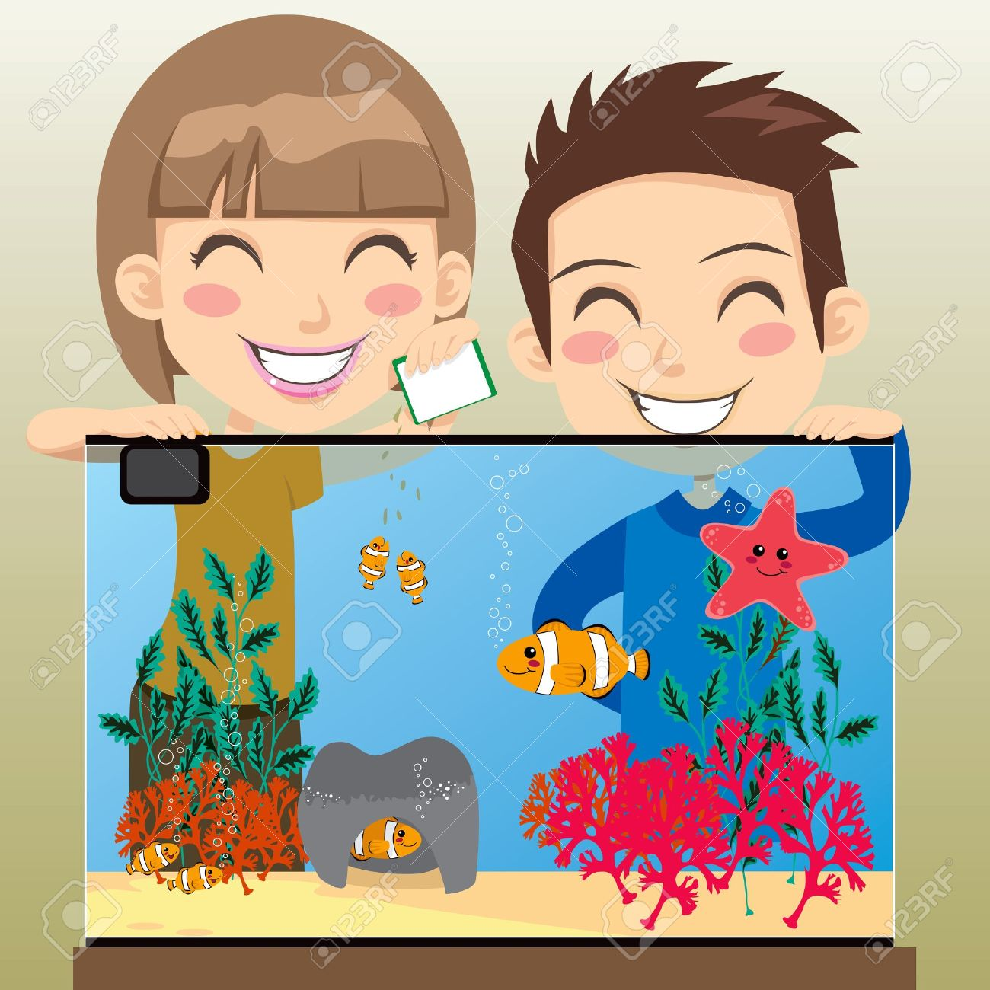

( /18)

Question Five :
Use the comparative or superlative form of the adjective to make a new sentence.

Example: Linda is 45 kg. / Maggie is 49 kg. / Sandy is 50 kg.
Answer: Sandy is the heaviest.

1. My father works 10 hours a day. / My mother works 12 hours a day. (busy)
My mother is busier than my father.
2. Mary’s score was 95. / John’s score was 98. / Sue’s score was 100. (good)
Sue’s score is the best.
3. The shirt costs 200 dollars. /The hat costs 300 dollars / The pants cost 500 dollars. (expensive)
The pants are the most expensive.
4. Sam is 1.65m. / Shawn is 1.70m. (tall)
Shawn is taller than Sam.

( /8)
Question Six:
There is one mistake in each sentence. Circle the mistake and then write the sentence correctly.

1. She draws good.
She draws well.
2. My mom always says my dad drives too fastly.
My mom always says my dad drives too fast.
3. I felt so sadly because our vacation was over.
I felt so sad because our vacation was over.
( /6)

Reading Comprehension
Question Seven:
Read the story. Then answer the questions in full sentences.

Lita was getting very skinny. It seemed that even insects went the other way when they spotted
the bright lizard. Her long, thin, quick tongue could not catch any insects for food.
“I will ask some other animals how they protect themselves,” said Lita.
First she went to the owl and asked him. He showed her his sharp claws and big beak. No help
there!
Then she talked to the goat. He showed her his hard hooves that let him run very fast.
“I have this, too!” he yelled and tried to butt Lita with his sharp horns.
The next day, Lita asked Mrs.Skunk, “How do you keep your enemies away, Mrs. Skunk?”
Mrs.Skunk laughed, “I’ll show you, “she said.
Lita was sorry she had asked. Why? from Reading Comprehension 3

1. What kind of animal is Lita?
Lita is a lizard.
2. Write a sentence to explain how these animals protect themselves from other animals.

Owl: He uses his sharp claws and big beak.
Goat: He uses his hard hooves and sharp horns.
Skunk: She uses her stinky juice.

2. Choose a word or phrase from the word bank to answer the questions. Then put the parts
together to make a good sentence.

went in the morning Lita into the forest to ask for help

When? in the morning
Who or What? Lita
Where? into the forest
Action? went
Why? to ask for help

Sentence: In the morning, Lita went into the forest to ask for help.
( /20)

Writing
Question Eight:
Combine each pair of sentences. Write one sentence.

1. Mr.Bean can speak English. Mr.Bean can speak French. Mr.Bean can speak Spanish.
Mr Bean can speak English, French and Spanish.

2. Mr. Bean got on the train. The boy got on the train.
Mr Bean and the boy got on the train.

3. Mr.Bean had his video camera. Mr Bean didn’t have his bag.
Mr Bean had his video camera, but not his bag.
( /6)
Question Ten:
Circle the homophone mistake in each sentence and then write the word correctly on the line.

1. We always have to weight for him. He’s never on time! wait

2. He ate the hole chocolate cake! whole

3. Be sure to right the correct answer on the paper. write

4. Their is only one week left before the test. There

( /4)

Question Ten: Read the story below. Then finish it with your own writing.

- Write at least 8 sentences.
- Write in the present and present continuous tenses.
- Remember, too many short sentences are boring. Join some sentences together.
- If you join two sentences together to form one longer sentence, it will count as two sentences.

A Day in my Life
On weekdays I usually get up at 6.30. First, I have a shower and then get dressed.
I like to have bread, fruit and a cup of tea for breakfast. After breakfast, I brush my teeth and get ready to go to school.

__________________________________________________________________________________

__________________________________________________________________________________

__________________________________________________________________________________

__________________________________________________________________________________

__________________________________________________________________________________

__________________________________________________________________________________

__________________________________________________________________________________

__________________________________________________________________________________

__________________________________________________________________________________

__________________________________________________________________________________

__________________________________________________________________________________

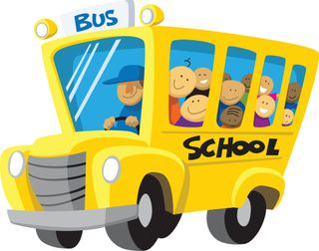  Content (5) | Language (2) | Spelling (2) | Length (1) | Total (10)

Listening Test (don’t copy for students)

Those Adorable Dolphins
Dolphins are animals that live in the sea. Does that mean dolphins are fish? No, dolphins are
mammals, not fish. Fish have fins, while dolphins have flippers. When fish swim, they move their
tails from side to side. When dolphins swim, they move their tails up and down.
Fish can breathe in water, but dolphins have to go to the surface of the water to breathe.

Dolphins use sounds to find things. They send out clicking sounds. The sound strikes something
and bounces back to the dolphin. They also use sounds to ‘talk” to each other.

If you go to an aquarium or zoo, you will probably see bottle-nosed dolphins. They look like
they’re smiling. They are very smart. They can learn how to do tricks, such as throwing balls
through nets and jumping through hoops. They even “walk” on the water using their strong
tails.

