Sun - Tek Elementary School
4th Grade — Fifth Practice Test

Class _________________ Name ______________________

English | Reading | Writing | Total
/60 | /20 | /20 | /100

Listening
Question One:
Listen carefully to the article about Earthquakes and then answer the questions.

1. How do people feel when there is an earthquake? ___________________________________

2. How fast do continents move? Underline the correct answer.
4 or 5 meters a second / several miles a day / about as fast as your fingernails grow

3. A place where two sections of the earth’s crust meet, is called a _______.
fault / mistake / earthquake (Underline the correct answer.)

4. How many earthquakes are there in the world every year? Underline the correct answer.
about 19 / about 100 000 / about 500 000

5. Underline TWO things that can happen during a big earthquake.
buildings may fall / there may be typhoons / there may be fires

6. Tsunamis are huge ____________. Underline the correct answer.
landslides / earthquakes / waves

7. What do scientists already know about earthquakes? Underline TWO correct answers.
they know what causes them / they can tell how strong they are / they know which day
there will be an earthquake
( /10)

English
Question Two:
Fill in for or since.
1. The weather has been terrible _________________ March.
2. Jerry has worked here __________________ several months.
3. They have known each other _______________ childhood.
4. I haven’t seen Amy _________________ a month.
5. Jerry has been sick __________________ two weeks.
6. They have been married __________________ 2010.
( / 6 )

Question Three:
Complete the sentences using the present perfect tense with the correct form of the given verb.

1. The kitchen is very messy. I ________________________________ (wash) the dishes yet.

2. You don’t need to clean the bathroom. I _________________ already _____________ (clean) it.

3. _____________________ you ever ________________ (see) a crocodile?

4. You can’t go out to play. You ___________________________ (finish) your homework yet.

5. ____________ they ever _________________ (swim) with the dolphins?

6. Why _____________ he _______________ (break) the window?

7. We have no food. My mom _______________________ (cook) dinner yet.

8. What ________________ you _______________ (do) today?

9. _______________ Teacher Benjamin ever ____________________ (eat) stinky tofu?
( /18)

Question Four:
Look at the pictures. Write present perfect sentences with yet and already.

1. (The Lins / arrive at the beach)

________________________________________________________

2. (They / go for a swim)
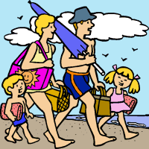
________________________________________________________

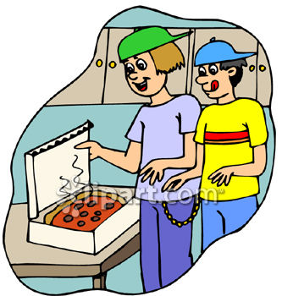
3. (The boys /open the pizza box)

______________________________________________________

4. (They / eat the pizza)

______________________________________________________
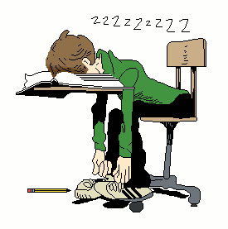
5. (Roger /fall asleep)

______________________________________________________

6. (He /finish his homework)

________________________________________________________

( /18 )

Question Five:
Rewrite the sentence, starting with the given words.

1. Stanley used to collect toy cars when he was in grade one.

2. Did ________________________________________________________________________?

3. What _______________________________________________________________________?

4. When ______________________________________________________________________?

5. Who _______________________________________________________________________?
( /8)

Reading Comprehension
Question Six:
Read the story and answer the questions in full sentences.
How do plants survive on Earth? How do they help us to survive? If you want to know the
answer, you need to know about photosynthesis.
“Photosynthesis” is really two words, “photo” and “synthesis”.
“Photo” means “light” and “synthesis” means “put together”. Plants use sunlight, carbon dioxide
and water to make their own food. Then they can help make our air breathable.
Plants have small holes in leaves called ‘stomata”, and they also have roots in the soil. The
air gives the plant carbon dioxide, and this goes into the plant through the small holes. The rain
gives plants water, and this goes into the plant through the roots, when the soil is wet.
The sun’s energy comes down to earth in the sunlight. The leaves have something
green called chlorophyll. Chlorophyll is why leaves are green in spring and summer. The
chlorophyll uses the sun’s energy to change water and carbon dioxide to make food called
glucose, and oxygen.
This is very important for humans and all other animal. We also need glucose for our own diet. When plants don’t use glucose, they save it. We find it in things like carrots, potatoes and apples.
It is also important because we need oxygen in the air. If we have too much carbon dioxide, we
can’t breathe and we get sick or even die.
We can see that photosynthesis is very important not just for plants and trees, but also for
people. Don’t you agree?

1. What does “photo” mean? Underline the correct answer.
put together / picture / light
2. Which three things do plants need to make their own food?
_______________________________________________________________________________________
3. What are “stomata”?
_______________________________________________________________________________________
4 How do plants get water?
_______________________________________________________________________________________
5. What makes leaves green in spring and summer?
________________________________________________________________________________________
6. Where do we find glucose? Write FOUR things.
________________________________________________________________________________________
7. What can happen to us if we have too much carbon dioxide?
________________________________________________________________________________________
( /20)
( / 20 )

Writing
Question Seven: Descriptive Paragraph: My classmate
You will write a descriptive paragraph about one of your classmates.
Before you write your paragraph, think about and answer the following questions.
1. Who is this person? __________________________________________________________________
2. Write two lively adjectives you can use to describe this person’s face or body parts.
_______________________________________________________________________________________
3. Write a vivid verb to describe how this person moves. _____________________________________
4. Write an adverb to describe how the person talks. ________________________________________
5. How does the person make you feel? __________________________________________________
( / 6 )
Question Eight: Now write a paragraph describing your classmate. Write at least 8 sentences.

___________________________________________________________________________________________

___________________________________________________________________________________________

____________________________________________________________________________________________

____________________________________________________________________________________________

____________________________________________________________________________________________

____________________________________________________________________________________________

____________________________________________________________________________________________

____________________________________________________________________________________________

____________________________________________________________________________________________

____________________________________________________________________________________________

____________________________________________________________________________________________
Description /8 | Grammar /2 | Spelling /2 | Length /2

Listening Test (don’t copy for students)
Our Shaky Planet
Have you ever been in an earthquake? How did it feel? An earthquake can be a scary experience.
Parts of the earth are always moving. The movements are usually so small and so slow that we don’t
feel them. Whole mountains and even continents move. We don’t feel it because continents move
only as fast as your fingernails grow.
Sometimes, though, we can see and feel the movements. Sections of the Earth’s crust push against
each other. Where they meet is called a fault. Faults look like large cracks in the ground. If the
two plates move in different directions, they build up energy at the fault line. When enough energy
builds up, the stress on the fault becomes too great and it ruptures. This releases the energy and the
ground starts to shake.
There are about 500 000 earthquakes every year. Only about 100 000 can be felt by people, and
19 a year cause big damage.
In a big earthquake buildings may fall. Pipes that carry water and gas can be broken, causing fires. Large earthquakes can cause landslides and huge waves called tsunamis.
Scientists know a lot about earthquakes. They know what causes them. They can tell how strong they
are. Maybe one day they will be able to predict earthquakes.

