一年 班 號姓名：
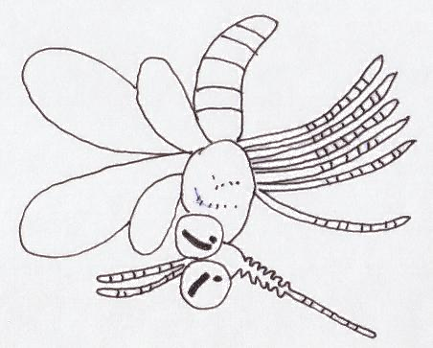  ㄝ |  | ㄝ
\s\up20(\o(\s\up6(\d\fo0()ˇ)\s\up20(\o(\s\up6(\d\fo0()ˊ)\s\up20(ㄕ)ㄕ\s\up20(ㄕ))\s\up20(ㄕ)  \s\up16(ㄨ)ㄨ\s\up16(ㄨ))\s\up16(ㄨ)\s\up16(ㄍㄨㄟ)ㄍㄨㄟ\s\up16(ㄍㄨㄟ))\s\up16(ㄍㄨㄟ)\s\up16(\o(\s\up5(\d\fo0()ˋ)\s\up16(\o(\s\up5(\d\fo6()ˇ)\s\up16(\o(\s\up5(\d\fo6()ˊ)，  \s\up16(ㄓㄤ)ㄓㄤ\s\up16(ㄓㄤ))\s\up16(ㄓㄤ)\s\up16(\o(\s\up5(\d\fo0()ˊ)\s\up16(\o(\s\up5(\d\fo0()ˋ)\s\up16(ㄊㄨㄛ)ㄊㄨㄛ\s\up16(ㄊㄨㄛ))\s\up16(ㄊㄨㄛ)\s\up16(\o(\s\up5(\d\fo6()ˊ)，  \s\up16(\o(\s\up5(\d\fo0()ˇ)\s\up16(\o(\s\up5(\d\fo0()ˇ)\s\up16(\o(\s\up5(\d\ba10()ˋ)\s\up16(ㄉㄤ)ㄉㄤ\s\up16(ㄉㄤ))\s\up16(ㄉㄤ)\s\up16(\o(\s\up5(\d\fo0()ˊ)，  \s\up16(\o(\s\up5(\d\fo0()ˊ)\s\up16(\o(\s\up0(\d\ba10()˙)\s\up16(\o(\s\up5(\d\ba10()ˋ)\s\up16(ㄏㄜ)ㄏㄜ\s\up16(ㄏㄜ))\s\up16(ㄏㄜ)\s\up16(\o(\s\up5(\d\fo6()ˇ)。 | \s\up13(\o(\s\up4(\d\fo0()ˇ)\s\up13(\o(\s\up4(\d\fo5()ˋ)\s\up13(\o(\s\up4(\d\fo0()ˋ)\s\up13(\o(\s\up4(\d\ba8()ˊ)，\s\up13(\o(\s\up4(\d\fo0()ˇ)\s\up13(\o(\s\up4(\d\fo5()ˋ)\s\up13(\o(\s\up4(\d\fo5()ˋ)\s\up13(\o(\s\up4(\d\ba8()ˊ)\s\up13(\o(\s\up4(\d\fo5()ˋ)：
家長簽名
一年 班 號姓名：
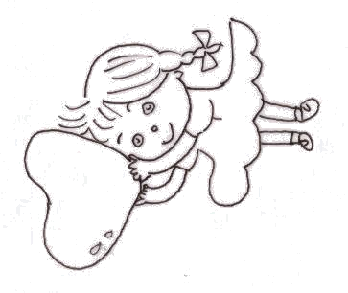  ㄞ |  | ㄞ
\s\up20(\o(\s\up6(\d\ba12()ˋ)  \s\up16(\o(\s\up5(\d\ba10()ˋ)，\s\up16(\o(\s\up5(\d\ba10()ˋ)\s\up16(\o(\s\up5(\d\fo0()ˇ)\s\up16(\o(\s\up5(\d\fo0()ˊ)\s\up16(\o(\s\up5(\d\fo6()ˋ)\s\up16(\o(\s\up5(\d\fo0()ˋ)！  \s\up16(\o(\s\up5(\d\fo0()ˊ)\s\up16(ㄏㄨㄚ)ㄏㄨㄚ\s\up16(ㄏㄨㄚ))\s\up16(ㄏㄨㄚ)\s\up16(\o(\s\up5(\d\fo0()ˇ)\s\up16(ㄐㄧㄠ)ㄐㄧㄠ\s\up16(ㄐㄧㄠ))\s\up16(ㄐㄧㄠ)\s\up16(\o(\s\up5(\d\fo6()ˇ)，  \s\up16(\o(\s\up5(\d\fo0()ˊ)\s\up16(\o(\s\up5(\d\fo6()ˇ)\s\up16(\o(\s\up5(\d\fo0()ˇ)\s\up16(\o(\s\up5(\d\fo0()ˇ)\s\up16(\o(\s\up5(\d\fo0()ˇ)，  \s\up16(\o(\s\up5(\d\fo0()ˋ)\s\up16(\o(\s\up5(\d\fo0()ˋ)\s\up16(ㄕㄥ)ㄕㄥ\s\up16(ㄕㄥ))\s\up16(ㄕㄥ)\s\up16(\o(\s\up5(\d\fo6()ˋ)\s\up16(\o(\s\up0(\d\ba16()˙)\s\up16(\o(\s\up5(\d\fo6()ˊ)\s\up16(\o(\s\up5(\d\fo6()ˊ)，  \s\up16(ㄊㄧㄥ)ㄊㄧㄥ\s\up16(ㄊㄧㄥ))\s\up16(ㄊㄧㄥ)\s\up16(\o(\s\up5(\d\fo6()ˊ)\s\up16(\o(\s\up5(\d\fo0()ˇ)\s\up16(ㄕ)ㄕ\s\up16(ㄕ))\s\up16(ㄕ)\s\up16(\o(\s\up0(\d\ba16()˙)\s\up16(ㄐㄧㄠ)ㄐㄧㄠ\s\up16(ㄐㄧㄠ))\s\up16(ㄐㄧㄠ)\s\up16(\o(\s\up5(\d\fo0()ˇ)，  \s\up16(\o(\s\up5(\d\ba10()ˋ)，\s\up16(\o(\s\up5(\d\ba10()ˋ)\s\up16(\o(\s\up5(\d\fo0()ˇ)\s\up16(\o(\s\up5(\d\fo0()ˊ)\s\up16(\o(\s\up5(\d\fo6()ˋ)\s\up16(\o(\s\up5(\d\fo0()ˋ)！ | \s\up13(\o(\s\up4(\d\fo0()ˇ)\s\up13(\o(\s\up4(\d\fo5()ˋ)\s\up13(\o(\s\up4(\d\fo0()ˋ)\s\up13(\o(\s\up4(\d\ba8()ˊ)，\s\up13(\o(\s\up4(\d\fo0()ˇ)\s\up13(\o(\s\up4(\d\fo5()ˋ)\s\up13(\o(\s\up4(\d\fo5()ˋ)\s\up13(\o(\s\up4(\d\ba8()ˊ)\s\up13(\o(\s\up4(\d\fo5()ˋ)：
家長簽名

