一年 班 號姓名：
ㄡ |  | ㄡ
\s\up20(\o(\s\up6(\d\fo0()ˋ)\s\up20(\o(\s\up6(\d\fo0()ˊ)  \s\up16(\o(\s\up5(\d\fo0()ˋ)\s\up16(\o(\s\up5(\d\fo0()ˊ)\s\up16(\o(\s\up5(\d\fo0()ˋ)\s\up16(\o(\s\up5(\d\fo0()ˊ)，  \s\up16(\o(\s\up5(\d\fo6()ˋ)\s\up16(\o(\s\up5(\d\ba10()ˇ)\s\up16(\o(\s\up5(\d\fo0()ˋ)\s\up16(\o(\s\up5(\d\fo0()ˊ)，  \s\up16(\o(\s\up5(\d\fo0()ˊ)\s\up16(ㄐㄧㄚ)ㄐㄧㄚ\s\up16(ㄐㄧㄚ))\s\up16(ㄐㄧㄚ)\s\up16(\o(\s\up5(\d\fo0()ˇ)\s\up16(\o(\s\up5(\d\fo0()ˇ)，  \s\up16(\o(\s\up5(\d\fo0()ˇ)\s\up16(\o(\s\up5(\d\fo0()ˇ)\s\up16(\o(\s\up5(\d\fo0()ˋ)\s\up16(\o(\s\up5(\d\fo0()ˊ)。 | \s\up13(\o(\s\up4(\d\fo0()ˇ)\s\up13(\o(\s\up4(\d\fo5()ˋ)\s\up13(\o(\s\up4(\d\fo0()ˋ)\s\up13(\o(\s\up4(\d\ba8()ˊ)，\s\up13(\o(\s\up4(\d\fo0()ˇ)\s\up13(\o(\s\up4(\d\fo5()ˋ)\s\up13(\o(\s\up4(\d\fo5()ˋ)\s\up13(\o(\s\up4(\d\ba8()ˊ)\s\up13(\o(\s\up4(\d\fo5()ˋ)：
家長簽名
一年 班 號姓名：
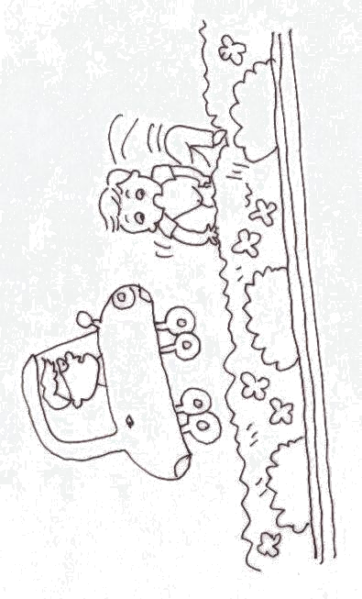  ㄢ |  | ㄢ
\s\up20(ㄢ)ㄢ\s\up20(ㄢ))\s\up20(ㄢ)\s\up20(\o(\s\up6(\d\fo8()ˊ)\s\up20(\o(\s\up6(\d\fo0()ˇ)  \s\up16(ㄢ)ㄢ\s\up16(ㄢ))\s\up16(ㄢ)\s\up16(\o(\s\up5(\d\fo6()ˊ)\s\up16(\o(\s\up5(\d\fo0()ˇ)，\s\up16(\o(\s\up5(\d\fo0()ˇ)\s\up16(\o(\s\up5(\d\fo6()ˊ)\s\up16(ㄢ)ㄢ\s\up16(ㄢ))\s\up16(ㄢ)，  \s\up16(\o(\s\up5(\d\fo0()ˊ)\s\up16(\o(\s\up5(\d\fo0()ˋ)\s\up16(\o(\s\up5(\d\fo6()ˇ)\s\up16(ㄔㄜ)ㄔㄜ\s\up16(ㄔㄜ))\s\up16(ㄔㄜ)\s\up16(\o(\s\up5(\d\fo0()ˊ)\s\up16(ㄒㄧㄤ)ㄒㄧㄤ\s\up16(ㄒㄧㄤ))\s\up16(ㄒㄧㄤ)\s\up16(\o(\s\up5(\d\fo6()ˋ)。  \s\up16(ㄢ)ㄢ\s\up16(ㄢ))\s\up16(ㄢ)\s\up16(\o(\s\up5(\d\fo6()ˊ)\s\up16(\o(\s\up5(\d\fo0()ˇ)，\s\up16(ㄏㄨㄚ)ㄏㄨㄚ\s\up16(ㄏㄨㄚ))\s\up16(ㄏㄨㄚ)\s\up16(\o(\s\up5(\d\fo0()ˋ)\s\up16(ㄉㄨㄛ)ㄉㄨㄛ\s\up16(ㄉㄨㄛ))\s\up16(ㄉㄨㄛ)，  \s\up16(\o(\s\up5(\d\fo6()ˊ)\s\up16(\o(\s\up5(\d\fo0()ˊ)\s\up16(\o(\s\up5(\d\fo0()ˊ)\s\up16(\o(\s\up5(\d\fo0()ˋ)\s\up16(\o(\s\up5(\d\fo0()ˋ)\s\up16(\o(\s\up5(\d\fo0()ˋ)\s\up16(\o(\s\up5(\d\fo0()ˇ)。 | \s\up13(\o(\s\up4(\d\fo0()ˇ)\s\up13(\o(\s\up4(\d\fo5()ˋ)\s\up13(\o(\s\up4(\d\fo0()ˋ)\s\up13(\o(\s\up4(\d\ba8()ˊ)，\s\up13(\o(\s\up4(\d\fo0()ˇ)\s\up13(\o(\s\up4(\d\fo5()ˋ)\s\up13(\o(\s\up4(\d\fo5()ˋ)\s\up13(\o(\s\up4(\d\ba8()ˊ)\s\up13(\o(\s\up4(\d\fo5()ˋ)：
家長簽名

