一年 班 號姓名：
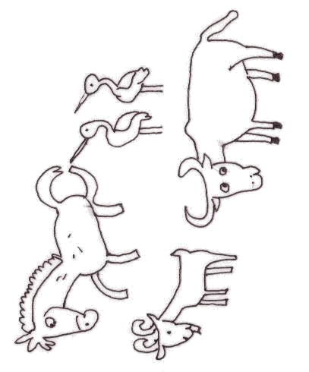  ㄋ |  | ㄋ
\s\up16(\o(\s\up5(\d\fo0()ˋ)\s\up16(ㄅㄧㄢ)ㄅㄧㄢ\s\up16(ㄅㄧㄢ))\s\up16(ㄅㄧㄢ)\s\up16(\o(\s\up5(\d\fo0()ˇ)\s\up16(\o(\s\up5(\d\ba10()ˋ)\s\up16(ㄆㄧ)ㄆㄧ\s\up16(ㄆㄧ))\s\up16(ㄆㄧ)\s\up16(\o(\s\up5(\d\fo0()ˇ)，  \s\up16(\o(\s\up5(\d\fo0()ˋ)\s\up16(ㄅㄧㄢ)ㄅㄧㄢ\s\up16(ㄅㄧㄢ))\s\up16(ㄅㄧㄢ)\s\up16(\o(\s\up5(\d\fo0()ˇ)\s\up16(\o(\s\up5(\d\fo6()ˇ)\s\up16(\o(\s\up5(\d\fo0()ˊ)\s\up16(\o(\s\up5(\d\fo6()ˊ)，  \s\up16(\o(\s\up5(\d\fo0()ˋ)\s\up16(ㄅㄧㄢ)ㄅㄧㄢ\s\up16(ㄅㄧㄢ))\s\up16(ㄅㄧㄢ)\s\up16(\o(\s\up5(\d\fo0()ˇ)\s\up16(ㄙㄢ)ㄙㄢ\s\up16(ㄙㄢ))\s\up16(ㄙㄢ)\s\up16(ㄓ)ㄓ\s\up16(ㄓ))\s\up16(ㄓ)\s\up16(\o(\s\up5(\d\fo0()ˊ)，  \s\up16(\o(\s\up5(\d\fo0()ˋ)\s\up16(ㄅㄧㄢ)ㄅㄧㄢ\s\up16(ㄅㄧㄢ))\s\up16(ㄅㄧㄢ)\s\up16(\o(\s\up5(\d\fo0()ˇ)\s\up16(\o(\s\up5(\d\ba10()ˋ)\s\up16(ㄓ)ㄓ\s\up16(ㄓ))\s\up16(ㄓ)\s\up16(\o(\s\up5(\d\fo0()ˇ)，  \s\up16(\o(\s\up5(\d\fo0()ˋ)\s\up16(ㄅㄧㄢ)ㄅㄧㄢ\s\up16(ㄅㄧㄢ))\s\up16(ㄅㄧㄢ)\s\up16(\o(\s\up5(\d\fo0()ˇ)\s\up16(\o(\s\up5(\d\ba10()ˇ)\s\up16(ㄓ)ㄓ\s\up16(ㄓ))\s\up16(ㄓ)\s\up16(\o(\s\up5(\d\fo0()ˋ)，  \s\up16(\o(\s\up5(\d\fo0()ˋ)\s\up16(ㄅㄧㄢ)ㄅㄧㄢ\s\up16(ㄅㄧㄢ))\s\up16(ㄅㄧㄢ)\s\up16(\o(\s\up5(\d\fo0()ˇ)\s\up16(\o(\s\up5(\d\fo6()ˋ)\s\up16(ㄓ)ㄓ\s\up16(ㄓ))\s\up16(ㄓ)\s\up16(\o(\s\up5(\d\fo6()ˇ)，  \s\up16(ㄘㄞ)ㄘㄞ\s\up16(ㄘㄞ))\s\up16(ㄘㄞ)\s\up16(ㄘㄞ)ㄘㄞ\s\up16(ㄘㄞ))\s\up16(ㄘㄞ)\s\up16(\o(\s\up5(\d\fo0()ˇ)\s\up16(ㄅㄧㄢ)ㄅㄧㄢ\s\up16(ㄅㄧㄢ))\s\up16(ㄅㄧㄢ)\s\up16(\o(\s\up5(\d\fo6()ˋ)\s\up16(\o(\s\up5(\d\ba10()ˋ)\s\up16(ㄉㄨㄛ)ㄉㄨㄛ\s\up16(ㄉㄨㄛ))\s\up16(ㄉㄨㄛ)？ | \s\up13(\o(\s\up4(\d\fo0()ˇ)\s\up13(\o(\s\up4(\d\fo5()ˋ)\s\up13(\o(\s\up4(\d\fo0()ˋ)\s\up13(\o(\s\up4(\d\ba8()ˊ)，\s\up13(\o(\s\up4(\d\fo0()ˇ)\s\up13(\o(\s\up4(\d\fo5()ˋ)\s\up13(\o(\s\up4(\d\fo5()ˋ)\s\up13(\o(\s\up4(\d\ba8()ˊ)\s\up13(\o(\s\up4(\d\fo5()ˋ)：
家長簽名
一年 班 號姓名：
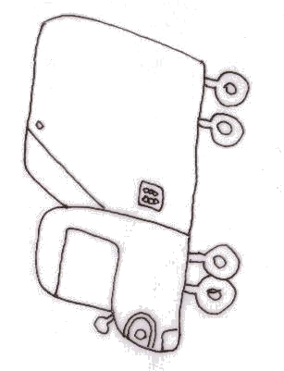  ㄌ |  | ㄌ
\s\up20(\o(\s\up6(\d\fo0()ˋ)\s\up20(\o(\s\up6(\d\fo0()ˋ)\s\up20(ㄔㄜ)ㄔㄜ\s\up20(ㄔㄜ))\s\up20(ㄔㄜ)  \s\up16(\o(\s\up5(\d\fo0()ˋ)\s\up16(\o(\s\up5(\d\fo0()ˋ)\s\up16(ㄔㄜ)ㄔㄜ\s\up16(ㄔㄜ))\s\up16(ㄔㄜ)，\s\up16(\o(\s\up5(\d\fo0()ˋ)\s\up16(\o(\s\up5(\d\fo0()ˋ)\s\up16(\o(\s\up5(\d\fo0()ˋ)。  \s\up16(\o(\s\up5(\d\fo0()ˋ)\s\up16(\o(\s\up5(\d\fo0()ˋ)\s\up16(\o(\s\up5(\d\fo0()ˋ)\s\up16(\o(\s\up5(\d\fo0()ˋ)\s\up16(\o(\s\up5(\d\fo0()ˇ)\s\up16(\o(\s\up5(\d\fo0()ˇ)\s\up16(\o(\s\up5(\d\fo0()ˇ)？  \s\up16(ㄑㄧㄥ)ㄑㄧㄥ\s\up16(ㄑㄧㄥ))\s\up16(ㄑㄧㄥ)\s\up16(\o(\s\up5(\d\fo6()ˊ)\s\up16(ㄍㄨㄥ)ㄍㄨㄥ\s\up16(ㄍㄨㄥ))\s\up16(ㄍㄨㄥ)\s\up16(\o(\s\up5(\d\fo0()ˊ)\s\up16(\o(\s\up5(\d\fo0()ˇ)\s\up16(\o(\s\up5(\d\fo0()ˊ)\s\up16(\o(\s\up5(\d\fo0()ˇ)，  \s\up16(\o(\s\up5(\d\fo0()ˇ)\s\up16(\o(\s\up5(\d\ba10()ˊ)\s\up16(\o(\s\up5(\d\fo6()ˊ)，\s\up16(\o(\s\up5(\d\fo0()ˋ)\s\up16(\o(\s\up5(\d\fo0()ˊ)\s\up16(\o(\s\up5(\d\fo0()ˊ)：  \s\up16(\o(\s\up5(\d\fo0()ˊ)\s\up16(\o(\s\up5(\d\ba10()ˋ)\s\up16(\o(\s\up5(\d\fo0()ˋ)\s\up16(\o(\s\up5(\d\fo0()ˋ)\s\up16(\o(\s\up5(\d\fo0()ˋ)，  \s\up16(\o(\s\up5(\d\fo0()ˊ)\s\up16(\o(\s\up5(\d\ba10()ˋ)\s\up16(\o(\s\up5(\d\fo0()ˋ)\s\up16(\o(\s\up5(\d\fo6()ˋ)\s\up16(\o(\s\up5(\d\fo0()ˇ)。 | \s\up13(\o(\s\up4(\d\fo0()ˇ)\s\up13(\o(\s\up4(\d\fo5()ˋ)\s\up13(\o(\s\up4(\d\fo0()ˋ)\s\up13(\o(\s\up4(\d\ba8()ˊ)，\s\up13(\o(\s\up4(\d\fo0()ˇ)\s\up13(\o(\s\up4(\d\fo5()ˋ)\s\up13(\o(\s\up4(\d\fo5()ˋ)\s\up13(\o(\s\up4(\d\ba8()ˊ)\s\up13(\o(\s\up4(\d\fo5()ˋ)：
家長簽名

