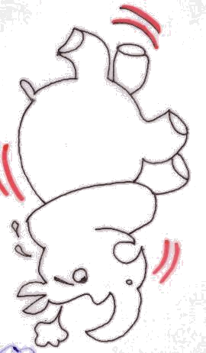  ㄒ |  | ㄒ
\s\up20(ㄒㄧ)ㄒㄧ\s\up20(ㄒㄧ))\s\up20(ㄒㄧ)\s\up20(\o(\s\up6(\d\fo8()ˊ)  \s\up16(ㄒㄧ)ㄒㄧ\s\up16(ㄒㄧ))\s\up16(ㄒㄧ)\s\up16(\o(\s\up5(\d\fo6()ˊ)\s\up16(ㄒㄧ)ㄒㄧ\s\up16(ㄒㄧ))\s\up16(ㄒㄧ)\s\up16(\o(\s\up5(\d\fo6()ˊ)\s\up16(\o(\s\up5(\d\fo6()ˋ)\s\up16(\o(\s\up5(\d\fo0()ˊ)\s\up16(\o(\s\up5(\d\fo0()ˋ)，  \s\up16(\o(\s\up5(\d\ba10()ˋ)\s\up16(\o(\s\up5(\d\fo0()ˋ)\s\up16(ㄎㄞ)ㄎㄞ\s\up16(ㄎㄞ))\s\up16(ㄎㄞ)\s\up16(ㄒㄧㄣ)ㄒㄧㄣ\s\up16(ㄒㄧㄣ))\s\up16(ㄒㄧㄣ)\s\up16(\o(\s\up5(\d\fo6()ˋ)\s\up16(\o(\s\up5(\d\fo0()ˋ)\s\up16(\o(\s\up5(\d\fo0()ˇ)，  \s\up16(ㄕㄣ)ㄕㄣ\s\up16(ㄕㄣ))\s\up16(ㄕㄣ)\s\up16(\o(\s\up5(\d\fo0()ˇ)\s\up16(\o(\s\up5(\d\fo6()ˋ)，\s\up16(\o(\s\up5(\d\fo0()ˋ)\s\up16(\o(\s\up5(\d\fo0()ˋ)\s\up16(\o(\s\up5(\d\fo0()ˋ)，  \s\up16(\o(\s\up5(\d\fo0()ˋ)\s\up16(\o(\s\up5(\d\fo0()ˋ)\s\up16(ㄕ)ㄕ\s\up16(ㄕ))\s\up16(ㄕ)\s\up16(\o(\s\up0(\d\ba10()˙)\s\up16(\o(\s\up5(\d\fo0()ˇ)\s\up16(\o(\s\up5(\d\fo0()ˊ)\s\up16(\o(\s\up5(\d\fo0()ˋ)，  \s\up16(\o(\s\up5(\d\ba10()ˋ)\s\up16(ㄔ)ㄔ\s\up16(ㄔ))\s\up16(ㄔ)\s\up16(\o(\s\up5(\d\fo0()ˋ)\s\up16(\o(\s\up5(\d\fo0()ˇ)，\s\up16(\o(\s\up5(\d\ba10()ˋ)\s\up16(\o(\s\up5(\d\fo0()ˇ)\s\up16(\o(\s\up5(\d\fo0()ˇ)  \s\up16(\o(\s\up5(\d\ba10()ˋ)\s\up16(\o(\s\up5(\d\fo0()ˋ)\s\up16(\o(\s\up5(\d\fo0()ˇ)\s\up16(\o(\s\up5(\d\fo0()ˊ)\s\up16(\o(\s\up5(\d\fo0()ˋ)\s\up16(\o(\s\up5(\d\fo0()ˊ)\s\up16(\o(\s\up5(\d\fo0()ˇ)。 | \s\up13(\o(\s\up4(\d\fo0()ˇ)\s\up13(\o(\s\up4(\d\fo5()ˋ)\s\up13(\o(\s\up4(\d\fo0()ˋ)\s\up13(\o(\s\up4(\d\ba8()ˊ)，\s\up13(\o(\s\up4(\d\fo0()ˇ)\s\up13(\o(\s\up4(\d\fo5()ˋ)\s\up13(\o(\s\up4(\d\fo5()ˋ)\s\up13(\o(\s\up4(\d\ba8()ˊ)\s\up13(\o(\s\up4(\d\fo5()ˋ)：

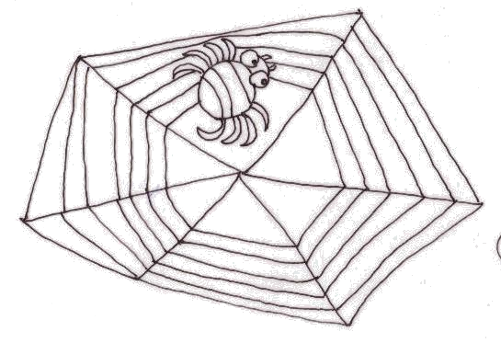  ㄓ |  | ㄓ
\s\up20(ㄓ)ㄓ\s\up20(ㄓ))\s\up20(ㄓ)\s\up20(ㄓㄨ)ㄓㄨ\s\up20(ㄓㄨ))\s\up20(ㄓㄨ)  \s\up16(ㄓ)ㄓ\s\up16(ㄓ))\s\up16(ㄓ)\s\up16(ㄓㄨ)ㄓㄨ\s\up16(ㄓㄨ))\s\up16(ㄓㄨ)\s\up16(\o(\s\up5(\d\fo0()ˇ)\s\up16(\o(\s\up5(\d\fo0()ˇ)\s\up16(ㄓ)ㄓ\s\up16(ㄓ))\s\up16(ㄓ)\s\up16(\o(\s\up5(\d\fo6()ˇ)？  \s\up16(ㄓ)ㄓ\s\up16(ㄓ))\s\up16(ㄓ)\s\up16(ㄓㄨ)ㄓㄨ\s\up16(ㄓㄨ))\s\up16(ㄓㄨ)\s\up16(\o(\s\up5(\d\fo0()ˇ)\s\up16(ㄅㄚ)ㄅㄚ\s\up16(ㄅㄚ))\s\up16(ㄅㄚ)\s\up16(ㄓ)ㄓ\s\up16(ㄓ))\s\up16(ㄓ)\s\up16(\o(\s\up5(\d\fo6()ˇ)。  \s\up16(ㄓ)ㄓ\s\up16(ㄓ))\s\up16(ㄓ)\s\up16(ㄓㄨ)ㄓㄨ\s\up16(ㄓㄨ))\s\up16(ㄓㄨ)\s\up16(\o(\s\up5(\d\fo6()ˋ)\s\up16(\o(\s\up5(\d\fo6()ˋ)\s\up16(\o(\s\up5(\d\ba10()ˊ)\s\up16(\o(\s\up0(\d\ba16()˙)？  \s\up16(ㄓ)ㄓ\s\up16(ㄓ))\s\up16(ㄓ)\s\up16(ㄓㄨ)ㄓㄨ\s\up16(ㄓㄨ))\s\up16(ㄓㄨ)\s\up16(\o(\s\up5(\d\fo6()ˋ)\s\up16(\o(\s\up5(\d\fo6()ˊ)\s\up16(\o(\s\up5(\d\fo0()ˇ)。  \s\up16(\o(\s\up5(\d\fo6()ˊ)\s\up16(\o(\s\up5(\d\fo0()ˇ)\s\up16(\o(\s\up5(\d\fo6()ˊ)\s\up16(\o(\s\up5(\d\fo0()ˇ)，  \s\up16(\o(\s\up5(\d\fo0()ˊ)\s\up16(\o(\s\up5(\d\fo0()ˋ)\s\up16(\o(\s\up5(\d\fo0()ˊ)\s\up16(\o(\s\up5(\d\fo0()ˇ)\s\up16(\o(\s\up5(\d\fo0()ˋ)\s\up16(\o(\s\up5(\d\ba10()ˋ)\s\up16(ㄓ)ㄓ\s\up16(ㄓ))\s\up16(ㄓ)\s\up16(\o(\s\up5(\d\fo0()ˊ) | \s\up13(\o(\s\up4(\d\fo0()ˇ)\s\up13(\o(\s\up4(\d\fo5()ˋ)\s\up13(\o(\s\up4(\d\fo0()ˋ)\s\up13(\o(\s\up4(\d\ba8()ˊ)，\s\up13(\o(\s\up4(\d\fo0()ˇ)\s\up13(\o(\s\up4(\d\fo5()ˋ)\s\up13(\o(\s\up4(\d\fo5()ˋ)\s\up13(\o(\s\up4(\d\ba8()ˊ)\s\up13(\o(\s\up4(\d\fo5()ˋ)：

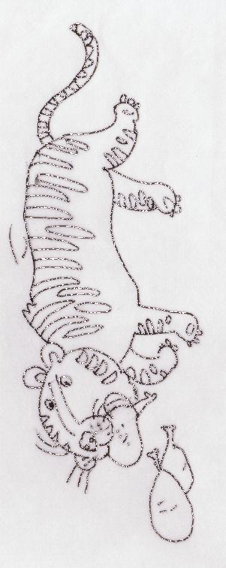  ㄔ |  | ㄔ
\s\up20(\o(\s\up6(\d\fo0()ˇ)\s\up20(\o(\s\up6(\d\fo0()ˇ)  \s\up16(ㄔ)ㄔ\s\up16(ㄔ))\s\up16(ㄔ)\s\up16(ㄔ)ㄔ\s\up16(ㄔ))\s\up16(ㄔ)\s\up16(ㄔ)ㄔ\s\up16(ㄔ))\s\up16(ㄔ)  \s\up16(\o(\s\up5(\d\fo6()ˋ)\s\up16(\o(\s\up5(\d\ba10()ˋ)\s\up16(\o(\s\up5(\d\fo0()ˊ)\s\up16(\o(\s\up0(\d\ba16()˙)\s\up16(\o(\s\up5(\d\fo0()ˇ)\s\up16(\o(\s\up5(\d\fo0()ˇ)，  \s\up16(\o(\s\up5(\d\ba10()ˋ)\s\up16(ㄊㄧㄢ)ㄊㄧㄢ\s\up16(ㄊㄧㄢ))\s\up16(ㄊㄧㄢ)\s\up16(\o(\s\up5(\d\fo0()ˋ)\s\up16(\o(\s\up5(\d\fo0()ˇ)\s\up16(\o(\s\up5(\d\fo0()ˇ)\s\up16(\o(\s\up0(\d\ba16()˙)\s\up16(ㄔ)ㄔ\s\up16(ㄔ))\s\up16(ㄔ)，  \s\up16(ㄔ)ㄔ\s\up16(ㄔ))\s\up16(ㄔ)\s\up16(\o(\s\up5(\d\fo0()ˊ)\s\up16(\o(\s\up5(\d\fo0()ˊ)\s\up16(\o(\s\up5(\d\fo6()ˋ)\s\up16(\o(\s\up5(\d\fo0()ˇ)\s\up16(\o(\s\up5(\d\fo0()ˊ)\s\up16(\o(\s\up5(\d\fo6()ˋ)\s\up16(\o(\s\up5(\d\fo6()ˋ)  \s\up16(ㄔ)ㄔ\s\up16(ㄔ))\s\up16(ㄔ)\s\up16(\o(\s\up5(\d\fo0()ˊ)\s\up16(\o(\s\up5(\d\fo0()ˇ)\s\up16(\o(\s\up5(\d\fo0()ˇ)\s\up16(\o(\s\up5(\d\fo0()ˋ)\s\up16(\o(\s\up5(\d\fo0()ˋ)，  \s\up16(\o(\s\up5(\d\fo6()ˋ)\s\up16(\o(\s\up5(\d\fo0()ˊ)\s\up16(ㄔ)ㄔ\s\up16(ㄔ))\s\up16(ㄔ)。 | \s\up13(\o(\s\up4(\d\fo0()ˇ)\s\up13(\o(\s\up4(\d\fo5()ˋ)\s\up13(\o(\s\up4(\d\fo0()ˋ)\s\up13(\o(\s\up4(\d\ba8()ˊ)，\s\up13(\o(\s\up4(\d\fo0()ˇ)\s\up13(\o(\s\up4(\d\fo5()ˋ)\s\up13(\o(\s\up4(\d\fo5()ˋ)\s\up13(\o(\s\up4(\d\ba8()ˊ)\s\up13(\o(\s\up4(\d\fo5()ˋ)：

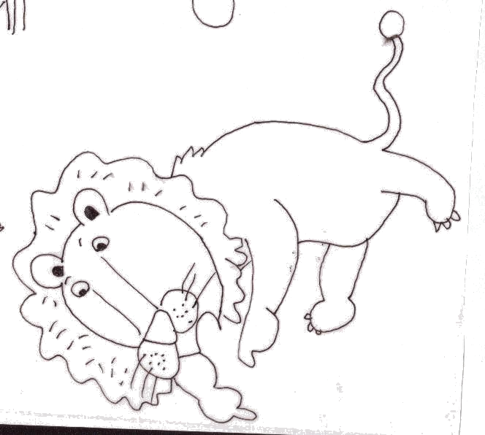  ㄕ |  | ㄕ
\s\up20(ㄕ)ㄕ\s\up20(ㄕ))\s\up20(ㄕ)\s\up20(\o(\s\up0(\d\ba12()˙)  \s\up16(ㄕ)ㄕ\s\up16(ㄕ))\s\up16(ㄕ)\s\up16(\o(\s\up0(\d\ba10()˙)\s\up16(ㄈㄚ)ㄈㄚ\s\up16(ㄈㄚ))\s\up16(ㄈㄚ)\s\up16(ㄧㄣ)ㄧㄣ\s\up16(ㄧㄣ))\s\up16(ㄧㄣ)\s\up16(\o(\s\up5(\d\fo0()ˊ)\s\up16(\o(\s\up5(\d\fo0()ˋ)\s\up16(\o(\s\up5(\d\fo6()ˋ)，  \s\up16(\o(\s\up5(\d\ba10()ˇ)\s\up16(ㄒㄧㄢ)ㄒㄧㄢ\s\up16(ㄒㄧㄢ))\s\up16(ㄒㄧㄢ)\s\up16(\o(\s\up0(\d\ba16()˙)\s\up16(ㄕㄨㄛ)ㄕㄨㄛ\s\up16(ㄕㄨㄛ))\s\up16(ㄕㄨㄛ)\s\up16(\o(\s\up5(\d\fo0()ˊ)\s\up16(\o(\s\up5(\d\ba10()ˇ)\s\up16(ㄒㄧㄢ)ㄒㄧㄢ\s\up16(ㄒㄧㄢ))\s\up16(ㄒㄧㄢ)\s\up16(\o(\s\up0(\d\ba16()˙)  \s\up16(ㄓㄤ)ㄓㄤ\s\up16(ㄓㄤ))\s\up16(ㄓㄤ)\s\up16(\o(\s\up5(\d\fo6()ˇ)\s\up16(\o(\s\up5(\d\fo6()ˇ)\s\up16(ㄕㄨㄛ)ㄕㄨㄛ\s\up16(ㄕㄨㄛ))\s\up16(ㄕㄨㄛ)\s\up16(\o(\s\up5(\d\fo0()ˊ)\s\up16(ㄗㄤ)ㄗㄤ\s\up16(ㄗㄤ))\s\up16(ㄗㄤ)\s\up16(\o(\s\up5(\d\fo6()ˇ)\s\up16(\o(\s\up5(\d\fo6()ˇ)  \s\up16(\o(\s\up5(\d\ba10()ˇ)\s\up16(\o(\s\up5(\d\fo0()ˊ)\s\up16(\o(\s\up5(\d\ba10()ˇ)\s\up16(ㄒㄧㄢ)ㄒㄧㄢ\s\up16(ㄒㄧㄢ))\s\up16(ㄒㄧㄢ)\s\up16(\o(\s\up0(\d\ba16()˙)\s\up16(ㄓㄤ)ㄓㄤ\s\up16(ㄓㄤ))\s\up16(ㄓㄤ)\s\up16(\o(\s\up5(\d\fo6()ˇ)\s\up16(\o(\s\up5(\d\fo6()ˇ)  \s\up16(ㄐㄩㄝ)ㄐㄩㄝ\s\up16(ㄐㄩㄝ))\s\up16(ㄐㄩㄝ)\s\up16(\o(\s\up5(\d\fo0()ˇ)\s\up16(\o(\s\up0(\d\ba16()˙)\s\up16(\o(\s\up5(\d\fo6()ˇ)。 | \s\up13(\o(\s\up4(\d\fo0()ˇ)\s\up13(\o(\s\up4(\d\fo5()ˋ)\s\up13(\o(\s\up4(\d\fo0()ˋ)\s\up13(\o(\s\up4(\d\ba8()ˊ)，\s\up13(\o(\s\up4(\d\fo0()ˇ)\s\up13(\o(\s\up4(\d\fo5()ˋ)\s\up13(\o(\s\up4(\d\fo5()ˋ)\s\up13(\o(\s\up4(\d\ba8()ˊ)\s\up13(\o(\s\up4(\d\fo5()ˋ)：

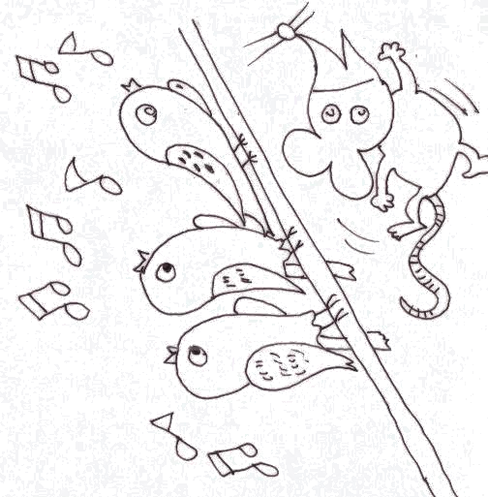  ㄗ |  | ㄗ
\s\up20(ㄗ)ㄗ\s\up20(ㄗ))\s\up20(ㄗ)\s\up20(ㄗ)ㄗ\s\up20(ㄗ))\s\up20(ㄗ)\s\up20(ㄗ)ㄗ\s\up20(ㄗ))\s\up20(ㄗ)  \s\up16(ㄗ)ㄗ\s\up16(ㄗ))\s\up16(ㄗ)\s\up16(ㄗ)ㄗ\s\up16(ㄗ))\s\up16(ㄗ)\s\up16(ㄗ)ㄗ\s\up16(ㄗ))\s\up16(ㄗ)，  \s\up16(\o(\s\up5(\d\fo0()ˋ)\s\up16(\o(\s\up5(\d\ba10()ˋ)\s\up16(\o(\s\up5(\d\fo0()ˊ)\s\up16(\o(\s\up0(\d\ba16()˙)\s\up16(ㄕㄥ)ㄕㄥ\s\up16(ㄕㄥ))\s\up16(ㄕㄥ)？  \s\up16(\o(\s\up5(\d\fo6()ˇ)\s\up16(\o(\s\up5(\d\fo6()ˇ)\s\up16(\o(\s\up0(\d\ba16()˙)\s\up16(\o(\s\up5(\d\fo0()ˋ)\s\up16(ㄍㄜ)ㄍㄜ\s\up16(ㄍㄜ))\s\up16(ㄍㄜ)\s\up16(ㄕㄥ)ㄕㄥ\s\up16(ㄕㄥ))\s\up16(ㄕㄥ)。  \s\up16(ㄗ)ㄗ\s\up16(ㄗ))\s\up16(ㄗ)\s\up16(ㄗ)ㄗ\s\up16(ㄗ))\s\up16(ㄗ)\s\up16(ㄗ)ㄗ\s\up16(ㄗ))\s\up16(ㄗ)，  \s\up16(\o(\s\up5(\d\fo0()ˋ)\s\up16(\o(\s\up5(\d\ba10()ˋ)\s\up16(\o(\s\up5(\d\fo0()ˊ)\s\up16(\o(\s\up0(\d\ba16()˙)\s\up16(\o(\s\up5(\d\fo6()ˋ)？  \s\up16(\o(\s\up5(\d\fo0()ˇ)\s\up16(\o(\s\up5(\d\fo0()ˇ)\s\up16(\o(\s\up5(\d\fo0()ˋ)\s\up16(\o(\s\up5(\d\fo0()ˋ)\s\up16(\o(\s\up5(\d\fo6()ˋ)。 | \s\up13(\o(\s\up4(\d\fo0()ˇ)\s\up13(\o(\s\up4(\d\fo5()ˋ)\s\up13(\o(\s\up4(\d\fo0()ˋ)\s\up13(\o(\s\up4(\d\ba8()ˊ)，\s\up13(\o(\s\up4(\d\fo0()ˇ)\s\up13(\o(\s\up4(\d\fo5()ˋ)\s\up13(\o(\s\up4(\d\fo5()ˋ)\s\up13(\o(\s\up4(\d\ba8()ˊ)\s\up13(\o(\s\up4(\d\fo5()ˋ)：

