新竹縣竹仁國民小學102學年度三年級上學期第一次月考評量卷 三年___班___號 姓名:_________

Part (1) What’s your name? 寫出英文名字，注意大小寫 (一題四分，共八分，錯一個字母算全錯。)
Hello! My name is ________________ . (也可以這樣說Hello! I’m __________. )
Part (2) Write the alphabets. 依順序填大寫字母(一題二分，共十分)
A( )CD( )FGH( )J( )L( )NOPQRSTUVWXYZ
Part (3) Write the alphabets. 依順序填小寫字母(一題二分，共十分)
abcdefghijklmno( )q( )s( )u( )w( )yz
Part (4) Number 填入數字的英文寫法(一題一分，共十分)
1. 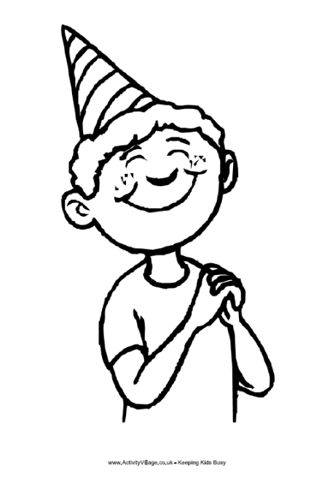 _______ boy  2. 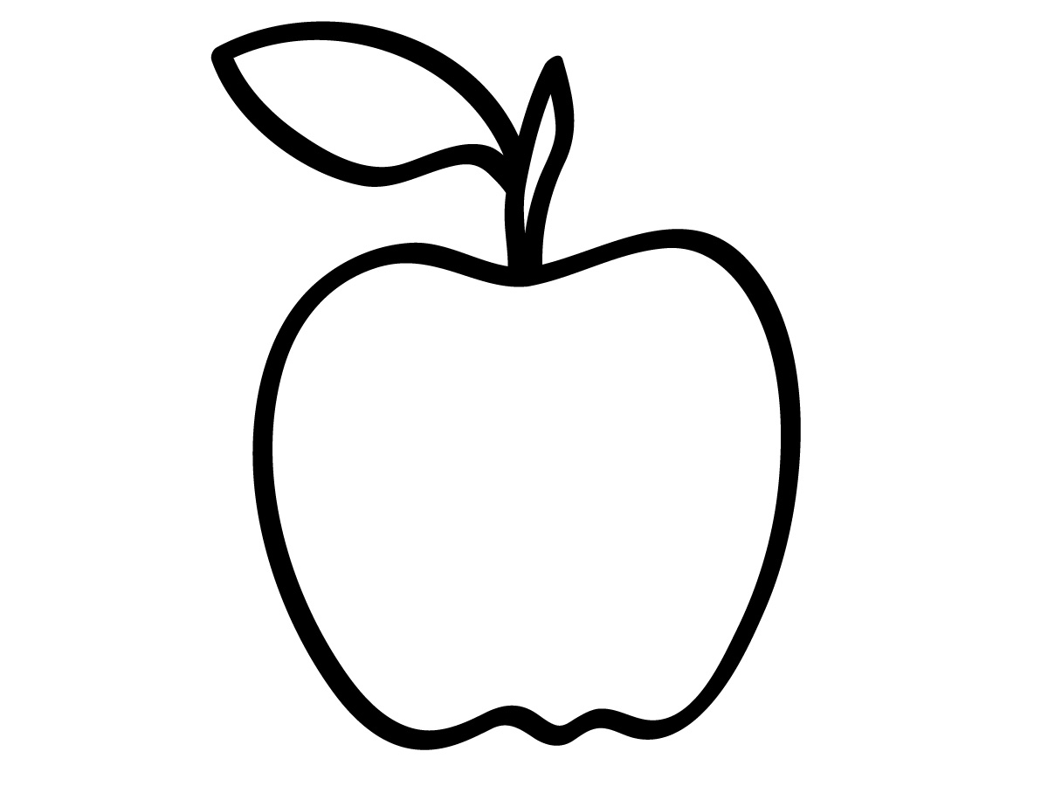 _______ apples  3.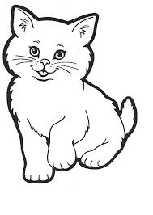 __________ cats  4.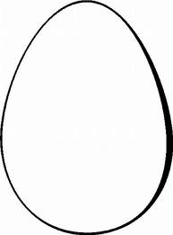____________ eggs  5.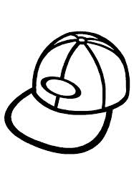 _________ caps | 6.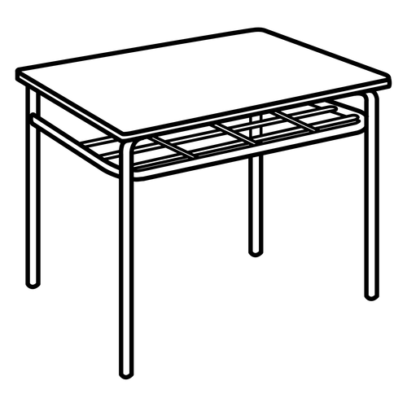 _________ desks  7.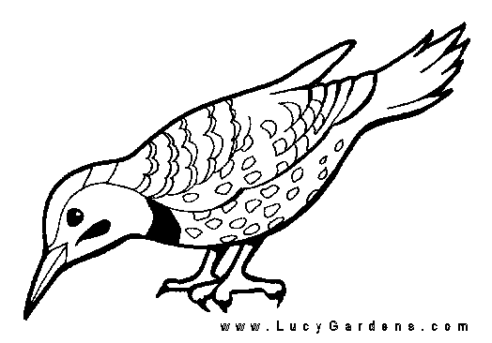 ________ birds  8.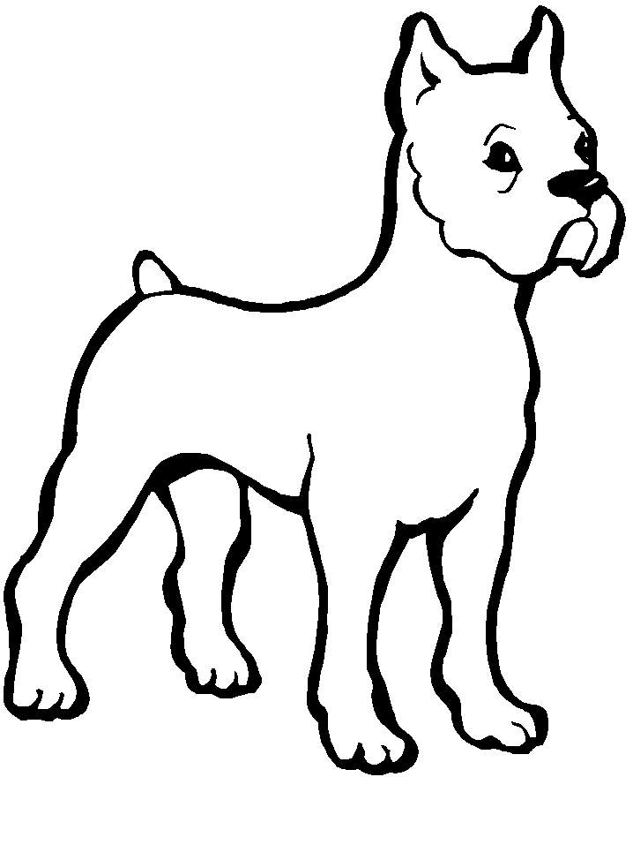 _________ dogs  9.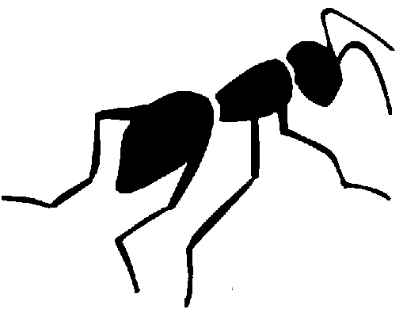  _____________ ants  10.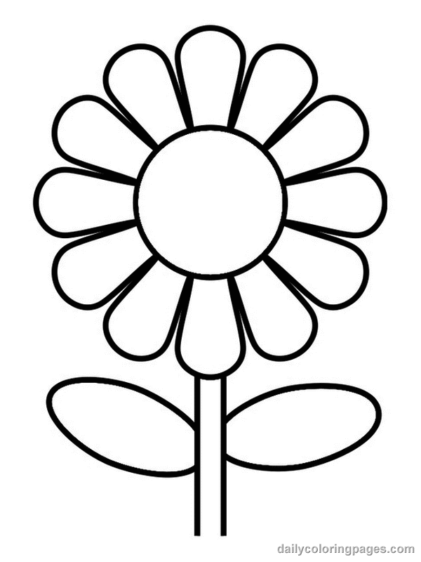  ____________ flowers


Part (5) Read, choose and write.看圖選對的字填_____上。 (一題二分，共八分)
1( )  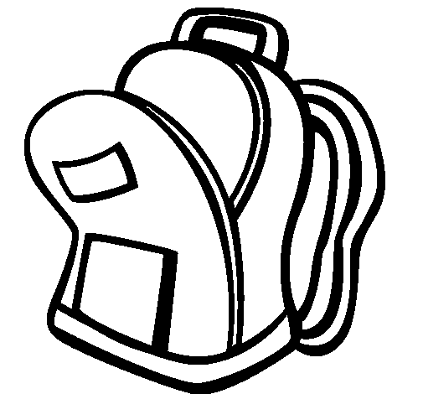  2( )  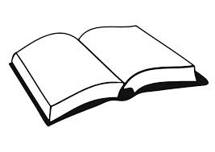  3( )    4( ) | What’s this? It’s a _________.  What’s this? It’s a _________________.  What’s this? It’s a __________.  What’s this? It’s a ____________.
  pen
  pencil
  book
  book bag
Part (6) Rewrite the words. 把大寫字母改小寫(一題二分，共八分，錯一個字母算全錯。)
1. DOG 3.STUDENT
2. OPEN 4.GIRL
Part (7) Rewrite the words. 把小寫字母改大寫(一題二分，共八分，錯一個字母算全錯。)
- cap 3.desk

2. rabbit 4.great
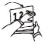
Part (8) Read and choose. 看圖選句子(一題三分，共十五分)
1( ) Open your book. Close your book. Sit down.
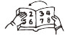
2( ) Open your book. Close your book. Sit down.
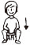
3( ) Stand up. Close your book. Sit down.
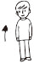
4( ) Sit down. Open your book. Stand up.
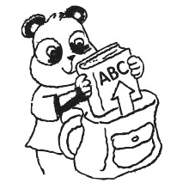
5( ) Good bye. Take out your book. Hi! I’m Chip.

Part (9) Read and choose. 看答句選問句 (一題三分，共十五分)
1( ) A: Hi! I’m Chip. ______? B: I’m Donny.
What’s your name? What’s this? It’s a pen.
2( ) A: _____. B: Hello! Kim. Hi! Bess. Good bye. What’s your name?
3( ) A: _____. B: See you later. Good bye. Take out your book. Stand up.
4( ) A: _____.B: Hello! It’s a pen. It’s a book. Hi!
5( ) A: _____. B: Good morning. One apple. Open your book. Good morning.
Part (10) Matching 配合題 (一題二分，共八分) 把適合的對話號碼填入( )
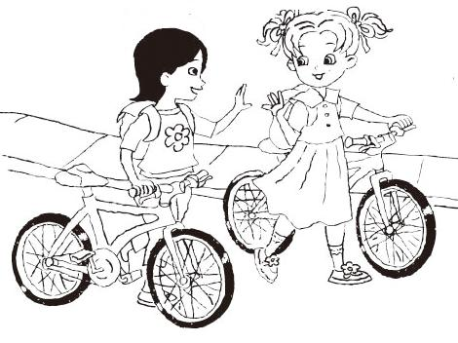( ) | 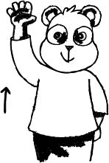  ( ) | 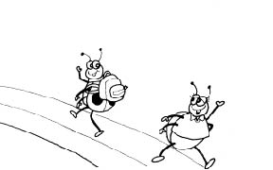( ) | 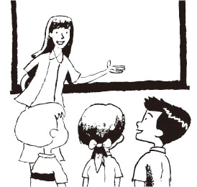 ( )
- A: Hi! I’m Bess. B: Hello! I’m Kim. 3. A: What’s this? B: It’s a book bag.
- A: Good bye! See you later. 4. A: Raise your hand.

