臺北縣 網溪 國民中小學99學年度 六 年級國際文化學習課程計畫 設計者：陳淑瑀
第 一 學期
  - 本領域每週學習節數（2）節，本學期共﹙42﹚節。
  - 本學期學習目標：
﹙一﹚樂於接觸課外英語教材(如：歌謠韻文、故事繪本、有聲媒體等)。
﹙二﹚能欣賞並尊重不同文化習俗，具有國際觀。
（三﹚學習尊重兩性之間的平等。(融入七大議題：兩性平等)
（四）能學習用英文表達自己的想法。
（五）能哼唱英文歌曲並瞭解其意思。
（六）能瞭解phonics rules:
（七）能運用繪本的故事，運用所學英文自行改編3分鐘短劇並上台表演。
  - 本學期課程內涵：
教學期程 | 領域或縣版能力指標 | 主題或單元活動內容 | 節數 | 使用教材 | 評量方式 | 備註
第一週 | PR1-1-12 能聽懂日常生活用語。  PR1-5-4 能聽懂簡易教室用語及日常生活應對中的常用語句（如：問候、致謝、道歉、道別等），並能做出適當的回應。 | 單元一 說明上課規則  Class rules:  - Hands up before you talk.  - Keep yourself to your seat.  - Have your books and pencils ready.  - Be nice.  活動一：  Greeting to each other and make sure everyone has their own English names.  Homework: do name card | 2 |  | 課堂問答
第二週  ∣  第四週 | PR1-1-14 能藉視覺輔助聽懂簡單兒童故事及短劇。  PR2-5 樂於接觸課外英語教材(如：歌謠韻文、故事繪本、有聲媒體等)。  3-2-4能朗讀短文、故事等。  PR2-3 能主動獨立或與他人合作完成老師交代的作業。  3-2-8能瞭解並欣賞簡易的詩歌及短劇。  PR1-2-13 能就現場情境作簡單的提問、回答、敘述及溝通。  PR1-4-6 能填寫簡單的表格及資料(如姓名、年齡等)。 | 單元一 story telling-  Handa’s surprise  介紹故事內容認識動物跟水果，  熟悉故事內容。  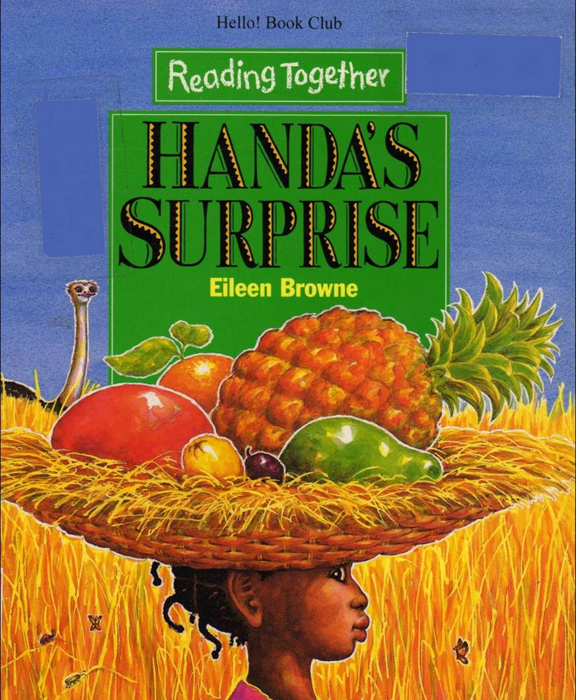  Ask some questions about the story.  1. How many fruits does Handa have in the end?  2. Is Handa’s friend suripsise?  Why?  Activity1: match game  Match the fruit and animal  Banana---monkey  Guava---ostrich  Orange—zebra  Maogo---elephant  Pimple--- giraffe  Avocado—goat  Passion fruit---bird  Tangerine  Activity2: Role play  Review the story  Role play (group practice)  Everyone choose a role, and ractice the story to know it.  Everyone can play the role of handa in turn.  （繪本有些字比較艱澀，教師可以斟酌）  Activity3: survey  Everyone ask 5 friends  A: Which fruit do you like?  B: I like .  Activity4: fruit salad  Everyone choose some fruits to make salad. | 2  2  1  1 | Picture book-Handa’s surprise | 課堂觀察  活動評量  口語評量  態度檢核
第五週  ∣  第七週 | PR1-1-11 能欣賞簡易韻文的音韻與節奏。  PR1-5-5 能運用多元智慧及不同媒材呈現學習成果(如：英語歌謠表演、卡片製作、簡易角色扮演等)。 | 單元一 songs-- Hokey Pokey  Activity1: sing a song  T can find its music from youtobe.  http://www.youtube.com/watch?v=3kDAsF_dhwM&feature=related  You put your left/ right hand in,  You put your left/ right hand out,  You put your left/ right hand in,  and you shake it all about.  You do the Hokey Pokey, then you turn around. (轉圈)  That's what it's all about.（兩手一攤）(arm, foot, head, you can create it )  Activity2:Group time  T guides Ss to sing the songs with actions.  Girls are in a circle  Boys are in a circle  They are hand in hand.  They practice the songs with action.  Activity3:show time  Two groups (girls and boys)  show their performance.  Activity4:game time--Simon says  If ‘’Simon says’’ touch your head, Ss touch their head.  If no ‘’Simon says’’, Ss don’t touch it.  In the beginning, teacher guide it. For a while, let Ss guide the game. | 2  2  1  1 |  | 課堂觀察  活動評量  口語評量  態度檢核
第八週  ∣  第十週 | PR1-3-8 能運用字母拼讀法讀出單字。  5-2-1能運用英語拼字與發音間的對應關係，看字發音，聽音拼字 | 單元一 Phonics-29  單元二 Phonics-30  Week10: midterm exam | 2  2  2 | Phonics-29 30 | 課堂觀察  活動評量  口語評量  態度檢核
第十一週  ∣  第十四週 |  | 單元一story telling-piggy book  （兩性平等）  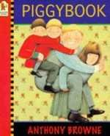  1.利用ppt介紹這本繪本,一邊介紹時,可以問學生圖片有何異樣？  2.發現報紙、圖片、壁紙、餐具等等都出現pig的圖案,有何含意？  3.為何書名是piggy book?  主角名字是？  4.圖中的光線有何變化？  為何作者這樣設計？  5.這故事告訴你什麼？  6.你還發現了什麼？  Activity2:大家來找碴  Where is the picture of pigs?  Write down on the black board.  Activity1: 超級比一比  Know the homework  1.wash the dishes  2.wash the clothes  3.iron(do the ironing)  4. made the beds  (老師可視其情況加入其他家事)  Activity3：role play  1.Group practice and know the story.  2.show time:  Every group perform their shows.  Activity4: survey  Ask 5 friends to ask them.  Q:What do you do everyday?  A:I wash the dishes everyday.  - Hope Ss realize everyone is equal. No matter you are male or female, you can do some homework. | 2  1  2  2  1 | Picture book-piggy book | 課堂觀察  活動評量  口語評量  態度檢核
第十五週  ∣  第十七週 | 2-1-9能吟唱歌謠及韻文 | 單元一Songs：Lemon Tree  Activity1: sing songs  http://www.youtube.com/watch?v=Va0vs1fhhNI  Everyone can sing the song, and know its meaning.  Lyrics: Lemon tree Fool's Garden  I'm sitting here in a boring room  It's just another rainy Sunday afternoon  I'm wasting my time, I got nothing to do  I'm hanging around, I'm waiting for you  But nothing ever happens -- and I wonder  I'm driving around in my car  I'm driving too fast , I'm driving too far  I'd like to change my point of view  I feel so lonely, I'm waiting for you  But nothing ever happens -- and I wonder  * I wonder how, I wonder why  Yesterday you told me 'bout the blue blue sky  And all that I can see is just a yellow lemon tree  I'm turning my head up and down  I'm turning, turning, turning, turing, turning around  And all that I can see is just another lemon tree  Da Da-la-da-la-de-la-da Da-la-la-la-de-la-da  Da-de-le-la  I'm sitting here, I miss the power  I'd like to go out, taking a shower  But there is a heavy cloud inside my head  I feel so tired, put myself into bed  where nothing ever happens -- and I wonder  Isolation is not good for me  Isolation, I don't want to sit on a lemon tree  I'm stepping around in a desert of joy  Baby, anyhow I'll get another toy  And everything will happen -- and you'll wonder (*)  Activity2: show time  Everyone can sing the songs, and group practice it with action.  Activity3: 傳球  Everyone sing the songs and pass the ball. When T says stop, the S must use hip to write word, and let Ss guess. | 2  2  2 |  | 課堂觀察  活動評量  口語評量  態度檢核
第十八週  ∣  第二十週 | PR1-3-8 能運用字母拼讀法讀出單字。  5-2-1能運用英語拼字與發音間的對應關係，看字發音，聽音拼字 | 單元一 Phonics-31  單元一 Phonics-32  Review phonics | 2  2  2 |  | 口語評量
第二十一週 |  | week20:期末考  review songs: Hokey Pokey and lemon tree  1/20休業式 | 2 |  | 課堂觀察
  - 補充說明:繪本有些字較艱深，老師可以中文輔助、或省略，重其有意義的學習。

臺北縣 網溪 國民中小學99學年度 六 年級 國際文化學習課程計畫 設計者：陳淑瑀
第 二 學期
      - 本領域每週學習節數（2）節，本學期共﹙36﹚節。
      - 本學期學習目標：
﹙一﹚樂於接觸課外英語教材(如：歌謠韻文、故事繪本、有聲媒體等)。
﹙二﹚能學習用英文表達自己的想法。
（三）能哼唱英文歌曲並瞭解其意思。
（四）能瞭解phonics rules:
（五）能運用繪本的故事，運用所學英文自行改編3分鐘短劇並上台表演。

三、本學期課程內涵：
教學期程 | 領域或縣版能力指標 | 主題或單元活動內容 | 節數 | 使用教材 | 評量方式 | 備註
第一週 | PR1-1-12 能聽懂日常生活用語。  PR1-5-4 能聽懂簡易教室用語及日常生活應對中的常用語句（如：問候、致謝、道歉、道別等），並能做出適當的回應。 | 單元一 review the class rules  Class rules:  - Hands up before you talk.  - Keep yourself to your seat.  - Have your books and pencils ready.  - Be nice.  活動一：  Greeting to each other and make sure everyone has their own English names.  Homework: do name card | 2 |  | 課堂問答
第二週  ∣  第五週 | PR1-5-5 能運用多元智慧及不同媒材呈現學習成果(如：英語歌謠表演、卡片製作、簡易角  色扮演等)。 | 單元一 story telling- There Was An Old Lady Who Swallowed A Fly  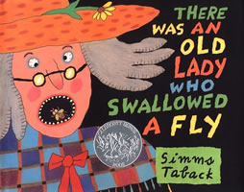  1.Look at the book cover. Why does the fly in the old lady’s mouth?  Activity1: words  fly spider bird cat dog cow horse  Some sentence repeats, and Ss can keep in mind.  Do some drills.  A: There was an old lady who swallowed a fly.  B: I don’t know why she swallowed the fly.  C: She swallowed the spider to catch the fly.  (the word underline can change)  將上述句型變成chants 一起念  Activity2: hammer game  Ask some questions about the story.  Hit the right picture and say it.  1. What does she swallow to catch the spider? Or  2. She swallowed the cat. What did it catch?  Activity2:超級比一比  Activity3: 小書製作 | 2  2  1  1  2 | There Was An Old Lady Who Swallowed A Fly | 課堂觀察  活動評量  口語評量  態度檢核
第六週  ∣  第八週 | 2-1-9能吟唱歌謠及韻文 | 單元一 songs-- You are my sunshine  Lyrics:  *You are my sunshine, my only sunshine  You make me happy when skies are gray  You'll never know dear, how much I miss you  Please don't take my sunshine away  I'll always love you and make you happy  If you will only say the same  But if you leave me to love another  You'll regret it all some day (*)  You told me once, dear, you really loved me  And no one else could come between  But now you've left me and love another  You have shattered all my dreams (*)  Activity1: sing a song  Activity2:Group time  Activity3:show time  Activity4:game time--Simon says | 2  2  2  1  1 |  | 課堂觀察  活動評量  口語評量  態度檢核
第九週  ∣  第十一週 |  | 單元一  Phonics-33  Phonics-34  Phonics-35  Week10: midterm exam | 2  2  2 | Phonics-33-35
第十二週  ∣  第十五週  11/07  ∣  11/27 | PR1-3-10 能藉由視覺輔助，獨立閱讀韻文或簡易故事。  PR1-2-14 能以簡易的英語說故事、看圖說話及演出短劇。  PR1-2-13 能就現場情境作簡單的提問、回答、敘述及溝通。  PR1-1-14 能藉視覺輔助聽懂簡單兒童故事及短劇 | 單元一story telling- Joseph Had A Little Overcoat  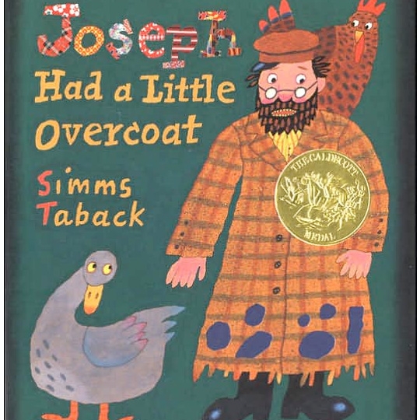  Activity1: learn the clothes  jacket overcoat vest scarf necktie  handkerchief button  Activity2: fashion show  請學生帶家中的衣服，分組比賽  必需回答身上所穿的衣服，並交換給同隊隊員，最先完成的為優勝。  Activity3：小書  製作三切頁小書練習衣服說法  Activity4：survey  Q: What do you like to wear?  A: I like to wear . | 2  2  3  1 | Picture book- Joseph Had A Little Overcoat | 課堂觀察  活動評量  口語評量  態度檢核
第十六週  ∣  第十八週 | PR1-1-11 能欣賞簡易韻文的音韻與節奏。 | Activity1：Sing song  Proud of you  Lyrics:  Love in your eyes  Sitting silent by my side  Going on Holding hand  Walking through the nights  Hold me up Hold me tight  Lift me up to touch the sky  Teaching me to love with heart  Helping me open my mind  I can fly  I'm proud that I can fly  To give the best of mine  Till the end of the time  Believe me I can fly  I'm proud that I can fly  To give the best of mine  The heaven in the sky  Stars in the sky  Wishing once upon a time  Give me love Make me smile  Till the end of life  Hold me up Hold me tight  Lift me up to touch the sky  Teaching me to love with heart  Helping me open my mind  I can fly  I'm proud that I can fly  To give the best of mine  Till the end of the time  Believe me I can fly  I'm proud that I can fly  To give the best of mine  The heaven in the sky  Can't you believe that you light up my way  No matter how that ease my path  I'll never lose my faith  See me fly  I'm proud to fly up high  Show you the best of mine  Till the end of the time  Believe me I can fly  I'm singing in the sky  Show you the best of mine  The heaven in the sky  Nothing can stop me  Spread my wings so wide  Activity2: card  對自己未來的期許，及我所感謝的師長。  Activity3:show time  Group practice and show. | 2  2  2 |  | 課堂觀察  活動評量  口語評量  態度檢核

