Class:_______ No.:________ Name:______________
Draw and Match
請你將這一家三口塗上顏色並將單字填上去。

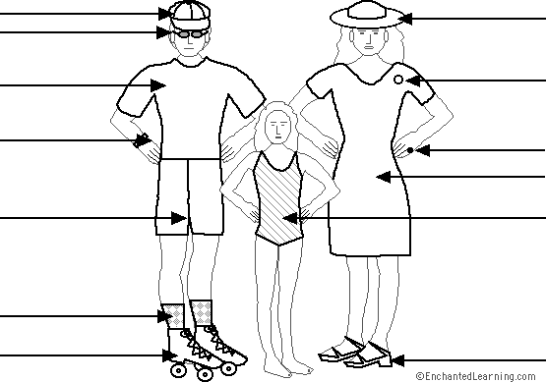

cap  dress  hat  pin  ring | roller skates  sandals  shorts  socks | sunglasses  swimsuit  T-shirt  watch

