100北北基高中職聯合入學測驗 英語科題本
班級： 座號： 姓名：

第一部分：下列各題(題號1-20)，請依據題意選出一個正確或最佳的答案。
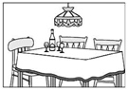
（D） 1. In the picture, the lamp is hanging _____ the table.
(A) up
(B) on
(C) from
(D) above
（A） 2. You’re really _____ to go swimming in the lake on a cold winter day. Don’t you feel cold?
(A) crazy (B) smart
(C) sweet (D) weak
（A） 3. Every night at 7:00, the garbage truck appears on the streets to _____ the garbage that people take out of their houses.
(A) collect (B) drop
(C) hide (D) save
（D） 4. There is no _____ near the theater, so let’s take the bus there.
(A) bright light (B) great food
(C) fresh air (D) parking space
（C） 5. I want to go camping in the mountains this afternoon, but a typhoon is coming. I’m not sure _____ the road to the mountains will be closed.
(A) how (B) what
(C) whether (D) why
（D） 6. All the dresses are pretty, but I think _____ black one is the best for the party tomorrow.
(A) any (B) each
(C) some (D) the
（C） 7. Joseph was painting the wall when the phone rang. He quickly ____ his brush and ran to answer it.
(A) gave up (B) handed in
(C) put down (D) took away
（B） 8. The boss called from the airport an hour _____, so I guess he will arrive at the office soon.
(A) after (B) ago
(C) before (D) later
（B） 9. I can’t find my history book, _____ I know it’s somewhere in the living room.
(A) because (B) but
(C) since (D) until
（A）10. The most convenient way to get around this small town is _____ a bike.
(A) to ride (B) to have ridden
(C) rides (D) rode
（D）11. The pie at your party _____ good. Where did you buy it?
(A) ate (B) bit
(C) made (D) tasted
（C）12. This kind of animal is ______ seen in everyday life because it lives 4,000m under the sea and is hard to find.
(A) commonly (B) possibly
(C) seldom (D) still

（D）13. ________ the dog that bites people yours? You should keep it home.
(A) Can (B) Does
(C) Has (D) Is
（B）14. Alice doesn’t take medicine when she has a cold. She believes the body is able to _____ the cold by itself.
(A) catch (B) fight
(C) hunt (D) pass
（D）15. I think _____ is more fun to go to the movies with my friends than with my family.
(A) that (B) there
(C) one (D) it
（C）16. Jason: Dear, dinner’s almost _____. Are you hungry?
Joyce: Yes! I can’t wait to eat!
(A) full (B) good
(C) ready (D) right
（A）17. Henry: Don’t you think fishing is _____? You just sit by the water and wait all day long.
Grace: No, I enjoy the quiet time of fishing.
(A) boring (B) cheap
(C) easy (D) lazy
（B）18. Mom: Oh, no! Your sister forgot her sports shoes. When ____ she have PE class? Can you take the shoes to her school?
Peter: It’s in the afternoon. Don’t worry. I’ll bring them to her.
(A) did (B) does
(C) has (D) is
（A）19. Jane: Ned hasn’t talked to me for two days because I laughed at his hair color. What should I do?
Lois: You should go and tell him that you’re sorry. He’s nice, and I’m sure he’ll give you another _____.
(A) chance (B) excuse
(C) headache (D) lesson
（D）20. Nana: Did you mail the cards to your teachers?
Annie: No, I want to check them again. I _____ them after dinner.
(A) mailed (B) mail
(C) have mailed (D) will mail
第二部分：下列十個題組，共有25題(題號21-45)，請依據選文或所表資料，選出一個正確或最佳的答案。
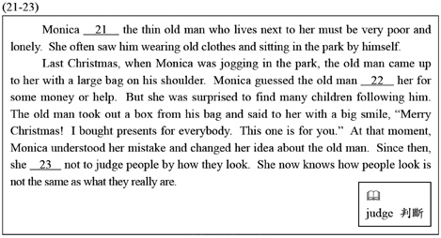

（A）21. (A) used to think (B) is thinking
(C) thinks (D) will think
（B）22. (A) asked (B) would ask
(C) is asking (D) has asked
（C）23. (A) tried (B) is trying
(C) has tried (D) will try
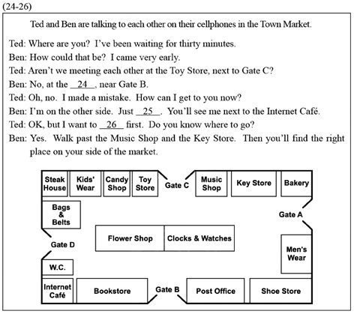
（A）24. (A) Bookstore (B) Shoe Store
(C) Post Office (D) Men’s Wear
（B）25. (A) find Gate A
(B) pass the Flower Shop
(C) go to the Steak House
(D) turn left to the Candy Shop
（C）26. (A) find a belt (B) look for a CD
(C) buy some bread (D) go to the restroom
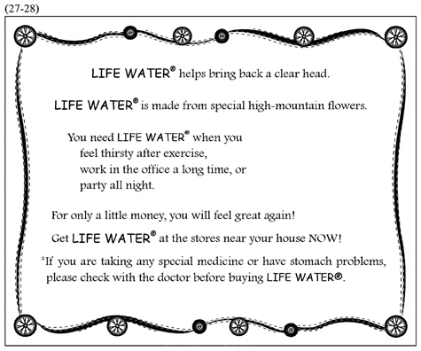
（B）27. What is LIFE WATER® for?
(A) Taking care of the sick in the hospital.
(B) Making people feel better and fresher.
(C) Helping children grow better and faster.
(D) Keeping people away from heart problems.
（A）28. Which is said about LIFE WATER®?
(A) It is not expensive.
(B) It is also good for the stomach.
(C) It cannot be sold without a doctor.
(D) It is made form spring water in the mountains.
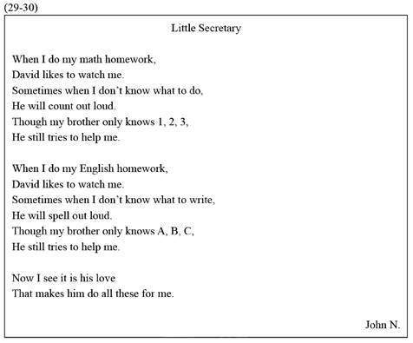
（D）29.What can we learn about the little secretary?
(A) He is a junior high school student.
(B) He does not like to be with his brother.
(C) He knows more about English than about
math.
(D) He cannot do his brother’s homework very
well.
（B）30. Which is said about the “I”?
(A) He is called David.
(B) He feels his brother’s love for him.
(C) He has taught his brother a lot of math and
English.
(D) He is smart enough to make his brother work
for him.
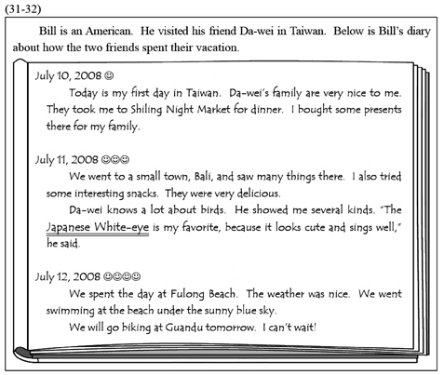
（A）31. What is the Japanese White-eye?
(A) A kind of bird. (B) A famous singer.
(C) A small town. (D) A kind of snack.
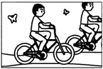
（D）32. Bill took a lot of pictures during his trip in Taiwan. Which one is the picture he took on July 12?
(A) (B)

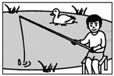
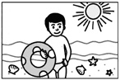
(C) (D)
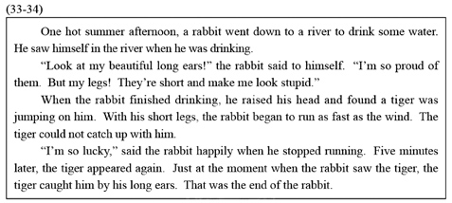
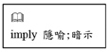
（C）33. Which idea is NOT implied in the reading?
(A) Beautiful things may bring
trouble.
(B) Even things we do not like can be useful.
(C) Ask others’ ideas before taking any action.
(D) People often fail to understand what may be
important.
（D）34. What do we know from the story?
(A) The tiger was proud of running fast.
(B) The rabbit was finally killed in his sleep.
(C) The tiger caught the rabbit’s tail in the end.
(D) The rabbit was able to run away the first time.
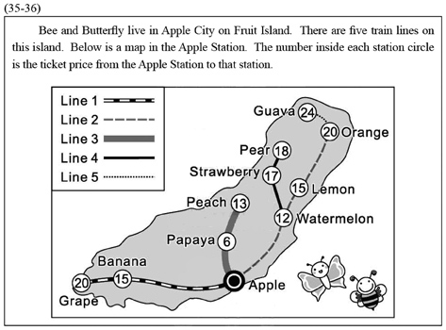
（C）35. Bee and Butterfly are now at the Apple Station. They are going to Strawberry for the Honey Festival. What is the total cost they have to pay for their train tickets?
(A) $17. (B) $29.
(C) $34. (D) $58.
（B）36. Bee and Butterfly will spend the night in Strawberry for the Honey Festival. The next day, they plan to visit a friend in Peach. How many train lines will they need to take that day?
(A) 2. (B) 3.
(C) 4. (D) 5.
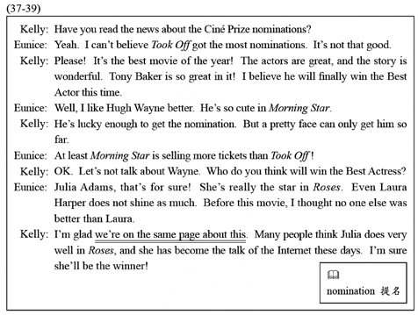
（C）37. What can we learn from the reading?
(A) Kelly likes the story of Morning Star.
(B) Kelly thinks Hugh Wayne will win the Best
Actor.
(C) Eunice has seen Laura Harper’s other movies
before Roses.
(D) Eunice is surprised that Morning Star is
selling more tickets than Took Off.
（B）38. Which is said in the reading?
- Morning Star is Hugh Wayne’s first movie.
- Julia Adams is noticed for her acting in Roses.
(C) Took Off has already won Tony Baker many
prizes.
(D) Laura Harper has won the Best Actress more
than once.
（A）39. What does we’re on the same page about this mean in the reading?
(A) Kelly and Eunice both agree who will win the
Best Actress.
(B) Kelly and Eunice are both reading news about
Roses on the Internet.
(C) Kelly and Eunice are both excited about the
Ciné Prize nominations.
(D) Kelly and Eunice both read the book Roses
before it was made into a movie.
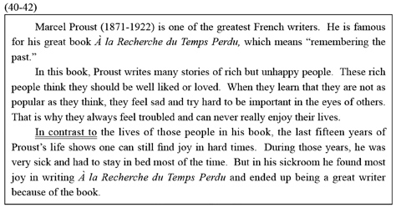
（B）40. What can we learn about Proust from this reading?
(A) He became poor and sick because of writing.
(B) He got a lot of pleasure from writing in his
later life.
(C) He often wrote about how people get stronger
in hard times.
(D) He started writing À la Recherche du Temps
Perdu when he was fifteen.
（B）41. Which is said about the rich people in Proust’s book?
(A) They try to forget their past.
(B) They try to get what they do not have.
(C) They are sick and stay in bed most of the time.
(D) They are rich enough to have their stories
written.
（D）42. What does In contrast to mean?
(A) Ahead of. (B) Worse than.
(C) Important to. (D) Different from.
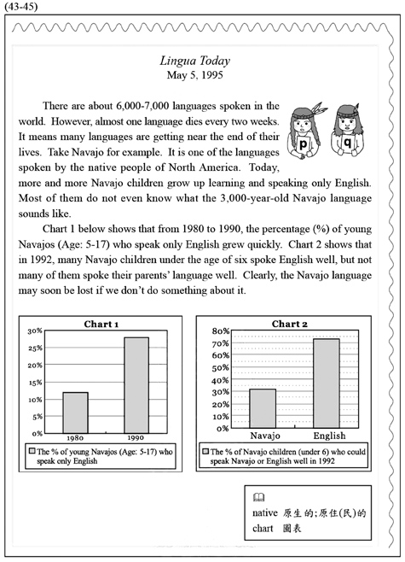
（C）43. What is the reading mostly about?
(A) Plans to save the Navajo language.
(B) Why more and more Navajos learn English.
(C) Facts that show the Navajo language is dying.
(D) What makes the Navajo language different
from English.
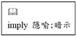
（D）44. Which is NOT said or implied in the reading?
(A) Many languages die every
year.
(B) The Navajo language is still spoken in North
America.
(C) The Navajo language have been spoken for
3,000 years.
(D) About 6,000-7,000 languages around the
world are now dead.
（C）45. From the charts, which is true?
(A) In 1980, less than 10% of young Navajo could
speak only English.
(B) In 1990, less than 30% of young Navajo could
speak their native language.
(C) In 1992, more than 70% of Navajo children
under six could speak English well.
(D) In 1992, more than 30% of Navajo children
under six could speak both Navajo and English well.
試題結束

