97學年度國中第二次基本學力測驗 英語領域
解析：葉木微老師

第一部分：下列各題（題號l～17），請依據題意選出一個正確或最佳的答案。
1. Look at the picture. The is the most expensive of all.
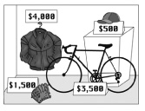
(A) baseball glove (B) bicycle
(C) cap (D) jacket

答案： (D)
解析：1. 能看圖作答。
2. 由圖中可得知，夾克是全部中最貴的。

2. Life in the mountains quieter than life in big cities.
(A) are (B) is (C) to be (D) being

答案： (B)
解析：1. 要能辨別主詞。
2. 其主詞為在山裡生活，life生活-是單數主詞，故選擇三單動詞(B) is。

3. Jim is good at singing and doing magic, so he is very at his friends' parties.
(A) careful (B) honest (C) popular (D) surprised

答案： (C)
解析： 關鍵片語be good at singing（擅長唱歌）和doing magic（變魔術），所以可得知Jim是受歡迎的（popular）。

4. When we stayed at the country house, we had only enough water for drinking. That's why we did not take a for two days.
(A) bath (B) rest (C) vacation (D) walk

答案： (A)
解析：1. 能清楚翻譯本題意思。
2. 關鍵句子we had only enough water for drinking（只有喝的水），所以無法洗澡
（we did not take a bath…）。

5. Everyone mistakes in his or her life. The important thing is not to repeat them.
(A) does (B) forgets (C) makes (D) takes

答案： (C)
解析： 能知道犯錯的片語（make mistakes）。

6. Lisa is new here, so she doesn't know the restroom is.
(A) that (B) where (C) whether (D) which

答案： (B)
解析：1. 能了解名詞子句-間接問句。
2. 直接問句：Where is the restroom?
間接問句：當she doesn't know的受詞（where the restroom is）。
7. I can you the book, but you have to give it back to me in three days.
(A) borrow (B) lend (C) read (D) show

答案： (B)
解析：1. 要能判斷borrow（借入）lend（借出）。
2. 關鍵you have to give it back to me（你必須把它還給我），故答案選(B) lend。

8. Although William is a in this country, he knows many people here and speaks our language very well.
(A) foreigner (B) leader (C) mailman (D) teenager

答案： (A)
解析：1. 能清楚翻譯本題意思。
2. 由連接詞（although-雖然）貫穿整題，雖然William是個外國人，他認識這裡的許多人而且也把我們的語言說的很好。

9. Albert usually brings a with him when he takes a trip, so that he can write down what he sees on the road.
(A) camera (B) dictionary (C) notebook (D) watch

答案： (C)
解析： 本題主要關鍵為he can write down-寫下，故答案選(C) notebook。

10. Jean is crazy about the color purple. The walls of her house are all purple.
(A) built (B) dug (C) painted (D) shown

答案： (C)
解析：1. 能了解被動式（be + Vpp）。
2. 因為Jean熱愛紫色，故將牆壁（walls）漆成紫色。

11. I walked to school every day my dad bought me a bike last month. It's really fun and convenient to go to school by bike.
(A) after (B) because (C) if (D) until

答案： (D)
解析：1. 會使用連接詞，將前後句連接。
2. 原來是每天走路，直到（until）…，才能用腳踏車（by bike）。

12. Ms. Wang thought she lost her ring last night. But this morning she found that it was on the table and was by a book.
(A) covered (B) moved (C) packed (D) stopped

答案： (A)
解析：1. 能了解被動式（be + Vpp）。
2. it-指戒指，被書本（by a book）覆蓋，故答案選(A) covered。

13. Deborah put some sugar and cream in her coffee to make it better.
(A) taste (B) tasted (C) tasting (D) to taste

答案： (A)
解析： 本題要能了解，使役動詞（make）後＋原形動詞（VR），故答案選(A) taste。

14. Betty TV when her little brother fell of the chair.
(A) watched (B) was watching (C) has watched (D) is going to watch

答案： (B)
解析：1. 能了解副詞子句，時態要一致
2. 當Betty的弟弟從椅子掉下來（fell off），而她『正』在看電視，故答案選過去進行式(B)。

15. Allen: you have twenty minutes right now? I need to talk to you.
Bruce: Sure! Come on in.
(A) Are (B) Do (C) Have (D) Should

答案： (B)
解析： 表詢問，你有…嗎？Do you have…? 故答案選助動詞(B) Do。

16. Kay: What do you do in your free time?
Amy: I go swimming a lot. Almost every day.
Kay: Wow! That's a good . It keeps you healthy.
(A) business (B) chance (C) dream (D) habit

答案： (D)
解析： 字彙理解。幾乎每天去游泳，所以是個好「習慣」。又可以keep healthy，故答案選(D) habit。

17. Daisy: I went to Taitung to visit my uncle there.
Grace: Really? were you there?
Daisy: For two weeks.
(A) How long (B) How often (C) How soon (D) What time

答案： (A)
解析： Daisy回答For two weeks.（已經兩個星期），故答案選(A)多久How long…；(B)多久一次How often-指頻率；(C)多快How soon-指時間還要多久；(D)幾點What time-指時刻。

第二部分：下列十一個題組，共有28題（題號18～45），請依據選文或所附圖表資料，選出一個正確或最佳的答案。
(18~20)
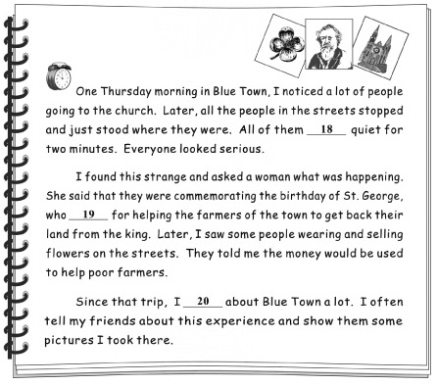


commemorate 紀念

18. (A) are (B) have been
(C) were (D) would be

答案： (C)
解析： 由第一段文意得知作者在描述過去所發生的事情，故答案選(C) were。

19. (A) has been killed (B) was killed
(C) would be killed (D) is going to be killed

答案： (B)
解析： 由第二段文意得知，St. George被殺，且整段文意仍是過去事實，故選(B) was killed。

20. (A) thought (B) was thinking
(C) have thought (D) will think

答案： (C)
解析： Since that trip,…將文意拉回現在時間，since+過去時間，主要子句要搭用現在完成式，故答案選(C) have thought。
(21~23)
(The phone rings.)
Mr. Chen: Chen's Supermarket. May I help you?
Ms. Fang: Yes. I bought a package of tomatoes at your supermarket, and all the tomatoes are bad.
Mr. Chen: Oh, I'm very sorry about that. You can bring them back and we'll 21 .
Ms. Fang: No, I'm very busy and I don't want to drive half an hour just to get a package of tomatoes.
Mr. Chen: Well….
Ms. Fang: And, this is not 22 . Last month it was a bag of apples. Every apple inside was bad. And now it has happened again! I'm really angry.
Mr. Chen: Did you bring them back?
Ms. Fang: No, of course not.
Mr. Chen: Well, if you don't bring them back, we cannot give you better ones.
Ms. Fang: Fine! I just called to let you know what happened and 23 . You should sell only fresh food if you want people to keep shopping at your market.
21. (A) drive you home
(B) cook them for you
(C) remember your name
(D) give you another package

答案： (D)
解析： 由兩人對話中，第2-6行得知，所有的番茄是壞的，且Ms. Fang非常忙，不想開一個半小時的車只為了去拿一箱番茄。故答案選(D) give you another package。

22. (A) the first time
(B) the fastest car
(C) the only change
(D) the lowest price

答案： (A)
解析： 由後一句得知，上個月是一袋壞掉的蘋果，故答案選(A)這已經不是第一次了。

23. (A) who I am
(B) how I feel
(C) where I live
(D) why I am lost

答案： (B)
解析： 由兩人最後一次的對話中得知，Ms. Fang說：我只是打電話讓你知道怎麼一回事以及我的感覺。
(24~25)
Look at the timetables of the four theaters and answer the questions.
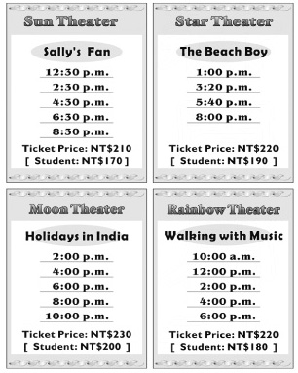

timetable 時刻表

24. Alice and John want to watch a movie in the morning. Which theater can they go to?
(A) Sun Theater.
(B) Star Theater.
(C) Moon Theater.
(D) Rainbow Theater.

答案： (D)
解析： 早上想看電影，四家電影院只有Rainbow Theater有早場電影a.m. 故答案選(D)。

25. Tina and Paul are high school students. They went to see one of the four movies, and it cost them NT$340. Which movie did they see?
(A) Sally's Fan.
(B) The Beach Boy.
(C) Holidays in India.
(D) Walking with Music.

答案： (A)
解析： Tina 和Paul，兩張學生票花340元，所以每張學生票為170元，故答案選(A)。

(26~27)
Read Charlie's diary and answer the questions.

 diary 日記

26. What did Charlie do on the bus?
(A) He fell and got hurt.
(B) He called his teacher.
(C) He talked to the driver.
(D) He gave his seat to an old man.

答案： (D)
解析： 由本文第一段第七行得知他讓位給一位老人家，故答案選(D)。

27. Who is He in the last paragraph?
(A) Mr. Du.
(B) The old man.
(C) Charlie's father.
(D) Charlie's classmate.

paragraph 段落
答案： (A)
解析： 末段因避免Mr. Du重複出現，而使用He取代。Mr. Du接到一個老人來電得知Charlie在公車上讓位這件事，故答案選(A)。

(28~29)
Look at the bus route map and answer the questions.
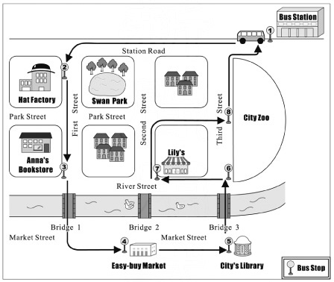
 route路線

28. Which is true about the bus route?
(A) The bus does not pass Park Street.
(B) There is no stop near Anna's Bookstore.
(C) The bus crosses three bridges in the city.
(D) You can get off at Stop to visit the Hat Factory.

答案： (D)
解析：(A) 由圖得知，公車有經過Park Street。
(B) 由圖得知，Anna's Bookstore可在站牌下車，故有經過Anna's Bookstore。
(C) 由圖得知，公車僅經過橋樑及兩座，並非三座。
(D) 由圖得知，站有Hat Factory與Swan Park，故答案選(D)。

29. Wilson just finished shopping at Easy-buy Market, and he is going to have lunch at Lily's restaurant. If he takes the bus, which place will he pass by?
(A) Stop .
(B) Bridge 1.
(C) River Street.
(D) Bus Station.

答案： (C)
解析： Pass by在問過哪些地方，從號站牌Easy-buy Market到號站牌Lily's中間經過站牌、站牌□、Market Street、Bridge與River Street，故答案選(C)。
(30~31)

Dear Luke,
My daughter Angela is very quiet. She seldom talks to us, and she does not have any friends. What's worse, she is not interested in studying. All she does every day is watch TV and play computer games. I have told her hundreds of times that she should study hard, but she does not listen to me. What should I do?
Tim
Dear Tim,
The problem with Angela is not that she does not study, but that she does not talk to people. If she can make some friends, her life will be more interesting.
Perhaps Angela has had this problem for a long time. It won't be solved soon. You should spend more time with her and help her. This is the "homework" both you and your daughter need to do!
Luke
 solve 解決

30. According to Luke, which will help solve Angela's problem?
(A) Doing mom exercise. (B) Meeting more people.
(C) Studying harder. (D) Watching less TV.

答案： (B)
解析： 在Luke的回覆中第一段第二行提到，要解決這個問題，就要make some friends（多交朋友），故答案選(B)。

31. What does "homework" mean in Luke's letter?

according to 根據
(A) Work that needs to be done in the family.
(B) Something that makes reading interesting.
(C) Something that children always forget to do.
(D) Work that teachers ask students to do at home.

答案： (A)
解析： "homework"為家庭功課，在Luke回覆的最後一行中提到是你和你的女兒需要去做的，故答案選(A)。
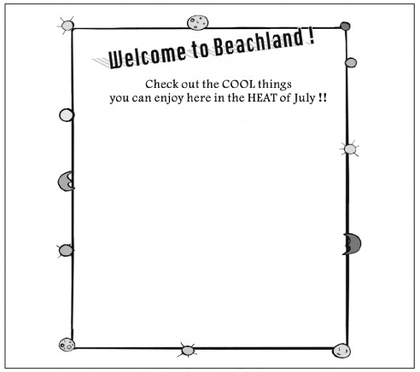
(32~33)
Week 1
Welcome party in the Boating Club
Opening of the Water Park

Week 2
Music show in front of the Sea Animal World
Street dance lessons on Marine Street

Week 3
Fresh foods at Fishermen's Market
Bike riding along the beach

Week 4
Cold drinks in the Beach Garden
Toy-making programs in the Art House

32. What is the poster about?
(A) An art show. (B) A fishing trip.
(C) A dancing party. (D) A summer festival.

poster 海報
答案： (D)
解析： 海報在介紹炎熱七月各星期的節目表，其中節目包羅萬象，宛若暑期的嘉年華會，故答案選(D)。

33. The Browns took a one-day trip to Beachland in July. When they were there, the kids enjoyed making kites with paper and chopsticks. When did they take the trip?
(A) Week 1. (B) Week 2. (C) Week 3. (D) Week 4.

答案： (D)
解析： 因為小孩喜歡用紙和筷子做風箏Making kites，故在Week 4有Toy-making programs（自製玩具節目），故答案選(D)。

(34~35)

mention 提及


leaves (單數為leaf )葉子

Why does the sun come up every morning?
Why does the moon become full every month?
When the flowers drop, the leaves grow.
When the old die, the new are born.

Life is a circle. Love is, too.
Our parents love us. We love our children.
When you think you cannot fall in love again,
The next love is right behind you.

Life is love, so live for love.
Love cannot be stopped.
It is as strong as life.
And that's all people live for.

By Linda H.

34. What does the writer try to tell us in the reading?
(A) Life is short.
(B) Love is crazy.
(C) To live is to love.
(D) The earth is beautiful.

答案： (C)
解析： 作者在第二段及第三段中，不斷的提起Life and Love，且最後一句And that's（love's）all people live for，故答案選(C)。

35. Which is NOT mentioned in the reading to say Life is a circle?
(A) The sun.
(B) The moon.
(C) The flowers.
(D) The seasons.

答案： (D)
解析： 文中第一行提到sun、第二行提到moon、第三行提到flower，唯一沒提到的是seasons，故答案選(D)。

(36~38)
Greg: Mom, who's that little boy over there? Why is he nodding his head like that on the road? He looks so strange.
Mom: Greg! It's not polite to talk about people like that. He's just sick.
Greg: Oh, I'm sorry. I won't do it again. But who is he? I've never seen him before.
Mom: Warren just moved into the apartment next to our house. Mrs. Hooper brought him home last month. She wants to take care of children who need special help. Warren is one of them.
Greg: Can I help, too?
Mom: Of course. But the first thing you should know is, though people look different, we are all the same. We all need love and care in difficult times.
Greg: I see, Mom. Let's find some time to visit Mrs. Hooper and Warren.
Mom: OK, we'll do that.
36. Which is true?
(A) Warren is living next to Greg.
(B) Warren is Mrs. Hooper's only child.
(C) Greg does not want to talk to Warren.
(D) Greg's mom helps take care of poor children.

答案： (A)
解析： 第五行提到Warren剛搬進Greg家的隔壁公寓，故答案選(A)。

37. What does it mean?
(A) Getting sick. (B) Not seeing the boy.
(C) Nodding the head on the road. (D) Not being polite in talking about others.

答案： (D)
解析： 在媽媽第一次說話時提到，It's not polite to talk about people like that. 與答案(D)吻合。

38. What does Greg's mother mean by saying we are all the same?
(A) People share the same space of the earth.
(B) People need to be loved and taken care of.
(C) People look the same when they are happy.
(D) People feel sorry for themselves in difficult times.

答案： (B)
解析： we are all the same，下一句即提到We all need love and care in…，故答案選(B)。

(39~42)
Many people know Robert Schumann was an important musician, but they do not know that his wife, Clara Wieck Schumann, was in fact more famous than he in their time.
Clara was born in 1819. In her time, most women did not appear before the public. Clara, however, started to play the piano in public at the age of nine and was very successful.
In 1840, Clara got married. She became very busy with the housework and her children. It was hard for her to find time to practice the piano. But Clara could never forget her love for music; she felt she had to share it with other people. In l842, Clara began to play in public again.
When Robert died in 1856, Clara had to make money for their seven children by herself. She taught music and played the piano around Europe. During this is hard time, music always gave her comfort and joy. Clara died at 77. Now she is still thought to be one of the best musicians in history.
 musician 音樂家 housework 家事 comfort 安慰

39. What is the reading mainly about?
(A) A musician's life. (B) A musician's husband.
(C) A musician's family history. (D) A musician and modem music.

mainly 主要
答案： (A)
解析： 本篇文章敘述Clara從出生1819到死亡77歲，故答案選(A)。

40. Which is true about Clara Wieck Schumann?
(A) She became mom famous after she died.
(B) She began to play the piano at an early age.
(C) She never played in public after she got married.
(D) She didn't have to worry about money after her husband died.

答案： (B)
解析：(A) 第二段末便提到他九歲就開始表演並successful（成功）。
(B) 第二段末便提到他九歲就開始表演，故答案選(B)。
(C) 第二段末便提到他九歲就開始表演，而他結婚已經是1940，21歲了。
(D) 末段第一行中提到make money表示他先生過世後他仍舊得賺錢養活七個小孩。

41. How old was Clara Wieck Schumann when her husband died?
(A) 21. (B) 37. (C) 40. (D) 46.

答案： (B)
解析： when her husband died當他先生死亡時，所以問Clara守寡時的年齡，第二段提到他出生於1919年，第四段提到他先生死於1956年，1956－1919＝37歲，故答案選(B)。

42. What does it mean in the third paragraph?
(A) Money. (B) The housework.
(C) The love for music. (D) Time to practice the piano.

paragraph 段落
答案： (C)
解析： 第三段第三行的it，往前看一句便提到never forget her love for music，故答案選(C)
(43~45)
The grizzly is the star of our little town in the mountains. Many people visit here for this kind of strong large brown bear. When a grizzly grows up, it may become as heavy as 680 kg. But never think this gigantic animal moves slowly. In fact, the grizzly can run as fast as 55 km an hour.
Though grizzlies look quite big and dangerous, they eat not only meat, but also flowers and grasses. Fish is their favorite food. On summer nights, they enjoy catching fish in the rivers. That is why people usually come watching grizzlies in this season.
Now the number of grizzlies is getting smaller because they have been killed by people who sell grizzly body parts as medicine. Many people of our town are worried about this and have asked for help to save our big friends.
43. Which is true about grizzlies?
(A) They have brown hair.
(B) They are slow in moving.
(C) They eat only meat and fish.
(D) They sleep most of the time in summer.

答案： (A)
解析： 第一段第二行前面的large brown bear，故答案選(A)。

44. What does gigantic mean?
(A) Fast and light.
(B) Quiet and shy.
(C) Big and strong.
(D) Round and cute.

答案： (C)
解析： Never think是「不要以為」，move slowly是「緩慢移動的」，全文是「不要以為gigantic移動的速度是慢的」，表示他的體型跟速度是相反的，故答案選(C)。

45. What does this mean?
(A) The fish in the rivers are getting fewer.
(B) People in the town are free to sell medicine.
(C) Many grizzlies are killed for their body parts.
(D) Grizzlies have started to leave the town for other places.

答案： (C)
解析： 往末句的前一句便可看到they have been killed by people who…，故答案選(C)。

