98第一次國民中學基本學力測驗 英語科題本
班級： 座號： 姓名：

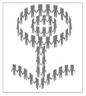
第一部分：下列各題（題號1～20），請依據題意選出一個正確或最佳的答案。
（B） 1. Look at the picture. How many circles are there in the picture?
(A)One.
(B)Two.
(C)Three.
(D)Four.
（D） 2. My brother enjoys having cold drinks, so he always puts his Coke in the before he drinks it.
(A)basket (B)bottle
(C)package (D)refrigerator
（B） 3. Sorry, but I didn’t hear the question you asked. Could you please it ?
(A)answer (B)repeat
(C)say (D)understand
（C） 4. Jim grew up with many animals at home and knows well how to pets.
(A)belong to (B)get away from
(C)take care of (D)wake up
（A） 5. Connie took off her . She wanted to feel the grass with her feet.
(A)shoes and socks (B)shirt and pants
(C)cap and gloves (D)sweater and jacket
（A） 6. The driving test is not very difficult, and most people are to pass it.
(A)able (B)afraid
(C)correct (D)serious
（D） 7. You can’t Tasty Bakery’s meat pie! It’s so delicious that even some restaurants in town order it.
(A)cook (B)cut
(C)hit (D)miss
（D） 8. I write down everything about work in my pink notebook; it, I’d forget the things I should do.
(A)before (B)except
(C)outside (D)without
（A） 9. Playing in the water lots of fun on a hot summer day.
(A)is (B)are (C)has (D)have
（D）10. Dad always tells me not only for tests. If that’s all I’m doing, he says, I will soon lose interest in learning.
(A)study (B)studying
(C)studied (D)to study
（A）11. I can’t believe you ate the piece of pizza and didn’t even leave one bite for me.
(A)last (B)least (C)less (D)most
（C）12. At dinner time, I often enjoy telling Mom everything at school.
(A)happened (B)was happening
(C)that happened (D)which happening
（D）13. Candy has decided to move to Taipei next year. When she studies in an art school there, she with her aunt for five months.
(A)lives (B)has lived
(C)lived (D)will live
（A）14. Linda: Do you have to get up early in the morning?
Peter: Yes, I . I can’t be late for school.
(A)do (B)can
(C)have (D)am
（B）15. Bob: When is Mr. Wang going to Japan?
Tim: On .
(A)June (B)June fourth
(C)the year 2010 (D)June, 2010
（D）16. Harry: Tomorrow is Mom’s birthday. Let’s buy
some flowers for her.
Cindy: Good idea. I know she likes
best.
(A)chocolates (B)dresses
(C)rings (D)roses
（D）17. Sue: Your hat looks so comfortable!
Ann: It’s more than comfortable. If you wear a
hat like , you won’t feel cold on a
windy day.
(A)I (B)myself
(C)one (D)this
（B）18. Ken: is a boat ticket for children?
Paul: How old is your child? It’s free for kids
under three years old.
(A)How long (B)How much
(C)How often (D)How soon
（B）19. Amy: You look worried. What’s the matter?
Ted: I can’t find my bicycle; I forget where I
it.
(A)followed (B)parked
(C)showed (D)stopped
（C）20. Mike: I heard there are many monkeys in this
mountain. But I didn’t see any of them last time when I was here.
Carl: Hope we can see today.
(A)another (B)others
(C)some (D)themselves
第二部分：下列十個題組，共有25題（題號21～45），請依據選文或所附圖表資料，選出一個正確或最佳的答案。
(21~23)
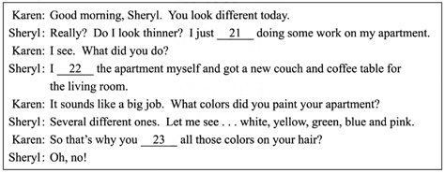

（C）21. (A)finish (B)will finish
(C)finished (D)would finish
（B）22. (A)paint (B)painted
(C)was painting (D)would paint
（A）23. (A)have (B)will have
(C)had (D)would have
(24~26)
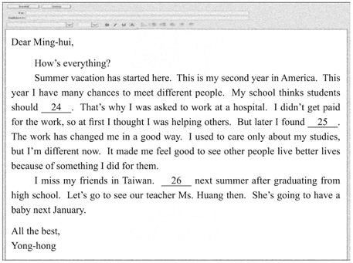
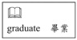

（C）24. (A) try to learn a foreign language
(B) make some friends when we are on vacation
(C) not only study hard but also try to help others
(D) not worry too much about things we can not
change
（B）25. (A)it was a boring job
(B)I was in fact helping myself
(C)I could also get better grades
(D)it was not easy to make money
（A）26. (A)I’m going back home
(B)You’ll know what to do
(C)They should change their jobs
(D)We should always remember to study hard
(27~28)
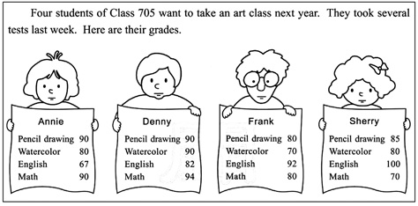

（C）27. Those who want to go to the art class must get 70 or above in English and math, and get 80 or above in pencil drawing and watercolor. How many students can go to the art class?
(A)0. (B)1.
(C)2. (D)3.
（A）28. Here is what the teacher wrote to one of the students.
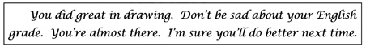
Who is that student?
(A)Annie. (B)Denny.
(C)Frank. (D)Sherry.
(29~30)
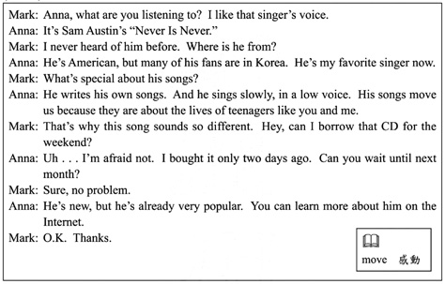

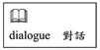
（A）29. What can we learn from the dialogue?
(A) Sam Austin can both sing
and write songs.
(B) Mark has collected many of Sam Austin’s
CDs.
(C) Anna will lend Mark the CD this coming
week.
(D) Teenagers like to listen to music on the
Internet.
（C）30. Which is NOT true about Sam Austin’s songs?
(A)They are sung slowly.
(B)They are popular in Korea.
(C)They are famous old songs.
(D)They are written about teenagers.
(31~33)
There are four food shops on Amanda’s way to school. Here are their ads.
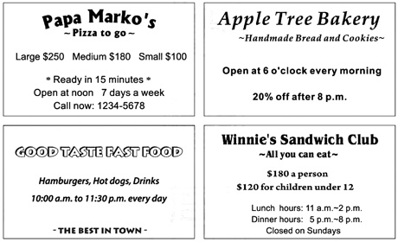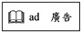

（B）31. Amanda has to get to school before 7:00 this morning. On her way to school, where can she buy her breakfast?
(A)At Papa Marko’s.
(B)At Apple Tree Bakery.
(C)At Good Taste Fast Food.
(D)At Winnie’s Sandwich Club.
（C）32. Yesterday was Amanda’s eleventh birthday. Her parents took her to Winnie’s Sandwich Club for dinner. How much did they spend?
(A)$300. (B)$360.
(C)$480. (D)$540.
（D）33. Amanda passes these four shops every day on her way to school. Look at the map. Which place is most likely to be Amanda’s school?
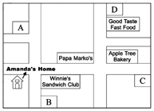
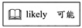
(A)A. (B)B.
(C)C. (D)D.
(34~35)
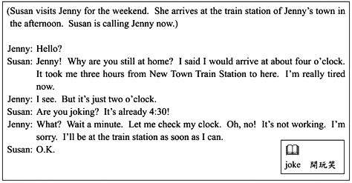
（C）34. Why was Jenny late?
(A)She was sleeping.
(B)The train was late.
(C)Her clock stopped.
(D)She forgot her friend was coming.
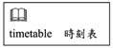
（C）35. Look at the timetable. Which train did Susan take?
Train  Station | 1051 | 505 | 1609 | 882
New Town | 12:00 | 12:10 | 13:00 | 14:00
Long Town | 12:50 | 13:05 | 13:40 | 14:32
Bell Town | 14:00 | 14:20 | 14:45 | 15:25
Wind Town | 15:30 | 15:55 | 16:02 | 16:32
Garden Town | 16:20 | 16:50 | 16:40 | 17:05
(A)1051. (B)505.
(C)1609. (D)882.
(36~37)
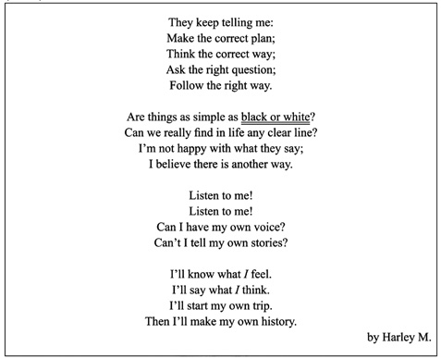

（B）36. What is the writer asking for?
(A)A safe way to take a trip.
(B)A chance to go his own way.
(C)An idea for writing his stories.
(D)A correct answer to his question.
（B）37. What does black or white mean in the reading?
(A)Now or then.
(B)Right or wrong.
(C)Two broken lines.
(D)The writer’s favorite colors.
(38~39)
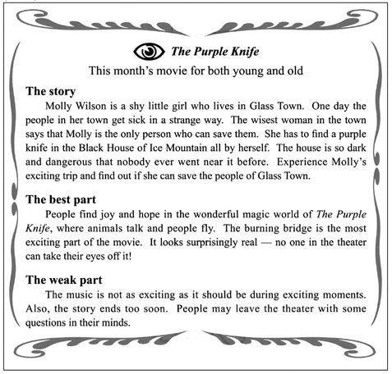

（A）38. What do we know about the story?
(A) It does not happen in the real world.
(B) Molly is too shy to save the people in her
town.
(C) The wisest woman is going to get the knife
with Molly.
(D) People in Glass Town get sick after they come
back from Black House.
（D）39. What does the writer think of the movie?
(A)The story is not exciting.
(B)Its music is great for the story.
(C)Some parts of it are bad for children.
(D)The writer is unhappy about the way it ends.
(40~42)
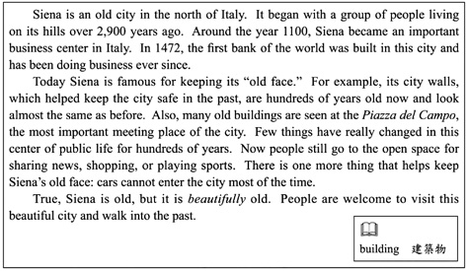

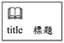
（D）40. What is the best title for the reading?
(A)A City of Love.
(B)A City of Festival.
(C)A Forgotten Old City.
(D)A City Living in History.

（A）41. What can we learn from the reading?
(A)The oldest bank in the world is in Italy.
(B)A good way to get around Siena is by car.
(C)Italy is making its cities beautiful with trees.
(D)Walls that were built around Siena are not
there now.
（C）42. Which is NOT true about the Piazza del Campo?
(A)It is in Siena.
(B)It is a public space.
(C)It is a new business center.
(D)It is kept almost as it was before.
(43~45)
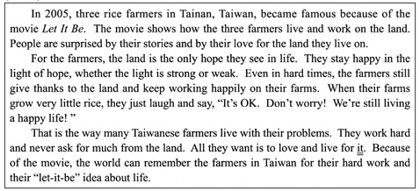

（C）43. What can we learn from the reading?
(A) Taiwanese farmers need help from foreign
countries.
(B) The farmland in Taiwan is getting worse for
growing rice.
(C) Many farmers in Taiwan are happy in good
and bad times.
(D) Some Taiwanese farmers are trying new ways
of growing rice.
（D）44. Which is NOT said about Taiwanese farmers in the reading?
(A) They do more but do not ask for much.
(B) They thank the land for what they have.
(C) They often look on the bright side of life.
(D) They work hard and are paid back with lots of
rice.
（B）45. What does it mean?
(A)The rice. (B)The land.
(C)The movie. (D)The money.
試題結束

