99學年度國中第二次基本學力測驗 英文領域
解析：陳潔老師

第一部分：下列各題（題號1-16），請依據題意選出一個正確或最佳的答案。
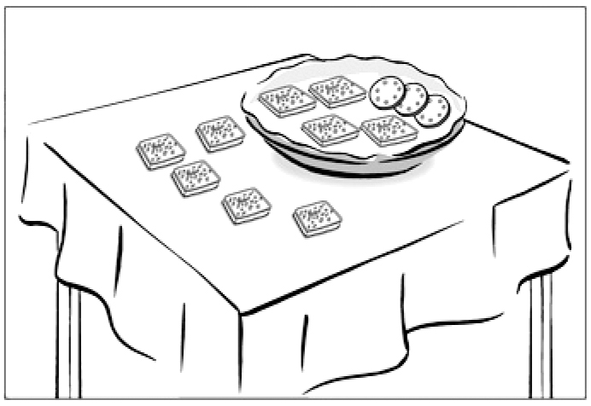
l. How many square cookies are there in the dish?
(A) Three.
(B) Four.
(C) Seven.
(D) Nine.

答案：(B)
解析： 有多少方型餅乾在餐盤裡？
依照圖片有三個圓形，四個方形，故答案選(B)。

2. Ken’s brothers like to watch tennis, but Ken . He is crazy about baseball.
(A) is (B) isn’t (C) does (D) doesn’t

答案：(D)
解析： Ken 的哥哥們喜歡網球，但是Ken 不喜歡，代替前句一般動詞喜歡，且為現在式三單，故答案選(D)。

3. Beatrice loves to draw apples. You can see in her notebooks, on her letters, and even on her school bag!
(A) one (B) others (C) them (D) which

答案：(C)
解析： Beatrice喜歡畫蘋果。你可以在她的筆記本、信件，甚至書包上都可以看到。代替前句的蘋果，因為複數，故答案選(C)。

4. I let the meat cook too long, so it was black.
(A) burned (B) kept (C) prepared (D) tasted

答案：(A)
解析： 我讓肉煮太久，所以它煮焦了。故答案選(A)。

5. There’s something wrong Gina and Greg. They haven’t talked to each other for over one month.
(A) beside (B) between (C) during (D) under

答案：(B)
解析： Gina和Greg之間有某些問題，他們互相已經超過一個月沒說話了。指在兩者之間，故答案選(B)。

6. On the way to work, Natasha was surprised to find she was wearing a white earring on one ear and a gray earring on .
(A) another (B) the next (C) the other (D) the second

答案：(C)
解析：在去工作的路上，Natasha很驚訝地發現她在一個耳朵上戴著白耳環，另一個戴著灰耳環。指定兩者東西，一個是one，另一個是the other，故答案選(C)。
7. The little boy jumped up and down happily when he saw a bee into the house.
(A) flown (B) to fly (C) flying (D) has flown

答案：(C)
解析： 當這個小男孩看到一隻蜜蜂飛進房間裡，他高興地跳上跳下。see 為感官動詞，之後接原形動詞(V.R.)或動名詞(Ving)。
故答案選(C)。

8. Please speak to those children with hearing problems so that they can read your lips more easily and understand better.
(A) honestly (B) politely (C) quietly (D) slowly

答案：(D)
解析： 請你對那些聽力有問題的小孩說慢一點，以便他們可以很容易地讀你的唇語和更瞭解你說的話。用副詞修飾一般動詞speak，故答案選(D)。

9. My father told me last night we’re going to the Food Festival this weekend. My brother and I felt very excited.
(A) whether (B) where (C) what (D) that

答案：(D)
解析：我父親昨晚告訴我們，這個週末將要去美食展。我弟弟和我都很興奮。此為名詞子句，連接詞沒有中文的意義，故答案選(D)。

10. This restaurant sells the best steak in Taipei; you can’t find steak in the city.
(A) delicious (B) more delicious
(C) the most delicious (D) deliciously

答案：(B)
解析： 在台北，這家餐廳賣最棒的牛排，在這個城市，你找不到更美味的一家。在此為比較級，故答案選(B)。

11. The poor family have only bread for today. Nothing is left for them to eat tomorrow.
(A) enough (B) few (C) much (D) other

答案：(A)
解析：這戶窮人家只有足夠的麵包給今天，沒有任何東西留給明天了。在此中文是只有足夠，故答案選(A)。

12. Derek: Oh, I missed the ball game on TV.
Frank: You can watch it on the .
Derek: But I don’t have a computer.
(A) blackboard (B) Internet (C) playground (D) tape

答案：(B)
解析：Derek：我錯過了電視上的球賽。
Frank：你可以在網路上看。
Derek：但是我沒有電腦。在此指電腦上看球賽，
故答案選(B)。
13. Pete: I really like your bag. Is it ?
Jane: I don’t know how much it is. It’s my brother’s.
(A) expensive (B) heavy (C) strong (D) useful

答案：(A)
解析：Pete：我真的很喜愛你的袋子。它很貴嗎？
Jane：我不知道多少錢。它是我哥哥的。
在此提及多少錢，故答案選(A)。

14. Ms. Cooper: Do you have this hat in a small size?
Shopkeeper: I’m afraid not. It only comes in .
(A) circles (B) dozens (C) medium (D) pink

答案：(C)
解析：Mr. Cooper：這頂帽子有小號的嗎？
Shopkeeper：恐怕沒有。它只有中號的。
在此提及物品尺寸大小，故答案選(C)。

15. Anita: I saw Nora in the Teacher’s office this morning. Do you know she was
there?
Brian: She cheated on tests.
(A) how (B) if (C) when (D) why

答案：(D)
解析：Anita：我今天早上看到Nora在老師的辦公室，你知道為什麼她在那裡。
Brian：她考試作弊。
在此為名詞子句，連接詞問為什麼，故答案選(D)。

16. Bobby: Where’s the food I ordered? I’ve waited for thirty minutes!
Waiter: I’m really sorry, but the kitchen is very busy. You’ll have it .
(A) already (B) early (C) once (D) soon

答案：(D)
解析：Bobby：我點的食物在那裡？我已經等了三十分鐘了。
Waiter：真抱歉，但是廚房現正在忙，你點的東西很快就來了。
在此為副詞解釋為很快，故答案選(D)。

第二部分：下列十一個題組，共有29題（題號17-45），請依據選文或所附圖表資料，選出一個正確或最佳的答案。
(l7-20)
People in Quiet Town are very sad that their old friend, Time River, is facing the end of its life next October. The river 17 a lot to the people in the town. They all grow up and live with it all their lives.
In the old times, people in the town 18 their houses on both sides of the river. The houses in each block shared a public washing room. On Mondays, people came and washed their clothes together there. They hung their clothes at the back of each house. Those clothes with different colors 19 a beautiful picture along the river.
Now Time River is going to be filled in to make more land to build on. People are happy that they 20 more living space. But at the same time, they feel sorry that they must say good-bye to their old friend. So they have decided to give a party one day a year to remember the river.

hung（原形為hang）懸掛

17. (A) means (B) is meaning (C) will mean (D) meant

答案：(A)
解析：這條河流對這個城鎮的人意義很大。在此為現在式三單，故答案選(A)。

18. (A) build (B) are building (C) have built (D) built

答案：(D)
解析： 在以前的時代裡，這個城鎮的人在這條河流的兩岸蓋房子。
在此以前的時代裡為過去式，故答案選(D)。

19. (A) make (B) are making (C) have made (D) made

答案：(D)
解析：人們會掛衣服在每一棟房子後面，沿著河岸，那些帶有不同顏色的衣服形成一幅漂亮的圖畫。在此形成為過去式，故答案選(D)。

20. (A) have (B) have had (C) will have (D) had

答案：(C)
解析：現在這條河流將要填滿形成更多陸地去建造房子。人們很高興將有更多的生活空間。
在此將有為未來式，故答案選(C)。

(21-23)
A small town has a good chance of 21 that can bring in a lot of money, if it has something special to be proud of. One example is Gukeng town of Yunlin, Taiwan. Gukeng has long been famous for growing good coffee, but the town didn’t start to make much money from it until some years ago. As more and more people have visited Gukeng for its coffee, the coffee farmers have begun to open their farms to the public. At these farms, people can have the fun of finding out where coffee comes from. 22 , coffee shops are opened all over Gukeng, and people can take a rest and taste delicious coffee on the sidewalks in or after a day’s visit. The new businesses make a better life possible for those who 23 the town. They don’t have to leave the town to find jobs in other places.

as 隨著

21. (A) growing the best tea
(B) starting a new business
(C) selling old farming lands
(D) opening a shopping center

答案：(B)
解析： 這裡有個小鎮，有個機會去開始新的生意帶來許多的財富。從文章第四行可知，開放農田給大眾，可以帶來賺錢的機會。故答案選(B)。

22. (A) First
(B) Also
(C) However
(D) For example

答案：(B)
解析： 人們可以在農田裡找到咖啡的來源，同時，人們可以在一天行程結束後，在人行道邊的咖啡店裡休息和品嚐美味的咖啡。在此是選連接詞，故答案選(B)。

23. (A) live in
(B) hear about
(C) take a trip to
(D) are interested in

答案：(A)
解析：這個新的生意帶給那些住在這個小鎮的人們有一個更好生活的可能。在此是指住在這個小鎮的人們，故答案選(A)。

(24-25)
Dr. Swan: Hello, Lynn. How can I help you?
Lynn: I was hit in the mouth when I was playing basketball.
Dr. Swan: Oh, that’s too bad! Let me check. Now, open your mouth, please.

(Lynn opens her mouth.)

Dr. Swan: Well …you’re lucky. I need to work on only two teeth. I’ll fill them first and then give you some medicine to take after meals. Is that OK with you?
Lynn: Much more than OK! I thought they would have to be taken out. But can I eat anything after you do it? I have a date at seven o’clock tonight.
Dr. Swan: Don’t worry. You can have soft food after 30 minutes, and then anything after four hours.
Lynn: Thank you so much, Dr. Swan.
Dr. Swan: No problem! Be careful next time you are playing sports!

soft 軟的

24. Which is NOT true about Lynn?
(A) Two of her teeth need fixing.
(B) She needs to take medicine for her teeth.
(C) She should stay away from food until tomorrow.
(D) Her teeth got hit when she was playing basketball.

答案：(C)
解析：題目：有關Lynn何者不對？
(C)她必須要等到明天才能進食。
在文章裡倒數第四行提及，醫師告知她30分鐘之後可以吃軟的食物。四小時後可以吃任何東西。
故答案選(C)。

25. What does it mean?
(A) Filling the teeth.
(B) Brushing the teeth.
(C) Checking the teeth.
(D) Taking the teeth out.

答案：(A)
解析：題目：Lynn問：你做完這件事後，我可以吃任何東西嗎？
it在文章裡第四和五行提及，醫師將先填補牙齒然後給她一些藥物。
故答案選(A)。

(26-28)
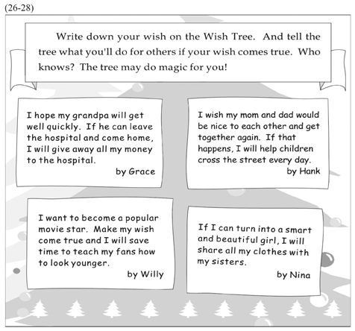
26. What can we learn about the Wish Tree?
(A) It tells people’s future. (B) It collects people’s name cards.
(C) It helps people to think of others. (D) It grows bigger when a wish comes true.

答案：(C)
解析：題目：有關許願樹我們可以知道什麼？
在文章裡第四和五行提及：告訴許願樹如果我們的願望成真，我們將會為他人做些什麼。故答案選(C)。

27. Which is most likely true?
(A) Nina is a movie star.
(B) Grace works in the hospital.
(C) Willy will teach people how to make a movie.
(D) Hank would like to keep children safe on the road.
&
likely 可能

答案：(D)
解析：題目：那一個最有可能是正確的？
(A)是 Willy 要成為電影明星。(B)是 Grace 的爺爺住在醫院。
(C) Willy 要省時間教他的影迷如何變得更年輕。故答案選(D)。

28. Who does NOT write about his or her family?
(A) Grace. (B) Hank. (C) Willy. (D) Nina.

答案：(C)
解析：題目：誰沒有提及他的家人？
(A) Grace提及她的爺爺住在醫院。(B) Hank提及希望父母親再次合好。
(C) Nina提及要與她的姐妹們分享她的衣物。故答案選(C)。
(29-30)
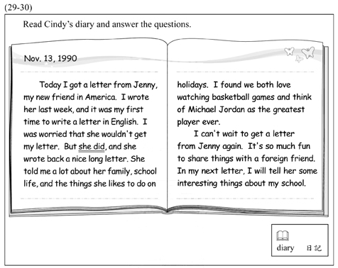

29. What does she did mean?
(A) Jenny got the letter.
(B) Jenny wrote in English.
(C) Jenny wrote back a nice long letter.
(D) Jenny told Cindy about her family and school life.

答案：(A)
解析：題目：she did是什麼意思？
在文章裡前一句提及：我擔心她沒收到我的信。但是她瞭解我信的內容並且回給我一封又好又長的信件。故答案選(A)。

30. Which is said about Cindy?
(A) She is a sports fan.
(B) She will visit Jenny.
(C) She wants to teach Jenny to speak Chinese.
(D) She often writes to foreign friends in English.

答案：(A)
解析：題目：在文章裡說了什麼有關Cindy？
在文章裡第十句提及：我察覺我們兩人都愛看籃球賽而且我們都認為Michael Jordan是最偉大的籃球員。故答案選(A)。
(31-33)
Joyce: Can you help me take care of my roses? I’ll be away for two weeks.
Ryan: Are you crazy? Don’t you know I’m a flower killer?
Joyce: Why’s that? I remember you have a beautiful garden with all kinds of flowers. I think you’ve been taking good care of them.
Ryan: Not me. It’s my dad. He is good at growing trees and flowers. I think you should ask someone else for help. I’m really not the right person.
Joyce: But I’m leaving tomorrow morning! There’s no time to look for someone else. Please! All you have to do is to water my roses every two days. Here’s the key to my house.
Ryan: It’s just as easy as that?
Joyce: Yeah, just as easy as that!
Ryan: Well ... will you kill me if anything goes wrong?
Joyce: Maybe, but I believe you’ll do just fine.

31. Why does Ryan say he is a flower killer?
(A) He likes to pick up flowers.
(B) He makes girls crazy for him.
(C) He cannot keep flowers living long.
(D) He does not like to have flowers in his house.

答案：(C)
解析：題目：為何Ryan說他是個“a flower killer”？
在文章裡第五句及第六句提及：那些花是他爸爸在照顧的，他真的不是那個適合照顧花的人。故答案選(C)。

32. If Joyce’s roses are watered on the afternoon of May 5, when should they be watered next time?
(A) On May 6. (B) On May 7. (C) On May 9. (D) On May 10.

答案：(B)
解析：題目：如果Joyce的花是在五月五號下午澆過水，下一次何時應該再澆水？
在文章裡倒數第第六句提及：你必須要做的事就是每隔兩天幫我的玫瑰澆水。因此下一次澆水是在五月七號。故答案選(B)。

33. Which is said in the reading?
(A) Ryan’s father has decided to help Joyce.
(B) Joyce is going on business for two weeks.
(C) Ryan’s father takes care of Ryan’s garden.
(D) Joyce has brought her roses to Ryan’s garden.

答案：(C)
解析：題目：在文章裡說了什麼？
在文章裡第五句提及：那些花是我爸爸在照顧的，他擅長種植樹木和花卉。
故答案選(C)。

(34-35)
Yellow Dress
by Janet Lee

Mary had a yellow dress
Bought from the department store.
It looked as beautiful as the moon,
And as bright as the sun.

Mary wore all the time
The yellow dress I felt so right.
Every day from day to night
I saw her in the dress so bright.

“Buy me a yellow dress,”
I cried to Mom and Dad,
“As beautiful and bright
As the dress the girl living near has!”

I cried and cried and cried,
Until they said with sad eyes,
“We need food for your baby sister,
And clothes for your coming brother.”

Since then I’ve learned
Mary’s yellow dress
Is better to dream of
Than to ask for.

34. Why does the writer say, “Every day from day to night / I saw her in the dress so bright”?
(A) The writer lived with Mary.
(B) The dress had sun shapes on it
(C) The writer liked the dress very much.
(D) The dress was Mary’s school uniform.

答案：(C)
解析：題目：為何作者說“她每天從早到晚都看到Mary穿著那件如此明亮的洋裝”？
在文章裡第三段提及：她一直哭著要求爸爸和媽媽買一件和隔壁女孩一樣明亮的洋裝”？因此表示作者非常喜歡那件洋裝。故答案選(C)。

35. What did the writer’s parents mean by their words?
(A) They did not like the yellow dress.
(B) They did not have money for a dress.
(C) They already had a dress for her baby sister.
(D) They would ask Mary where to buy the yellow dress.

答案：(B)
解析：題目：作者的雙親說的話是什麼意思？
在文章裡第四段提及：我們需要食物給你小妹妹和衣服給你將誕生的小弟弟。因此表示作者的雙親沒有錢買那件漂亮的黃洋裝。故答案選(B)。
(36-37)

ES-ME is a fun computer program. Here is how it works:

˙ First, tell ES-ME your birthday.
˙ Then ask your question.
˙ Finally, you will get an answer from ES-ME.

Below are the four questions people most often ask, and the funny answers they get.

Q1: Will I get a good job?
ES-ME  Sure you will, if you are able to do a good job.

Q2: When will I die?
ES-ME  You’ll know when the time comes.

Q3: Can I find my true love?
ES-ME  Yes you can, if there’s true love in the world.

Q4: What will be on my next school test?
ES-ME  It will be what you’ve been taught.

36. What does ES-ME do?
(A) It takes tests.
(B) It collects ideas.
(C) It gives answers.
(D) It repeats questions.

答案：(C)
解析：題目：ES-ME是做什麼用處的？
在文章裡第三點提及：最後，你將從ES-ME得到答案。故答案選(C)。

37. What does You’ll know when the time comes mean in the reading?
(A) You will die when you get old.
(B) You should know time flies and never waits.
(C) You can know when you will die only when you are dying.
(D) You can believe time is the best medicine for a broken heart.

答案：(C)
解析：題目：在文章裡“You’ll know when the time comes.”這句話是什麼意思？
You’ll know when the time comes在文章裡它的意思是：當你即將離開這個世界時，你將會知道這個時間已經到來了。故答案選(C)。

(38-40)
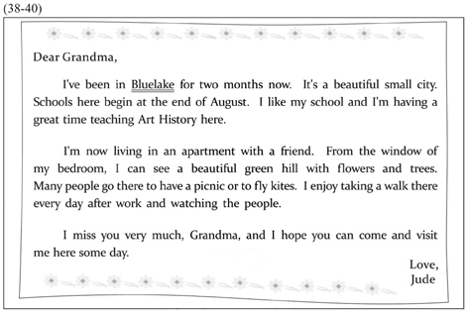
38. What is Bluelake?
(A) A city. (B) A park. (C) A school. (D) An art museum.

答案：(A)
解析：題目：什麼是“Bluelake”?
在文章裡第一和第二句提及：我住在“Bluelake”已經兩個月了。它是一個漂亮的小城市。故答案選(A)。

39. What is Jude doing in Bluelake?
(A) Working. (B) Studying.
(C) Visiting a friend. (D) Taking a vacation.

答案：(A)
解析：題目：Jude在Bluelake正在做些什麼事？
在文章裡第六行裡提及：我喜歡在每天工作後在那裡散步和看看那些人們。由此可知Jude在Bluelake工作。故答案選(A)。

40. Which picture best shows what Jude sees out of his bedroom window?
(A) (B)
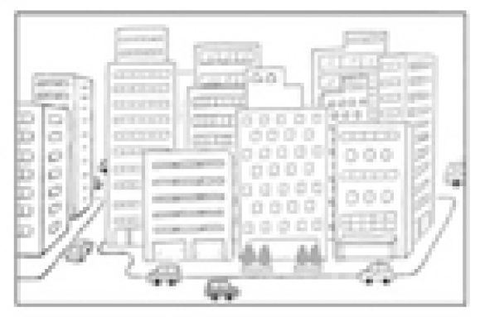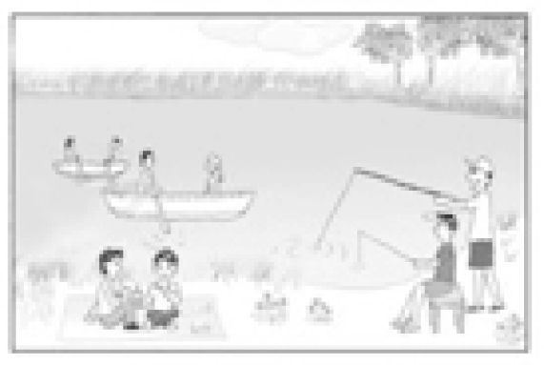
(C) (D)
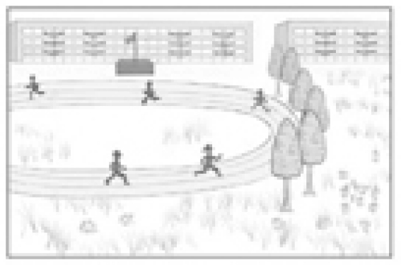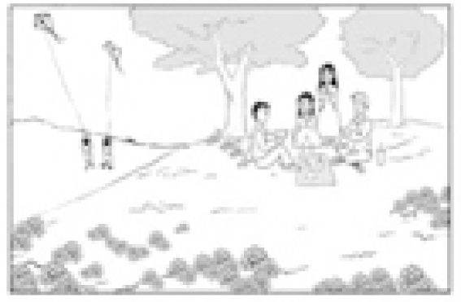

答案：(D)
解析：題目：哪一個圖片最能顯示Jude從臥室窗外所看到的景象？
在文章裡第五行裡提及：我可以看到一個有花和樹的漂亮綠色小山坡。很多人會在那裡野餐或放風箏。故答案選(D)。
(41-42)
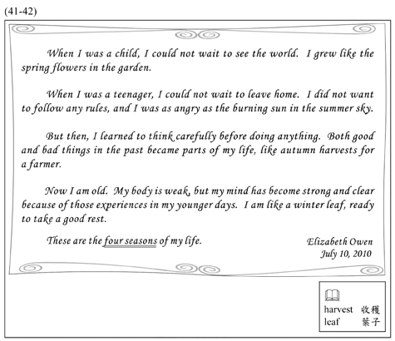
41. What does four seasons mean in the reading?
(A) Four times of life.
(B) Four parts of the year.
(C) Four parts of the body.
(D) Four kinds of weather.

答案：(A)
解析：題目：文章裡four seasons (四季) 是什麼意思？
在文章裡前四段的每一句提及：When I was a child (當我還是小孩)；When I was a teenager (當我在青少年期)；But then…. (而後) ……; Now I am old (現在我老了)。
因此表示作者人生的四個階段。故答案選(A)。

42. Which is most likely true about the writer?
(A) She is wiser than before.
(B) She has a strong and healthy body.
(C) She enjoys growing flowers in her garden.
(D) She tries hard to forget what happened in the past.
&
likely 可能

答案：(A)
解析：題目：哪一個有關作者是最有可能的事實？
在文章裡第四段提及：現在我老了，我的身體很虛弱，但是我的心智變得堅強和清晰，那是因為在我年輕時代的那些經驗。故答案選(A)。
(43-45)
I had a dream － a strange dream that has helped me to understand Eric much better.

In the dream, Eric looked angry and said, “Melissa, I have something to tell you.”

I’ve lived with Eric for more than five years. He is the cutest thing I’ve ever seen. I buy him fish and milk and lots of toy mice once a week. I even bought a small house for him, because he sometimes likes to be left only by himself. I love him with all my heart, and give him all I love.

But what has gone wrong? In the dream Eric said angrily, “I don’t like fish. I don’t like milk. And toy mice? Are you crazy? I’m not a cat. And I don’t want to be a cat, either!” Then he ran back to his small house.

After the dream, I know better: dogs don’t like fish or milk. And surely they do not like toy mice. Most important of all, they will let you know when they are really angry!

43. What can we learn about Eric in the reading?
(A) He likes cats.
(B) He is Melissa’s pet.
(C) He is four years old.
(D) He enjoys talking with Melissa.

答案：(B)
解析：題目：在文章裡我們可知有關Eric什麼事情？
在文章倒數第三行提及：在這夢過後，我知道更清楚：狗狗們不喜歡魚或牛奶。由此可知Eric是隻寵物狗。故答案選(B)。

44. Why was Eric angry in the dream?
(A) He did not have many friends.
(B) Melissa loved him the wrong way.
(C) Melissa did not take him out for a long time.
(D) There were too many mice in Melissa’s house.

答案：(B)
解析：題目：在夢裡Eric為什麼生氣？
在文章第三段提及：Eric在夢裡很生氣地說：我不喜歡魚。我不喜歡牛奶。還有玩具老鼠。故答案選(B)。

45. Why did Melissa buy a house for Eric?
(A) Eric did not sleep well in her room.
(B) Eric needed more space for his toys.
(C) Eric was too big to share a bed with her.
(D) Eric did not always like to be with others.

答案：(D)
解析：題目：為什麼Melissa要買一個房子給Eric？
在文章第六行提及：我甚至買了一個小房子給Eric，因為他有時喜歡單獨自己一個。
故答案選(D)。

