99第一次國民中學基本學力測驗 英文科題本
班級： 座號： 姓名：

第一部分：下列各題（題號1-18），請依據題意選出一個正確或最佳的答案。
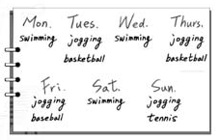
（D） 1. Here’s Mary’s plan for one week during her summer vacation. What kind of plan is this?
(A) A trip plan.
(B) A party plan.
(C) An eating plan.
(D) An exercise plan.
（A） 2. I put the fish in the ice box to keep it .
(A) fresh (B) full
(C) new (D) young
（B） 3. The pants I bought last year are too small now. I think I need a new .
(A) belt (B) pair
(C) shirt (D) space
（B） 4. How can you study in the living room when other people are watching TV? I think you need a
place.
(A) cleaner (B) quieter
(C) safer (D) smaller
（D） 5. Marsha thought her friends would do something
to celebrate her birthday, but they just gave her a little card.
(A) correct (B) honest
(C) quick (D) special
（A） 6. When I heard my baby girl say her first word, my heart was with joy.
(A) filled (B) marked
(C) prepared (D) shown
（C） 7. It’s me a lot of time to find out what I really want to do in the future.
(A) paying (B) spending
(C) taking (D) using
（A） 8. The fishermen knew little about the island when they there.
(A) arrived
(B) would arrive
(C) arrive
(D) have arrived
（A） 9. I cannot understand why Steven bought so many watches but never wears of them.
(A) any (B) both
(C) every (D) others
（D）10. In this five-person game, the one who finds hidden balls will win the last free ticket for the movie A Born Player.
(A) many (B) some
(C) the more (D) the most
（B）11. Elsa hates going shopping, she went last night when her grandpa asked her to buy some medicine for him.
(A) because (B) but
(C) if (D) so
（D）12. Gary: I can’t find my pen.
Nina: Is the one on Jack’s desk ?
Gary: Yes. Thank you.
(A) mine (B) ours
(C) theirs (D) yours
（B）13. Lucy: Does Aunt Tara enjoy ?
Mark: Yes. She has three dogs, two rabbits, four birds, and some fish in her house.
(A) collecting dolls
(B) keeping pets
(C) visiting the zoo
(D) working on the farm
（A）14. Sandy: How was your vacation in America?
Linda: It couldn’t be worse! I don’t want
to talk about it!
(A) even (B) least
(C) never (D) then
（C）15. Teacher: Does anyone know the famous
writer was born?
Mei-ling: I know! In Taitung, right?
Teacher: You got it!
(A) how (B) when
(C) where (D) whether
（C）16. Alex: Why are you still here? It’s already eight
o’clock.
Tom: Because I my work. Don’t worry.
It’s almost done.
(A) wasn’t finishing (B) wouldn’t finish
(C) haven’t finished (D) won’t finish
（B）17. Mike: I always forget what I want to buy when I
go to the market.
Oscar: Well, you can make a of things
you want to buy.
(A) habit (B) list
(C) pack (D) wish
（C）18. Billy: I’ve been fixing the computer for over three
hours, but it still doesn’t work.
Nana: Why don’t you take a rest and try ?
Maybe you’ll do better then.
(A) early (B) finally
(C) later (D) once
第二部分：下列十一個題組，共有27題（題號19-45），請依據選文或所附圖表資料，選出一個正確或最佳的答案。
(19-21)
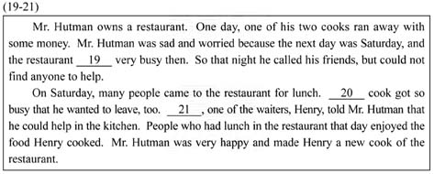

（A）19. (A) would be (B) is
(C) has been (D) will be
（D）20. (A) One (B) Each
(C) Another (D) The only
（C）21. (A) Also (B) In fact
(C) Luckily (D) For example

(22-24)
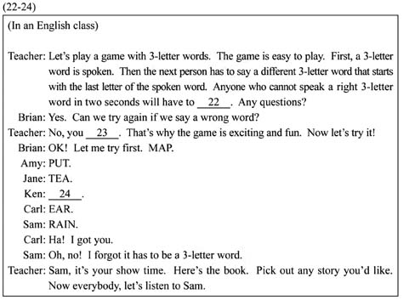

（B）22. (A) sing a song
(B) read a story
(C) draw a picture
(D) make a funny face
（A）23. (A) have just one chance
(B) have to give a different word
(C) may look it up in the dictionary
(D) must ask your classmates for help
（D）24. (A) TEN
(B) RED
(C) EAT
(D) AGE
(25-26)
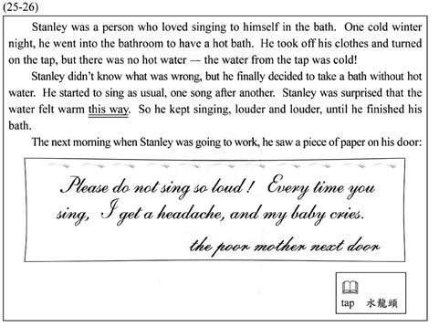

（D）25. What does the mother think of Stanley?
(A) He gets up too early.
(B) He is a helpful person.
(C) He should see a doctor.
(D) He makes too much noise.
（B）26. What does this way mean?
(A) Singing to a crying baby.
(B) Singing when taking a cold bath.
(C) Taking a cold bath in the morning.
(D) Taking a bath before going to bed.

(27-28)
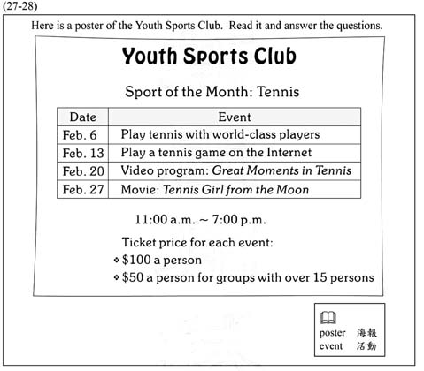

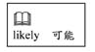
（C）27. Mr. Brown, a PE teacher, took his students to the club. There they watched early tennis games and learned about the history of the sport. When did they most likely visit the club?
(A) February 6.
(B) February 13.
(C) February 20.
(D) February 27.
（B）28. Mr. Brown paid $1,050 for the tickets. How
many students did he take with him?
(A) 25. (B) 20.
(C) 15. (D) 10.
(29-30)
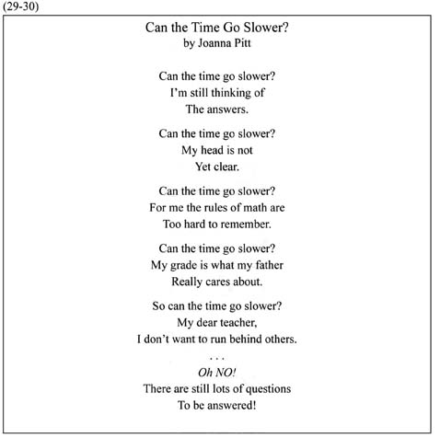

（A）29. What is the reading about?
(A) Taking a test.
(B) Teaching math.
(C) Learning driving.
(D) Running at the school.
（C）30. Why does the writer keep asking “Can the time go slower?”
(A) She is missing her good old times.
(B) She does not want to get old with time.
(C) She is worried that there’s not enough time.
(D) She is afraid that her father will be home soon.
(31-32)
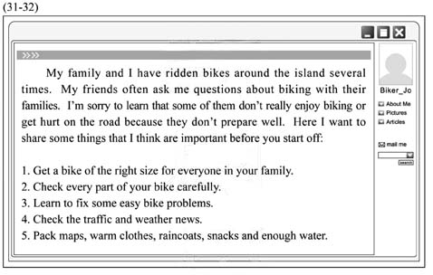

（C）31. What is the writer talking about?
(A) How to fix a bike on the road.
(B) How to save money on a bike ride.
(C) Things to do for a safe and happy bike ride.
(D) Things to remember when you get hurt on the road.
（D）32. Which is said in the reading?
(A) Biking is good for health.
(B) More and more people go to work by bike.
(C) Biking around the island is getting popular.
(D) The size of the bike is important for biking.
(33-35)
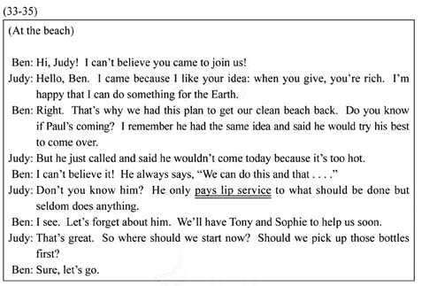

（B）33. Why are Ben and Judy at the beach?
(A) To go swimming.
(B) To clean up the beach.
(C) To have a beach party.
(D) To learn about sea animals.
（C）34. What does Judy mean by saying Paul pays lip
service?
(A) He enjoys eating.
(B) He is good at singing.
(C) He talks a lot but does little.
(D) He kisses people to show his thanks.
（C）35. Which is true?
(A) Paul comes to the beach in the end.
(B) Judy feels bad about going to the beach.
(C) Ben is surprised to see Judy at the beach.
(D) Tony and Sophie will not come to the beach.

(36-38)
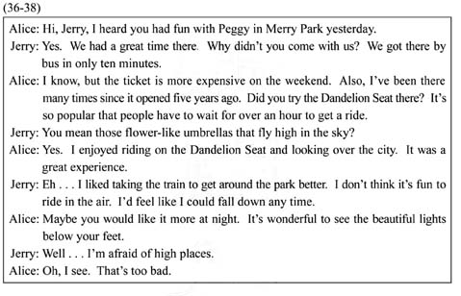

（B）36. What can we learn about Merry Park?
(A) It is newly opened.
(B) It is also open at night.
(C) It is across from Jerry’s house.
(D) It has the same ticket price every day.
（D）37. What may the Dandelion Seat look like?
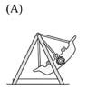
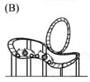
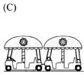
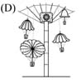
（C）38. Which is NOT true?
(A) Alice went to Merry Park before.
(B) Jerry enjoyed going around Merry Park by train.
(C) Jerry would like to try the Dandelion Seat next time.
(D) Jerry and Peggy went to Merry Park on the weekend.

(39-40)
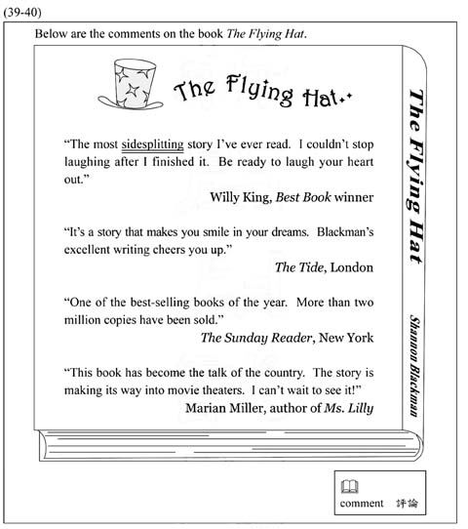
（A）39. Which is said about The Flying Hat?
(A) A movie about the story is coming out.
(B) The story is about a boy who has a magic hat.
(C) The writer started the book because of a dream.
(D) People can buy the book in different languages.
（A）40. What does sidesplitting mean?
(A) Funny. (B) Simple.
(C) Serious. (D) Difficult.
(41-42)
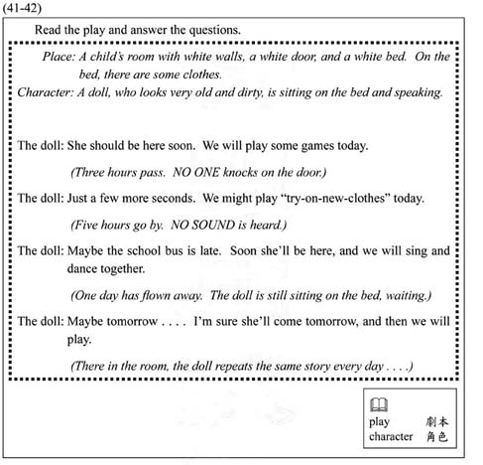

（B）41. What happens in the play?
(A) A doll is changing clothes.
(B) A doll is talking to herself.
(C) A doll is singing and dancing.
(D) A doll is waiting for the bus to school.
（D）42. What can we learn about the doll?
(A) She likes to play by herself.
(B) She is good at telling stories.
(C) She lives in a room full of colors.
(D) She has been forgotten for some time.

(43-45)
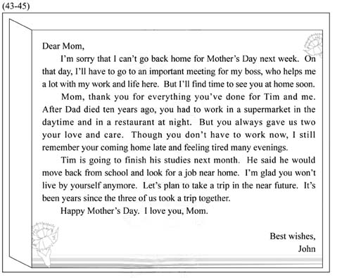
（A）43. What can we learn about John’s mother?
(A) She lives by herself now.
(B) She still works day and night.
(C) She will make a plan to save money.
(D) She used to be too busy to care for her
children.
（C）44. What do we know from the letter?
(A) John has two brothers.
(B) John is unhappy with his boss.
(C) John has to work on Mother’s Day.
(D) Tim will leave home for his job soon.
（D）45. Which is said in the letter?
(A) John’s father died at work.
(B) Tim will look for a teaching job.
(C) John bought a gift for his mother.
(D) John hopes to take a trip with his family.

試題結束

