四年級英與第七課評量
Name: ___________________No: ____________________
Class: ________________ Sign: ________________

1 Listen and number.
a 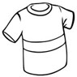 |  | b 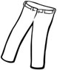
c 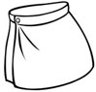 |  | d 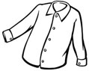
( /4)
2 Write.
1 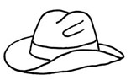  a _________________ |  | 2 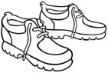  _________________
3 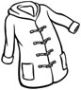  a _________________ |  | 4 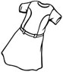  a _________________
( /4)
3 Listen and check .
1 |  |  | 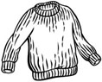
2
( /4)
4 Write.
a hat He's She's a skirt a T-shirt wearing
1 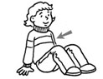 | She's _______________ a sweater.
2 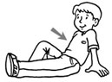 | _______________ wearing _______________.
3 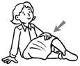 | _______________ wearing _______________.
( /5)
5 Listen and check the words with the same sound.
1 ring  neck  rock | 2 king  kick  ring | 3 kick  long  king
( /3)
Level 2 - Unit 7 Test
Answer key | Total points: 20

1 Listen and number.
a |  | b | 
c |  | d | 
Test script Number 1. a shirt [2x] Number 2. pants [2x]
Number 3. a skirt [2x] Number 4. a T-shirt [2x]
(4 points)
2 Write.
1  t h a  a hat |  | 2  h e o s s  shoes
3  t o c a  a coat |  | 4  s e r d s  a dress
(4 points)
3 Listen and check .
1 | 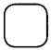 | 
2
Test script 1. I'm wearing a sweater and pants. [2x]
2. I'm wearing a T-shirt and a skirt. [2x]
(4 points)
4 Write.
a hat He's She's a skirt a T-shirt wearing
1 | She's wearing a sweater.
2 | He's wearing a T-shirt.
3 | She's wearing a skirt.
(5 points)
5 Listen and check the words with the same sound.
1 ring  neck  rock | 2 king  kick  ring | 3 kick  long  king
Test script 1. ng, ng, ring; ck, ck, neck; ck, ck, rock [2x]
2. ng, ng, king; ck, ck, kick; ng, ng, ring [2x]
3. ck, ck, kick; ng, ng, long; ng, ng, king [2x]
(3 points)
Level 2 - Unit 7 Test
Points to percentage conversion table

Points | %
20 | 100
19 | 95
18 | 90
17 | 85
16 | 80
15 | 75
14 | 70
13 | 65
12 | 60
11 | 55
10 | 50
9 | 45
8 | 40
7 | 35
6 | 30
5 | 25
4 | 20
3 | 15
2 | 10
1 | 5
0 | 0

