unicycle
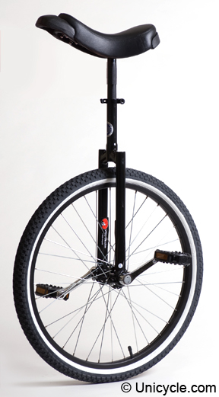

seat | 座鞍 | wheel | 輪胎
post | 直桿 | rim | 鋼圈
frame | 叉架 | pedal | 踏板
crank | 曲桿 | valve | 充氣閥

