☺☺☺☺☺☺☺☺☺☺☺☺☺☺☺☺☺☺☺☺☺☺☺☺
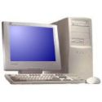

網路用語

Internet | 網路
website | 網址
turn on | 開機
turn off | 關機
log in | 登入
log out | 登出
on-line game | 線上遊戲
電腦用語

computer | 電腦
mouse | 滑鼠
keyboard | 鍵盤
monitor | 螢幕
speaker | 喇叭
earphone | 耳機

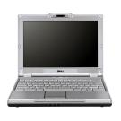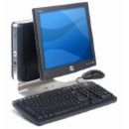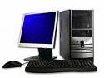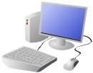

In the computer classroom…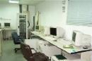

Teacher：Please turn on the computer and log
in.
Students：O.K.
Teacher：Now, please tell me what’s this?
Students：This is a mouse
Teacher：What’s this
Students：This is a keyboard.
Teacher：What’s this
Students：This is a monitor.
Teacher：You can’t play on-line games in
school. Please log out the website.
Students：O.K.
Teacher：Now, turn off your computer. See you
next time.
Students：See you.

What’s this?

This is a ________________.

a computer | 電腦
a mouse | 滑鼠
a keyboard | 鍵盤
a monitor | 螢幕
a speaker | 喇叭
an earphone | 耳機

☺☺☺☺☺☺☺☺☺☺☺☺☺☺☺☺☺☺☺☺☺☺☺☺
