- Go Away the Big Green Monster/ Ed Emberley
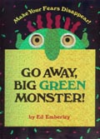
- Does a kangaroo have a mother, too/ Eric Carle
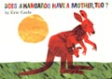
- From Head to Toe/ Eric Carle
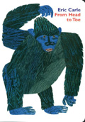
- Where are you going ? To see my friend./ Eric Carle & Kazuo Iwamura
