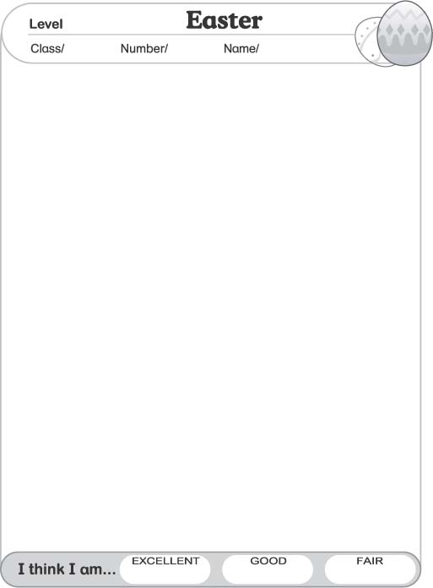

Look, Say, and Match
★ 看圖，念念看，並將圖片連至正確的答案。
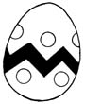
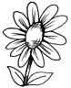
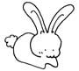
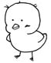
a flower
an egg
a chick
a rabbit
1-1

Rabbit, Rabbit, Carrot Easter
- Please write the word “Easter” in the box below then color the picture.
請在下方的空白處寫下 “Easter” 這個字，並將圖畫著上美麗的顏色。
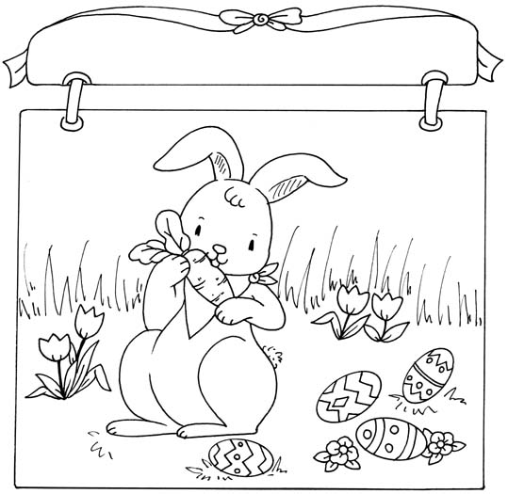
1-2
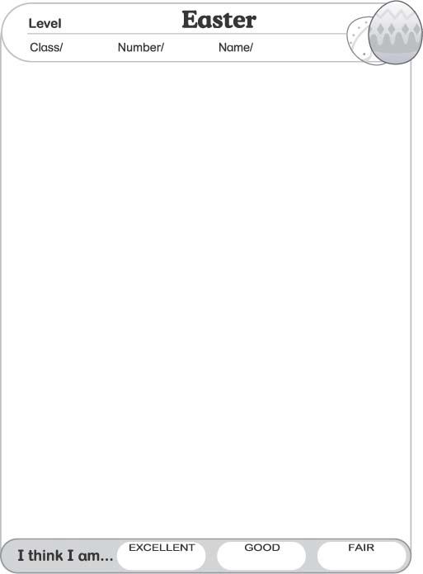





Read and Check
- 我們會在復活節做哪些活動呢？想想看，並勾選出正確的圖片。
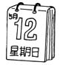
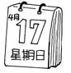
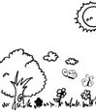
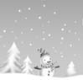
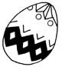
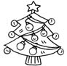
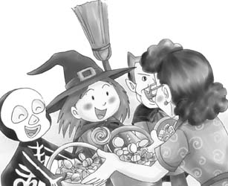
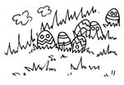

1. Children like to color…
2. Children like to play with…
3. Easter is a holiday on…
4. Easter is a holiday in…
2-1

Easter Egg
- Listen to your teacher’s instructions, follow the steps below then make an Easter Egg for Easter.
聽老師的指示，完成彩蛋的製作。
1. Get two hard-boiled eggs.
2. Wrap the eggs with paper.
3. Bring makers to school.
4. Paint a face (eyes, nose, mouth) on the egg.
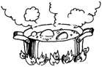
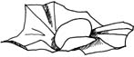
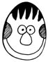
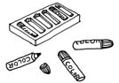
2-2

Read and Match

Easter is a Christian holiday on Sunday in spring.  This year, Easter is on . |  | 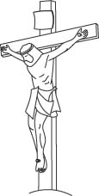
Christians say Jesus became alive again on Easter. |  | 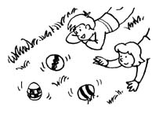
They go to church on Easter Sunday. |  | 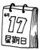
Children color Easter eggs. |  | 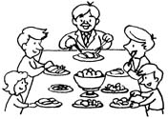
Everyone has a painted egg.  They roll the eggs down the hill.  The one who has the last egg to break is the winner. |  | 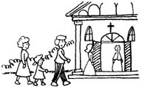
Family eats a big dinner on Easter Sunday. |  | 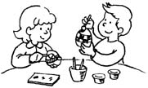
Eggs, flowers, rabbits, and chicks are all the signs of Easter.  They are signs of new life. |  | 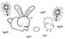

3-1

Happy Easter Chant
- 念念看，並寫出新的韻文唷！
* Let’s Chant Together…
Rabbit, rabbit, carrot eater.

He says there is nothing sweeter
Than a carrot every day.
Munch and crunch and run away.
* Let’s Chant More…
Chick, chick, rice eater.
Rabbit, rabbit, carrot eater.
She says there is nothing sweeter
Than rice every day,
Munch and crunch and run away.
* Now, please create your own chant. Then read it to your classmates.
, , eater.
says there is nothing sweeter
Than every day.
Munch and crunch and run away.
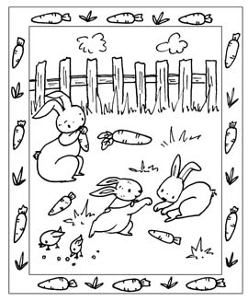
3-2

