拯民國小97學年度第一學期 第二次考試 英語科 六年甲 班 號姓名___________

一、看圖並連至正確單字 (8 分)
1. |   ( ) 1. wood  ( ) 2. wool  ( ) 3. brook
2. | 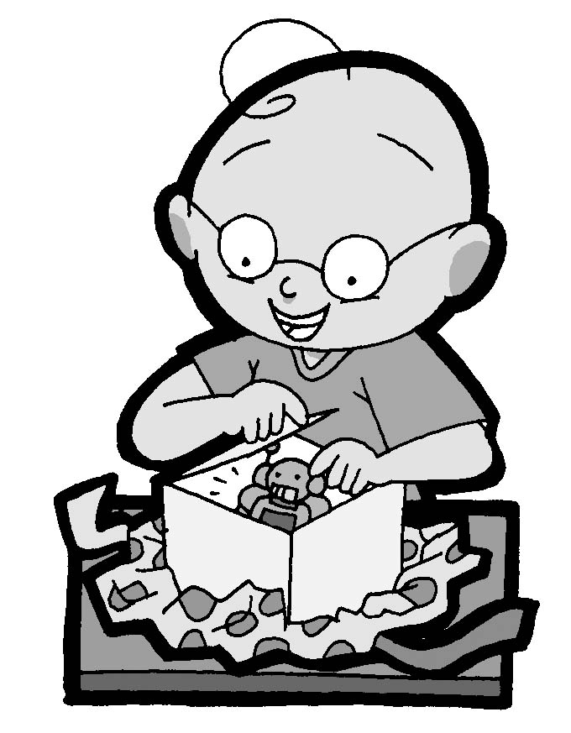  1. bored  a.  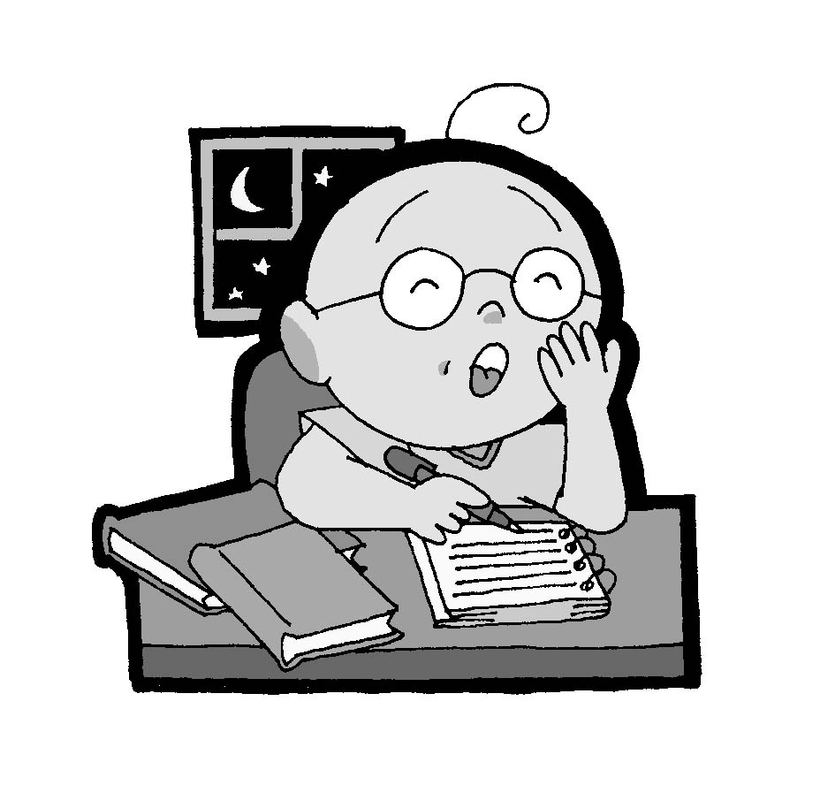  2. tired  b.    3. excited  c.  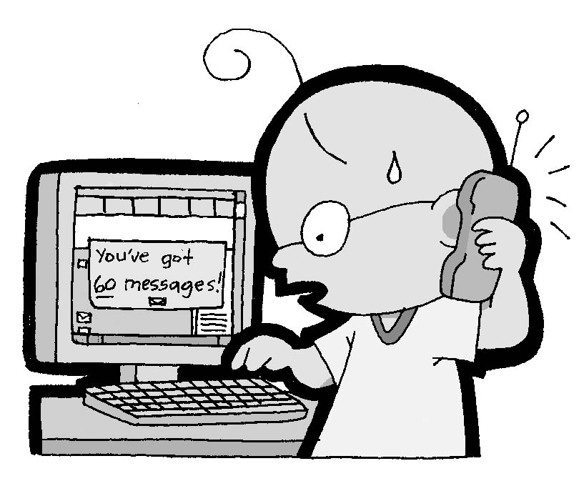  4. happy  d.  5. busy  e.  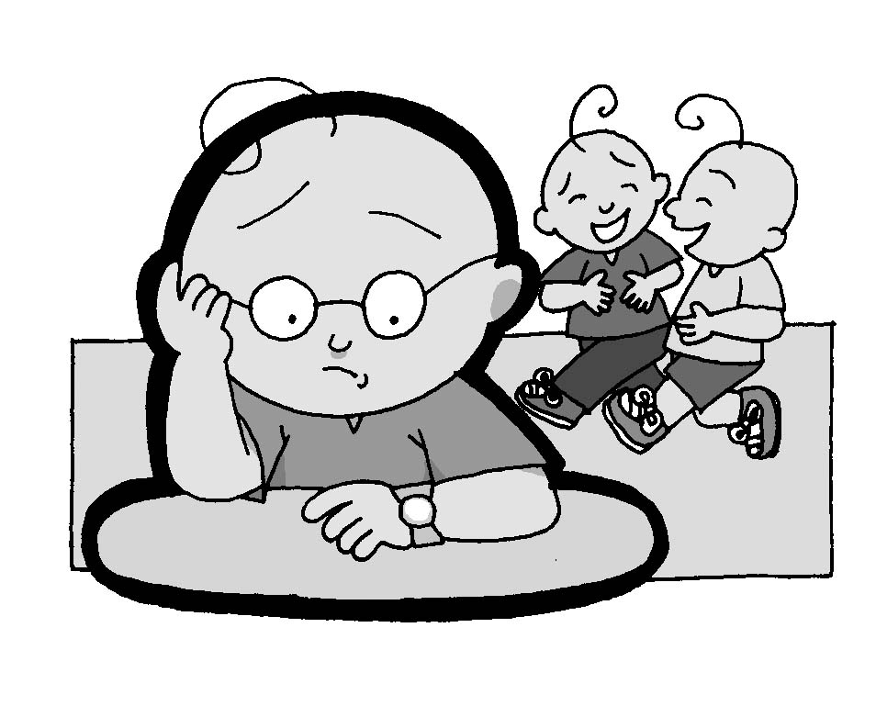

二、圈出符合圖片的單字 (10 分)
1. | (A) restaurant  (B) bookstore  (C) hospital
2. | 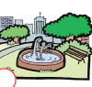  (A) bank  (B) park  (C) zoo
3. | (A) happy  (B) excited  (C) sick
4. | 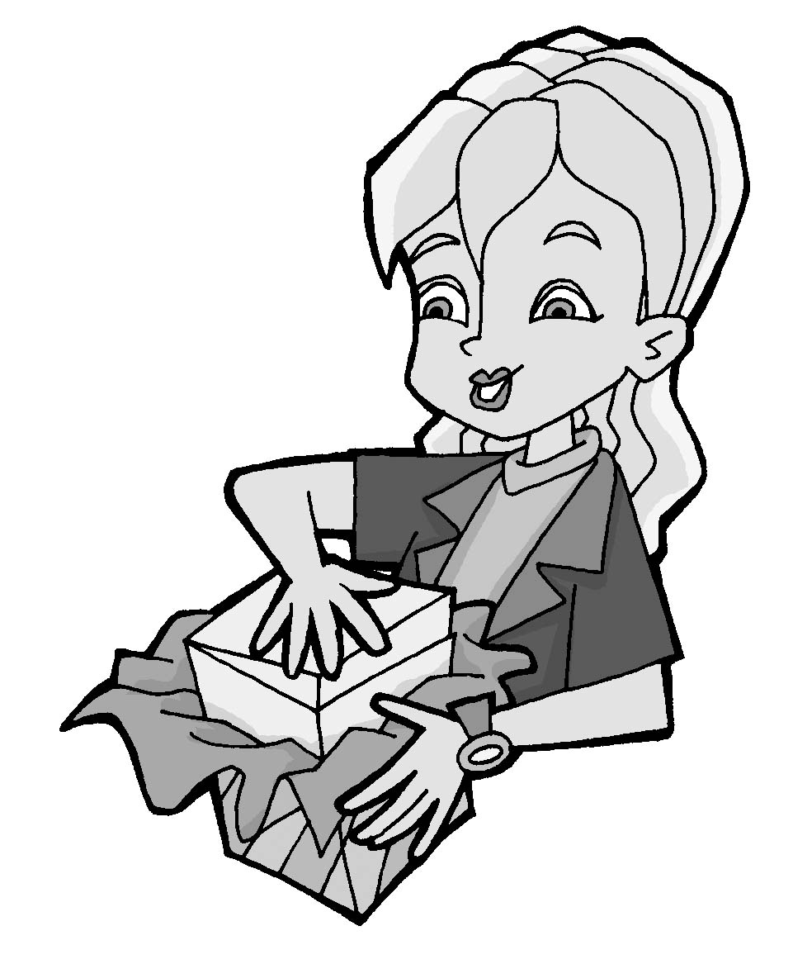  （ ） (A) bored  (B) excited  (C) tired
5. | 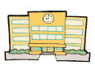  (A) beach  (B) park  (C) school

三、看圖並判斷句子正誤 (16 分)
1. | ( ) I have to walk my dog  every day.
2. | （ ）She plays the guitar.
3. | ( ) Anna is going to the park.
4. | （ ）My brother feeds the fish every day.
5. | 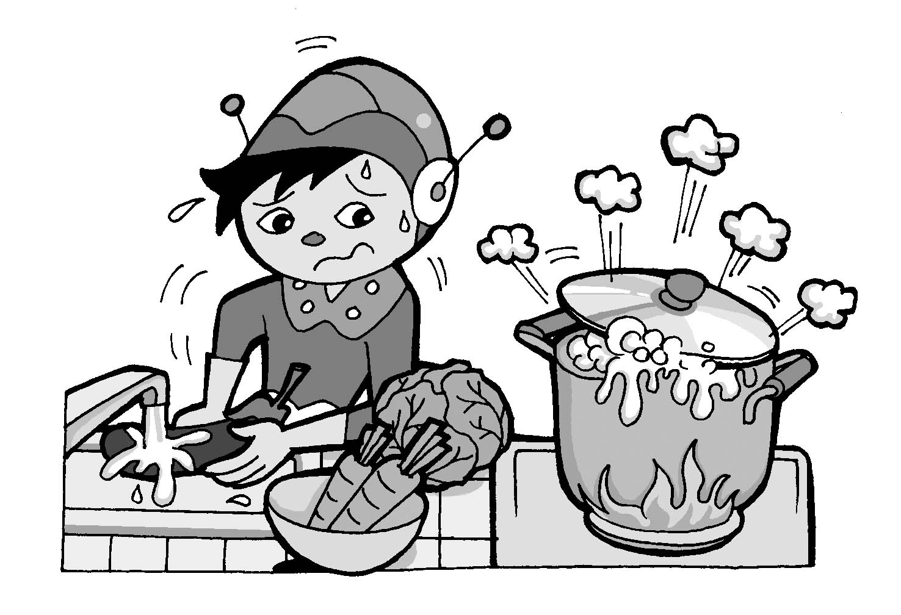   He is happy.   He is busy.   He is tired.
6. | （ ）These are Monkeys. They are a family.
7. | 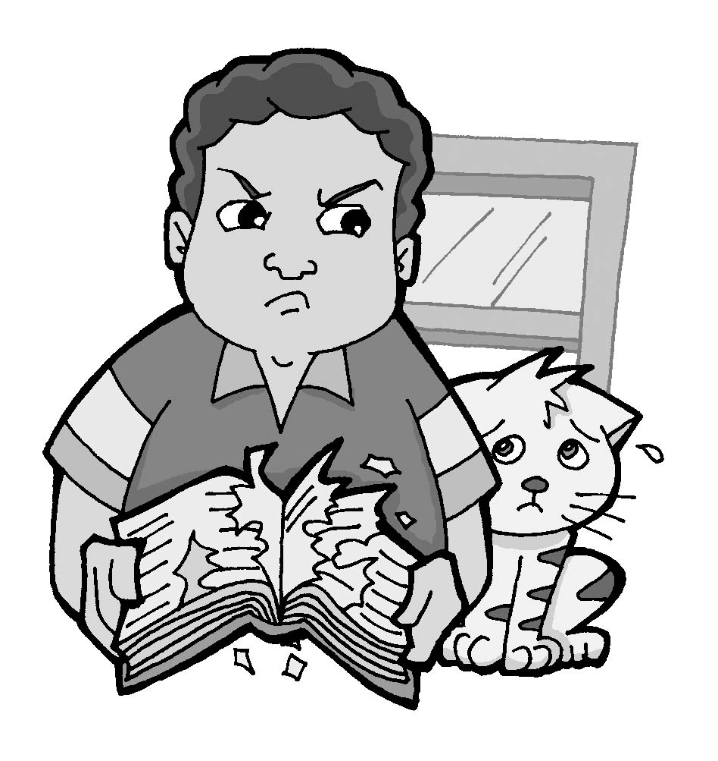   He is excited.   He is mad.   He is sick.
8. | 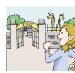  ( ) Come on! Let’s go to the  zoo!

四、仔細讀並選出正確的回答 (16 分)
1. | They have a show seven o’clock.  (A) in (B) on (C) at
2. | ( ) Where is Carlos ?  (A) go to  (B) going to  (C) going
3. | These are the monkeys. They are a .  (A) band (B) piano (C) singers
4. | ( ) A: Where are you going?  B: I going to the hospital.  (A) is  (B) are  (C) am
5. | （ ） A: How is Anna?  B: She is ______.  (A) coil (B) moon  (C) sad
6. | ( )  A: Grandma, I forgot my English book.  B: your book?  A: It’s on the sofa in the living room.  (A) Where’s (B) What’s (C) How is
7. | （ ） A: I think Kelly is mad.  B: That’s ______ bad.  (A) sorry (B) too  (C) excited
8. | ( )  A: can you help me, .  B: Sure.  (A) too (B) OK (C) please

五、仔細讀並完成句子的順序 (12 分)
1. | （ ） Me, too.  （ ） OK! Let’s eat lunch.  （ ） I am starving.
2. | （ ） She is a singer.  （ ） Who is she?  （ ） She’s pretty.
3. | ( ) I’m going to the bank. What about Anna?  ( ) She’s going to the park.  ( ) Where are you going?
4. | （ ） Come on! Let’s go there.  （ ） She’s happy now.  （ ） Look! That’s a castle.

六、看圖圈出正確的答案 (9分)
1. | 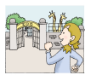  (A) Let’s go to the zoo.  (B) Let’s go home.
2. | (A) Time to go home.  (B) Time to walk the dog.
3. | (A) David is sick in bed.  (B) Bob does the dishes.  (C) Fred cleans the bathroom.

七、重組 (14 分)
1. | ekstmraurep
2. | t / o / a / b / s  →______________
3. | o / e / g / o / s  →______________
4. | lopo
5. | ! / Well / to / , / go / time / home  →___________________________________
6. | you / do / What / ? / play

八、聽教師念並寫出正確答案 (15 分)
1. | Sorry, I have to go to the .
2. | Where’s Bruce going?  He’s going to the .
3. | Jason is so .
4. | What do you play?  I play the .
5. | Kelly is going to the .

