國小英語科 第三次考試五 年級___________ 班別___________ 姓名___________

一、看圖並連至正確單字 (0 分)
1. | 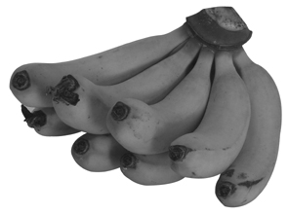  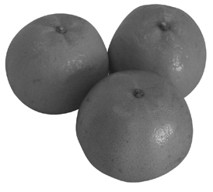  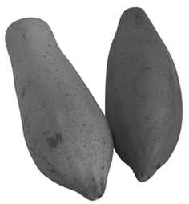  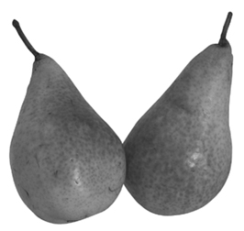  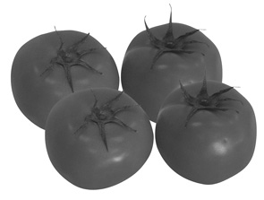  1.papayas a  2.bananas  b  3.pears c  4.oranges d  5.pears e
2. | 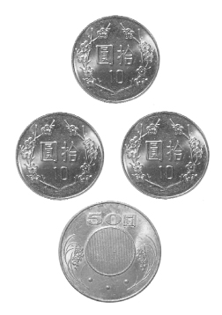  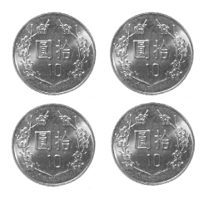  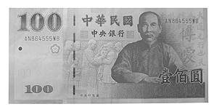  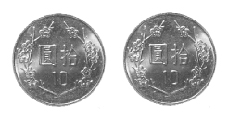  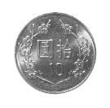  1. ten  a  2. twenty  b  3. forty  c  4. one hundred  d  5. eighty  e
3. | 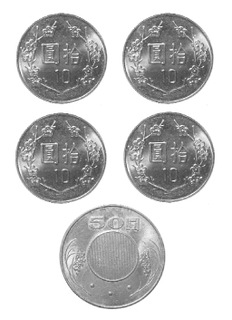  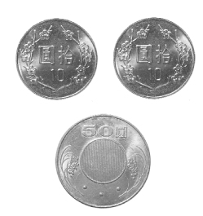  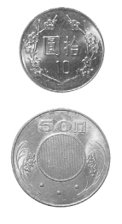  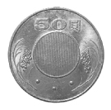  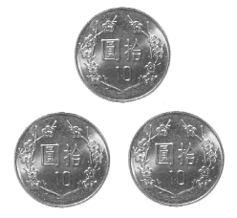  1. thirty  a  2. ninety  b  3. sixty  c  4. seventy  d  5. fifty  e
4. | 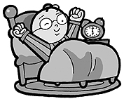  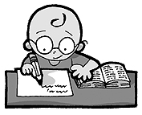  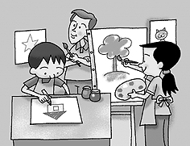    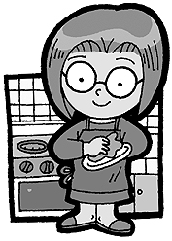  1.busineseman a  2.get up b  3.art c  4.do homework d  5.housewife e

二、圈出符合圖片的單字 (0 分)
1. | ( ) (A) ten dollars  (B) fifty dollars  (C) one hundred dollars
2. | ( ) (A) ten dollars  (B) one hundred dollars  (C) fifty dollars
3. | ( ) (A) twenty dollars  (B) sixty dollars  (C) seventy dollars
4. | ( ) (A) eighty dollars  (B) twenty dollars  (C) forty dollars
5. | ( ) (A) ninety dollars  (B) ten dollars  (C) fifty dollars

三、看圖並判斷句子正誤 (0 分)
1. | 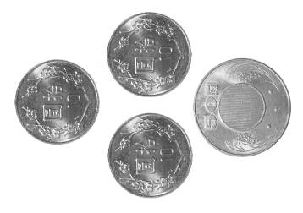   The markers are eighty dollars.   The markers are eighty dollars.   The markers are eighty dollars.
2. |  The umbrella is forty dollars.   The umbrella is fourty dollars.   The umbrella is four ten dollars.

四、仔細讀並選出正確的回答 (0 分)
1. | ( ) What color is the guava?  (A) It is green.  (B) It is a green.  (C) It is a guava.
2. | ( ) What color is the orange?  (A) I need two oranges.  (B) The orange is orange.  (C) The orange is sweet.
3. | ( ) How much are the bananas?  (A) It is forty dollars.  (B) I only have forty dollars.  (C) They’re forty dollars.
4. | ( ) How many crayons do you need?  (A) I need twenty dollars.  (B) I need twelve crayons.  (C) The crayons are cheap.
5. | ( ) John: How much is the book?  Rudy:  (A) It’s cheap.  (B) It’s ten dollars.  (C) It’s expensive.
6. | ( ) Harry: How much are the pencils?  Ron:  (A) They’re twenty dollars.  (B) It’s twenty dollars.  (C) They is twenty dollars.
7. | ( ) Kevin: How much are the crayons?  David:  (A) It’s a good one.  (B) It’s thirty dollar.  (C) They’re thirty dollars.
8. | ( ) How many pears does your sister need?  (A) She has ten pears.  (B) She likes to eat pears.  (C) She needs ten pears.
9. | ( ) How many apples do you need for your salad?  (A) I can make a salad.  (B) I need four apples for my salad.  (C) I love salad.
10. | ( ) Leo: How much are the oranges?  Lucy:  (A) They’re seventy dollars.  (B) It’s seventy dollars.  (C) It’s seventy dollar.

五、仔細讀並完成句子的順序 (0 分)
1. | ( ) I want to be a reporter, too.  ( ) My father is a reporter.  ( ) My name is Jane.
2. | ( ) Here you are.  ( ) A sandwich, please.  ( ) Thank you.
3. | ( ) How much are the pencils?  ( ) They’re cheap.  ( ) They’re seventy dollars
4. | ( ) Ouch! It is hurt!  ( ) That’s OK.  ( ) I’m sorry.
5. | ( ) It’s sixty dollars.  ( ) How much is the book?  ( ) OK! Here you are.
6. | ( ) How much are the bags?  ( ) They’re ninety dollars.  ( ) Wow! They’re cheap.
7. | ( ) They’re sixty dollars.  ( ) They’re so expensive.  ( ) How much are the books.
8. | ( ) They’re fifty dollars.  ( ) How much are the crayons?  ( ) It’s expensive.
9. | ( ) How much are the crayons?  ( ) They’re fifty dollars.  ( ) They’re cheap. I can buy them.
10. | ( ) They’re forty dollars.  ( ) How much are the apples?  ( ) I’ll take that.
11. | ( ) Yes. How many mangoes do you need?  ( ) Do you have mangoes?  ( ) I need seven mangoes.
12. | ( ) How much is the apple?  ( ) That’s expensive!  ( ) It’s five dollars.
13. | ( ) We need three pears.  ( ) I like pears. How many pears do we need?  ( ) Let’s make a salad.
14. | ( ) It’s three dollars.  ( ) How much is the orange?  ( ) Wow! It’s cheap!
15. | ( ) I need a pencil case.  ( ) It’s forty dollars.  ( ) How much is the pencil case?
16. | ( ) How many guavas do you need?  ( ) I need one guava.  ( ) Here you are.
17. | ( ) Wow! It’s expensive.  ( ) It’s eighty dollars.  ( ) How much is the pencil?

六、看圖圈出正確的答案 (0 分)
1. | How many oranges do you need?  How much oranges do you need?
2. | She has fifty dollars.  She has fifteen dollars.
3. | I only have thirty dollars.  I only have thirteen dollars.
4. | The flowers are ninety dollars.  The flowers are nine dollars.
5. | 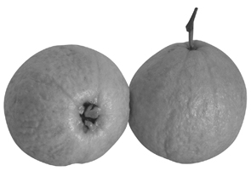  We need two guavas.  We need two apples.
6. | I only have twenty dollars.  I only have twelve dollars.
7. | I have one hundred dollars.  I have one hundred dollar.
8. | The notebook is seven dollars.  The notebook is seventy dollars.

七、重組 (0 分)
1. | have / wish / can / . / a / of / you / Each  →
2. | fitfy→
3. | sityx→
4. | expensive / , / too / . / The / crayons / are  →
5. | thirty / dollars / have / only / . / I  →
6. | forty-five / . / They’re / dollars  →
7. | ehyitg→
8. | How / are / much / the / ? / oranges  →
9. | is / book / the / ? / How / much  →
10. | hrduedn→
11. | pencils / the / are / ? / How / much  →
12. | sixty / . / dollars / They’re  →
13. | are / . / too / The / expensive / , / crayons  →

八、看圖拼字 (0 分)
1. | s__v__nty
2. | one h__ndr__d
3. | n__n__ty
4. | tw__nty d__llars
5. | s__xty d__llars
6. | f__ __ty
7. | f__fty
8. | __ __irty

九、聽教師念並寫出正確答案 (0 分)
1. | __ __ __ __ __
2. | __ __ __ ty
3. | __ __ __ __ __
4. | __ __ __ __ __ __
5. | __ __ __ __ __ __
6. | __ __ __ __ __ __

十、聽教師念並選出字母 (0 分)
1. | 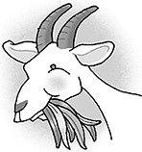  chew  watch
2. | 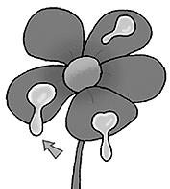  dew  do
3. | 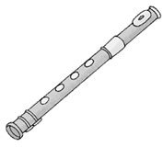  flute  flower
4. | 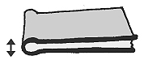  ting  thin
5. | 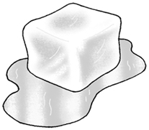  cube  cut

十一、聽教師念並選出正確的回應句 (0 分)
1. | ( ) (A) They’re one hundred dollars.  (B) They’re expensive.  (C) They’re cheap.
2. | ( ) (A) I am a doctor.  (B) I want to be a doctor.  (C) You are good kids.
3. | ( ) (A) It’s ten o’clock.  (B) It’s ten dollars.  (C) It’s ten days.
4. | ( ) (A) It’s fifty dollars.  (B) I like orange.  (C) I like it.
5. | ( ) (A) They’re twenty dollars.  (B) It’s twenty days.  (C) It’s two o’clock.
6. | ( ) (A) I like pencil.  (B) It’s 6:00.  (C) They’re forty dollars.
7. | ( ) (A) It’s thirty dollars.  (B) They’re thirty dollars.  (C) It’s thirty days.
8. | ( ) (A) I am a doctor.  (B) I want to be a teacher.  (C) My name is Peter.
9. | ( ) (A) We need seven apples.  (B) I like apples.  (C) It’s seventy dollars.
10. | ( ) (A) It’s time to go to school.  (B) I go to school by bike.  (C) I go to school at 7:30.
11. | ( ) (A) I like apples.  (B) They’re eighty dollars.  (C) I like oranges.
12. | ( ) (A) I like apples.  (B) It’s ninety dollars.  (C) We need five apples.

十二、聽教師念並圈出正確圖片 (0 分)
1.
2.
3.
4.
5.

十三、聽教師念並填入正確號碼 (0 分)
1. | ( ) how much  ( ) notebook  ( ) store  ( ) only
2. | ( ) cheap  ( ) hundred  ( ) ninety  ( ) dollar
3. | ( ) How many guavas does Ruby need?  (A) She needs two guavas.  (B) She needs two dollars.  (C) She needs twenty guavas.
4. | ( ) Are the guavas cheap?  (A) Yes, I am.  (B) Yes, they are cheap.  (C) Yes, she wants guavas.
5. | ( ) ninety  ( ) forty  ( ) thirty  ( ) sixty
6. | ( ) crayons  ( ) dollars  ( ) new  ( ) twenty
7. | ( ) singer  ( ) teacher  ( ) watch TV  ( ) art
8. | ( ) how much  ( ) notebook  ( ) store  ( ) only
9. | ( ) cheap  ( ) hundred  ( ) ninety  ( ) dollar
10. | ( ) How many tomatoes does Ruby need?  (A) She needs forty dollars.  (B) She needs four tomatoes.  (C) Tomatoes are cheap.
11. | ( ) fifty  ( ) sixty  ( ) seventy  ( ) eighty
12. | ( ) twenty  ( ) fifty  ( ) seventy  ( ) ninety
13. | ( ) forty  ( ) thirty  ( ) ten  ( ) one hundred

十四、填空 (0 分)
1. | is, seventy, It’s  Mary: How much the orange?  Blue: dollars.
2. | Come, ready, am  Jerry: Are you ?  Allen: Yes, I .  Jerry: on, let’s go!
3. | are, oranges, They  Wang: How much are the ?  Joe: eighty dollars.
4. | only, dollars, expensive  The crayons are . I have thirty .
5. | all, How, many, else  Boy: bananas do we need?  Girl: We need four bananas.  Boy: Anything ?  Girl: That’s .
6. | the, How, is, It  Cheng: much is banana?  Maya: ninety dollars.
7. | cool, Excuse, dollars, much, Look  Mary: at the toy cars!  Edison: They’re !  Mary: me. How are the toy cars?  Jason: They’re eighty .
8. | dollars, expensive, only, hundred, is  Judy: How much the notebook?  Shopkeeper: It’s one .  Judy: It’s . I have ninety dollars.
9. | Here, fifty, please, May  Bonnie: I have the pencil case, ?  Annie: you are.  Bonnie: How much is the pencil case?  Annie: It’s dollars.
10. | seventy, They’re, book, are  How much is the ?  It’s dollars.  How much the pencils?  sixty dollars.
11. | are, much, many, dollars  How oranges do we need?  We need two oranges.  How they?  They are eighty .
12. | ten, much, book  Carlos: How is the ?  Nett: It’s dollars.
13. | two, too, many, need  Chanson: We three apples.  Mon: We need pears, .  Chanson: How oranges do we need?  Mon: We need oranges.
14. | twenty, are, books  Bob: How much the ?  Catch: They’re dollars.
15. | how, dollars, much  Alice: is the pencil?  May: It’s thirty .
16. | are, They’re, How  David: much the pencils?  Nice: forty dollars.
17. | They’re, are, the  Guess: How much apples?  Harry: sixty dollars.

十五、把不同類型的字刪掉 (0 分)
1. | Cross the word that doesn’t belong to the group.（把不同類型的字刪掉）  housewife reporter apple
2. | teacher pencil engineer
3. | 把不同類型的字刪掉  go home get up math
4. | 把不同類型的字刪掉  music go to bed go home
5. | 把不同類型的字刪掉  science lunch math

十六、根據提示回答問題 (0 分)
1. | 根據提示回答問題  What’s your name? (Anna)
2. | 根據提示回答問題  What classes do you like? (math)
3. | 根據提示回答問題  Do you like English class? (Yes)
4. | 根據提示回答問題  “Do you want to be a doctor? (No)
5. | 根據提示回答問題  What time do you get up? (7:20)

十七、閱讀 (0 分)
1. | Read and choose.  （仔細讀，並選出正確答案。）  Ann: Do you have book bag?  Bill: Yes, we do.  Ann: How much is the book bag?  Bill: It’s one hundred dollars.  Ann: It’s cheap. I need pencils, too.  Bill: How many pencils do you need?  Ann: I need five pencils.  Bill: Here you are.  Ann: How much are the pencils?  Bill: They’re fifty dollars.  Ann: Wow! They’re cheap, too. I want a book bag and five pencils.  ( ) What does Ann need?  (A) She needs a book bag and five pencils.  (B) She doesn’t need anything.  (C) She needs five crayons.
2. | ( ) How much is the book bag?  (A) She needs a book bag.  (B) The book bag is one hundred dollars.  (C) The book bag is cheap.
3. | ( ) How many pencils does Ann need?  (A) She needs a book bag.  (B) They’re fifty dollars.  (C) She needs five pencils.
4. | ( ) How much are the pencils?  (A) They’re one hundred dollars.  (B) They’re fifty dollars.  (C) She needs five pencils.
5. | ( ) How much is a pencil?  (A) It’s ten dollars.  (B) It’s fifty dollars.  (C) They’re five pencils.
6. | Ruby: Excuse me. How much are the tomatoes?  Willy: How many tomatoes do you need?  Ruby: I need four tomatoes. How much are they?  Willy: They’re twenty dollars.  Ruby: OK. That’s cheap. I need two guavas, too. How much are they?  Willy: They’re twenty dollars.  Ruby: Great! Guavas are cheap, too.  Willy: Here you are.  Ruby: Thank you.  ( ) What does Ruby need?  (A) She needs tomatoes and guavas.  (B) She needs forty dollars.  (C) She wants to make a salad.

十八、仔細聽，勾選出正確單字 (0 分)
1. | Listen to the teacher and check the sounds.  （仔細聽，勾選出正確的單字）   bone   born   been
2. |  cold   coat   cool
3. |  juice   choose   chew
4. |  fly   flute   flower
5. |  nose   snow   show

