拯民國小97學年度第一學期 第二次知能考查 英語科 五年甲班 號 姓名 ___________

一、圈出符合圖片的單字 (10 分)
1. | 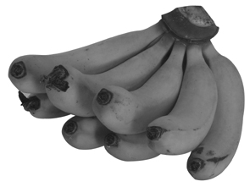  ( ) (A) tomatoes  (B) bananas  (C) pears
2. |   ( ) (A) reporter  (B) doctor  (C) teacher
3. |   ( ) (A) doctor  (B) reporter  (C) singer
4. |   ( ) (A) reporter  (B) businessman  (C) police officer
5. | 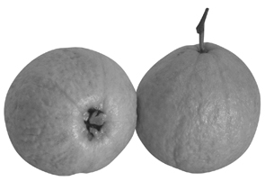  ( ) (A) guavas  (B) bananas  (C) mangoes

二、看圖並判斷句子正誤 (6 分)
1. | （ ） My father is a businessman.
2. | （ ） There are eight mangoes.

三、仔細讀並選出正確的回答 (15 分)
1. | ( ) Lucy: What do you want to be?  Tracy:  (A) I want to be an engineer.  (B) I want to go home.  (C) I go to school at 7:30.
2. | ( ) Rod: How many guavas do we need?  May:  (A) We need two dollars.  (B) We need four guavas.  (C) We can do it.
3. | ( ) Hans: What time do you do your homework?  Mary:  (A) I eat breakfast at 6:30.  (B) I watch TV at 6:30.  (C) I do my homework at 6:30.
4. | ( ) Kevin: How many oranges do we need?  Coco:  (A) We need five oranges.  (B) We need two books.  (C) We need three dollars.
5. | ( ) Vivian: What time do you go to bed?  Coco:  (A) I eat breakfast at 9:30.  (B) I go to bed at 9:30.  (C) I go to school at 9:30.

四、仔細讀並完成句子的順序 (15 分)
1. | ( ) I want to be a singer.  ( ) That’s a good idea.  ( ) What do you want to be?
2. | ( ) We need seven bananas.  ( ) How many bananas do we need?  ( ) Are you sure?
3. | ( ) I have no idea.  ( ) What do you want to be?  ( ) Try to think.
4. | ( ) I want to be a reporter.  ( ) What do you want to be?  ( ) I know you can.
5. | ( ) My PE class is at 9:00.  ( ) You are late! It’s 9:10.  ( ) What time is your PE class?

五、看圖圈出正確的答案 (10 分)
1. |   Joy wants to be a singer.  Joy want to be a singer.
2. |   I want to be a engineer.  I want to be an engineer.
3. | 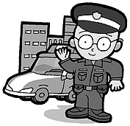  He is a police officer.  He is a teacher.
4. | 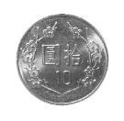  It’s ten dollars.  It’s ten o’clock..
5. | My father is a teacher.  My fatyer is a reporter.

六、重組 (25 分)
1. | books / bring / ? / How / you / many / do  →
2. | great / sounds / ! / It  →
3. | people / family / in / ? / your / How / many  →
4. | can / well / sing / I/.  →
5. | all / my / for / salad / ! / That’s  →

七、聽教師念並填入正確號碼 (8 分)
1. | ( ) job  ( ) kid  ( ) people  ( ) right
2. | ( ) fruit  ( ) grapes  ( ) need  ( ) we

八、填空 (11 分)
1. | you, sandwich, please  Chanson: Give me a , .  Billy: Here are.
2. | idea, be, Superman, want  Teacher: What do you to ?  Tom: I want to be a .  Teacher: That is a good
3. | name, Hello, too, want  ! My is Jeffrey. My mother is a housewife. My father is a doctor. I to be a doctor, .

