雲林縣拯民國小九十七國小英語科 第一次考試 年級___________ 班別___________ 姓名___________

一、看圖並連至正確單字 (5 分)
1. | 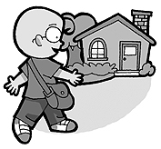  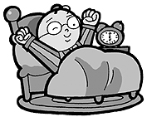  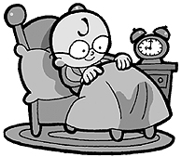  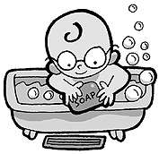  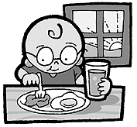  1. go home a  2. go to bed b  3. take a bath c  4. eat breakfast d  5. get up e
2. | 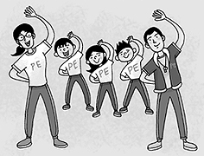  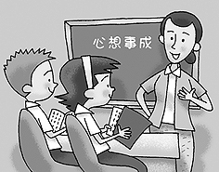  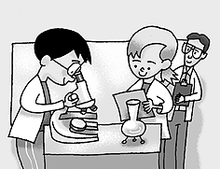  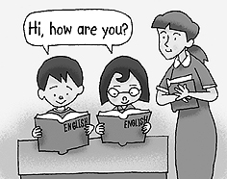  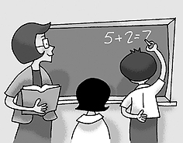  1. Chinese  a  2. English  b  3. math  c  4. PE  d  5. science  e
3. | 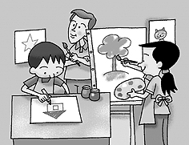  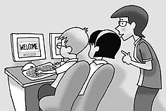  1. art  a  2. computer  b  3. music  c  4. English  d  5. math  e

二、圈出符合圖片的單字 (5 分)
1. | ( ) (A) English  (B)Chinese  (C)science
2. | ( ) (A) do homework  (B) eat breakfast  (C) take a bath
3. | 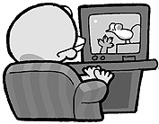  ( ) (A) take a bath  (B) eat breakfast  (C) watch TV
4. | 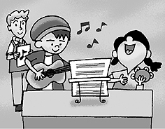  ( ) (A) computer  (B) science  (C) music
5. | 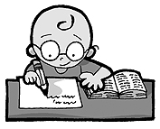  ( ) (A) do homework  (B) eat breakfast  (C) science

三、看圖並判斷句子正誤 (5 分)
1. | （ ） That’s PE class.
2. | （ ） It’s time for music class.
3. | （ ） What time do you go to bed?
4. | （ ） What time do you eat breakfast?
5. | （ ） I study art on Monday.

四、仔細讀並選出正確的回答 (7 分)
1. | ( ) John: What time do you play computer games?  Bob:  (A) I eat breakfast at 7:30.  (B) I watch TV at 7:30.  (C) I play computer games at 7:30.
2. | ( ) David: What time do you eat breakfast?  Leo:  (A) I eat breakfast at 6:30.  (B) I watch TV at 7:30.  (C) I like to eat breakfast!
3. | ( ) Carlos: How are you today?  Kelly:  (A) Nice to meet you, too.  (B) I’m great. Thanks.  (C) See you.
4. | 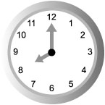  ( )  My first class is at .  (A) 10:00  (B) 8:00  (C) 9:00
5. | ( ) Gigi: What time do you go home?  Sam:  (A) I eat breakfast at 7:30.  (B) I go home at 6:30.  (C) I go to school at 7:30.
6. | ( ) Jacky: What time do you watch TV?  Jerry:  (A) I eat breakfast at 6:30.  (B) I watch TV at 7:30.  (C) I take a bath at 5:30.
7. | 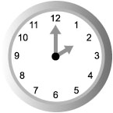  ( )  Anna: What time’s your math class?  Mark: It’s at ______.  (A) 2:00  (B) 12:00  (C) 10:00

五、仔細讀並完成句子的順序 (6 分)
1. | ( ) I go to school at 7:00.  ( ) What time do you go to school?  ( ) Me too.
2. | ( ) Do you like to do homework?  ( ) No, I don’t like to do it at all.  ( ) But you don’t have choice, right?
3. | ( ) I get up at 6:00.  ( ) What time do you get up?  ( ) It’s early.
4. | ( ) What time do you eat breakfast?  ( ) Hurry up! Time to go to school.  ( ) I eat breakfast at 7:40.
5. | ( ) It’s music class.  ( ) What class is that?  ( ) Look! That’s my school.
6. | ( ) Yes, I love it.  ( ) It’s at 10:30. Do you like your English class?  ( ) What time’s your English class?

六、看圖圈出正確的答案 (10 分)
1. | get up  do homework
2. | What class is that?  That’s computer class.  That’s Chinese class.
3. | 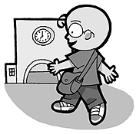  go to school  go to bed
4. | take a bath  watch TV
5. | go home  do homework
6. | go to bed  go home
7. | What time is it?  What class is that?
8. | I like study English.  I like study Chinese.
9. | What time is your PE class?  10:30  It’s at ten thirty.  It’s at nine thirty.
10. | Do you like your science class?  Do you like your math class?

七、重組 (10 分)
1. | your / ! / I / like / school  →
2. | It's / . / o’clock / at / eleven  →
3. | too / , / to / meet / you / Nice / .  →
4. | mtah→
5. | are / How / you / ?  →
6. | I / great /. /am /  →
7. | scneeic→
8. | English / class / ? / like / your / Do / you  →
9. | meet / nice / too / , / . / to / you  →
10. | is / your / What / class / ? / time / Chinese  →

八、看圖拼字 (19 分)
1. | __ __t breakfast
2. | m __ s __ c
3. | go h__m__e
4. | go to sch__ __l
5. | Ch__n__s__

九、聽教師念並寫出正確答案 (1 分)
1. | __ __ __ __ __ __ __
2. | __ __ __ __ __ __ __ __ __ __

十、聽教師念並選出字母 (1 分)
1. | 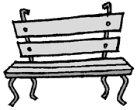  bench  brush

十一、聽教師念並選出正確的回應句 (1 分)
1. | ( ) (A) I go home at 5:00.  (B) I do homework at 8:30.  (C) I go to bed at 9:30.
2. | ( ) (A) My math class is at 4:00.  (B) I like science class.  (C) My science class is at 4:00.
3. | ( ) (A) It’s nine o’clock.  (B) That’s PE class.  (C) Yes, I love it.

十二、聽教師念並圈出正確圖片 (1 分)
1. | ( ) (A) Let’s O.K.  (B) See you.  (C) Nice to meet you, too.
2.

十三、聽教師念並填入正確號碼 (12 分)
1. | ( ) PE  ( ) Chinese  ( ) music  ( ) math
2. | ( ) go to bed  ( ) get up  ( ) go home  ( ) go to school
3. | ( ) watch TV  ( ) eat breakfast  ( ) take a bath  ( ) go home
4. | ( ) go to school  ( ) watch TV  ( ) do homework  ( ) get up
5. | ( ) Cool!  ( ) Bye.  ( ) late  ( ) love
6. | ( ) go to bed  ( ) eat breakfast  ( ) go home  ( ) take a bath

十四、填空 (5 分)
1. | at, computer, time  Coco: What is your class?  Frank: It’s 10:00.
2. | at, math, time’s  Sue: What your class?  May: It’s 11:00.
3. | at, English, time  Park: What is your class?  Bob: It’s 1:00.
4. | at, music, time  Mary: What is your class?  Leo: It’s 6:00.
5. | school, do, at  Candy: What time you go to ?  Mary: I go to school 8:00.

十五、把不同類型的字刪掉 (1 分)
1. | 把不同類型的字刪掉  juice math art

十六、根據提示回答問題 (1 分)
1. | Do you like your school? (Yes)  →
2. | Answer the question.（根據提示回答問題）  What time is your English class? (8:30)  →

十七、仔細聽，圈出聽到的圖片並寫出單字 (10 分)
1. | 仔細聽，圈出聽到的圖片並寫出單字
2. | 仔細聽，圈出聽到的圖片並寫出單字

