拯民國小97學年度第一學期英語科 第三次考試四 年級___________ 班別___________ 姓名___________

一. Read and Write the Letter 20%
讀一讀並填上正確圖片的字母
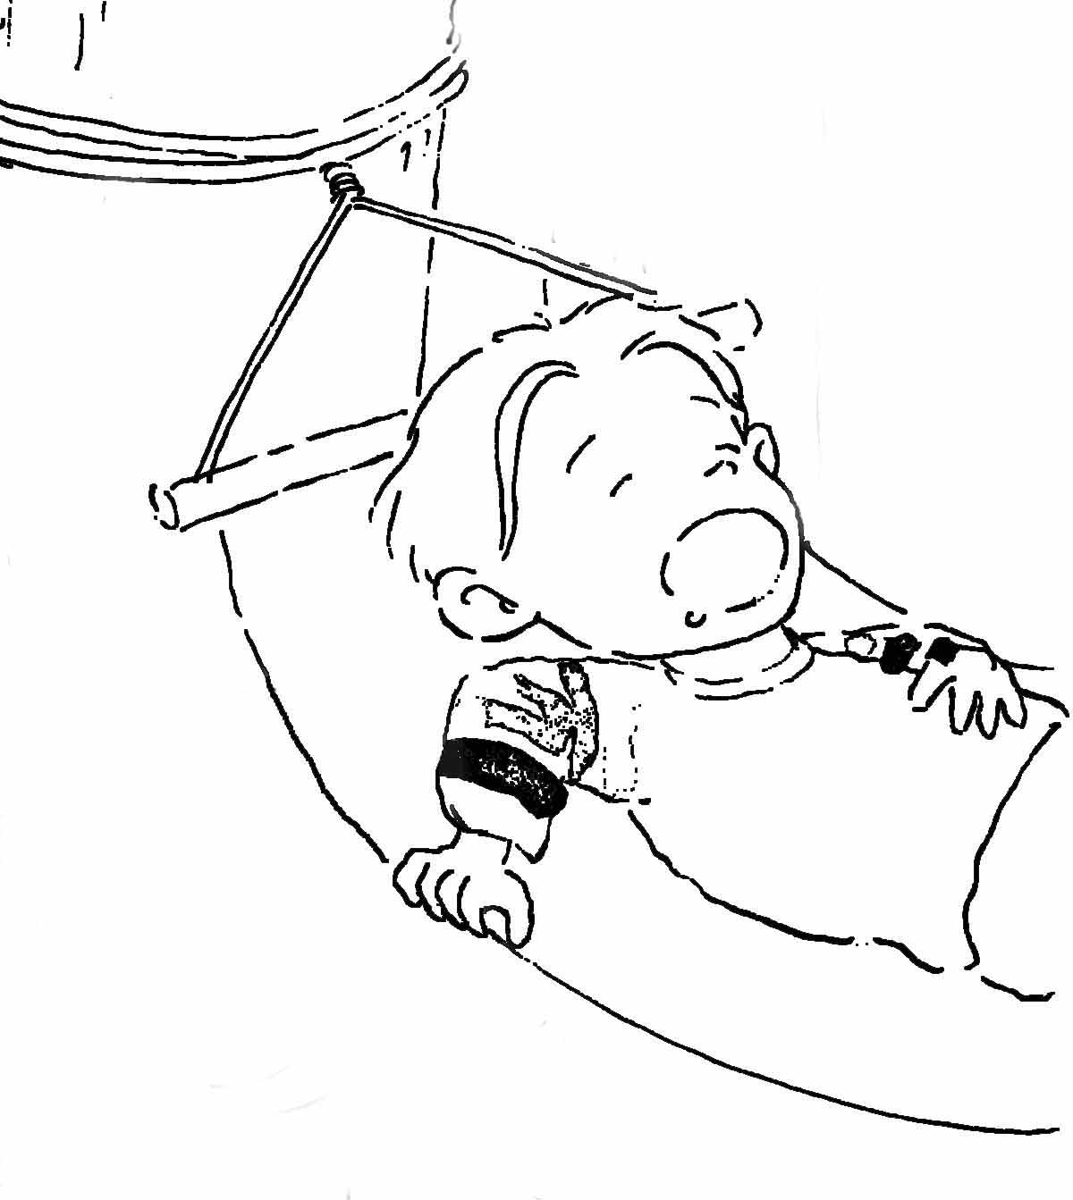  a. |  | 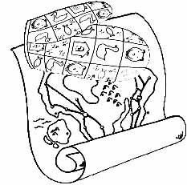  f.
  The mitt is on the map.
  Kim is hungry.
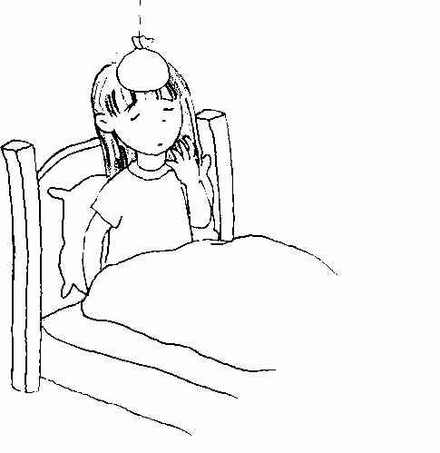  b. |  | 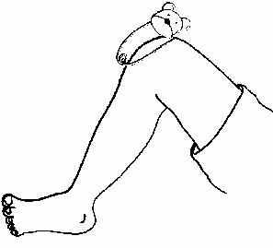  g.
  He is sleeping.
  The pin is on the leg.
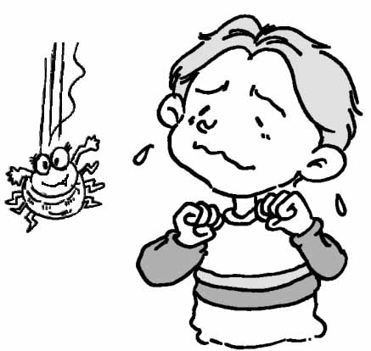  c. |  | 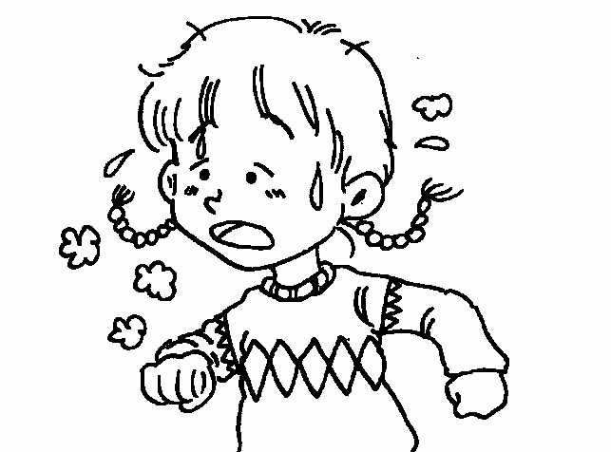  h.
  Angie is tired.
  Tony is scared.
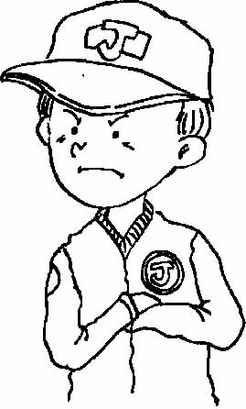  d. |  | 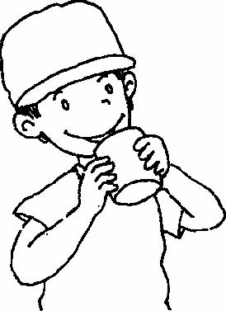  i.
  She is sick.
  Johnny is angry.
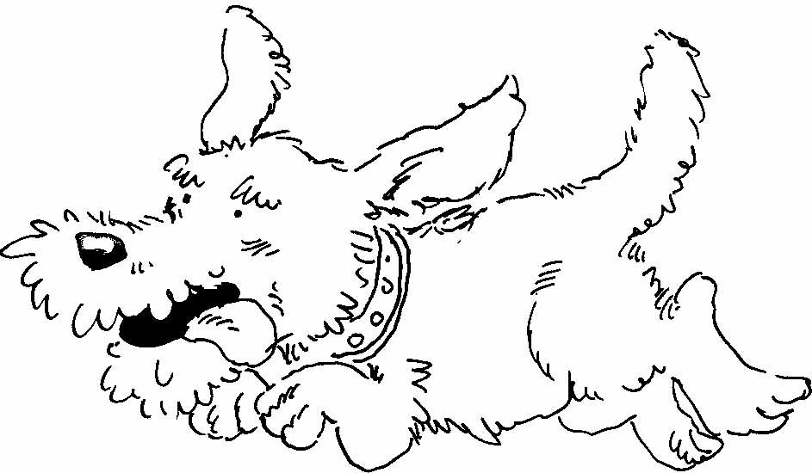  e. |  | 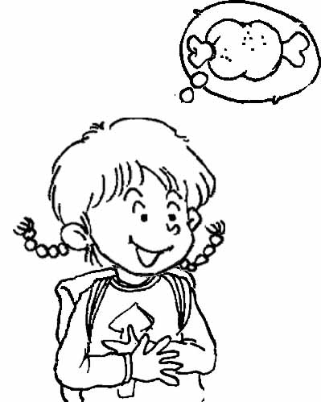  j.
  He is drinking.
  Fatty is running.

二. Unscramble the Sentences重組22%
1. are These . pine apples

2. ? / are / these / They’re / . / oranges / What

3. the juicy Are ? mangos

4. the is The . sun under bus

三. Multiple Choice選擇 10%
1. ( ) The pen is (❶ at ❷ on ❸ to) the lid.
2. ( ) This is (❶ in ❷ on ❸ for) you.
3. ( ) How (❶ old ❷ is old ❸olds) are you?
4. ( ) (❶ Are ❷ Am ❸ Is) he sick?
5. ( ) What are you (❶ do ❷ doing ❸ does)?

四. Look, read and check the correct sentences.
看圖並勾選出正確句子 10%
- We are going to the zoo. Have a good time.

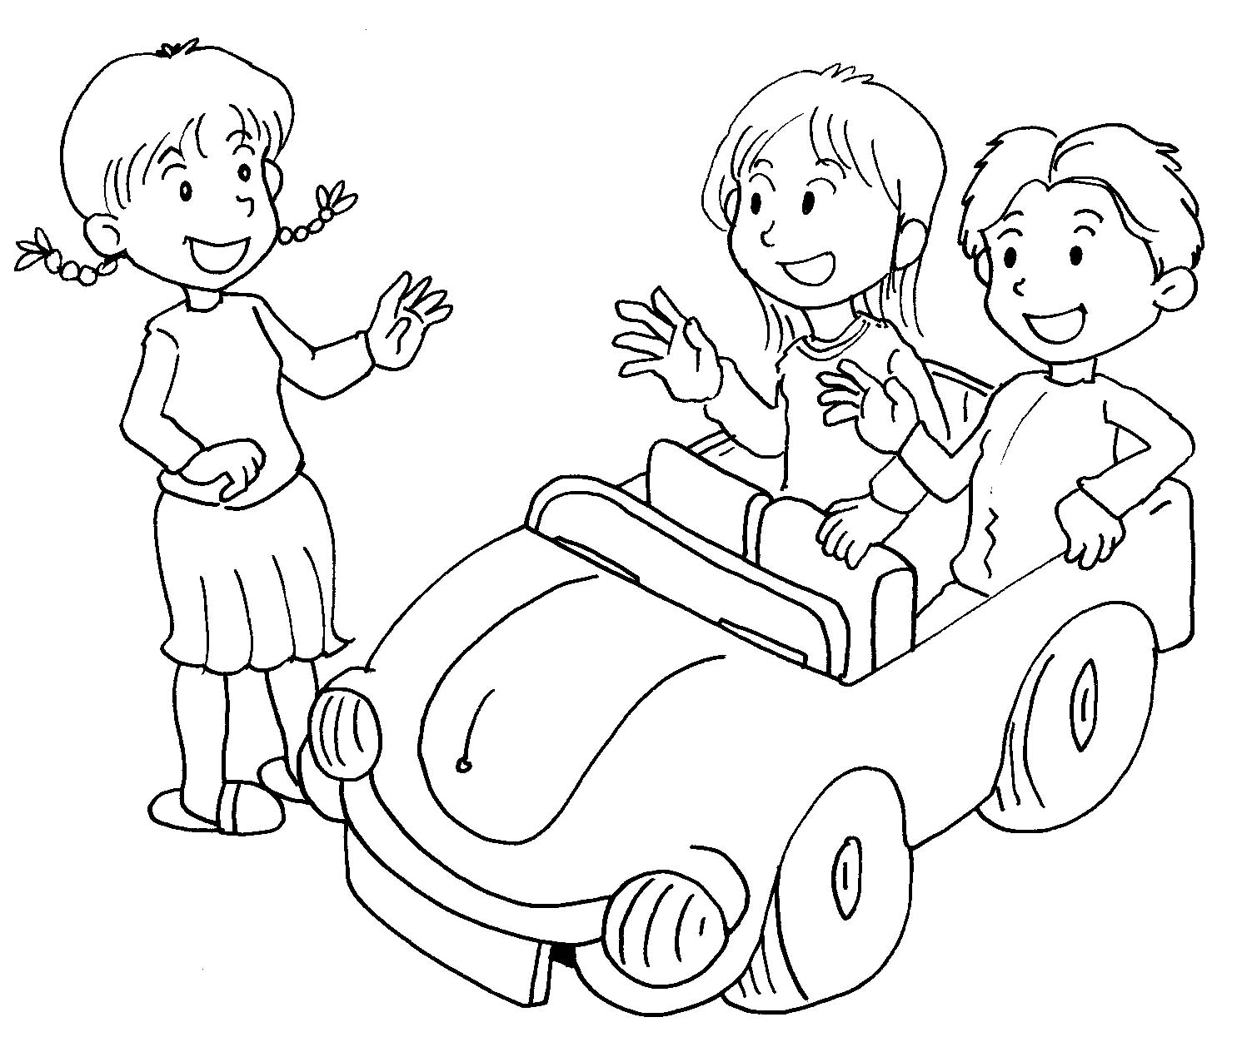
We are not hungry.

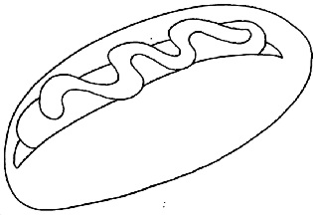
- We want a hot dog for Mom.

The doll is by the top.

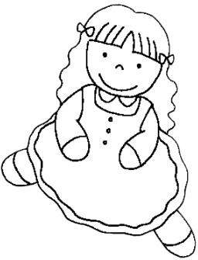
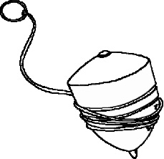
- The nut is wet.

The doll is by the top.

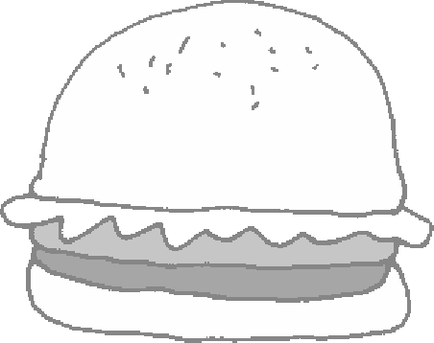
- What do you want? I want a hamburger.

What do you like? I like monkeys.

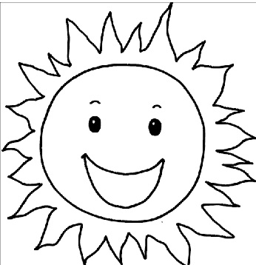
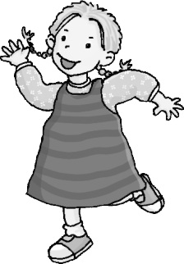
5. The cop is hopping.

I jump under the sun.

五.Circle the word that doesn’t belong to the group
圈出畫線部份發音不同獲不同類型的字 (20%)
1 pizza pencil police

2 teacher pencil doctor

3. brother birth mother

4. knee key new

5. thank three they

6. fly candy money

7. say bath hay

8. term singer sister

9. eight night right

10. mouse house could

六Look and Fill in the Blanks填充 18%
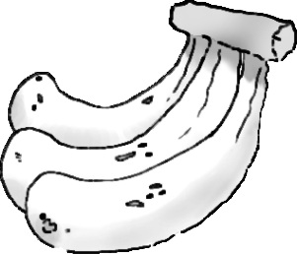
1. What are these?
They’re .

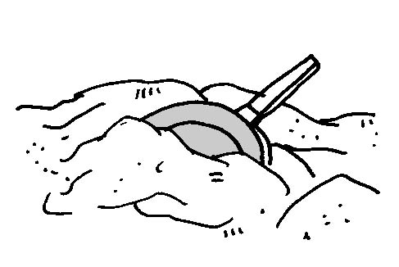
2. The pot is in the .

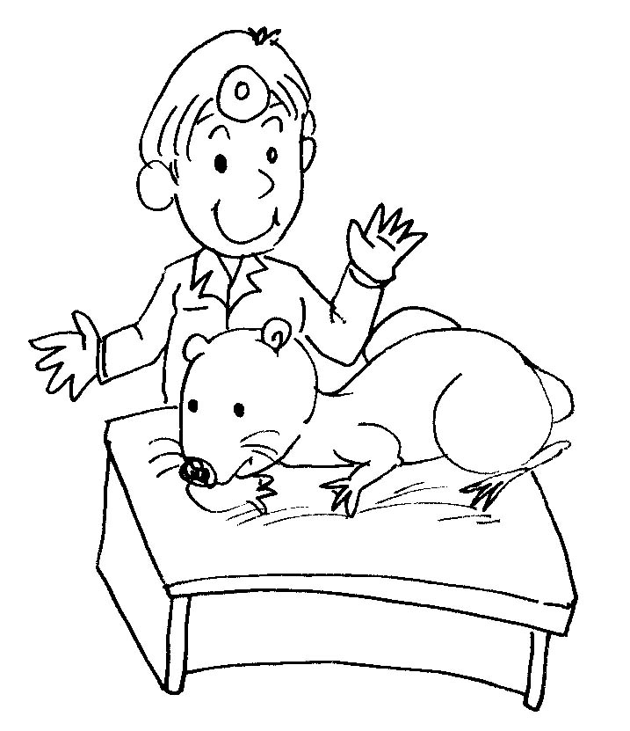
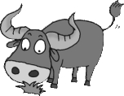
3. The is by an ox.

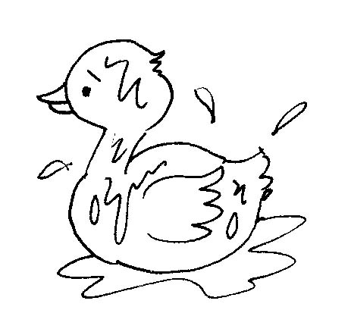
4. The duck is .

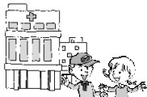
5. Where are you going?
We’re going to the .

6. . Kim: Where are you going,
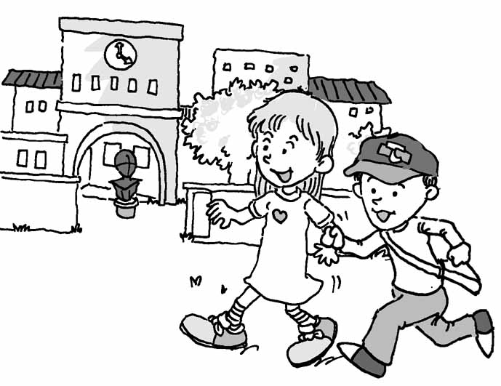
Angie and Johnny?

Angie & Johnny: We are going to the .

