一. Translation翻譯16%
1. She’s sleeping

2. Let’s be quiet!

3. 這是給你的。

4. 他累了嗎?是的，他累了。

二. Read and check the same short vowel sounds.

勾出相同的短母音的圖片8%
1. 2.

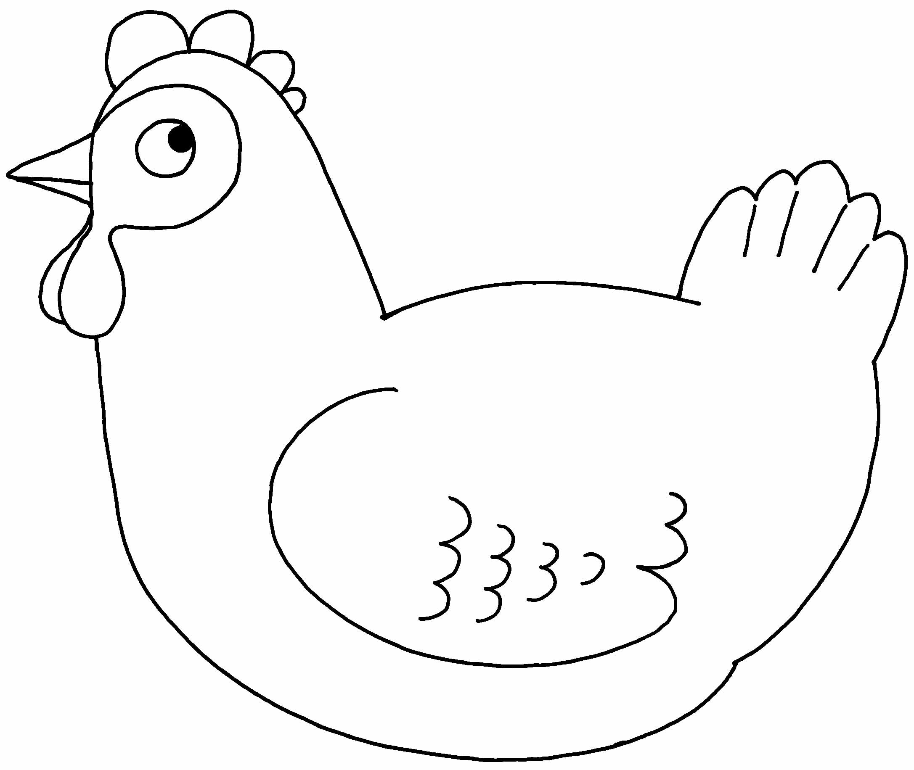
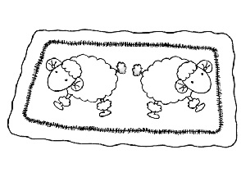



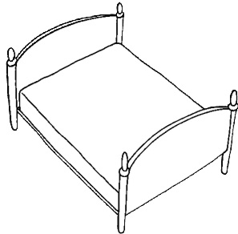
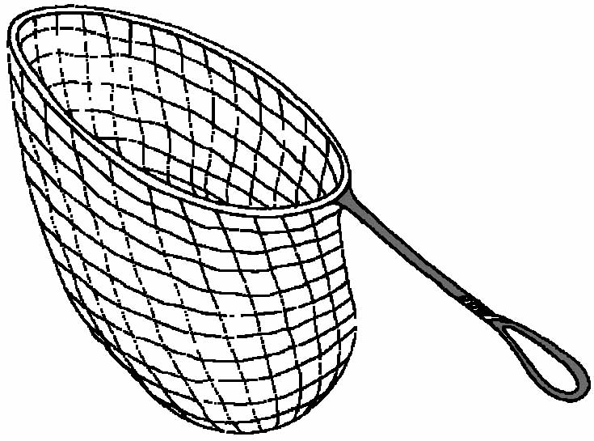
2.

3. 4.

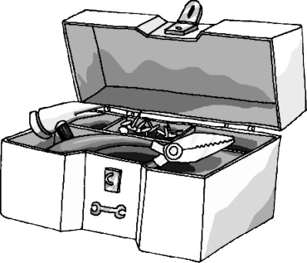
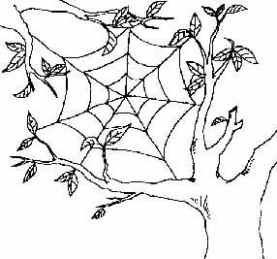
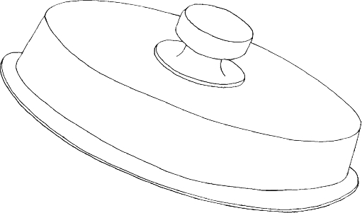

4.

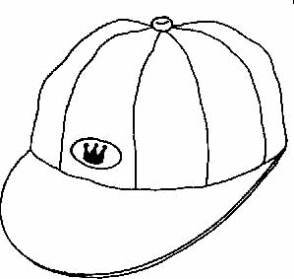
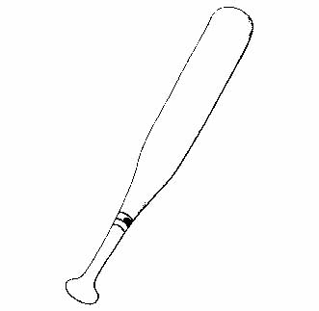
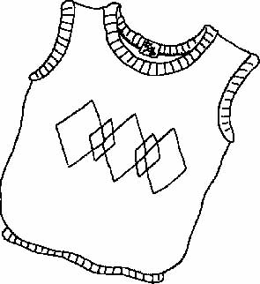

三. Read, Write and Number
讀句子寫出答案並在圖片中填入正確數字24%

1. The is on the rock.
2. Angie: Where are you going?
Tony: I am going to the .
3. She is going to the .
4. I like .
5. The old man is going to the .
6. Student: ! I’m late. May I come in?
Teacher: Come in, .
7. The hot is by the .
8. My mother is going to the .

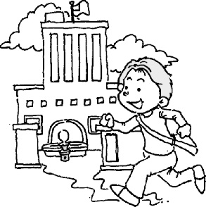 | 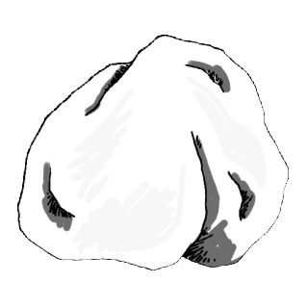  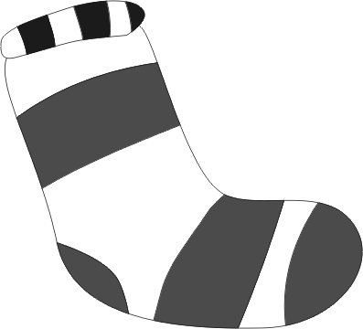 | 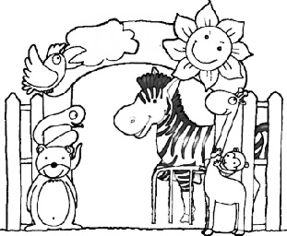  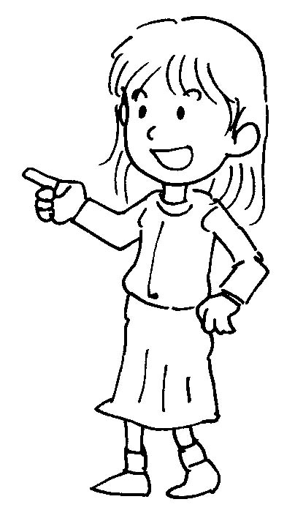 | 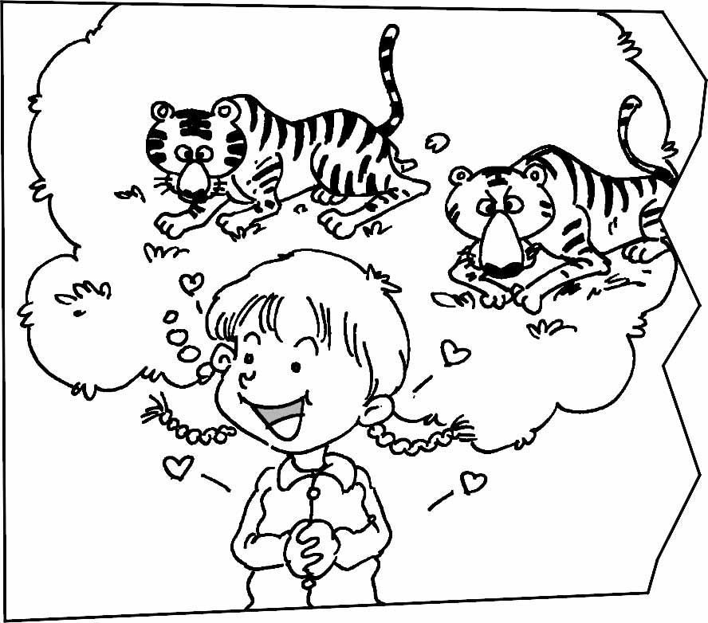
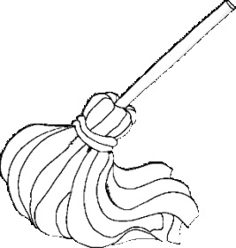  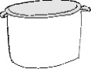 | 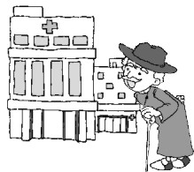 | 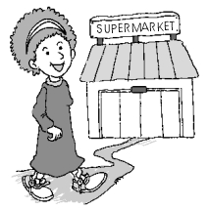 | 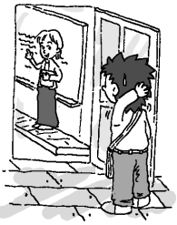

四. Look and Fill in the Blanks填充12%
2.
3.
4.
4.
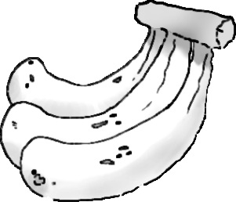
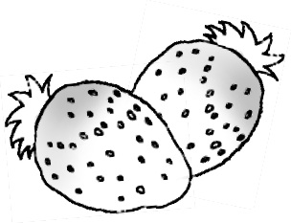
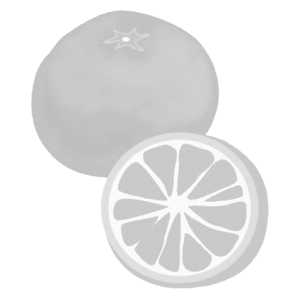
1.
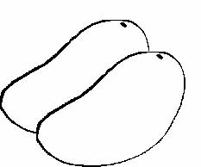

1. What are these? They’re .

2. What are these? They’re .

3. These are .

4. What are these? They’re .

五. Unscramble the Sentences重組12%

1. your Please hand . raise

2. the is The . sun under bus

六. Read and Circle圈選正確答案15%
1. The dog is wet. | 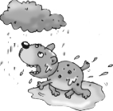 | 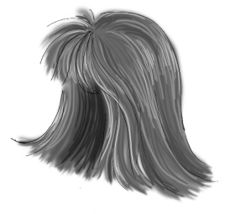

2. Mom: What do you want?  Angie: I want a sandwich. | 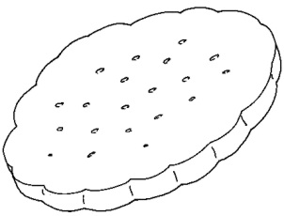 | 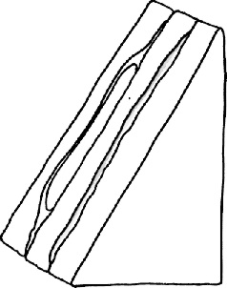

3. It is a fat rat. | 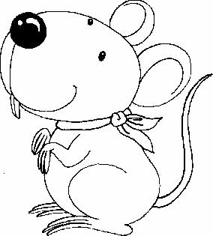 | 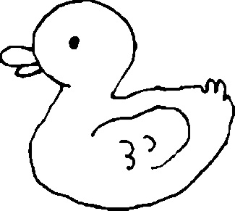

4. Tony: Repeat after me! Apples!  Angie: Apples! | 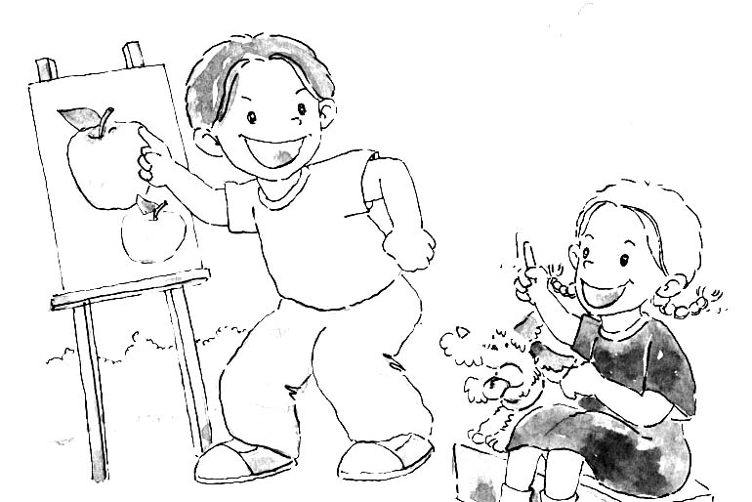 | 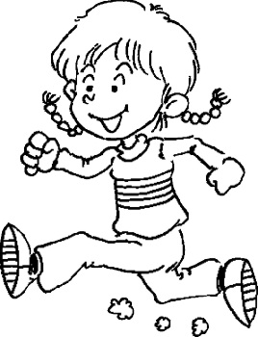  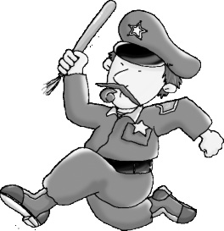

5. He is a vet. | 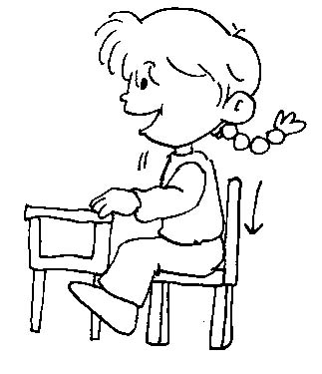 | 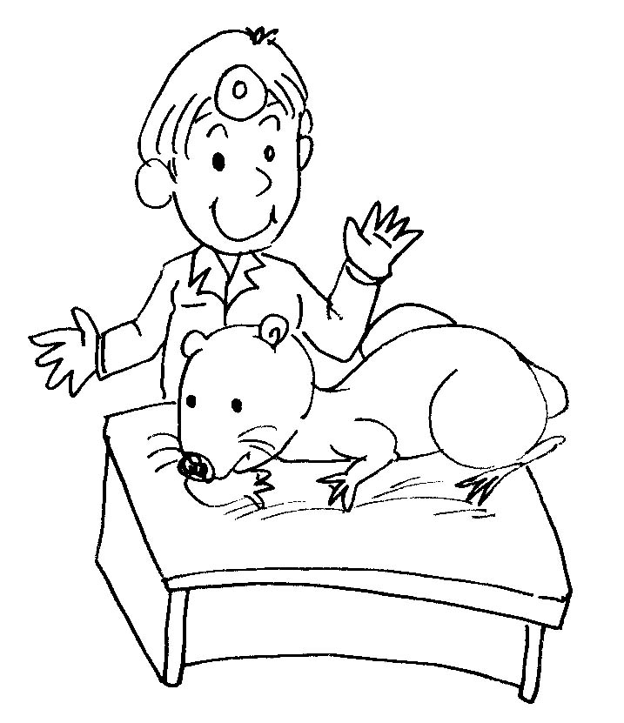

七 Read and number （How to make pizza?）13%
（ ）Eat!
（ ）Spread the sauce.
（ ）Roll the dough.
（ ）Bake in the oven.
（ ）Put the pizza in the pan.
（ ）Spread the cheese on the top.
（ ）Add the toppings.

