.
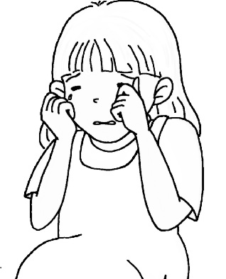
A. Fill in the Blanks填充
1. Are you ? Yes, I am.

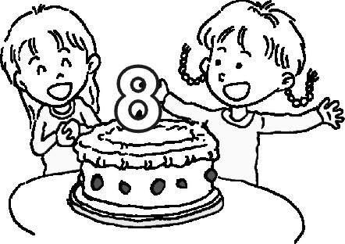
2. old are you?
I’m eight old.
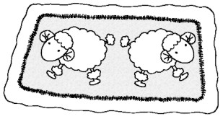
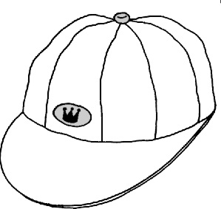
3. A is on the .
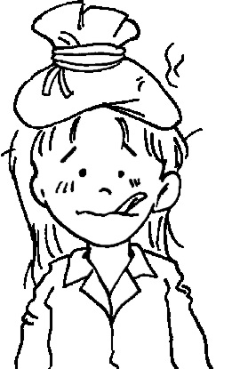
4. Are you ? Yes, I am.
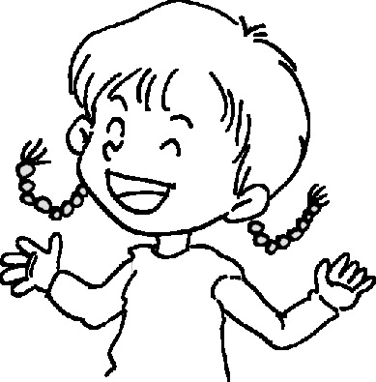
5. Ha! Ha! Ha! I am .
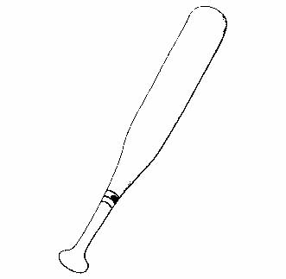
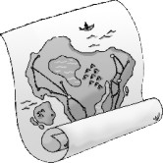
6. A map is on the .
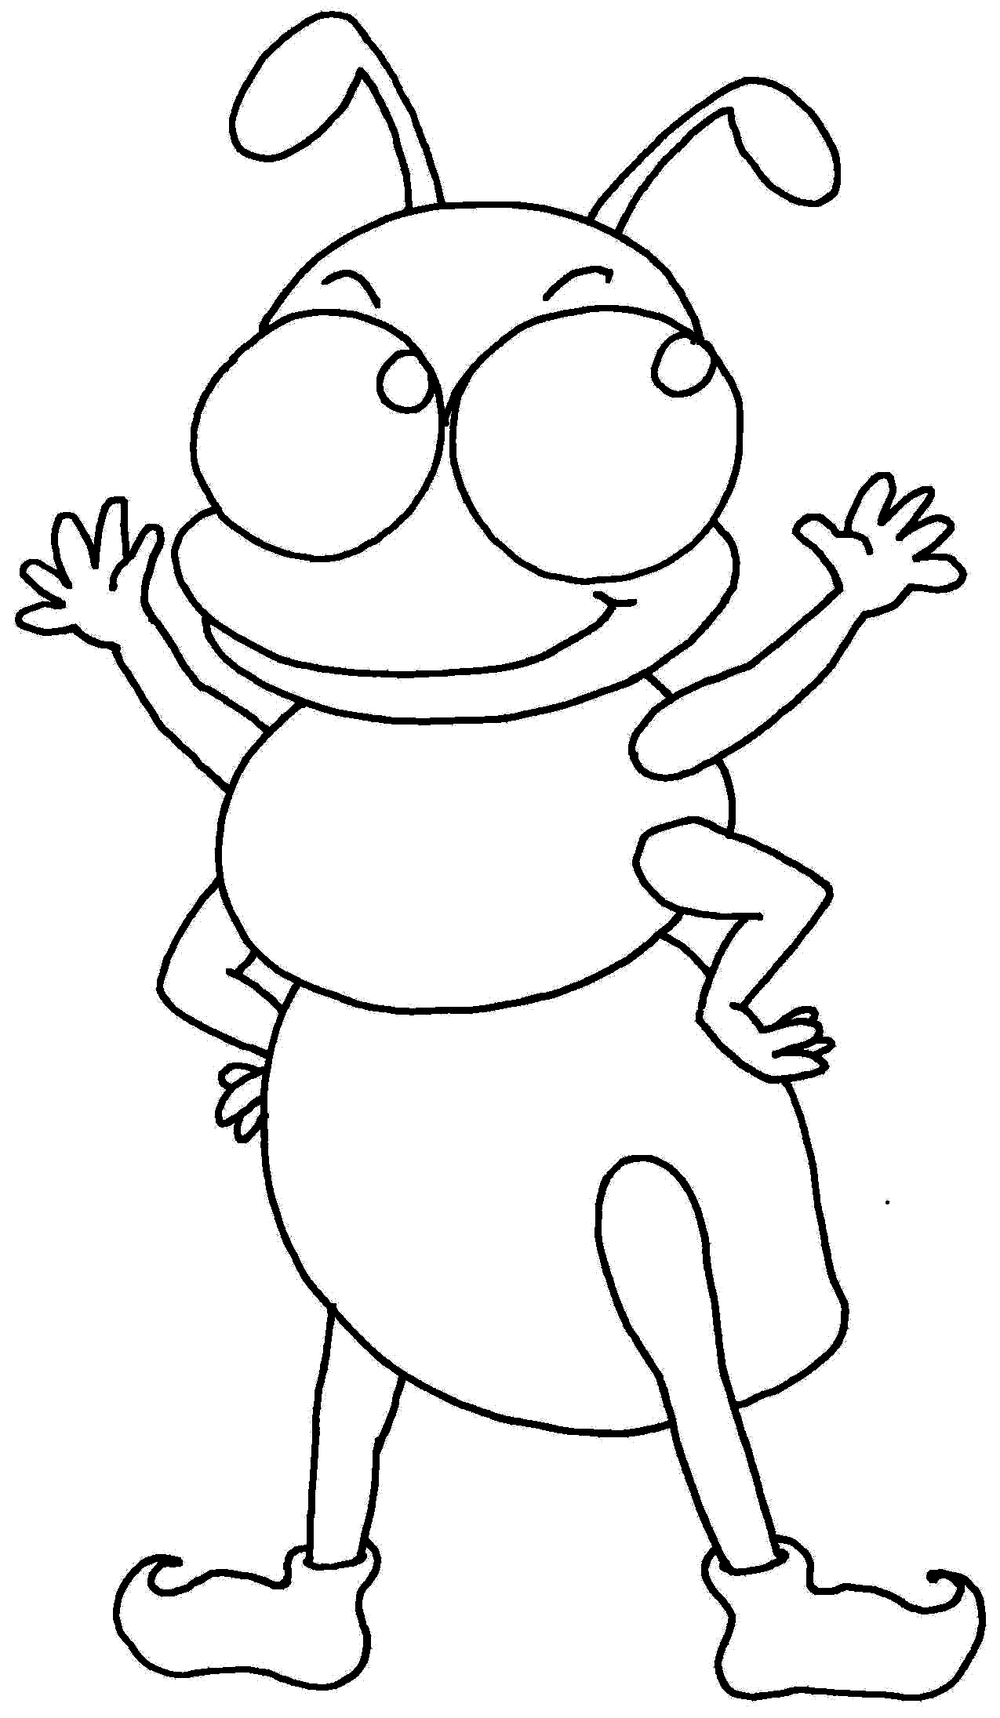
7. An is on the .

B.Read and Number讀句子填號碼
1. The hen is on the bed.
2. Is he scared? Yes, he is.
3. Is he thirsty? Yes, he is.
4. Is she hungry? Yes, she is.
5. Is she tired? Yes, she is.
6. Don’t push.
7. Line up.
8. The pen is on the leg.

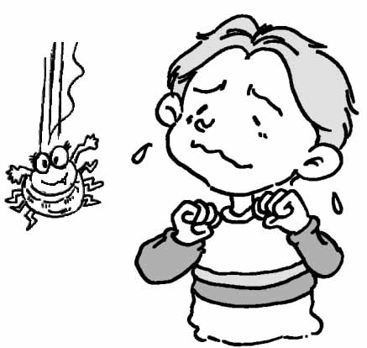 | 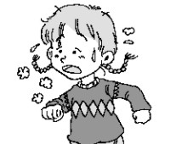 | 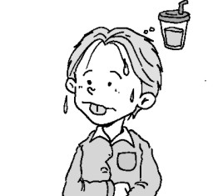 | 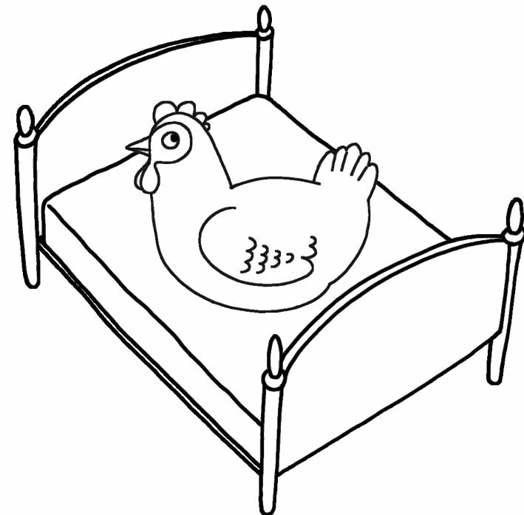
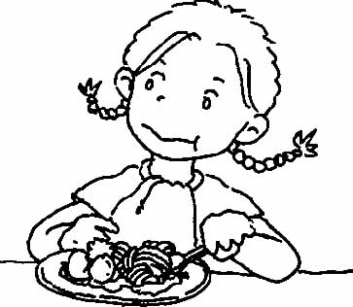 | 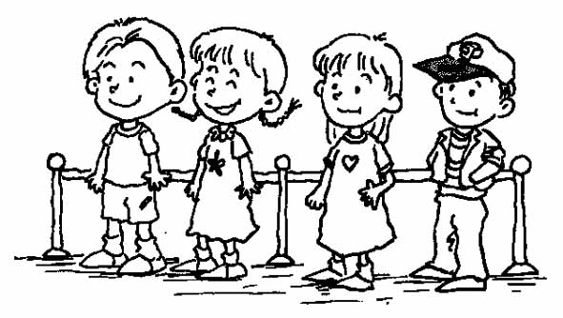 | 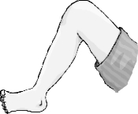  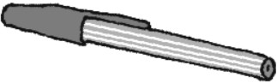 | 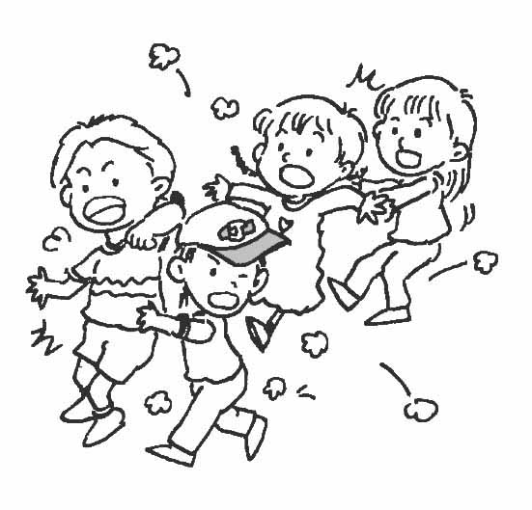

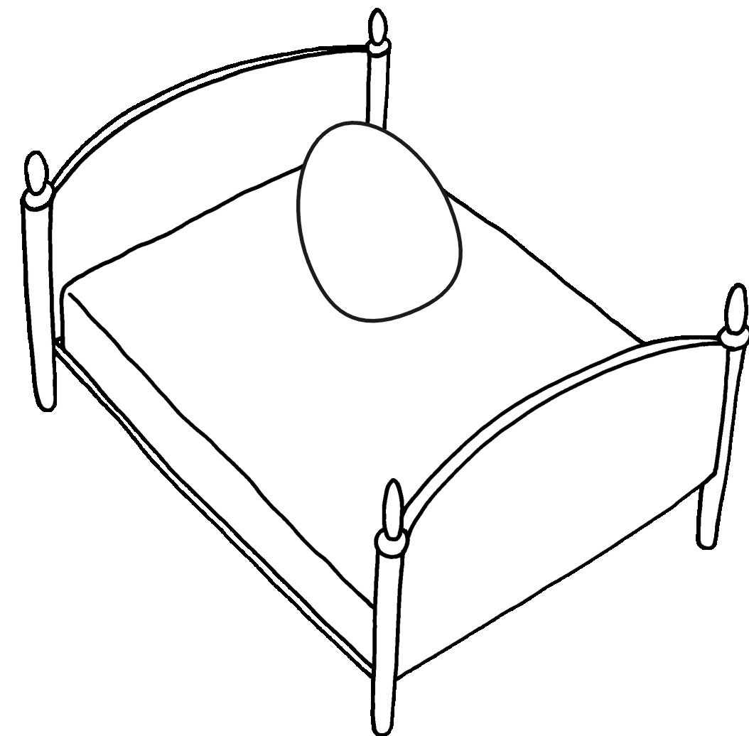
C. True (O) or False (X)是非題
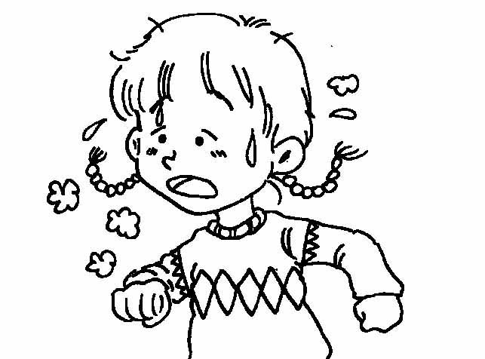
1. ( ) The egg is on the net.
2. ( ) Is she tired? Yes, she is.
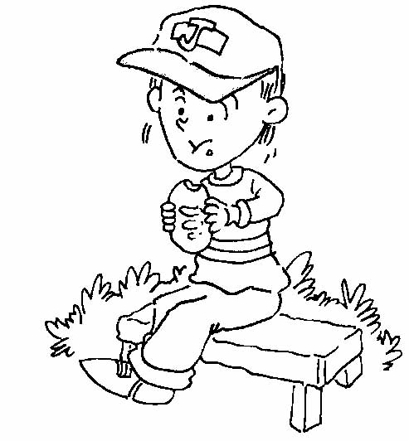
3. ( ) Is he hungry? Yes, he is.
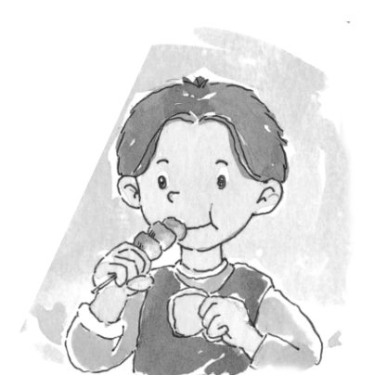
4. ( ) Is he scared? No, he isn’t.
5. ( ) This is good.
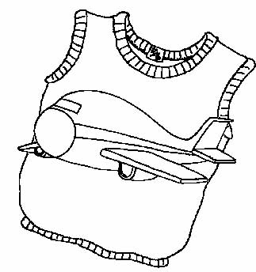
6. ( ) The jet is on the vest.
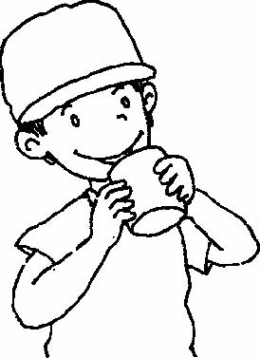
7. ( ) Who is thirsty? Johnny is.
8. ( ) Kim is thirsty.
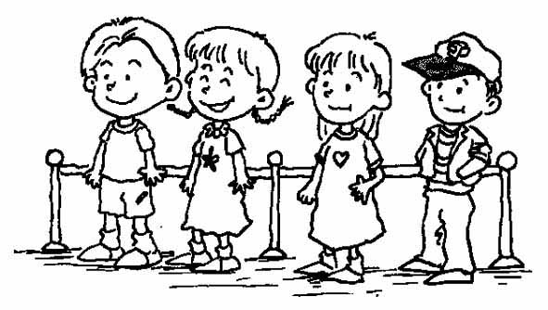
9. ( ) Line up.
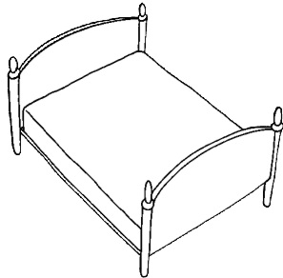
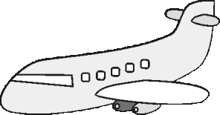
10. ( ) The jet is by the bed.

D .Look and Write 看圖填字
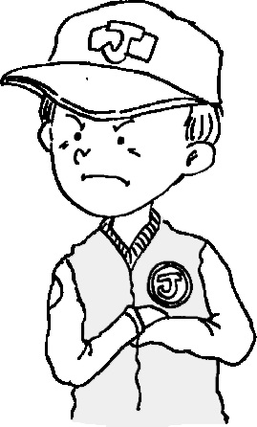
1.
2.
3.
4.

