拯民國小97學年度第一學期英語科 第三次考試三 年級___________ 班別___________ 姓名___________

一. True or False是非題

 | 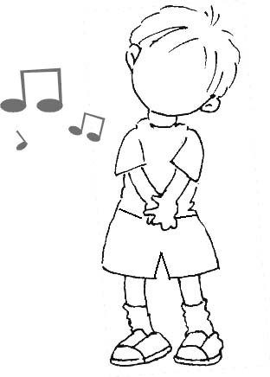 | 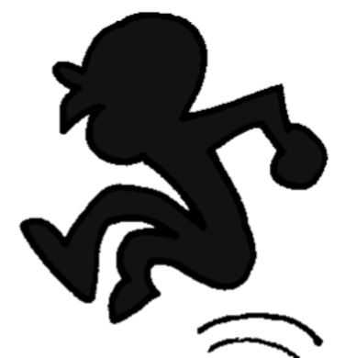 | 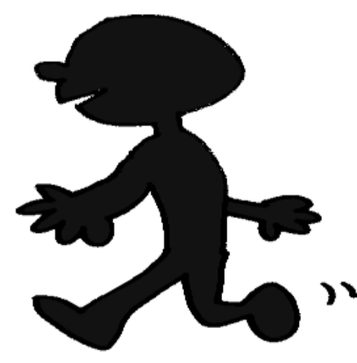 | 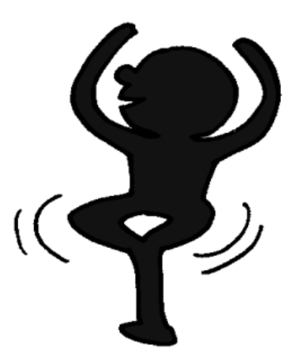
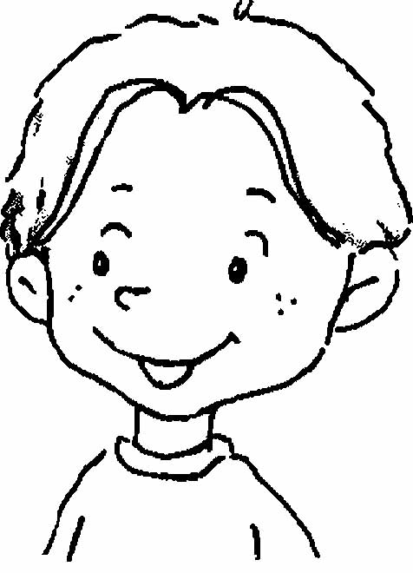 | ✓
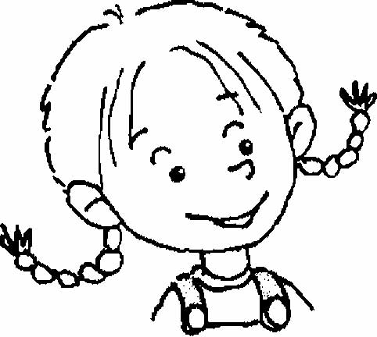 |  | ✓
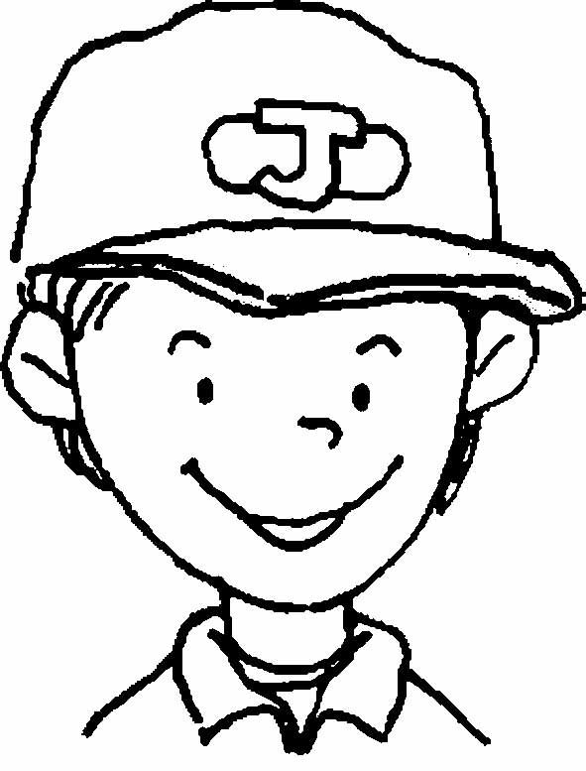 |  |  | ✓
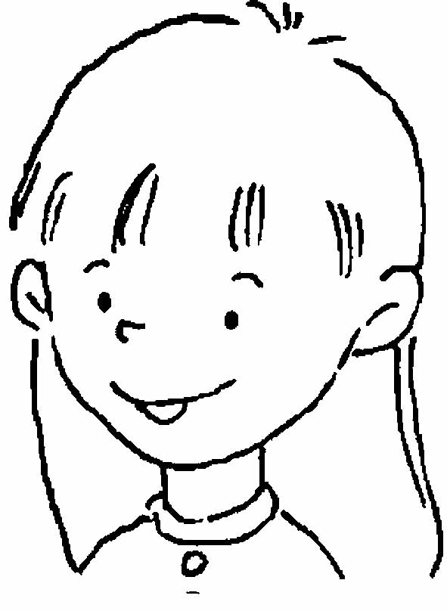 |  |  |  | ✓
1. I can dance. -
2. I can sing. ----
3. I can walk. --------
4. I can jump. ----

二. Read and Write看圖填入正確單字
juice ink insect jam

1.
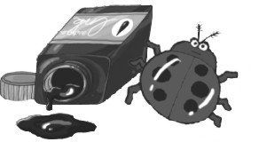
The is by the .

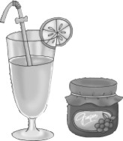
2.

The is by the .

3.
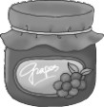
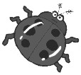
The is by the .

4.
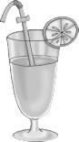
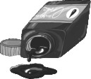
The is by the .

三.. Write the Correct Letter填入正確字母代號
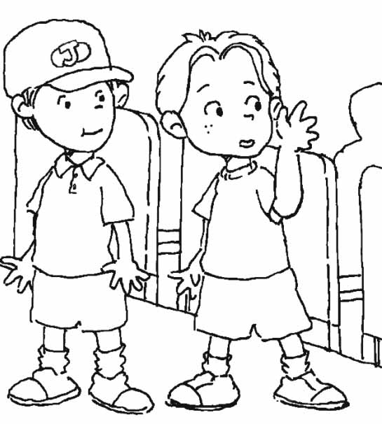
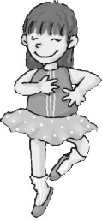
1. Be quiet!
a. b.
2. The juice is by the hat.
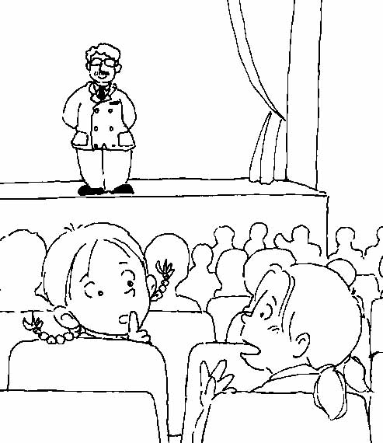
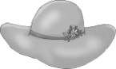
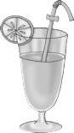
3. I can dance.
c. d.
4. Listen!

四 .Read and Write填入正確的單字
dance write sing read
walk fly jump swim

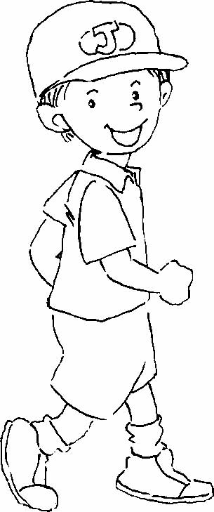
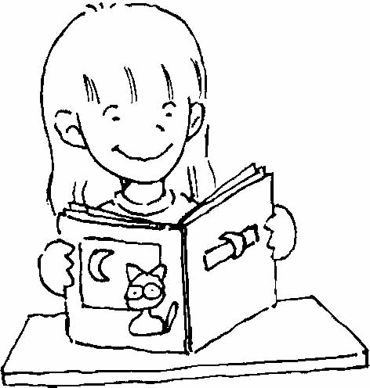
1. 2. 3. 4.
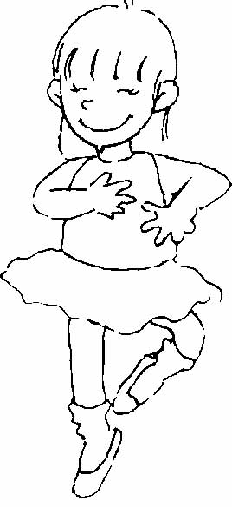
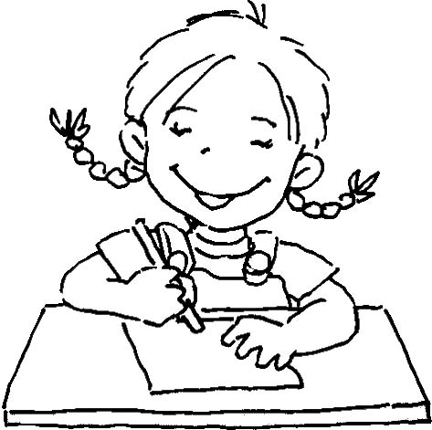

5. 6. 7. 8.
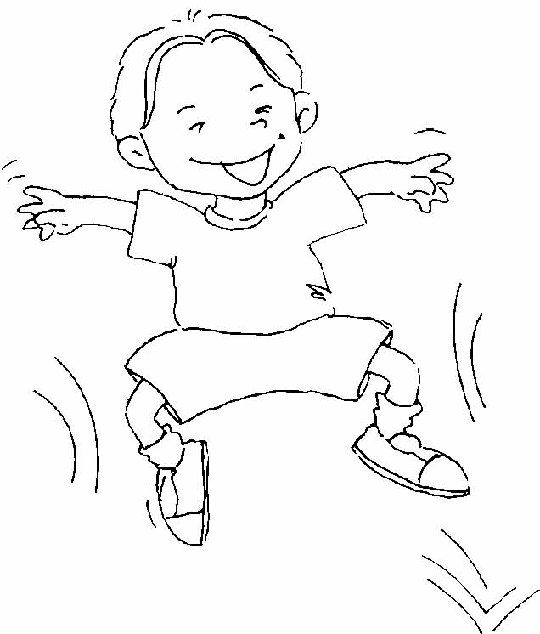
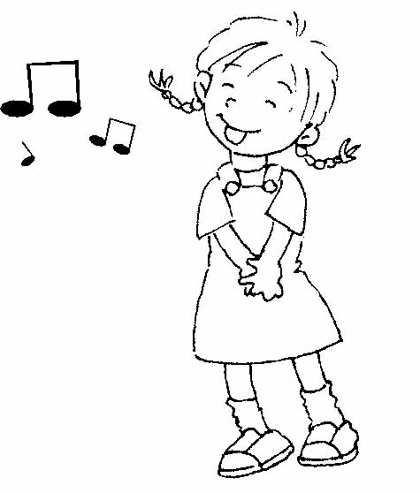
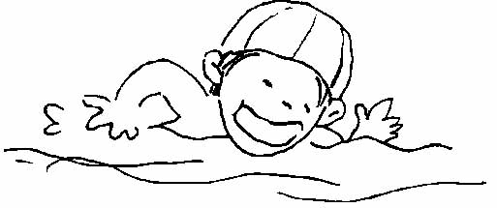
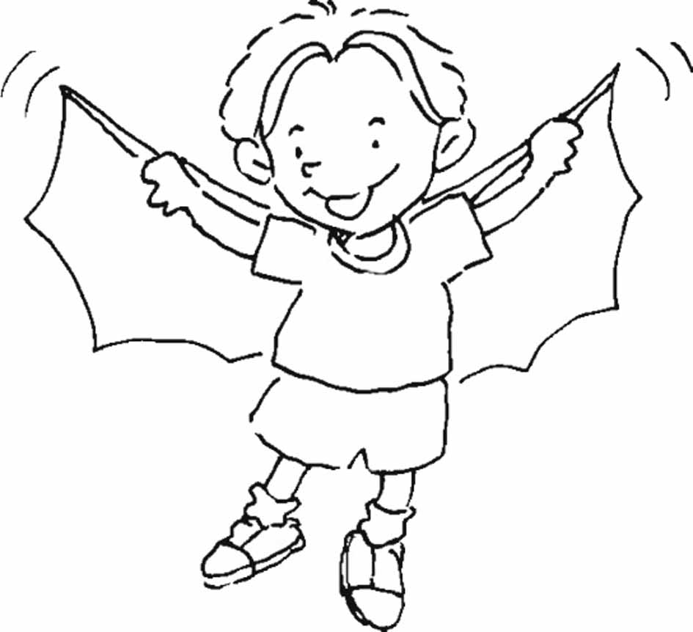

五. True or False是非題
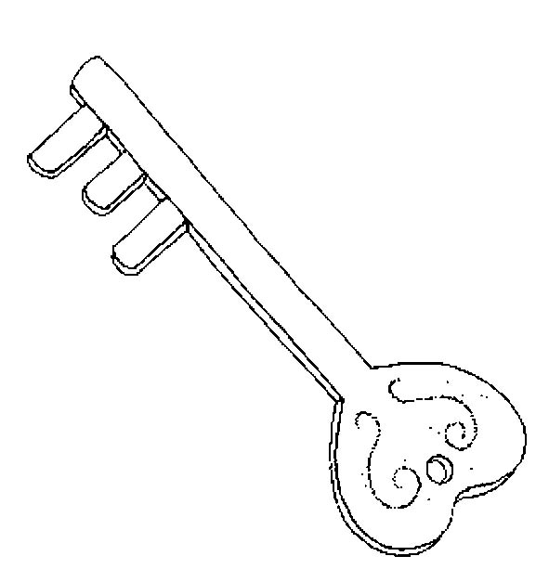
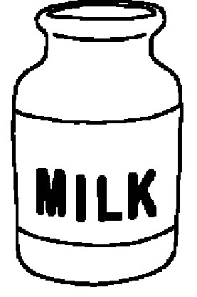
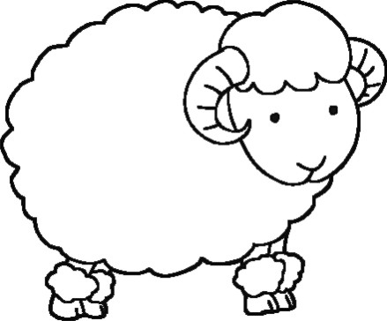
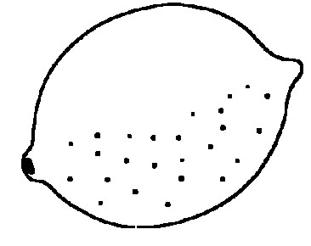
- The lamb is by the milk. -
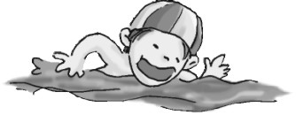
- The lime is by the king. ------------
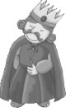
- Can you swim? Yes, I can.
- This is the king. -----

六. Multiple Choice選擇
1. ( ) Can you (❶sing ❷dance ❸swim)? Yes, I can.
2. ( ) Take (❶in ❷on ❸out) your book, please.
3. ( ) The (❶key ❷king ❸milk) is by the lime.
4. ( ) Can you swim? (❶Yes ❷No ❸Not), I can.
5. ( ) I (❶am not ❷can’t ❸not) fly.
6. ( ) Can you sing? No, I (❶can ❷am not ❸can’t).
7. ( ) (❶Do ❷Can ❸Are) you write? Yes, I can.
8. ( ) The lamb is by the (❶man ❷lime ❸milk).
❶ ❷ ❸ ❹
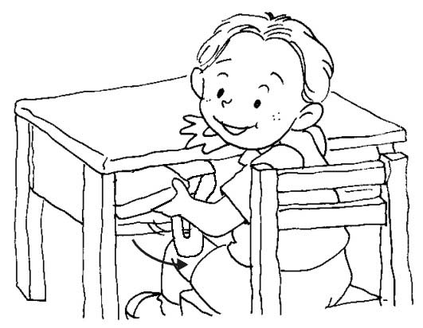


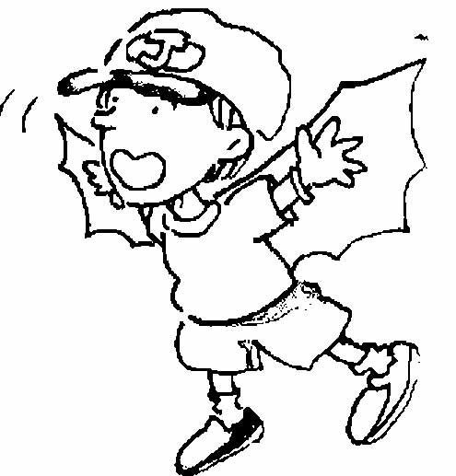
❺ ❻ ❼ ❽
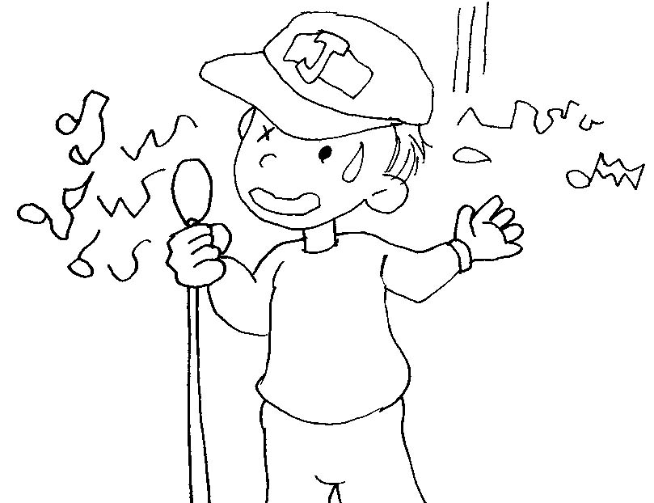

七Fill in the letter 填入大小寫字母
- a c f

- G I K

3.M O P Q

八.Read and Check 勾出正確答案

1. 2.
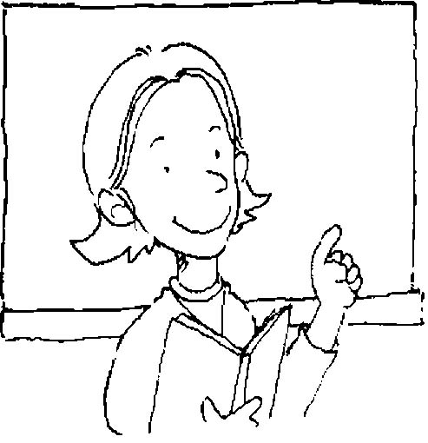
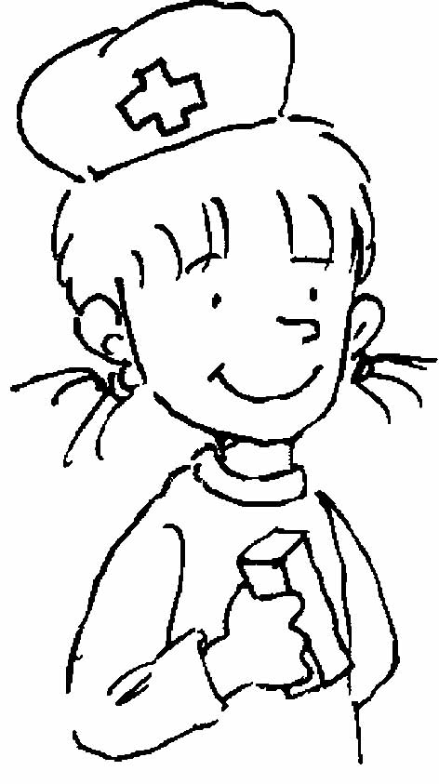
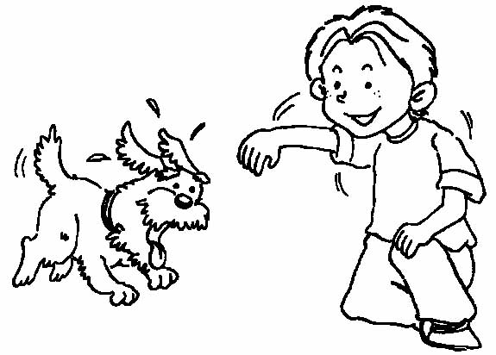
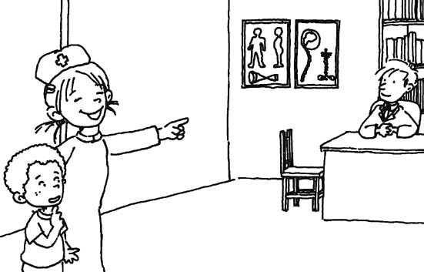
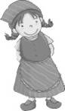
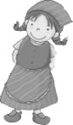
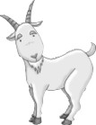
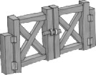
3. 4.
I can write.
I’m a teacher.
Come here, please.
A girl is by the gate.
…….
…….
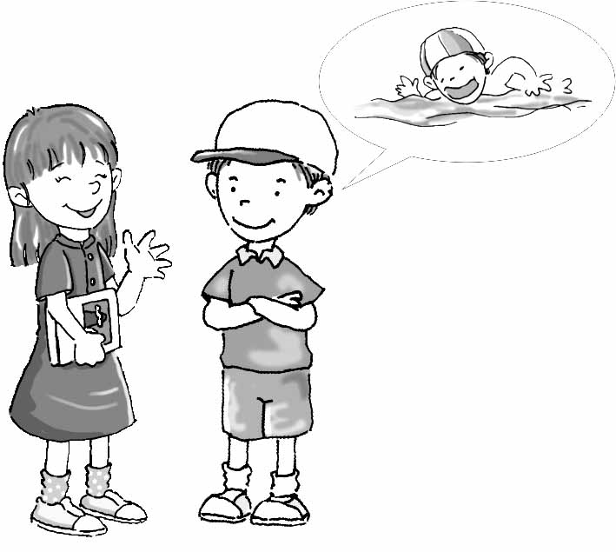
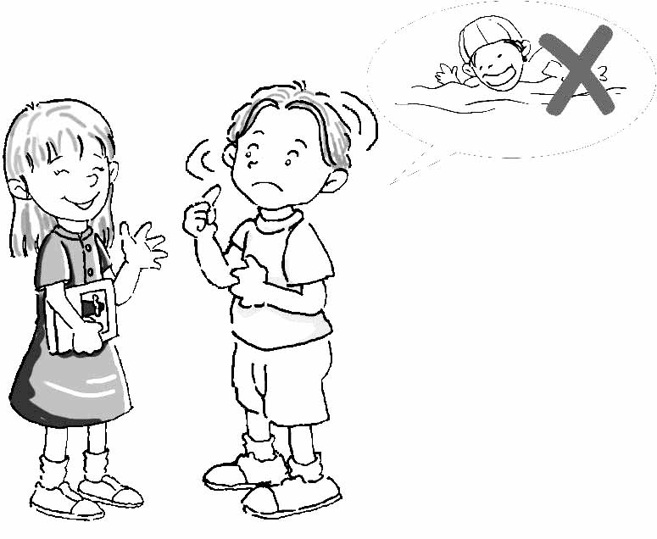
5. 6.
I can’t swim.
Be quiet.
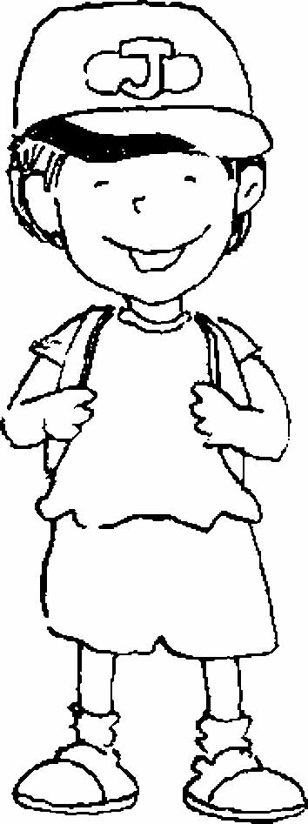
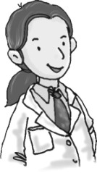
7. 8.
Are you a nurse? Yes, I am.
I am not a teacher.
I am a doctor.

