一. Fill in the Blanks填充15%
1. What is it? It’s a .
2. A: I’m . B: It’s OK.
3. A is on a fish.
4. It’s a .
5. An is on an elephant.
……
❶ ❷ ❸ ❹ ❺
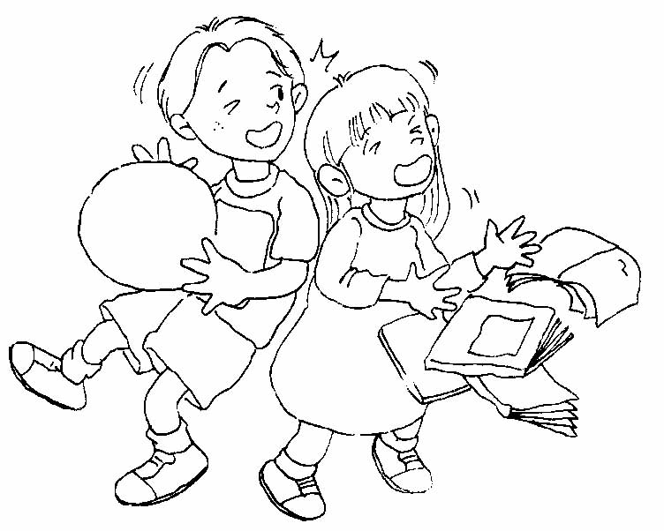
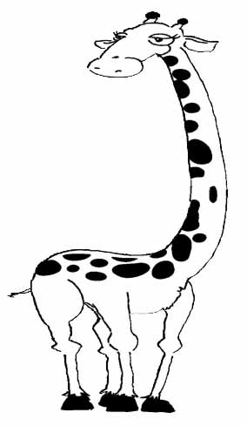
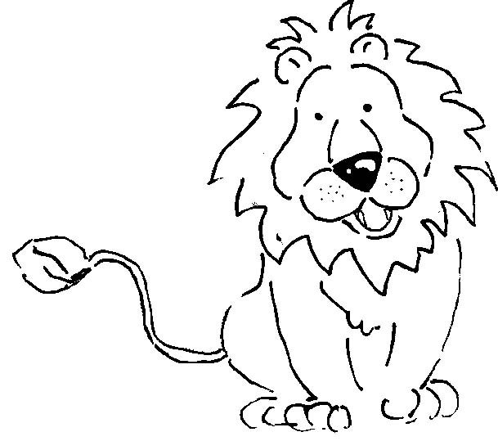
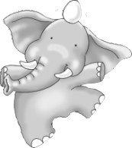
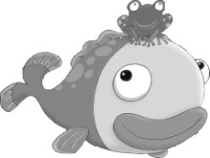

二. Read and Write看圖寫出正確單字18%
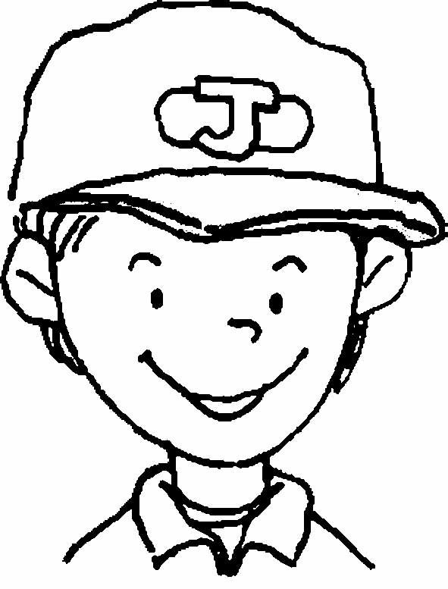

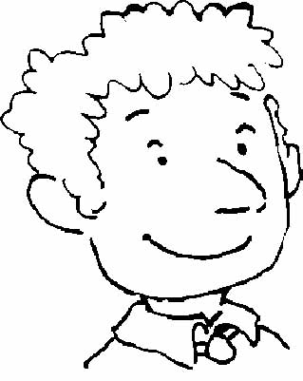
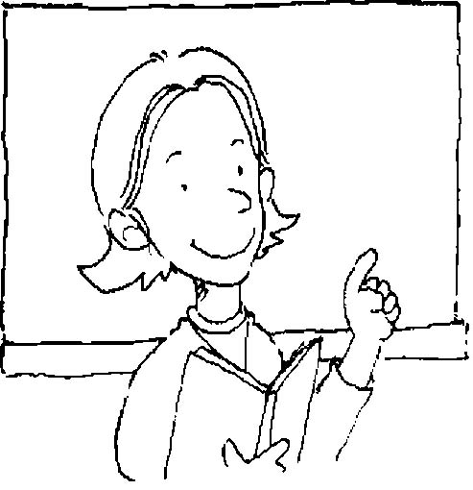
Hi, I’m . This is my family.
❶
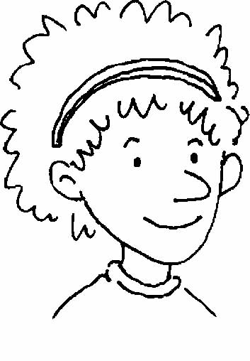
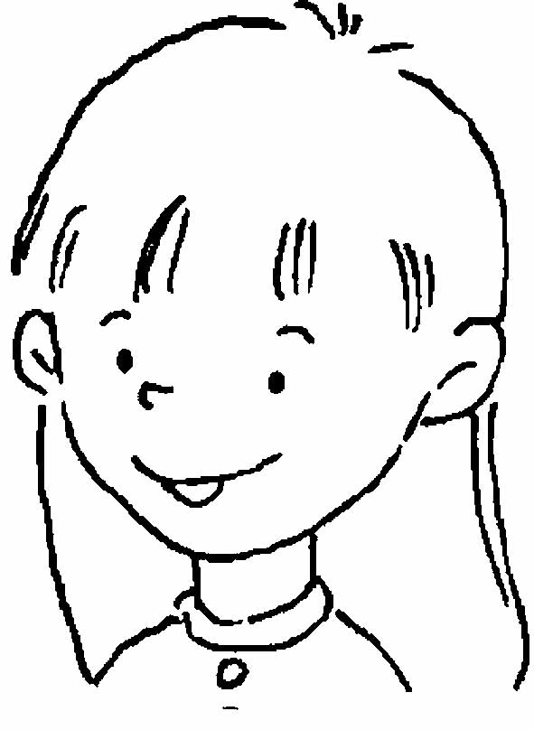
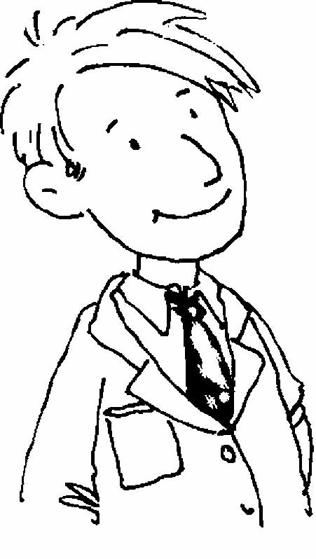
She’s my . She is a . He’s my .
❷
❸
❹
He is a . This is my .
❻
❺
I love my family.
❶ ❷ ❸

❹ ❺ ❻

doctor Johnny mother father sister teacher

三.
Multiple Choice選擇24%
1. ( ) Excuse (❶you ❷he ❸me)! Are you a
teacher?
2. ( ) I (❶is ❷am ❸are) a nurse.
3. ( ) Are you a (❶teacher ❷doctor
❸student)? Yes, I am.
4. ( ) Are you a teacher? No, I (❶ don’t ❷ am not
❸ am ).
5. ( ) Go (❶there ❷here ❸this), please.
6. ( ) A girl is by a (❶goat ❷horse ❸doll).
7. ( ) Come (❶there ❷here ❸this), please
8. ( ) A hen is by a (❶cat ❷goat ❸hat).
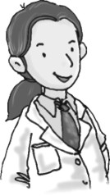
❶ ❷ ❸ ❹
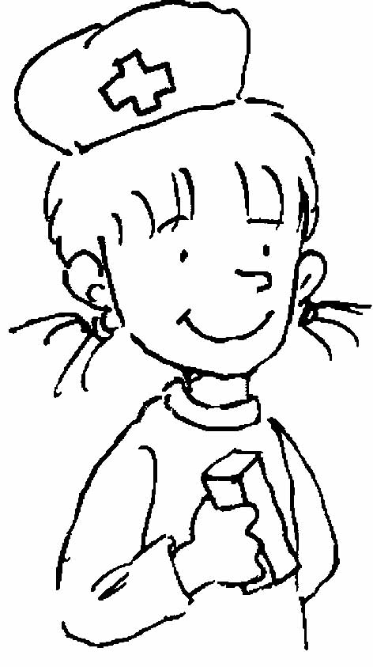
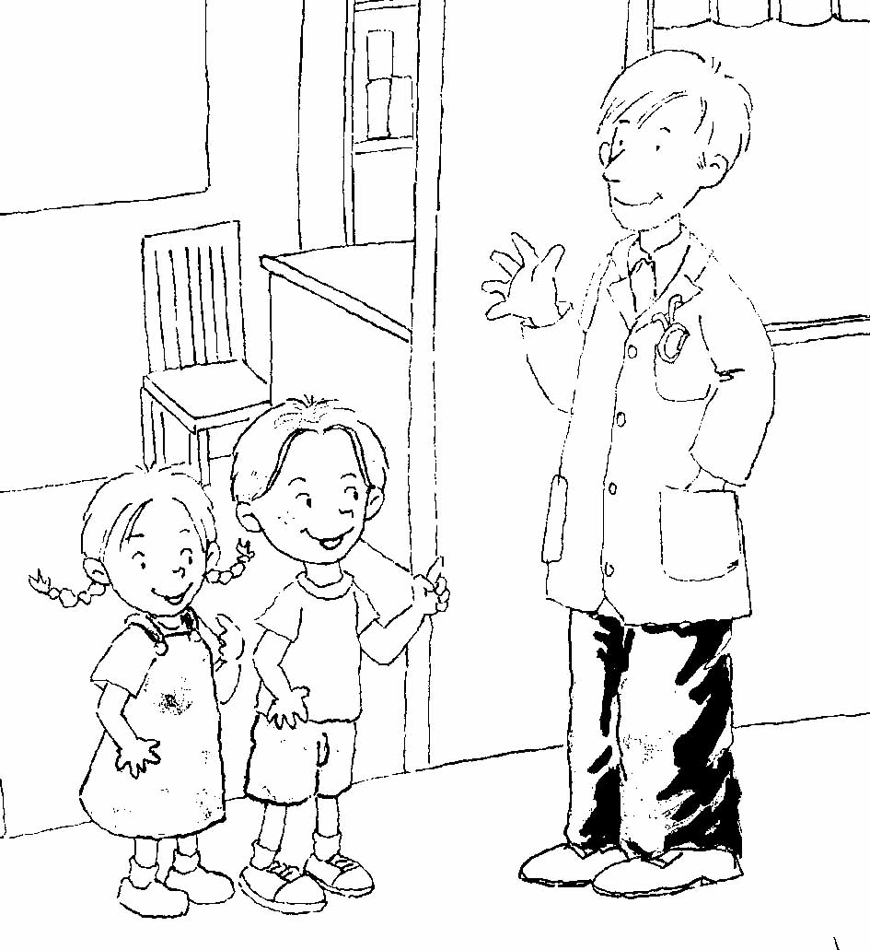
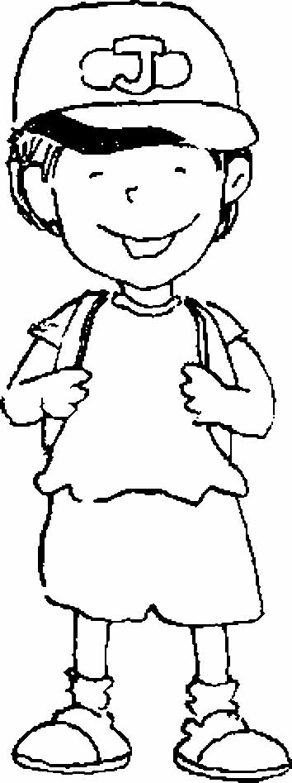
……

❺ ❻ ❼ ❽
……
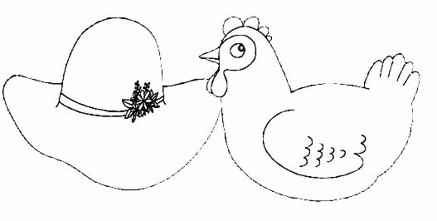
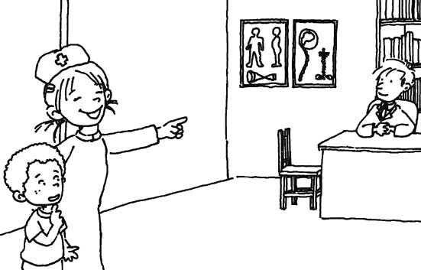
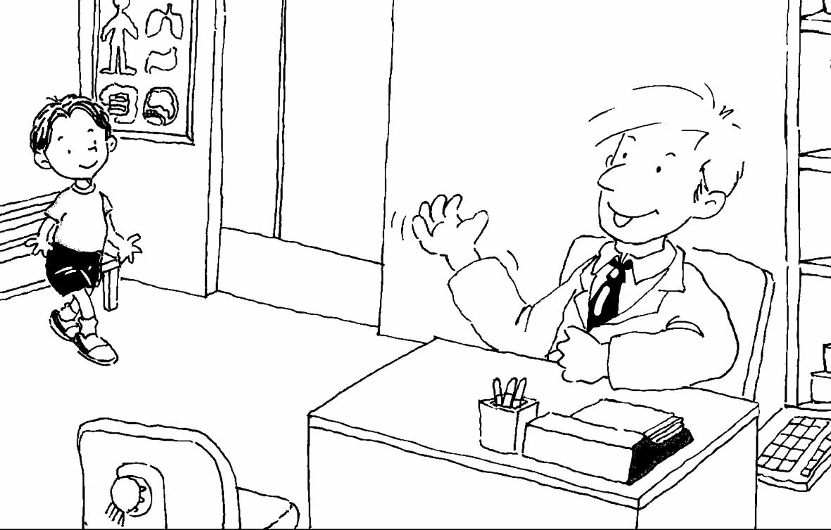
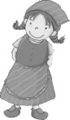
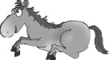

四Write the Letter寫出正確發音字母 12%

1. 2.
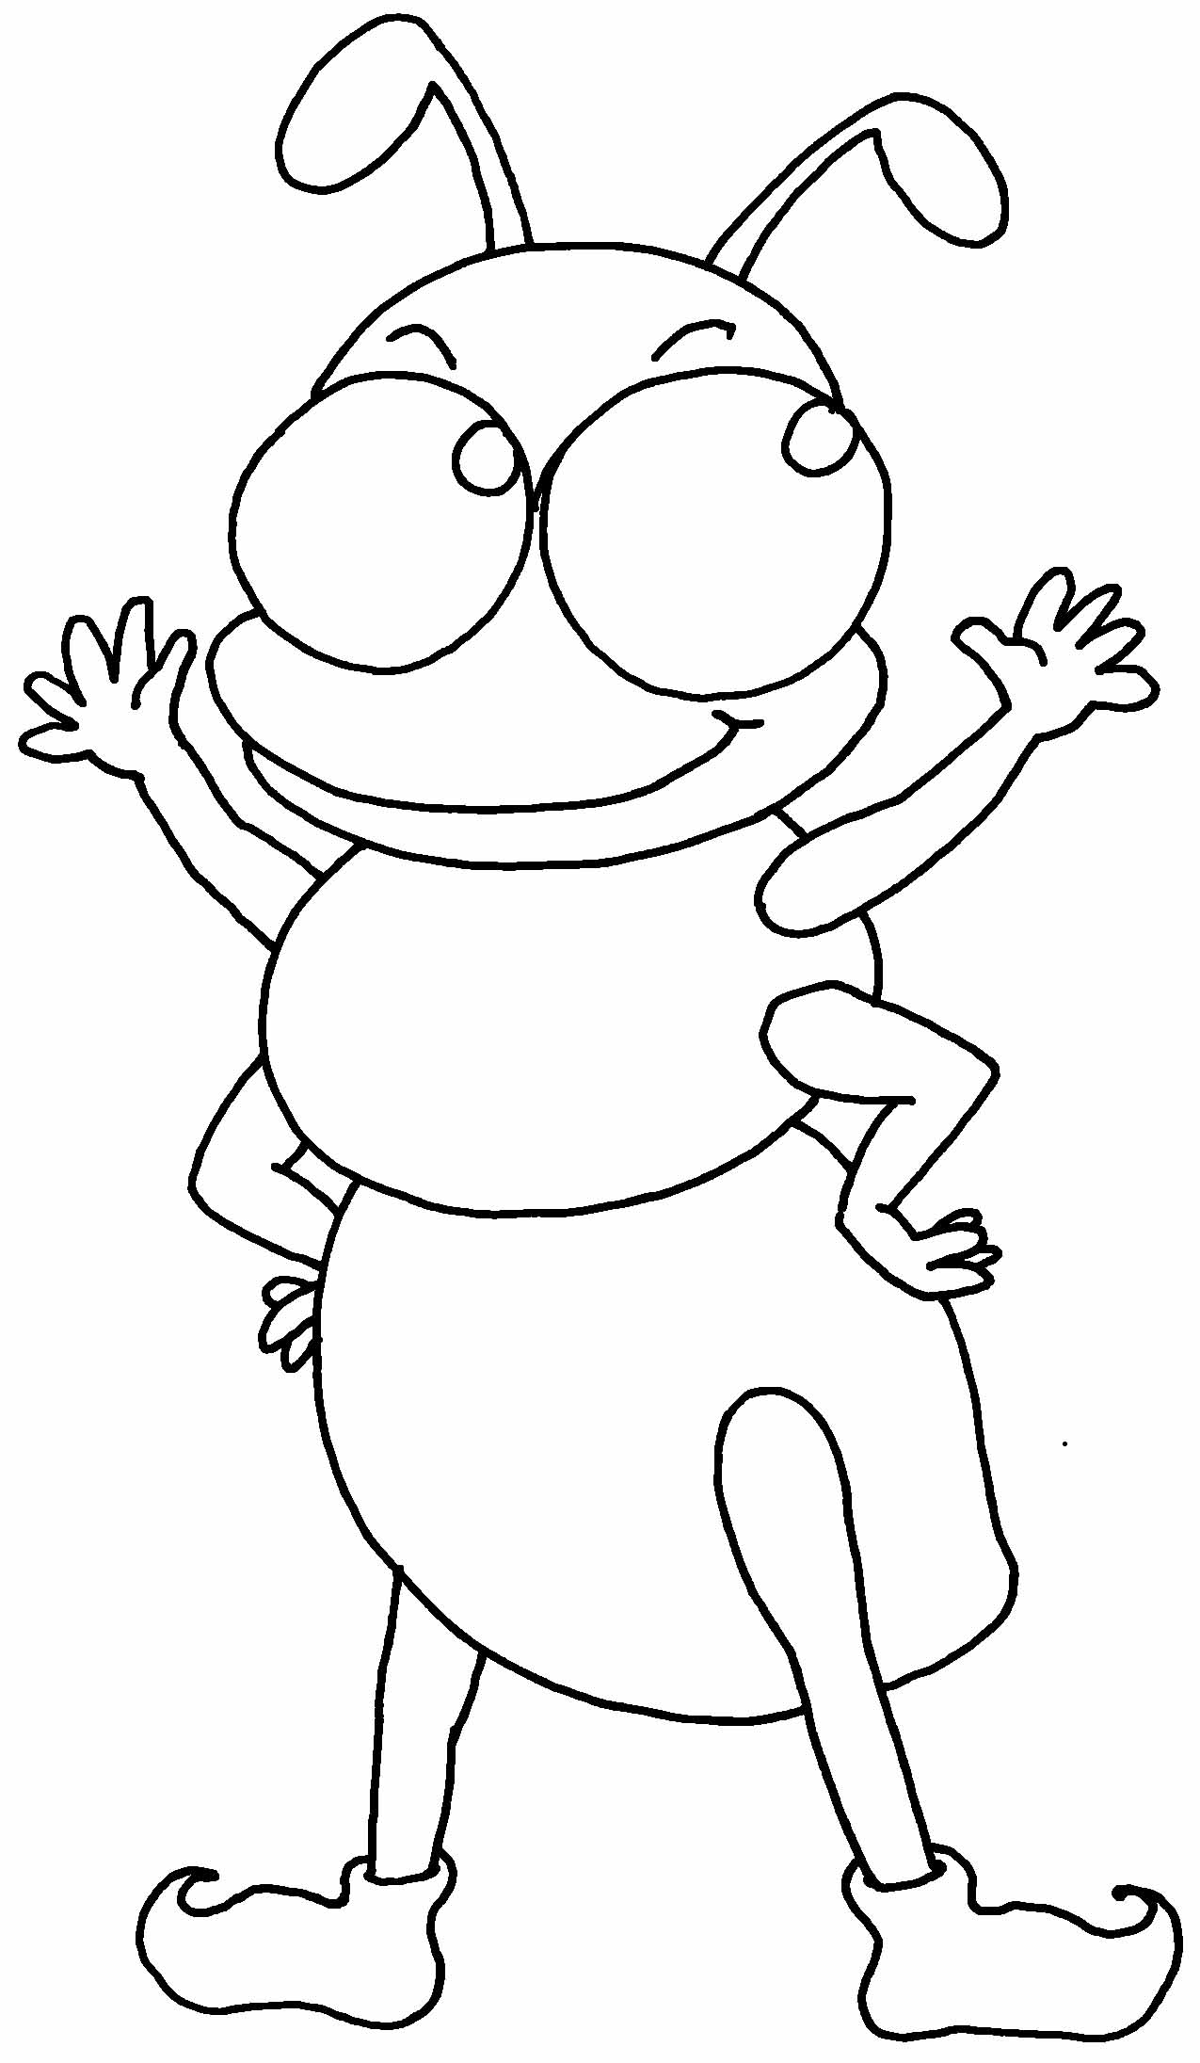
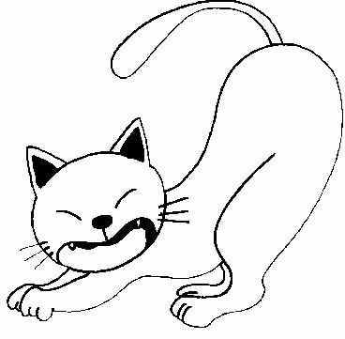

at
nt

- 4
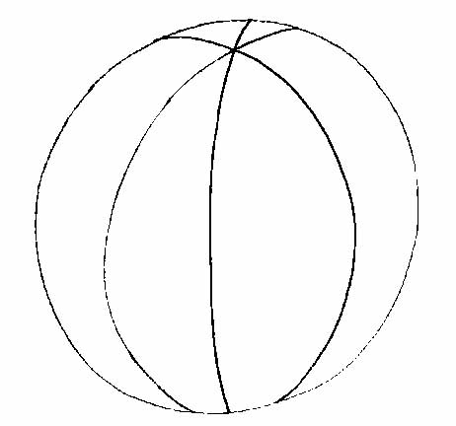
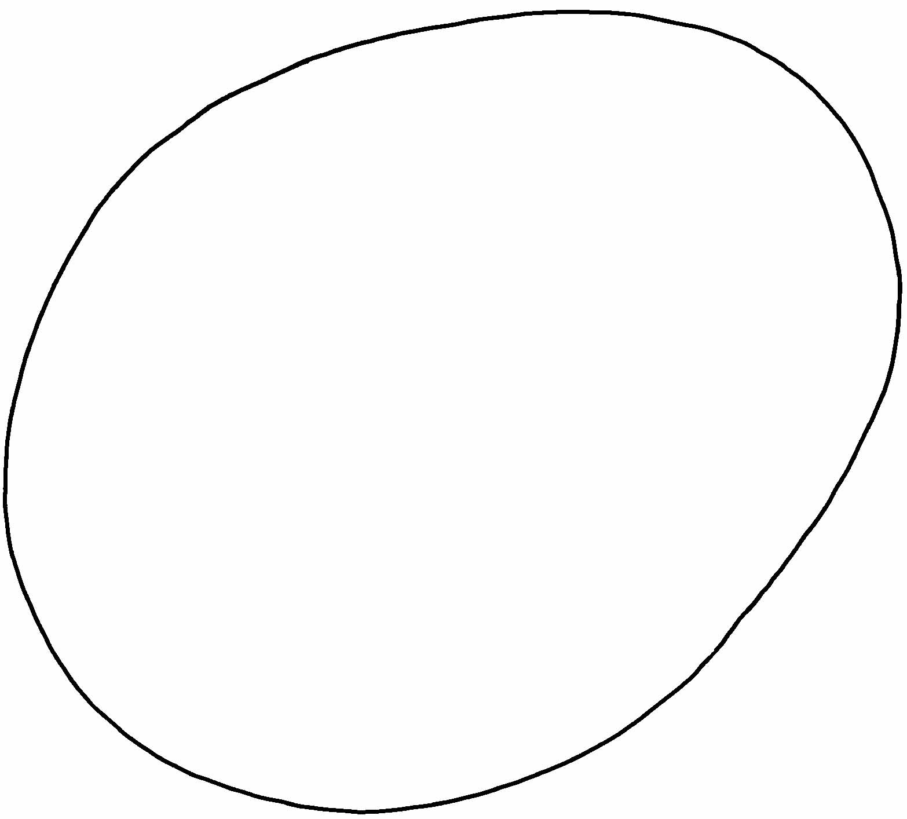

all
gg

五match大小寫字母配對 21%
- a d f h b n m

F H D N M A B

