A. Read and Write the Letter填出正確的字母 24分
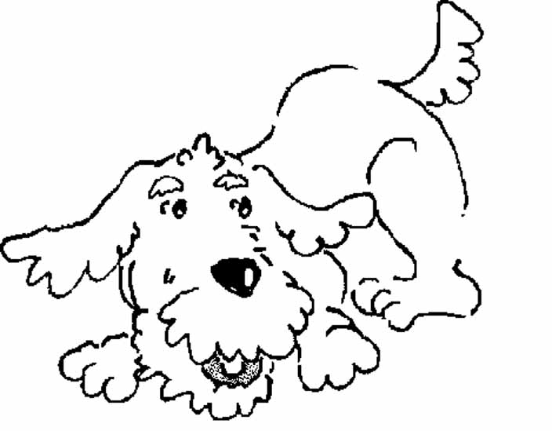
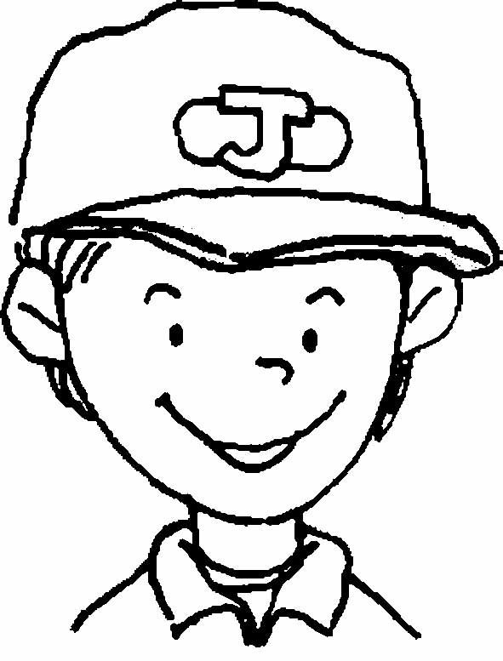
1.
Angie
Johnny
a.
b.
2.
Tony

c.
d.
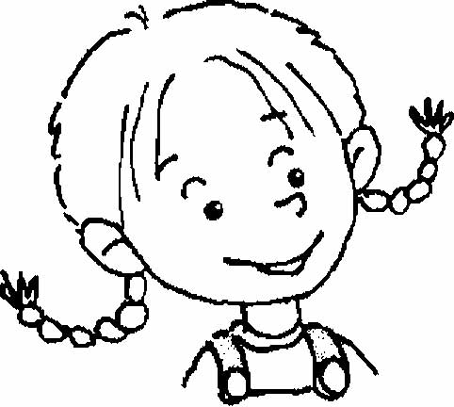
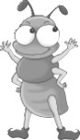
3.
ant
4.
Fatty
e.
f.
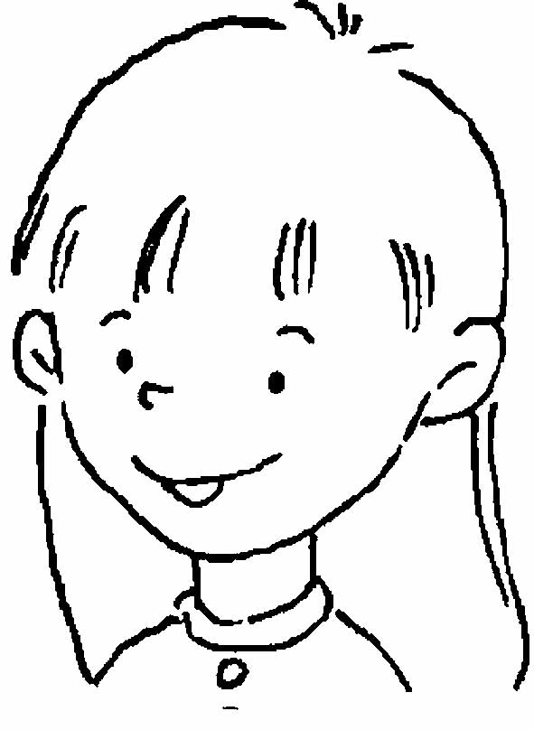
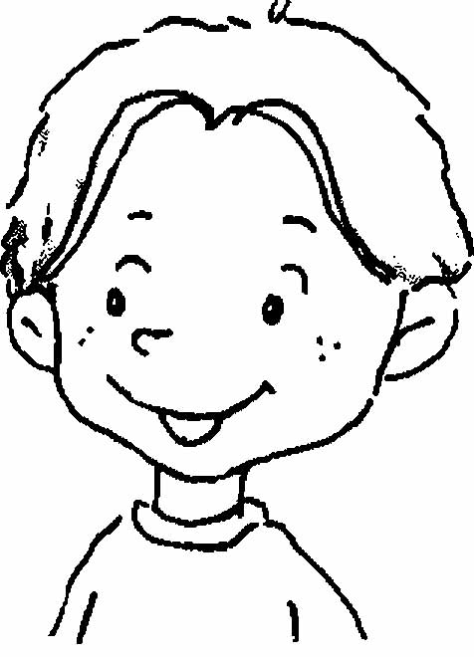
5.
6.
Kim
B. Fill in the Blanks填充 20分
1. My name is .
What’s your name?
2. An is on Johnny.
3. Hello, my name is .

4. An is on a .
5. up, please.
❶ ❷ ❸ ❹ ❺

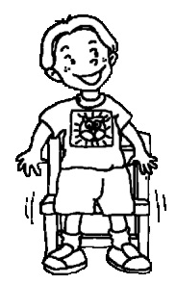
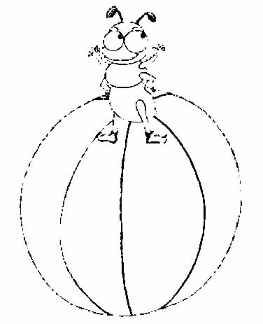
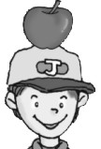

C. Read and Write 寫出正確的單字
mother brother doll camel father sister

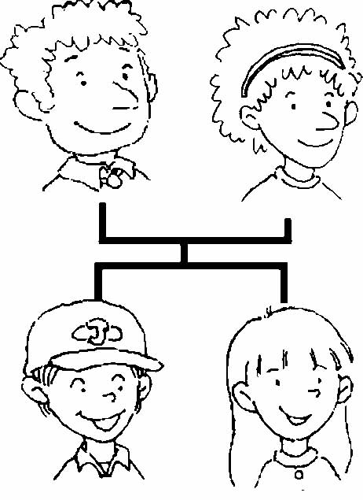
1.
She’s my .

2.
He’s my .

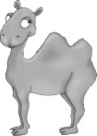
3.
This is a .

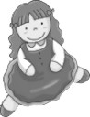
4.
This is my .

5.
She’s my .

6.
He’s my .

D. Multiple Choice選擇
1. ( ) A: (❶What’s your name? ❷How are you? ❸Thank you.)
B: You’re welcome.
2. ( ) A (❶dog ❷cat ❸doll) is on a camel.
3. ( ) This is my (❶mother ❷father ❸brother).
4. ( ) A (❶ball ❷doll ❸door) is on a dog.
5. ( ) She’s my (❶mother ❷brother ❸sister).
6. ( ) A: (❶What’s ❷Who’s ❸How’s) he?
B: He’s my father.
7. ( ) A cat is on a (❶camel ❷bear ❸doll).
8. ( ) (❶He’s ❷His ❸He) my brother.
❶ ❷ ❸ ❹
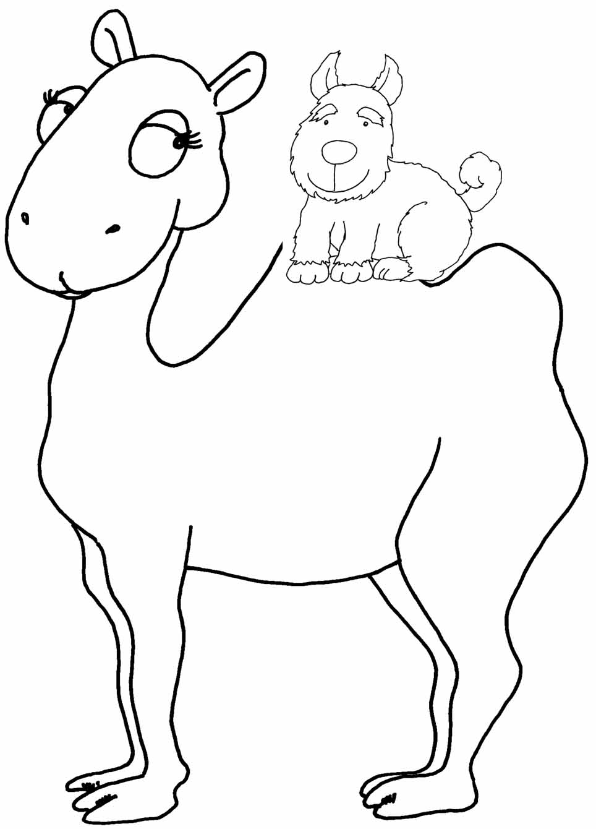
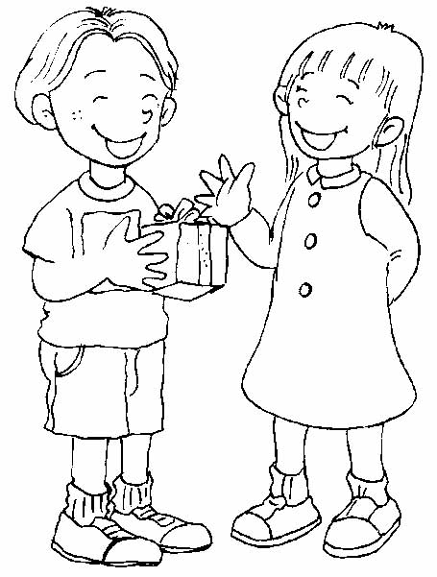
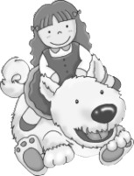

❺ ❻ ❼ ❽
